Week 1: miRNA-mRNA human – chimp brain development
Goals: 1.) assemble the core PFC expression and metadata resources
2.) confirm the matched subjects
3.) build small test datasets

1.) PFC dataset summary from article
Prefrontal cortex sample sizes and retained expression features in the human, chimpanzee and rhesus macaque comparison.
Dataset | Human n | Chimpanzee n | Macaque n | Total n | Retained PFC features
mRNA microarray | 23 | 12 | 26 | 61 | 12,447 expressed genes
miRNA microarray | 8 | 11 | 8 | 27 | 198 detected miRNAs
Selection notes
- mRNA: probes were restricted to sequences matching the human, chimpanzee and macaque genomes perfectly and uniquely; 12,447 genes were expressed in the PFC dataset.
- miRNA: 866 array features were reduced to 500 mature miRNAs conserved across all three species and then to 198 miRNAs detected in the PFC after expression filtering.
- The mRNA and miRNA experiments used different, only partially overlapping sets of individuals and should not be treated as a completely paired cohort.

Data downloaded (prefrontal cortex (PFC) and cerebellum (CBC))
Source | Download | Decscription
GSE29356 | Processed PFC and CBC miRNA file and series metadata | Processed PFC miRNA expression.  198 detected in PFC
GPL10850 | Platform annotation table | Annotations for individuals in expression data PFC and CBC
GSE22521 | Processed PFC mRNA expression or series matrix | PFC mRNA expression. 12447 genes expressed in PFC
GSE22569 | Processed CBC mRNA expression or series matrix | CBC mRNA expression. 12853 genes expressed in CBC
GPL6244 | Platform annotation table | Map Affymetrix probes to genes
Somel et al. | Table S1 and Text S1 | Sample metadata and methods
Naming note. The article cites GSE22570, the complete mRNA data. GSE22521 is its PFC component and is therefore the appropriate starting dataset for the PFC-only analysis.
Normalization note. The authors' processed expression values were log2 transformed and quantile normalized. They are suitable for learning and for reproducing downstream analyses without beginning with raw microarray preprocessing.
Data files:
- series_matrix.txt.gz = expression matrix;
- family.soft.gz = detailed metadata and documentation, sometimes including another representation of the processed values;

Sources
1. Somel M et al. MicroRNA-Driven Developmental Remodeling in the Brain Distinguishes Humans from Other Primates. PLOS Biology 9(12): e1001214. https://doi.org/10.1371/journal.pbio.1001214
2. NCBI Gene Expression Omnibus GSE29356. https://www.ncbi.nlm.nih.gov/geo/query/acc.cgi?acc=GSE29356
3. NCBI Gene Expression Omnibus GSE22521. https://www.ncbi.nlm.nih.gov/geo/query/acc.cgi?acc=GSE22521
4. NCBI Gene Expression Omnibus GPL6244. https://www.ncbi.nlm.nih.gov/geo/query/acc.cgi?acc=GPL6244
5. TargetScanHuman Release 8.0 data download. https://www.targetscan.org/cgi-bin/targetscan/data_download.vert80.cgi

Week 2: miRNA-mRNA human PFC – chimp brain development
2.) PFC mRNA sample reconciliation
Comparison of GEO GSE22521 microarray measurements, Table S1 subject annotations, and the published PFC mRNA sample counts.
Sample counts
Source / selection | Human n | Chimpanzee n | Macaque n | Total n
GEO arrays (original) | — | — | — | 68 arrays
GEO after five repeat pairs are removed | 23 | 12 | 28 | 63*
Table S1 PFC mRNA subjects | 23 | 12 | 27 | 62
Published PFC mRNA analysis | 23 | 12 | 26 | 61
*The 63-subject count is provisional: it assumes the five identified pairs exhaust repeated measurements.
Identified repeated measurements
Species | Age (days) | Measurement 1 | Measurement 2 | Batch
Human | 2 | GSM559193 | GSM559194 | b1 / b2
Human | 35,770 | GSM559198 | GSM559199 | b1 / b2
Macaque | 10,220 | GSM559208 | GSM559209 | b1 / b2
Macaque | 16 | GSM559215 | GSM559216 | b1 / b2
Macaque | 2,936 | GSM559223 | GSM559224 | b2 / b2_2

Selection note. Omit Measurement 2, as measurements are highly correlated. This convention is not a verified reconstruction of the original authors’ choices.
Additional macaque sample and unresolved omission
GSM559211: rhesus macaque, superior frontal gyrus, age 1,487 days (~4.1 years). This GEO sample has no species-and-age match among the PFC mRNA subjects in Table S1; its absence from the table is unexplained. One further macaque remains unidentified: Table S1 lists 27 PFC mRNA macaques, but the publication reports 26. The excluded subject’s Table S1 number and GSM accession cannot be established.
Working data and remaining checks
Original matrix: 13,042 features × 68 arrays. Replicate-deduplicated working matrix: 13,042 × 63. Table S1–r Working matrix: 13,042 × 62 (additionally omit GSM559211). The 62-subject matrix should not be described as the published 61-subject cohort.

Exploratory expression-correlation filtering
Filtering rule. For each individual, calculate the Pearson correlation of its 13,042-feature mRNA expression profile with every other individual of the same species. Exclude self-correlation, take the median, and retain samples only when their within-species median correlation is strictly greater than 0.90 (90%).
Samples flagged by the 0.90 cutoff:
Species | Age (days) | GEO sample | Median correlation
Human | 2 | GSM559193 | 0.845729
Human | 19 | GSM559186 | 0.877110
Rhesus macaque | 30 | GSM559225 | 0.885962
Dataset counts after this exploratory cutoff: 62 Table S1–matched samples → 59 retained (21 human, 12 chimpanzee, 26 macaque)

3.) Annotation of the filtered PFC mRNA data.
Feature-to-gene mapping using GPL6244
Selection stage | Count | Interpretation
Starting expression matrix | 13,042 features | 59 samples; one row per Affymetrix feature
No identified gene | 354 features | N_genes = 0; exclude from primary gene matrix
Ambiguous gene mapping | 772 features | N_genes >= 2; exclude from primary gene matrix
Exactly one gene per feature | 11,916 features | N_genes = 1; retain for gene-level screening
Distinct identifiable genes | 11,783 genes | Some genes are represented by multiple features
Genes with multiple features | 116 genes | Exclude all under the one-feature-per-gene rule
Final gene-expression matrix | 11,667 genes × 59 samples | One unambiguous feature per gene; no averaging
Filtering rules and quality checks
Gene mapping. The GPL6244 gene_assignment field was parsed into distinct gene symbols. Only features mapping to exactly one symbol were eligible. Genes with two or more eligible features were removed, rather than averaging their measurements.
4.) PFC miRNA annotation
Processed miRNA expression and annotation
Property | Result | Notes
GEO expression series | GSE29356 | Processed prefrontal cortex (PFC) file, separate from CBC
Expression matrix | 198 miRNAs × 27 profiles | Published processed subset; values are already log2-scale and normalized
Species distribution | 8 human; 11 chimpanzee; 8 macaque | Species coded Hsa, Ptr, Mml in processed column labels
Feature labels | Mature miRNA names | Retain original historical names, including * passenger-strand suffixes
Platform annotation | GPL10850 | Platform record available for verifying historical probe-to-miRNA assignments
Missing/constant features | No exclusion based on variability | SD across profiles ranged from 0.200 to 2.547; verify basic missing/duplicate QC separately

Sample annotations and GEO accession reconciliation
The 27 processed columns encode species, brain region, and age (e.g., Hsa_PFC_3days). Comparing these names with original GEO family-SOFT metadata revealed a systematic one-day offset: processed age = original age in days + 1. Matching on species, PFC region, and this adjusted age recovered 22 profiles with one candidate GSM and five chimpanzee profiles with two GSM records (batch 1 and batch 2); none remained unmatched. Batch pairs are plausible repeated measurements.

Processed chimpanzee profile | Original GSM pair (batch 1 / batch 2)
Ptr_PFC_1days | GSM725625 / GSM725626
Ptr_PFC_2days | GSM725632 / GSM725631
Ptr_PFC_40days | GSM725636 / GSM725635
Ptr_PFC_526days | GSM725624 / GSM725623
Ptr_PFC_16132days | GSM725678 / GSM725677

5.) Files saved during data processing
Filename | Contents / role
pfc_mrna_gene_expression.csv | Filtered mRNA gene-symbol expression matrix: 11,667 genes × 59 profiles; current exploratory sample selection
pfc_mrna_gene_annotation.csv | GPL6244 feature-to-gene annotation for uniquely mapped features and traceability of retained mRNA measurements
pfc_mirna_sample_info.csv | Metadata for 27 processed PFC miRNA profiles, including age, species, and mapped GSM accessions (one or two per profile)
Files listed above were saved in the local analysis workflow; this report records their filenames and intended contents rather than incorporating the complete CSV data.
6.) mRNA and miRNA regression analysis in PFC and age distribution
Model specification and interpretation
Species model. Categorical species indicators (chimpanzee reference); age model: log2(age in days + 1); combined model: both predictors, with a common age slope across species.
a.) mRNA: Exploratory linear regression of 11,667 retained PFC genes across 59 individuals (21 human, 12 chimpanzee, 26 rhesus macaque).
Explanatory power of species and developmental age
Regression model | Mean R² | Median R²
Species only | 0.2558 (25.58%) | 0.1916 (19.16%)
Age only | 0.1347 (13.47%) | 0.0642 (6.42%)
Species + age | 0.3835 (38.35%) | 0.3660 (36.60%)
Age added after species | 0.1277 (12.77 pp) | 0.0554 (5.54 pp)
Species added after age | 0.2488 (24.88 pp) | 0.1875 (18.75 pp)

Interpretation. Across genes, the mean in-sample R² was 25.6% for species, 13.5% for age, and 38.3% for the combined model. Adding age after species improved R² by 12.8 percentage points on average.

b) miRNA: Exploratory linear regresssion of 198 miRNAs across 27 individuals. The models predict processed log2 expression from species alone, log2(age in days + 1) alone, or both predictors (common age slope across species).
Explanatory power of species and developmental age
Regression model | Mean R² | Median R²
Species only | 0.2477 (24.77%) | 0.1673 (16.73%)
Age only | 0.2386 (23.86%) | 0.1432 (14.32%)
Species + age | 0.4966 (49.66%) | 0.5174 (51.74%)
Additional age after species | 0.2489 (24.89 pp) | 0.1652 (16.52 pp)
Additional species after age | 0.2580 (25.80 pp) | 0.1843 (18.43 pp)

Interpretation. Species-only explanatory power was comparable between mRNA and miRNA datasets (mean R² ≈ 0.26 versus 0.25), while age was associated with more of the observed miRNA variation (0.239 versus 0.135). The combined model explained on average 49.66% per miRNA versus 38.35% per gene.

Age distributions

a) mRNA – PFC
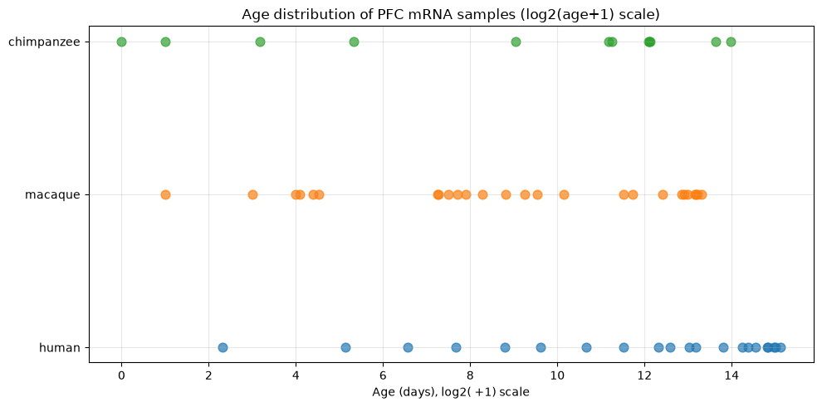
b.) miRNA – PFC


