Executive Summary: Seismic Event Classification from Waveforms
Justin Pickett, Eivind Joerstad, Shanece Esdaille
Project Github
https://github.com/Erdos-Projects/fall-2026-waveforms-for-earthquake-explosion-classification
Problem Statement
Can we distinguish earthquakes from explosions in seismic data using a simple classifier model?

Motivation
Seismic stations record not only earthquakes but also man-made events such as mine and quarry blasts, and even nuclear explosions. Correctly identifying an event’s origin is necessary to keep earthquake catalogs clean. These are used to assess regional seismic hazard. Similar classification tasks are also relevant to the monitoring of nuclear tests with seismic data. Our challenge is to find patterns that distinguish the sources and train models on them.

Stakeholders and KPIs
Stakeholders: Seismologists and other researchers who classify events, and agencies that build hazard models from earthquake catalogs (e.g. the US Geological Survey). For the broader question of automatic event classification, nuclear-test monitoring organizations (e.g. the CTBTO).

KPIs: Our primary KPI is average precision (AP) for explosion detection, which measures how well the classifier ranks explosions above earthquakes across all thresholds. Secondary KPIs are ROC-AUC, and precision, recall and F1-score at a 0.5 threshold.

Data source
Pacific Northwest Curated Seismic Dataset (2002-2022)¹

Modeling approach/methodology
We analyzed 38,581 events: 32,913 earthquakes (85.31%) and 5,668 explosions (14.69%). We combined recordings into one row per event and compared logistic regression, a shallow decision tree, and a random forest. We trained each model on five setups: catalog information alone (magnitude, hour, weekend/weekday), catalog information + depth, waveform features only (e.g., spectral entropy, crest features), catalog + waveform features, and catalog + depth + waveform features. Using a geographic holdout, we created five folds, and held out a randomly selected fold for testing.

Result
Our results indicate that seismic waveform features do a reasonably good job of classifying events, and that combining these with catalog features improves on the baseline. This improvement was observed both with and without depth features (Experiments E and C in figures) and across all three classification models used in this study. Combining catalog, depth, and waveform features (Experiment E) produced the best overall results for Logistic Regression and Random Forest. Random Forest achieved the highest Average Precision (0.960). The tables below illustrate the values of the evaluated KPIs for all three models.
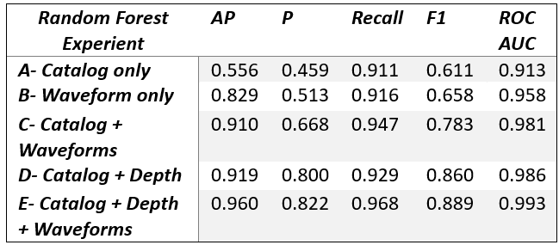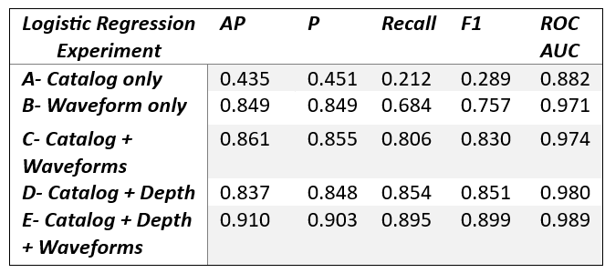
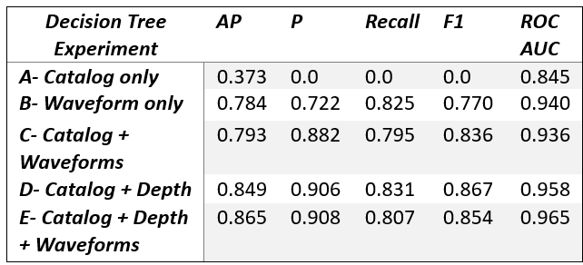
Interpretation
- Waveform features matter: Experiment B performs substantially better than catalog-only Experiment A for all 3 models, particularly for Logistic Regression and Random Forest.
- Combining features generally helps: Adding catalog, depth, and waveform information improves performance for Logistic Regression and Random Forest.
- Random Forest benefits most from the full feature combination: Its Average Precision reaches 0.960.
- Logistic Regression remains competitive: It achieves the highest F1 Score (0.8988) and precision (0.9028) for Experiment E.
- Decision Tree behaves differently: Although it achieves the highest precision (0.906) for Experiment E, its best F1 Score is Experiment D (0.861), rather than Experiment E.
- Overall, waveform features improved model performance, while the choice of model depends on the evaluation metric and practical requirements (e.g., Average Precision and ROC AUC measure discrimination across thresholds, whereas precision, recall, and F1 depend on the classification threshold)

Future work
Future work could test the model across more geographical regions, expand the dataset to include additional seismic events, and explore other seismic features that may improve discrimination. Another goal is to investigate how automated classification could support real-world seismic monitoring by helping analysts identify events that require further investigation.

