Eral Edree – Numerical Optimization in Python – python ex2.  
Link to github repo: <https://github.com/ErelEdree/numerical_optimization_exercise_2>

**Test_QP:**

QP solution: [4.99999850e-01 5.00000150e-01 7.09945318e-15]

Objective: 1.500000000000052

Equality constraint (Ax = b): [-2.22044605e-16]

Ineq 0: -0.4999998498598121

Ineq 1: -0.5000001501401806

Ineq 2: -7.099453176403091e-15

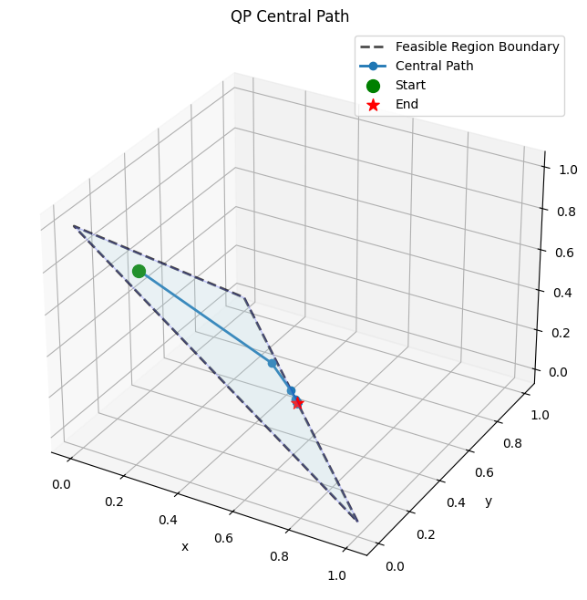

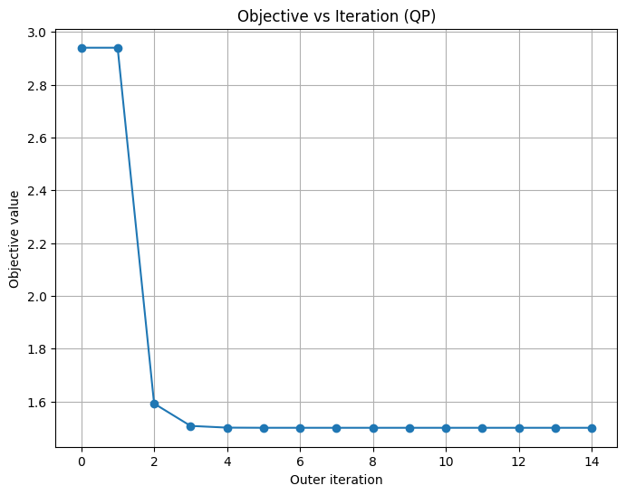

**Test_LP:**

LP solution: [2. 1.]

Objective: -2.999999999999611

Ineq 0: -1.999999999999611

Ineq 1: -1.9451107391432743e-13

Ineq 2: -1.9451107391432743e-13

Ineq 3: -0.9999999999998055

