Orbital Compute Cyber-Physical Threat Model
SPARTA-Based Risk Engineering and Assurance Documentation

Version 0.4.4 — Safety Framing and Numerical Validation Baseline
Kernel Guard / Eren Arı
8 August 2026

Version 0.4.4 reframes the retained timing-to-temperature result as a thermal-safety/resource-control coupling rather than an intrinsically adversarial effect; corrects the sensitivity-case accounting; decomposes the observed sensitivity range by parameter class; replaces the stochastic timestep check with a true fixed-forcing numerical-convergence experiment; makes QA provenance explicit; and strengthens release-distribution integrity. Earlier v0.4-series releases remain superseded or withdrawn as recorded in Section 1.

TSM-01 supports one primary mechanism claim, now stated as a safety finding before it is interpreted as a security scenario:
Under TSM-01's stated assumptions, compute traces matched to the same sampled post-warmup orbit-average power can yield materially different modelled peak thermal states when workload timing couples to a time-varying orbital thermal environment. A separately generated non-malicious synthetic power-aware schedule reproduces 84.0 % of the full phase-shaped excursion. Cumulative energy accounting alone is therefore not sufficient evidence of thermal safety in this model; adversarial timing is one possible exploitation of an underlying resource-safety coupling.

Contents
1 Document Control
2 Executive Summary
3 Findings from Model TSM-01
4 Threat-Modelling and SPARTA/NRS Method
5 Scenarios
6 Prioritised Risk Register
7 Requirements
8 Open Actions
9 Assumption Register
A TSM-01 Parameters, Provenance and Uncertainty
B Documentation Practice
C Source Register
Section numbering is stable across revisions; page numbers appear in the footer.

1 Document Control

1.1 Revision History
Version | Date | Change | Status
0.3.1 | 7 Aug 2026 | Vendor-independent restructuring; expert input incorporated as method, not finding. | Superseded
0.4 | 7 Aug 2026 | Model TSM-01 built and executed; six findings published. | Withdrawn — see 1.2
0.4.1 | 7 Aug 2026 | Four numbered findings retracted or replaced after audit. Corrective experiments X1–X3 added. Two code defects fixed. | Superseded
0.4.2 | 7 Aug 2026 | Second corrective audit; narrowed inference and improved figure/document reproducibility, but revision contamination and experiment-control defects remained. | Superseded
0.4.3 | 8 Aug 2026 | Single authoritative numerical pipeline/result file; legacy claim-generating scripts removed; hazard terminology normalised; controlled uncertainty calibration and period-relative warmup added; source register itemised; residual claims narrowed. | Superseded
0.4.4 | 8 Aug 2026 | Safety-first F-01 framing; sensitivity accounting and range-driver decomposition corrected; deterministic fixed-forcing convergence added; QA provenance and distribution-integrity rules made explicit; Turyshev order-of-magnitude corroboration elevated with limits. | Current

1.2 Retraction Record
Findings were re-examined through AI-assisted technical audits and direct project re-execution of the released code. Version 0.4.4 additionally separates the underlying thermal-safety mechanism from its adversarial exploitation, corrects sensitivity-case taxonomy, and replaces a mixed stochastic timestep check with a fixed-forcing numerical-convergence experiment. This is not independent human peer review, spacecraft-thermal validation, certification, or organisational endorsement.
v0.4 claim | Status | Basis for retraction
F-02 — "Temperature telemetry cannot attribute the fault." | RETRACTED | Only peak temperature was matched. Full trajectories differ by 17.9–22.9 K RMSE and mean node temperature differs by 13–17 K. The evidence supports only the far weaker claim that peak temperature alone is insufficient.
F-03 — "Natural and induced faults separate at 414σ." | RETRACTED | Only radiator-emissivity degradation was used as the natural comparator. Loop/pump degradation yields a residual of −11.2 W against the induced load's −11.3 W: identical. Detector A is structurally blind to internal heat-transfer faults.
F-03 — the 414σ figure itself | RETRACTED | Sensor-only noise was not an adequate operational uncertainty model. v0.4.4 reports pooled effect size, empirical AUC and TPR at a project-selected 5 % induced false-positive threshold under an explicitly illustrative uncertainty model; no sigma-significance claim remains.
F-04 — "31 % power under-reporting is required to mimic a natural fault." | RETRACTED | Fault-specific, not a threshold: 30.6 % for emissivity, 24.0 % for environmental, and 0 % for loop/pump degradation, which requires no manipulation at all.
F-04 — "Attribution difficulty is a property of telemetry independence, not thermal physics." | RETRACTED | Attribution depends jointly on the telemetry architecture and on which physical fault family is in question. The dichotomy was false.
F-05 — "The attack evades the two most likely controls." | RETRACTED | The two controls named were selected, not established as ‘most likely’. In the v0.4.4 marginal reference case, the specified 75 °C / 30 % shed policy stays below the assumed model limit at the tested 1 400 s latency and exceeds it at 1 500 s; this remains a model-specific reference result. An energy-balance residual is not a thermal safety control.
F-05 — "ρ = 1.00 vs 0.001 nominal." | RETRACTED | Circular: the attack was generated from in_hot_phase() and correlated against in_hot_phase(). The v0.4.1 replacement was also invalid — its depth sweep changed generator function at depth 0, and its 'benign' case was the attack generator itself. Rebuilt in X3 with a controlled interpolation and an independent benign generator.
"Any node carrying less than roughly 17 K of margin is reachable." | RETRACTED | The 14.1–16.8 K range came from sweeping radiator area and emissivity only. Varying design power, average load, loop conductance, capacitance and orbit period gives 8.0–23.7 K. SR-THM-06 is withdrawn.
"The flagship hypothesis is no longer a hypothesis." | RETRACTED | Contradicted the document's own evidence status. A parametric simulation supports a mechanism under stated assumptions; it does not settle a hypothesis about real architectures.
F-01 — timing / thermal-state mechanism | RETAINED, reframed | RETAINED, reframed as safety finding. The 12 sensitivity entries are 10 single-factor cases, one joint radiator-area/emissivity case and one baseline reference. The full 8.03–23.68 K observed range is set by power-related assumptions. A separate non-malicious synthetic power-aware schedule reproduces 84.0 % of the full phase-shaped excursion, so the mechanism is not intrinsically adversarial.
F-06 — reference protection-policy behaviour | RETAINED, narrowed | Project re-execution reproduces a 1 410–1 415 s threshold-to-model-limit window in the defined marginal case. The result is conditional on the stated 75 °C / 30 % shed / 5 K hysteresis policy and assumptions; no independent human validation is claimed.

1.3 Reproducibility and Revision-Integrity Defects Corrected
Defect | Effect | Fix
Revision contamination in normative package | Legacy scripts re-emitted retracted 414σ / 31 % / 17 K / damage-language conclusions and could disagree with the document. | Normative package now has one numerical entry point (run_all_v044.py) and one authoritative result file; legacy numerical scripts are excluded.
Result/script mismatch and hard-coded figure data | Bundled results could not be regenerated by the bundled script; some plotted sensitivity values were embedded manually. | All current tables/figures are sourced from results_v044.json generated by run_all_v044.py; plot_results.py consumes current outputs.
Calibration sweep confounding | Earlier calibration sweeps changed random realisations and/or reused a stale induced distribution while tolerance changed. | Common standard-normal draws are reused; nominal, induced and fault distributions are recomputed at each radiative tolerance with other assumed uncertainties fixed.
Orbit-period warmup bug | Warmup/duration were hard-coded around a 90-minute orbit, so 120-minute cases were not full-orbit controlled comparisons. | Warmup and duration are period-relative; period sensitivity uses complete orbit windows.
Consequence terminology | Code retained T_damage / hit_damage names after the document had withdrawn generic hardware-damage claims. | Renamed T_model_hazard / hit_model_hazard; both 75 °C and 90 °C are explicit model assumptions.
Release-environment ambiguity | Reproducibility claims did not pin all numerical dependencies or distinguish numerical from graphics-byte reproducibility. | Python/NumPy/Matplotlib/Numba versions pinned; SHA-256 manifest added; claim narrowed to numerical reproducibility in the recorded environment.
Sensitivity taxonomy error | The baseline reference was counted as a one-factor case and A=80 m² / ε=0.75 changes two factors jointly. | v0.4.4 classifies the 12 entries as 10 single-factor + 1 joint + 1 baseline reference and reports parameter-class spans separately.
Timestep “convergence” mislabelling | Changing dt also changed the stochastic workload realisation, so non-monotonic differences mixed discretisation and forcing changes. | A fixed, noise-free forcing experiment now provides numerical-convergence evidence; the stochastic dt table is retained only as release-step/realisation sensitivity.
QA provenance omission | A PASS-labelled QA report could be read as independent review even though the checks were AI-assisted. | The QA report now names GPT-5.6 Sol/ChatGPT tooling, states that no independent human reviewer participated, and limits PASS to build/release QA.
v0.4.4 corrects three remaining process defects in v0.4.3: twelve sensitivity entries had been mislabelled as twelve one-factor-at-a-time cases; the timestep table changed workload realisations as well as the Euler step and therefore was not a convergence series; and the standalone QA report did not identify its AI-assisted provenance. The release now classifies sensitivity cases explicitly, decomposes the observed range by parameter group, adds a deterministic fixed-forcing convergence experiment, labels the old stochastic table as release-step/realisation sensitivity, and defines the manifested ZIP as the authoritative review object.

1.4 What the Review Did Not Cover
The audit examined modelling method, statistical inference, code/release consistency, numerical integration behaviour and documentation provenance. It did not establish whether the Appendix A thermal parameters are physically defensible for representative orbital compute hardware, whether a two-node lumped formulation is adequate, or whether the S-02 adversary preconditions occur in a real architecture. Independent spacecraft-thermal review remains the highest-value open item.

2 Executive Summary
The project tests whether treating orbital data-centre security as either spacecraft cybersecurity or cloud security is adequate. The working thesis is that it is not, because authority held in the tenant, ground, update or communications layer may be convertible into physical mission consequence through shared compute, power, thermal, attitude-control and fault-management resources.
That thesis remains a thesis. TSM-01 provides project-generated modelling evidence for a narrower coupling; it does not establish attack feasibility or a real-system consequence. v0.4.4 makes the safety/security distinction explicit: temporal workload placement changes thermal state even in a separately generated non-malicious synthetic schedule, while S-02 asks whether an adversary could intentionally exploit the same coupling.
# | Finding | Standing
F-01 | Baseline phase shaping raises the model peak by 15.46 K at <0.001 % sampled-power mismatch. The separately generated non-malicious synthetic power-aware schedule produces a 12.981 K excursion — 84.0 % of the full phase-shaped excursion. The 12 sensitivity entries are 10 single-factor + 1 joint + 1 baseline reference; the 8.03–23.68 K overall range is set by power-related cases. | Supported by TSM-01 under stated assumptions as a thermal-safety/resource-control coupling. Adversarial timing is one possible exploitation; no real-system attack evidence is claimed.
F-02 | Synthetic peak-matched physical-fault constructions match the induced peak to <0.0001 K but differ in trajectory by 17.9–22.9 K RMSE. Peak temperature alone is insufficient; trajectory-based attribution remains untested. | Supported only for the synthetic model cases.
F-03 | No tested single metric separates all modelled cases. The energy residual shifts for radiator/environment constructions; apparent conductance shifts for the loop construction; phase correlation is ambiguous with intent. | Candidate-observability result; no universal detector architecture inferred.
F-04 | Under the illustrative uncertainty model, energy-residual AUC / TPR@5% induced false positives are 0.955/0.770 (emissivity), 0.911/0.603 (environment), and 0.500/0.052 (loop). Calibration sweeps are sensitivity evidence only. | No operational detector threshold or fixed ±5 % design requirement is derived.
F-05 | The controlled phase-shaping sweep reaches ρ = 1.000; the independently generated, energy-matched non-malicious synthetic power-aware schedule yields ρ = 0.918 and 12.981 K peak excursion. Correlation measures shaping, not intent. | Candidate feature only. The benign comparator is synthetic; no representative operational workload trace has been evaluated.
F-06 | For the specific marginal reference case and policy (75 °C threshold, shed to 30 %, 5 K hysteresis), tested 1 400 s control latency stays below the assumed 90 °C model limit while 1 500 s exceeds it. Mean unprotected threshold-to-limit window is 1 413.2 s. | Reference-model protection behaviour only; no generic hardware or latency requirement.
F-01 is now the primary thermal-safety/resource-control finding; F-06 shows only that one explicitly defined reference protection policy prevents crossing an assumed model limit for the tested latency range. F-02 through F-05 constrain attribution and intent-classification claims. These are claims about TSM-01, not about orbital compute systems as a class.

2.1 Standing of External Contributors
Contributor | Scope and standing
Brandon Bailey  (The Aerospace Corporation) | Provided the SPARTA/NRS tailoring philosophy applied in Section 4. Methodological feedback, not organisational endorsement. Separately suggested the tailoring write-up could be useful on the NRS resource page; not yet pursued.
Gregory Falco  (Cornell / Aerospace ADVERSARY Lab) | Redirected the research toward intentional induction of naturally expected faults and thermal/physical credibility. Informal technical input; a follow-up discussion was offered. No formal spacecraft-physics review has been completed or committed.
Edd Salkield  (University of Oxford) | Stated on 6 August 2026 that the topic aligns with his expertise and offered a discussion. Consultation scheduling remains pending; no technical finding, validation or endorsement has been provided. Scoped prospectively to S-07 communications questions.
AI-assisted technical audit  (v0.4–v0.4.2) | AI-assisted code re-execution and inference/release-consistency review, checked against project outputs. Not independent human peer review, spacecraft-thermal validation, third-party assessment or organisational endorsement.

3 Findings from Model TSM-01

3.1 Model Description
TSM-01 is a two-node lumped-capacitance thermal model of a single orbital compute node: a compute/coldplate mass coupled through a fluid loop to a radiator that rejects heat radiatively while absorbing environmental flux varying over the orbit. It is a parametric model, not a digital twin, and may not be described as one before calibration against representative hardware or operational telemetry.
Forward-Euler integration uses a 1 s release step. v0.4.4 separates two numerical checks. The stochastic headline experiment retains a 0.25–10 s release-step/realisation sensitivity table in the JSON, but it is not convergence because changing dt also changes random workload samples. A separate fixed, noise-free forcing experiment uses a 0.0625 s reference and shows decreasing error toward that reference; at dt = 1 s the peak-difference error is approximately 0.00176 K, and the 0.5–2 s region is approximately first-order. No exact baseline parameter is taken from a vendor sizing claim.
dt (s) | Peak ΔT (K) | |error| vs 0.0625 s ref (K) | Estimated order vs finer
0.125 | 17.451714 | 0.000119 | —
0.25 | 17.451951 | 0.000356 | 1.581
0.5 | 17.452420 | 0.000825 | 1.213
1.0 | 17.453355 | 0.001761 | 1.094
2.0 | 17.455217 | 0.003622 | 1.041
4.0 | 17.458296 | 0.006701 | 0.888

3.2 Adversary Model and Preconditions
The underlying F-01 thermal-safety coupling does not require an adversary: v0.4.4 includes a separately generated non-malicious synthetic power-aware schedule that exercises most of the modelled excursion. S-02 adds a distinct adversary model: a legitimate tenant with no privilege escalation, no exploit and no violation of any declared limit, who can intentionally place high demand into a thermally adverse window and compensate at other times.
v0.4 described the required capability as workload timing control plus publicly derivable orbital phase. That understated the precondition set. The full set is:
Precondition | Why required | Status
Sufficient tenant control over execution timing | To place load in the hot phase at all | Plausible; unverified
Predictable physical node placement | To repeatedly consume the same node's margin | Unverified
Scheduler does not smooth or migrate load | Otherwise the burst is dispersed | Unverified
Workload actually draws the requested power | Tenant input must reach physical demand | Unverified
Thermal hot phase inferable from orbital phase | Orbital elements alone do not give radiator thermal state; absorptivity, emissivity, geometry and attitude all enter the heat balance | Weak — assumption AS-05 downgraded
No thermal-aware admission control | Otherwise the attack is refused at submission | Unverified
Chain feasibility for adversarial exploitation in S-02 remains Unknown / Conditional. The inference from public orbital elements to an exploitable thermal window is not established. These preconditions constrain the security scenario; they do not constrain the existence of the more general thermal-safety coupling shown by the synthetic scheduling experiments.

3.3 F-01 — Temporal Workload Placement Is a Thermal-Safety Variable
Against the synthetic diversified trace, the full phase-shaped trace is matched to the same sampled post-warmup average compute power to within 0.001 % in the baseline run while increasing peak node temperature by 15.46 K. This is the central retained model result: cumulative sampled compute energy is controlled while timing is changed.
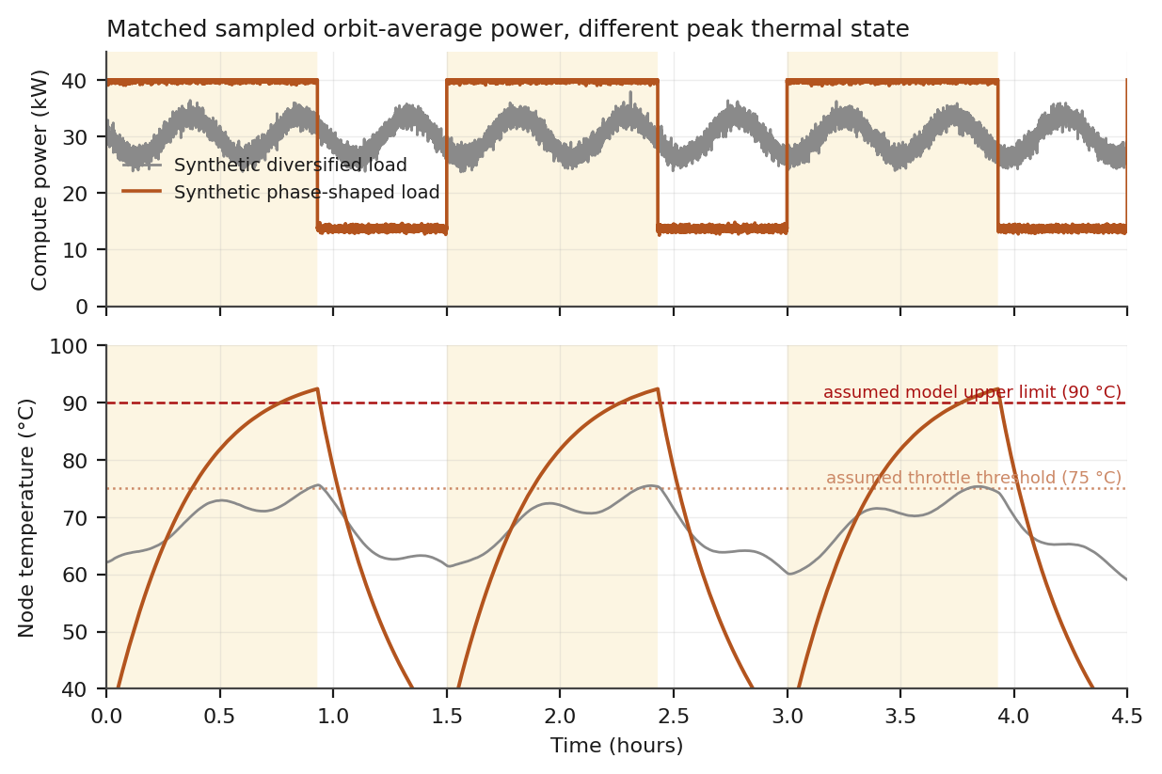
Figure 1. Matched sampled post-warmup orbit-average compute power, different peak thermal state in the thermally marginal A = 80 m², ε = 0.75 reference case. The figure demonstrates timing-to-state coupling, not malicious intent. Both the 75 °C throttle threshold and 90 °C upper model limit are project assumptions, not generic hardware limits.
A separately generated, energy-matched non-malicious synthetic power-aware schedule reaches 65.79 °C versus 52.81 °C for the diversified baseline: a 12.981 K excursion, equal to 84.0 % of the full phase-shaped excursion of 15.461 K. It also exceeds the model peak of every partial phase-shaped case through 75 % depth. Because this comparator is synthetic rather than empirical, it does not establish how an operational scheduler behaves; it does establish within TSM-01 that the timing-to-temperature mechanism is not intrinsically adversarial. The security question is therefore whether an attacker can intentionally exploit a pre-existing resource-safety coupling.
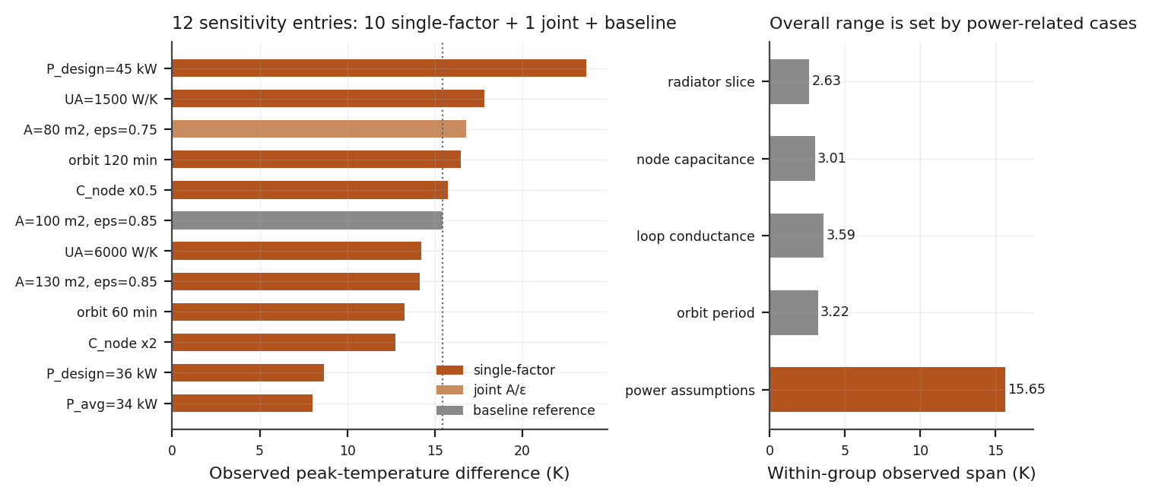
Figure 2. Twelve sensitivity entries are shown: 10 true single-factor cases, one joint radiator-area/emissivity case, and the baseline reference. The observed overall range is 8.03–23.68 K, but both extremes are power-related assumptions. Local observed spans around the baseline are 2.63 K for the radiator slice, 3.01 K for node capacitance, 3.59 K for loop conductance, 3.22 K for orbit period, and 15.65 K for the power-related cases. These are tested local slices, not global uncertainty bounds.
What survives is the mechanism, not a universal number: in this model, cumulative energy accounting alone does not bound peak temperature when workload timing interacts with a time-varying thermal environment. Within the tested local ranges the result magnitude is less sensitive to radiator, capacitance, conductance and orbit-period changes than to the assumed compute-power envelope; this is descriptive sensitivity evidence, not a robustness proof.
No universal margin threshold is claimed, and SR-THM-06 remains withdrawn. The engineering consequence is broader than the threat scenario: thermal safety cases resting on cumulative energy accounting require a separate state-aware thermal argument even under non-malicious workload placement.

3.4 F-02 — Peak Temperature Alone Is Insufficient for Attribution
Three synthetic peak-matched physical-fault constructions were tuned to reproduce the induced peak temperature, with maximum peak mismatch below 0.0001 K. Their scale factors (emissivity ×0.824, conductance ×0.408, environmental flux ×1.664) are numerical constructions for identifiability testing; no evidence is offered that those degradation magnitudes are operationally representative.
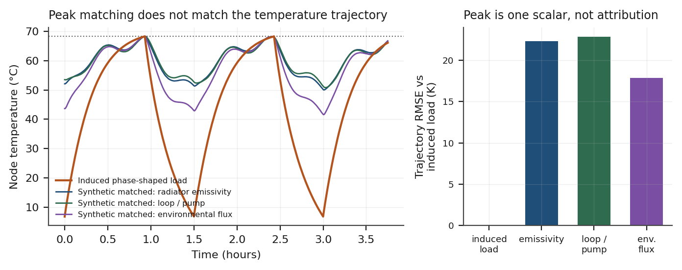
Figure 3. Synthetic peak-matched cases share a peak but have different temperature trajectories. Relative to the induced-load case, trajectory RMSE is 17.9–22.9 K in TSM-01; no trajectory classifier or real-sensor validation is implied.
Case | Peak (°C) | Mean (°C) | Trajectory RMSE vs induced
Induced phase-shaped load | 68.27 | 42.91 | —
Synthetic radiator-emissivity construction | 68.27 | 59.63 | 22.3 K
Synthetic loop/conductance construction | 68.27 | 59.86 | 22.8 K
Synthetic environmental-flux construction | 68.27 | 56.32 | 17.9 K
Matching peak temperatures does not imply indistinguishable thermal telemetry. Full temperature trajectories, node–radiator gradients, rate of rise, orbital phase and other temporal features remain candidate discriminators and require separate testing.
No trajectory-based classifier has been built or evaluated. Whether these separations survive sensor noise, model error and adversarial shaping is open (RB-07).

3.5 F-03 — No Tested Single Metric Separates All Modelled Cases
v0.4 used one physical-fault comparator and over-generalised the result. v0.4.3 evaluates the candidate whole-system energy residual and apparent-conductance metric across all three synthetic peak-matched physical-fault constructions, and treats phase correlation separately as a candidate temporal feature.
Case | Detector A residual | Detector C apparent conductance
Nominal | −11.2 W | 1.000×
Induced phase-shaped load | −11.3 W | 1.001×
Synthetic radiator-emissivity construction | +9 153 W | 1.000×
Synthetic loop/conductance construction | −11.2 W | 0.408×
Synthetic environmental-flux construction | +7 169 W | 1.000×
The energy-balance residual shifts strongly for the radiator-emissivity and environmental-flux constructions but not for the loop/conductance construction or induced load. The apparent-conductance metric shows the inverse pattern for the loop construction. The project-selected 200 W and 5 % thresholds in Figure 4 are screening aids only; they are not calibrated detector thresholds.
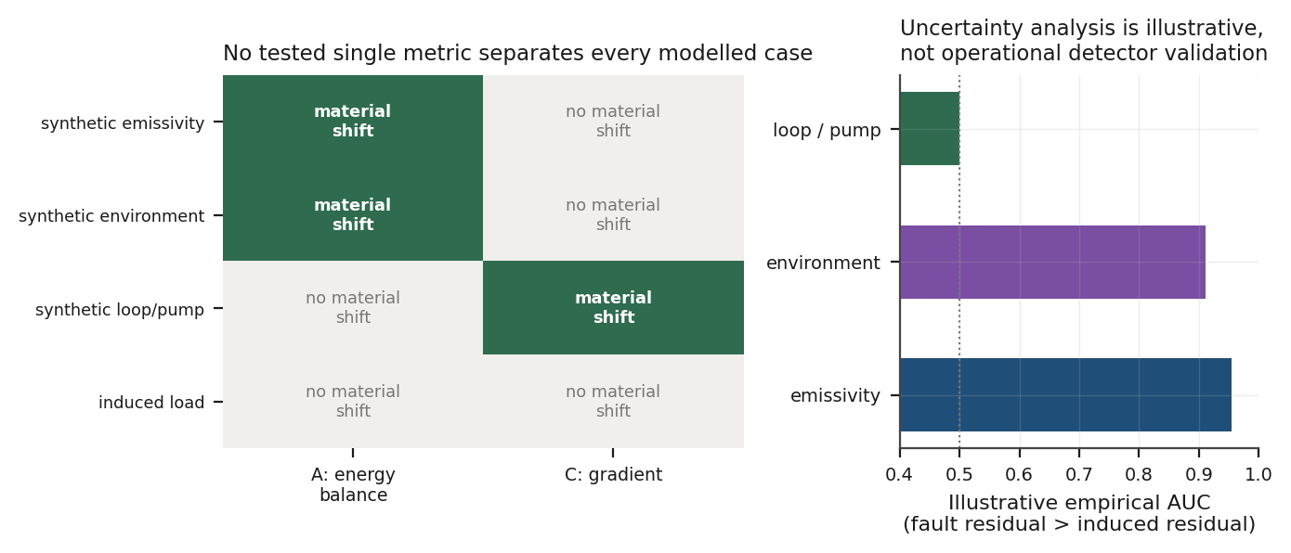
Figure 4. Left: candidate metric shifts across the modelled cases under project-selected screening thresholds. Right: empirical discrimination of the energy-balance metric under the illustrative v0.4.3 uncertainty model. No operational detector performance is claimed.
The tested metrics are complementary, but the evidence does not justify the universal claim that thermal attribution requires any particular fixed feature set. The requirement is therefore outcome-based: the eventual system must demonstrate sufficient independent observability against its defined fault and workload classes; energy balance, node–radiator gradient and temporal features are candidate observables.

3.6 F-04 — Illustrative Discrimination Is Uncertainty-Limited
The v0.4 “414σ” result is withdrawn. v0.4.3 uses an illustrative Monte Carlo model with 400 draws and project-assumed Gaussian standard deviations: effective radiative-coefficient σ = 7 %, electrical-power calibration σ = 3 %, environmental-load model σ = 15 %, and temperature-sensor noise σ = 0.3 K. These are not measured operational error distributions.
Comparison | Pooled standardised mean difference | Empirical AUC / TPR @ 5 % induced false-positive threshold
Emissivity construction vs induced | 2.393 | 0.955 / 0.770
Environmental construction vs induced | 1.909 | 0.911 / 0.603
Loop construction vs induced | 0.000 | 0.500 / 0.052
Interpretation | Illustrative synthetic discrimination only | Not operational detector qualification
Performance is reported with a pooled-standard-deviation effect size, empirical AUC, and true-positive rate at a threshold chosen for 5 % induced-case false positives. These metrics are descriptive for this synthetic experiment; they are not certification thresholds, operational false-alarm rates, or a claim of Gaussian “sigma significance”.
At the baseline illustrative uncertainty, the energy residual separates the emissivity construction from the induced case with pooled effect size 2.393, AUC 0.955 and TPR 0.770 at 5 % induced false positives; the environmental construction yields 1.909 / 0.911 / 0.603, while the loop construction remains 0.000 / 0.500 / 0.052. This shows model-family dependence, not a universal detector ranking.
Radiative-coefficient σ | Pooled standardised mean difference | Empirical AUC / TPR @ 5 % induced false-positive threshold
7 % | 2.393 | 0.955 / 0.770
5 % | 3.038 | 0.985 / 0.915
3 % | 3.926 | 0.997 / 0.993
2 % | 4.397 | 0.999 / 0.998
1 % | 4.749 | 0.999 / 1.000
0.5 % | 4.833 | 1.000 / 1.000
The radiative-coefficient calibration study now uses common standard-normal draws and recomputes nominal, induced and fault distributions at every tolerance while holding the other assumed uncertainty terms fixed. Tightening the radiative coefficient improves the synthetic emissivity-vs-induced discrimination, but v0.4.3 derives no fixed ±5 % design requirement from this sensitivity curve.
The perturbed parameter is explicitly an effective radiative coefficient in the rejection term. It is not represented as a true emissivity-area-product uncertainty: emissivity, radiating area, environment-facing projected area and view factors must be separated in a successor physics model.
The telemetry-bias calculation remains fault-comparator-specific: reproducing Detector A’s residual would require about 30.60 % reported-power under-reading for the emissivity construction, 23.98 % for the environmental construction, and 0 % for the loop construction. These are model outputs for one candidate metric, not general masquerade thresholds.
The uncertainty results are illustrative only. Correlated measurement error, drift, quantisation, estimator bias, geometry uncertainty and model-form error remain outside the experiment; those omissions must be addressed before any operational attribution claim.

3.7 F-05 — The Phase Detector Is a Candidate Feature, Not a Control
Earlier releases built the adversarial trace from the same hot-phase indicator used by the correlation statistic, and v0.4.1 also reused the adversarial generator for its “benign” case. v0.4.3 uses a controlled blend of fixed source traces across attack depths and a separately generated, energy-matched synthetic power-aware schedule. Residual circularity remains for the adversarial construction because the attack trace and statistic still share the hot-phase indicator.
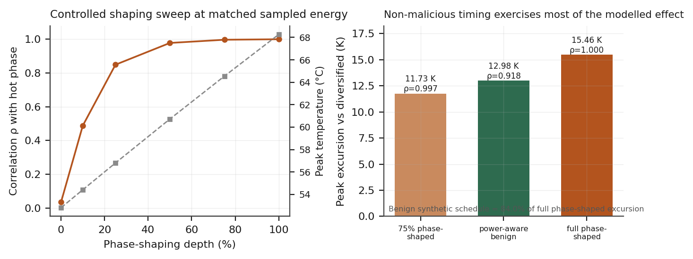
Figure 5. Left: controlled phase-shaping depth sweep at matched sampled post-warmup average compute power. Right: thermal excursion relative to the diversified baseline. The independently generated non-malicious synthetic power-aware schedule produces 12.98 K of excursion — 84.0 % of the full phase-shaped case — while ρ = 0.918. This simultaneously shows that temporal shaping can matter for safety and that phase correlation does not establish malicious intent.
The controlled depth sweep yields ρ = 0.034, 0.488, 0.849, 0.978, 0.997 and 1.000 from depth 0 to 1.0, with every trace matched to approximately 29.950 kW sampled post-warmup average. The independently generated power-aware schedule likewise yields ≈29.950 kW, ρ = 0.918 and a 65.79 °C model peak. Relative to the diversified 52.81 °C peak, that is a 12.981 K non-malicious synthetic excursion, compared with 15.461 K for the full phase-shaped case.
The benign synthetic schedule therefore exercises most of the same timing-to-temperature mechanism while occupying an ambiguous region of the phase-correlation statistic. This is enough to establish two model-bounded conclusions: phase correlation alone does not identify intent, and the underlying thermal-safety problem is not unique to an attacker. It does not establish how common such scheduling is in operational orbital compute.
SR-THM-05 therefore remains a candidate feature only. A future evaluation must use representative workload traces, an independent attack generator, adversarial jitter/evasion, and predeclared false-positive/false-negative criteria.
Residual circularity remains: the attack profile and the detector still share the in_hot_phase() indicator. Only the benign case is now independently generated. A fully independent evaluation requires real workload traces, adversarial jitter and evasion modelling.
AS-03 is not classified as “likely false”. v0.4.4 records a synthetic non-malicious counterexample and independently cites terrestrial thermal-aware workload-distribution literature as evidence that non-malicious thermal-aware scheduling is a real scheduling class [R19]. Neither point establishes the prevalence or exact form of orbital-phase-aware scheduling in an operational platform.

3.8 F-06 — Reference Protection Policy Prevents the Model-Limit Crossing in the Tested Case
In the A = 80 m², ε = 0.75 reference case, the energy-matched unprotected phase-shaped runs cross from the assumed 75 °C throttle threshold to the assumed 90 °C upper model limit in 1 410–1 415 s (mean 1 413.2 s; median 1 413.5 s). The local 60 s fitted rise rate after the throttle crossing is 1.074 K/min, while the average rate over a 15 K rise using the mean window is 0.637 K/min.
Detect-and-shed latency | Peak temperature | Assumed 90 °C model limit crossed
10 s | 75.21 °C | No
300 s | 79.90 °C | No
900 s | 86.56 °C | No
1 400 s | 89.95 °C | No
1 500 s | 90.46 °C | Yes
2 400 s | 92.37 °C | Yes
The tested protection is specific: throttle threshold 75 °C; compute shedding to 30 % of design power; 5 K hysteresis; trusted/unbiased temperature measurement; no additional sensor delay; idealised immediate actuator transition after the stated control latency; no controller failure; and no telemetry deception. With those assumptions, 1 400 s latency stays below the assumed model limit (89.95 °C), while 1 500 s exceeds it (90.46 °C). No generic 1.4 ks requirement is inferred.
The unprotected 92.37 °C result is a model-limit crossing with protection disabled; it is not evidence of irreversible hardware damage. The control lesson is narrower: physical safety should be validated directly against state limits, not inferred from whether an energy-balance residual appears nominal.

3.9 What TSM-01 Does Not Show
- It does not show that this attack works against orbital compute systems. It shows that workload timing changes peak thermal state in a two-node model under specific assumptions, including under one separately generated non-malicious synthetic schedule.
- It does not establish any margin threshold, detection performance, or attribution capability for a real architecture.
- It does not demonstrate that a tenant can reach the required preconditions (Section 3.2), several of which are unverified.
- It does not evaluate multi-node behaviour. Whether margin consumption aggregates across a shared loop or averages out across independent nodes is unknown and is the largest single threat to F-01's generality.
- It does not model thermal fatigue from the induced cycling, which may be a more relevant damage mechanism than peak overtemperature.

3.10 Threats to Validity
- Single-node lumped model; no node-to-node coupling, intra-rack gradients or cluster interaction.
- Simplified two-phase environmental flux rather than full view-factor orbital geometry.
- Parameters are explicit project assumptions unless Appendix A identifies independent support. External literature provides physical context and order-of-magnitude comparators; it does not validate the exact TSM-01 baseline. Absolute temperatures must not be quoted as predictions for a real system. The broad 8.03–23.68 K sensitivity range is dominated by assumed compute-power parameters; local thermal-design slices moved the result by only about 2.6–3.6 K within the tested ranges, which does not establish global robustness or interaction effects.
- Real fault management would include limit and rate checks not modelled. Evasion claims are specific to the detectors implemented here.
- The uncertainty distributions are illustrative project assumptions. They do not include correlated measurement error, long-term drift, quantisation, geometry uncertainty, estimator bias or model-form error, and must not be called “realistic” without empirical support.
The stochastic release-step table is not a convergence proof because changing dt changes the random workload samples. Numerical-convergence evidence comes only from the separate deterministic fixed-forcing experiment; model-form error remains outside that test.
- The model has had no independent physics review. All findings carry project-generated evidence status only.

4 Threat-Modelling and SPARTA/NRS Method
Retained from v0.3.1; it survived both reviews.
- SPARTA Notional Risk Scores are starting points for mission-specific tailoring, not operational risk measurements. They use a 5×5 risk matrix whose cell values are not the arithmetic product of likelihood and impact.
- Mission and architecture principally drive impact; verified countermeasures principally drive likelihood.
- Upward re-weighting is legitimate where the architecture introduces surfaces the generic baseline did not assume, provided the rationale states whether the driver is consequence or probability.
- Techniques are scored atomically; chain feasibility and consequence are separate metrics and are never summed into a technique score.
- Assume-breach posture: execution, persistence, evasion and lateral movement all presuppose initial access.

4.1 Control Evidence Level
Project-defined level | Evidence | Use in residual-risk assessment
E0 Unknown | No public evidence | No credit
E1 Claimed | Marketing material or intent | No credit; recorded as open assumption
E2 Designed | Architecture or interface disclosure | Design evidence only
E3 Verified | Reproducible implementation-specific test or applicable certification | May reduce residual likelihood within verified scope
E4 Demonstrated | Production telemetry, exercise or incident evidence | Strongest credit; requires review date
E0–E4 evidence levels and P0–P2 scenario priorities in this document are project-defined analytical labels; they are not SPARTA, NASA or NIST scales. Model-generated evidence is recorded as project-generated modelling evidence. It can inform architecture hypotheses and scenario consequences but does not by itself confer implementation-level control assurance.

4.2 Architecture Decision Records
ADR | Decision | Status
ADR-001 | MEDIUM SPARTA NRS for the commercial reference mission; HIGH as justified sensitivity case. | Unchanged
ADR-002 | Atomic technique scoring; chain feasibility and consequence kept separate. | Unchanged
ADR-003 | No residual-likelihood credit at E0–E2. | Unchanged
ADR-004 | Onboard safety envelope operates at higher trust than tenant or ground authority. | Unchanged
ADR-005 | Thermal-margin risk is assessed against thermal state and orbital phase, not cumulative energy. | Retained; threshold removed
ADR-006 | Attribution capability is an architectural property of the detector set, not an assumed difficulty. | Revised — was 'telemetry path'; corrected per F-03
ADR-007 | Where SPARTA has no technique matching a mechanism, an architecture-specific extension is declared rather than forcing a near-fit mapping. | New — see 5.1

5 Scenarios

5.1 S-02 — Adversarial Exploitation of Temporal Thermal Coupling by Authorised Workload
v0.4 mapped this mechanism to EX-0012.09 and EX-0012.10. That mapping remains withdrawn. Those techniques sit under the Modify On-Board Values family; the initial mechanism modifies no onboard value and uses authorised workload demand. v0.4.4 also separates hazard from threat: F-01 is the underlying thermal-safety/resource-control coupling, while S-02 is the hypothesis that an authorised tenant could intentionally exploit it under the Section 3.2 preconditions.
Field | Content
Priority | P0
Primary assets | A-04 thermal control state, A-05 electrical power state, A-08 tenant isolation boundary, A-09 workload scheduler / resource policy
Mechanism classification | Architecture-specific extension: Adversarial Authorised Workload Resource Shaping. The underlying temporal thermal coupling also occurs in a non-malicious synthetic schedule; the security mechanism is intentional exploitation of that coupling.
SPARTA relationship | Used for consequence mapping (IMP-0003 Denial) and for later chain steps where control-surface compromise is present. Not used to describe the initial mechanism.
Sub-scenario A | Honest telemetry. TSM-01 exposes candidate trajectory, energy-balance, gradient and temporal observables; attribution performance is not yet validated.
Sub-scenario B | Telemetry-deception enhanced. Power under-reporting defeats Detector A. Formerly S-03.
Evidence status | Underlying timing-to-thermal-state coupling supported by project-generated modelling evidence (F-01), including a non-malicious synthetic comparator. Adversarial exploitation preconditions remain unverified; magnitude is model-specific; no independent physics review.
Consequence severity | Conditional and architecture-dependent. F-06 only demonstrates that one specified reference protection policy prevents crossing an assumed model limit for tested latencies up to 1 400 s; no generic hardware-loss/service-loss conclusion is inferred.
Chain feasibility | Unknown / Conditional — downgraded from Medium–High. Several preconditions in Section 3.2 are unverified.

5.2 S-02B — Telemetry Deception (formerly S-03)
v0.4 stated that S-03 was no longer a separate evasion story while retaining it as an independent P0 entry. That inconsistency is resolved by folding it into S-02 as a variant.
Field | Content
Mechanism | Biasing reported node power so induced heating reproduces the residual signature of physical degradation.
Quantified residual-matching values | Comparator-specific: 30.60 % reported-power under-reading for the emissivity construction; 23.98 % for environmental flux; 0 % for loop/conductance.
Limitation identified | Power-magnitude bias alone does not defeat temporal or gradient detectors. A consistent masquerade would require coherent falsification across magnitude, temporal profile, phase correlation and any independent bus-current measurement — a substantially harder problem.
Standing | “Power-telemetry bias can defeat Detector A for selected comparators” is supported within TSM-01. A coherent natural-fault masquerade is not demonstrated.

6 Prioritised Risk Register
ID | Scenario | Severity | Evidence status | Priority
S-01 | Malicious commanding with valid ground authority | Conditional 5 | Provisional; architecture-dependent | P0
S-02 | Adversarial exploitation of temporal thermal coupling by authorised tenant workload (A: honest telemetry; B: telemetry deception) | Conditional, design-dependent | Underlying safety coupling modelled (F-01); non-malicious synthetic scheduling produces 84.0 % of full phase-shaped excursion. Adversarial feasibility remains Unknown/Conditional. | P0
S-04 | Software supply-chain or on-orbit update compromise | Conditional 5 | Medium hypothesis | P0
S-05 | Virtualization escape and tenant-to-platform lateral movement | Conditional 4–5 | Medium hypothesis | P1
S-06 | Attestation or key-release trust-plane compromise | Conditional 5 | Low–Medium hypothesis | P1
S-07 | Link/terminal spoofing, jamming or denial | TBD | Consultation offered; scheduling pending. No Salkield technical finding yet. | P1
S-08 | Scheduler / shared-resource policy manipulation | Conditional 4–5 | F-01 supports physical-consequence coupling if scheduler authority controls workload timing/resource placement; scheduler-compromise feasibility is not established. | P1
S-09 | PNT / time-state corruption | Conditional 4–5 | Separate threat hypothesis. F-01 provides no evidence about PNT/time compromise feasibility; impact depends on architecture-specific time/PNT dependencies. | P1
S-10 | AI / model / data poisoning | Conditional 2–5 | Low–Medium | P2
S-03 is removed as an independent entry and appears as S-02B. P0–P2 priorities below are project-defined triage labels, not SPARTA NRS values.

7 Requirements
Req ID | Requirement | Source | Status
SR-THM-01 | The onboard admission/resource controller shall bound accepted workload against instantaneous and predicted thermal state, not cumulative energy alone; the safety control shall apply regardless of whether workload timing is benign or adversarial. | F-01 safety coupling | Retained
SR-THM-02 | For selected operational thresholds, autonomous protection shall be validated to reduce workload with demonstrated timing margin before the applicable hardware or model safety limit. Protection shall not depend on tenant/cloud authorisation. | F-06 | Retained, outcome-based; the ≈1.4 ks model window is not generalised.
SR-THM-03 | Node power, node temperature and radiator temperature shall be reported through an authenticated path independent of the compute domain and of accelerator firmware. | F-03, F-04 | Retained
SR-THM-04 | The platform shall cross-check reported node power against at least one independent physical measurement sufficient to detect sustained bias. | F-04 | Retained; specific percentage removed as fault-specific
SR-THM-05 | Orbital-phase correlation of aggregate demand may be computed as a candidate detection feature. It shall not be relied upon as a control until false-positive behaviour against benign power-aware scheduling is characterised. | F-05 | DOWNGRADED from mandatory
SR-THM-06 | — | — | WITHDRAWN. The 17 K threshold was not generalisable.
SR-THM-07 | Spacecraft bus safety functions shall retain priority over all tenant workloads, including during shedding and recovery. | F-06, ADR-004 | Retained
SR-THM-08 | If an energy-balance estimator is used for fault discrimination, uncertainty in radiative properties, electrical-power measurement, environmental heat-load estimation and relevant sensors shall be characterised and propagated into validated decision performance. | F-04 | Revised; no fixed ±5 % requirement.
SR-THM-09 | The system shall provide sufficient independent observability to distinguish the defined thermal-fault classes from workload-driven thermal excursions to a stated validation criterion. Energy balance, node–radiator gradient and temporal features are candidate observables, not mandated implementation. | F-02–F-05 | Revised, outcome-based.

8 Open Actions
# | Action | Rationale
1 | Obtain an independent spacecraft-thermal review of TSM-01, its two-node formulation, sensitivity interpretation and Appendix A assumptions. Use the offered Falco follow-up as an entry point if appropriate, without representing it as a committed formal review. | Highest remaining epistemic risk: code/inference have been repeatedly audited, but model-form and parameter validity have not.
2 | Replace or validate assumed hardware/environment parameters, including 75/90 °C thresholds, q_hot/q_cold, capacitances, loop conductance and compute-power envelope. | Absolute temperatures, F-06 timing and the observed F-01 magnitude depend on them; the overall sensitivity range is power-assumption-dominated.
3 | Evaluate F-01/F-05 against representative workload traces and realistic benign power/thermal-aware scheduling policies. | The synthetic non-malicious comparator produces 84.0 % of the full phase-shaped excursion; operational prevalence and false-positive behaviour are unknown.
4 | Extend TSM-01 to multi-node/shared-loop and resource-placement cases. | Largest architecture-level threat to the single-node result and necessary to determine whether timing effects aggregate, migrate or average out.
5 | Schedule the offered S-07 communications consultation with Edd Salkield. | Consultation has been offered; technical scope correction is pending, not completed.
6 | Build and evaluate attribution/trajectory features across synthetic fault classes under expanded uncertainty and model-form perturbation. | F-02/F-03 identify candidate observability but do not establish attribution.
7 | Prepare the Bailey/SPARTA tailoring write-up only after the risk workbook and evidence boundaries are stable. | Preserves the methodological contribution without overstating the thermal result.

9 Assumption Register
ID | Assumption | Impact if wrong | Status
AS-01 | Rack-scale thermal capacitance ≈3.6 × 10⁵ J/K. | Alters excursion timescale and the F-06 latency budget. | Open — physics review
AS-02 | The selected radiator area/emissivity range is a useful order-of-magnitude reference slice. Turyshev’s independent 1 MW representative case uses 2,500 m² of radiator area (2.5 m²/kW), matching TSM-01’s baseline 100 m² / 40 kW ratio to rounding. | Alters absolute temperatures and sensitivity; does not invalidate radiative heat-balance physics. | Independently corroborated at order-of-magnitude area/power-ratio level [R9]; transient dynamics, exact optical properties, environment, capacitances and design validity remain open.
AS-03 | Representative benign workload scheduling may exhibit thermal- or power-aware temporal structure that correlates with orbital state. | Changes false-positive behaviour of temporal features. | Synthetic non-malicious counterexample demonstrated; terrestrial thermal-aware scheduling is independently established as a scheduling class [R19]; orbital operational prevalence unknown.
AS-04 | Realistic fault management includes no phase-aware check. | Would reduce S-02 feasibility. | Open
AS-05 | Orbital phase is derivable by a tenant and yields an exploitable thermal window. | Removes the principal S-02 precondition. | DOWNGRADED — first clause likely, second not established
AS-06 | Induced thermal cycling is not the dominant damage mode. | Changes the impact mechanism from overtemperature to fatigue. | Open
AS-07 | 75 °C and 90 °C are convenient model thresholds for the reference protection experiment. | Changes F-06 timing and any consequence statement tied to the thresholds. | Explicit project assumption; not a generic hardware limit.
AS-08 | The two-level q_hot/q_cold environmental-flux abstraction captures enough of orbital thermal forcing for the mechanism experiment. | A full view-factor/attitude/orbit model may change timing and magnitude. | Open — exact 150/40 W/m² values are assumed.

Appendix A — TSM-01 Parameters, Provenance and Uncertainty
Exact TSM-01 baseline values are project assumptions unless this appendix names an independent source. NASA thermal guidance supports the heat-balance terms and radiative-rejection physics; independent 2026 orbital-compute literature provides order-of-magnitude context for high-power/radiator constraints. None validates this model as a flight design.
Parameter | Value | Basis | Uncertainty / sensitivity
Radiator effective area | 100 m² baseline; 80–130 m² swept | ASSUMED baseline. Turyshev (2026) gives an independent representative 1 MW case with 2,500 m² radiator area = 2.5 m²/kW, numerically matching TSM-01’s 100 m² / 40 kW area-to-IT-power ratio. This is order-of-magnitude corroboration only, not calibration of transient dynamics or exact radiator properties. Turyshev is a JPL research scientist [R9][R20]. | Sensitivity entries: A=130 m² is a single-factor area case; A=80 m² / ε=0.75 is a joint case; together with the baseline they form a 14.16–16.79 K radiator slice (2.63 K span).
Radiator emissivity | 0.85 baseline; 0.75–0.85 swept | ASSUMED exact values. NASA thermal guidance supports high-IR-emissivity radiator surfaces and radiative heat rejection, not ε = 0.85 for this design. [R12] | Swept; effective radiative coefficient σ = 7 % in illustrative Monte Carlo.
Node thermal capacitance | 3.6 × 10⁵ J/K | ASSUMED — node/coldplate/coolant lump (AS-01). | Single-factor local slice around baseline: 12.75–15.76 K (3.01 K span).
Radiator capacitance | 2.25 × 10⁵ J/K | ASSUMED — lumped radiator structure. | Not swept in v0.4.3.
Loop conductance | 3 000 W/K | ASSUMED — lumped conductance. | Single-factor local slice around baseline: 14.23–17.82 K (3.59 K span).
Compute design point | 40 kW | ASSUMED exact value. Independent 2026 work confirms that high-power orbital compute is thermally constrained and radiator-coupled, but does not validate 40 kW. [R10][R11] | Power-related sensitivity is dominant in the tested set: 36–45 kW design-point cases contribute to an 8.03–23.68 K power-group range when combined with P_avg=34 kW and baseline.
Diversified average | 30 kW | ASSUMED — synthetic utilisation point. | P_avg=34 kW gives 8.03 K; together with baseline and P_design cases, the power-related group spans 15.65 K and sets both extremes of the overall sensitivity range.
Housekeeping load | 2 kW | ASSUMED. | Not swept.
Throttle threshold | 75 °C | ASSUMED model threshold; not generic hardware throttling value. | F-06 reference experiment only.
Shed level on protection | 30 % of design point | ASSUMED; part of F-06 reference policy. | Not swept.
Throttle hysteresis | 5 K | ASSUMED; part of F-06 reference policy. | Not swept.
Sensor delay / actuator response | 0 s additional sensor delay / idealised immediate transition after stated control latency | ASSUMED optimistic policy behaviour. | F-06 scope limitation.
Temperature sensor trust | Trusted, unbiased in F-06 | ASSUMED; telemetry-deception variant is excluded from F-06. | Not swept.
Model upper threshold | 90 °C | ASSUMED model hazard limit; no irreversible-damage claim. | F-06 reference experiment only.
Orbit period / hot fraction | 5 400 s / 0.62 baseline | ASSUMED representative orbital abstraction. | Full-orbit single-factor local slice including baseline: 60 min → 13.26 K; 90 min baseline → 15.46 K; 120 min → 16.48 K (3.22 K span).
Absorbed environmental flux | 150 W/m² hot; 40 W/m² cold | ASSUMED exact values. NASA supports solar/albedo/planetary-IR heat-balance terms, area/view-factor and optical-property dependence, not these numbers. [R12] | Environmental-model σ = 15 % in illustrative Monte Carlo.
Deep-space sink temperature | 3 K | Physical idealisation used in Stefan–Boltzmann rejection term; σ uses the exact CODATA value. [R13] | Negligible sensitivity compared with radiator temperature in this abstraction.
Initial node / radiator temperatures | 320 K / 305 K | ASSUMED initial states. | Two-orbit period-relative warmup is used before metrics; initial-state sensitivity not separately reported.
Effective radiative-coefficient uncertainty | σ = 7 % baseline illustrative case | PROJECT ASSUMPTION; Gaussian standard deviation, not ±7 % bound. | Sensitivity evaluated from σ = 7 % to 0.5 %; no fixed design requirement inferred.
Electrical-power calibration uncertainty | σ = 3 % | PROJECT ASSUMPTION; illustrative Gaussian standard deviation. | Held fixed during radiative-coefficient calibration sweep.
Environmental-load model uncertainty | σ = 15 % | PROJECT ASSUMPTION; illustrative Gaussian standard deviation. | Held fixed during radiative-coefficient calibration sweep.
Temperature measurement noise | σ = 0.3 K | PROJECT ASSUMPTION; illustrative independent Gaussian noise. | Correlated noise, drift, quantisation and bias remain unmodelled.
Numerical integration check | Forward Euler; release dt = 1 s | Deterministic fixed-forcing convergence uses 0.0625 s reference. Stochastic headline dt changes are treated separately as release-step/realisation sensitivity. | At dt=1 s, deterministic peak-ΔT error vs 0.0625 s reference ≈0.00176 K; 0.5–2 s region shows approximately first-order error scaling.
Threshold note. Both 75 °C and 90 °C are project-assumed model thresholds. They are not generic accelerator throttling, shutdown or irreversible-damage limits. Hardware-specific safety requirements require sourced device thresholds and independent thermal review before the model may be used for consequence severity.

A.1 Reproduction
Artefact | Purpose
thermal_model.py | Vendor-independent two-node parametric model, synthetic load profiles and candidate metrics.
run_all_v044.py | Single authoritative numerical campaign: baseline, classified sensitivity entries/group spans, matched constructions, metrics, uncertainty, calibration, temporal feature, protection case, mixed release-step/realisation sensitivity, and deterministic fixed-forcing convergence.
results_v044.json | Single authoritative machine-readable numerical result file.
plot_results.py | Generates the five figures from the v0.4.4 model/results.
requirements.txt + MANIFEST.sha256 | Pinned numerical dependencies and release-file integrity.
Authoritative workflow: review the complete release ZIP, verify MANIFEST.sha256 first, install the pinned dependencies, run run_all_v044.py to generate the single authoritative results_v044.json, then run plot_results.py for the five figures. Legacy v0.4–v0.4.3 campaign scripts are intentionally excluded from the normative package. The release claims numerical reproducibility in the recorded environment; exact PNG bytes may differ across operating-system/font stacks.

Appendix B — Documentation Practice
Rule | Origin
Requirements trace to a threat scenario, a SPARTA technique or declared extension, a control and test evidence. | NASA lifecycle traceability [R1]
Decisions are recorded as ADRs with context, alternatives and reopening conditions. | AWS architecture decision records
Documentation is updated in the same change as the model or code. | Google living documentation
Threat modelling occurs during design; mitigations name a component, an enforcement point and a test oracle. | Microsoft SDL
Security is engineered across the lifecycle with control evidence rather than assertion. | NIST SP 800-160 [R4]
Published claims are retracted explicitly, in the document, when evidence does not support them. | Adopted in this revision

Appendix C — Source Register
The source register below records itemised public references with publication identity and URLs/DOIs where available. Company-authored material is not used to calibrate TSM-01. Independent sources are separated by role: NASA constrains spacecraft thermal physics, Turyshev provides order-of-magnitude orbital-data-centre sizing context, and terrestrial scheduling literature establishes only that non-malicious thermal-aware workload distribution is a legitimate scheduling class. Private expert correspondence is provenance, not organisational endorsement or independent validation.
Ref | Source | Role
R1 | Hirshorn, S.R.; Voss, L.D.; Bromley, L.K. NASA Systems Engineering Handbook, NASA/SP-2016-6105 Rev. 2 (2016; NTRS release 2017). https://ntrs.nasa.gov/archive/nasa/casi.ntrs.nasa.gov/20170001761.pdf | Lifecycle, ConOps, requirements, interfaces, V&V and technical-review practice.
R2 | NASA IV&V Program. S3001: Guidelines for Risk Management, Version G, effective 16 Oct 2017. https://www.nasa.gov/sites/default/files/atoms/files/s3001_guidelines_for_risk_management_-_ver_g_-_10-25-2017.pdf | NASA IV&V risk-management guidance; not a general V&V standard. Source of the 5×5 matrix referenced by SPARTA.
R3 | The Aerospace Corporation. SPARTA User Guide and Notional Risk Scores. https://sparta.aerospace.org/resources/user-guide ; https://sparta.aerospace.org/notional-risk-scores (accessed 8 Aug 2026). | Technique taxonomy, NRS starting point, 5×5 cell scoring and mission-specific tailoring.
R4 | Ross, R.; Winstead, M.; McEvilley, M. NIST SP 800-160 Vol. 1 Rev. 1, Engineering Trustworthy Secure Systems (Nov 2022). DOI 10.6028/NIST.SP.800-160v1r1. | Systems-security engineering across the lifecycle.
R5 | Lightman, S.; Suloway, T.; Brule, J. NIST IR 8401, Satellite Ground Segment: Applying the Cybersecurity Framework to Satellite Command and Control (Dec 2022). DOI 10.6028/NIST.IR.8401. | Ground-segment and command/control cybersecurity framing.
R6 | Souppaya, M.; Scarfone, K.; Dodson, D. NIST SP 800-218, Secure Software Development Framework (SSDF) Version 1.1 (Feb 2022). DOI 10.6028/NIST.SP.800-218. | Secure development, provenance and software/update supply chain.
R7 | Smailes, J.; Salkield, E.; Köhler, S.; Birnbach, S.; Martinovic, I. Dishing Out DoS: How to Disable and Secure the Starlink User Terminal. arXiv:2303.00582 (2023). | Independent terminal-management/DoS evidence relevant to S-07; not transferred to other link classes without evidence.
R8 | Salkield, E. et al. Satellite Spoofing from A to Z: On the Requirements of Satellite Downlink Overshadowing Attacks. WiSec 2023, pp. 341–352. DOI 10.1145/3558482.3590190. | RF/downlink overshadowing feasibility context; does not validate optical-link assumptions.
R9 | Turyshev, S.G. Orbital Data Centers: Spacecraft Constraints and Economic Viability. arXiv:2604.27197 (29 Apr 2026). | Independent orbital-data-centre spacecraft-constraint analysis. Representative 1 MW case uses 2,500 m² radiator area = 2.5 m²/kW, an order-of-magnitude area/power corroboration for TSM-01 only; not transient-model calibration.
R10 | Mugdho, S.S.; Hasan, M.S.; Wang, C. Space-CIM: Enabling Compute-In-Memory Accelerators for Thermally-Constrained Space Platforms. arXiv:2606.05741 (4 Jun 2026). | Independent radiator-in-the-loop compute/thermal analysis; supports thermal coupling relevance, not TSM-01 calibration.
R11 | Shi, Jiahao; Zhang, Xudong; Yang, Min et al. Thermal Management Technologies for Space Data Centers: Current Status and Prospects. Journal of Refrigeration 47(1):1–19 (2026). DOI 10.12465/issn.0253-4339.20251030004. | Independent review of space-data-centre thermal-management constraints and technology directions.
R12 | NASA Small Spacecraft Systems Virtual Institute. State-of-the-Art of Small Spacecraft Technology, 7.0 Thermal Control, updated 7 May 2026. https://www.nasa.gov/smallsat-institute/sst-soa/thermal-control/ | Spacecraft heat balance, radiative rejection, radiator area/emissivity and environmental-load context.
R13 | NIST/CODATA. Stefan–Boltzmann constant, exact value 5.670374419×10⁻⁸ W m⁻² K⁻⁴. https://physics.nist.gov/cgi-bin/cuu/Value?sigma | Physical constant used in the radiative term.
R14 | Kunce, D.; Goby, D. AWS Prescriptive Guidance, Using Architectural Decision Records to Streamline Decision-Making During Development. https://docs.aws.amazon.com/prescriptive-guidance/latest/architectural-decision-records/ | ADR context/decision/consequence and history discipline.
R15 | Google Style Guides. Documentation Best Practices. https://google.github.io/styleguide/docguide/best_practices.html | Minimum viable documentation; update docs with code; remove dead/duplicated documentation.
R16 | Microsoft Learn. Getting Started — Microsoft Threat Modeling Tool. https://learn.microsoft.com/en-us/azure/security/develop/threat-modeling-tool-getting-started | DFD and trust-boundary modelling practice.
R17 | Private correspondence: Brandon Bailey (23–24 Jun 2026); Gregory Falco (23 Jun 2026); Edd Salkield (6 Aug 2026). | Expert-input provenance within stated scope. No organisational endorsement; Salkield consultation not yet held.
R18 | AI-assisted technical audits of v0.4–v0.4.3 plus project re-execution of numerical outputs. | Audit provenance only. Not independent human peer review or spacecraft-thermal validation.
R19 | Rostami, S.; Down, D.G.; Karakostas, G. Thermal-aware Workload Distribution for Data Centers with Demand Variations. IGSC 2023, pp. 63–66. DOI 10.1145/3634769.3634811; arXiv:2308.12559. | Independent evidence that non-malicious thermal-aware workload distribution is an established data-centre scheduling class. Used only as terrestrial scheduling context; no claim of orbital prevalence is transferred.
R20 | NASA Jet Propulsion Laboratory Science. Slava G. Turyshev researcher profile. https://science.jpl.nasa.gov/people/turyshev/ (accessed 8 Aug 2026). | Author-affiliation provenance for R9 only; does not imply JPL/NASA endorsement of TSM-01 or of the orbital-data-centre paper.
The remaining source gap is hardware-specific: the project has deliberately not selected a generic accelerator temperature limit. Until a target architecture exists, 75 °C and 90 °C remain model assumptions rather than sourced requirements.

Nothing in this document asserts a vulnerability in any named company, product or platform. The reference architecture is generic and vendor-independent. The findings describe behaviour of a parametric model under stated assumptions, not the behaviour of any deployed system.

