1. Overview
The algorithm pipeline ingests a mathematical artefact (a PDF problem or a video) and produces a MathE‑compatible structured output: a Topic, a Subtopic, five free‑form descriptive keywords, and the five most relevant items from a closed reference vocabulary. The implementation is a modular, layered pipeline whose stages can be toggled or replaced independently; the same tagging and presentation layers serve both PDFs and videos. Core components include: Nougat (Meta’s transformer OCR for academic PDFs) as an optional complementary hypothesis; Gemini 2.5 Pro / Flash as the primary vision–language stack for image‑to‑LaTeX, native video understanding, and keyword tagging; Together.ai (LLaMA 3.3 70B) as an OpenAI‑compatible text fallback when the primary solver is unavailable; yt‑dlp and OpenCV for downloading and frame sampling in Deep video mode; late fusion of native PDF text, Nougat output, and VLM LaTeX into a single solver prompt; chain‑of‑thought‑style solving with optional multi‑attempt reconciliation when the configuration requests more than one solve; SymPy for deterministic re‑evaluation of parseable definite integrals; and trigram Jaccard similarity to merge near‑duplicate frame transcriptions into distinct on‑screen problems. Every generative call exposed to tagging and keyword selection runs at temperature zero; disk artefacts are content‑addressed (SHA‑256) where applicable; and completed runs are cached so repeated requests for the same content are inexpensive.

2. Step‑by‑step pipeline
PDFs are opened with PyMuPDF, yielding native text plus page rasters at a DPI that adapts to whether Nougat or VLM‑only ingestion is enabled. YouTube URLs are normalised to the canonical https://www.youtube.com/watch?v=<id> form and may be analysed natively by the video model; local videos are uploaded through the Gemini Files API. A regex‑driven taxonomy assigns a primary mathematical category and drives the solver’s system prompt. Page rasters are sent to Gemini 2.5 under a strict read‑only prompt that returns visible mathematics as LaTeX; Nougat may run in parallel as a second OCR hypothesis. A multi‑source prompt is assembled, privileging the strongest extraction and using the others as cross‑checks. The fused prompt is solved by Gemini 2.5 Pro with chain‑of‑thought reasoning, with Together.ai as a fallback text provider. For responsiveness, the default configuration uses a single long Pro pass when Gemini 2.5 Pro is primary; additional reconciliation across attempts remains available when a multi‑attempt profile is enabled. A regex‑based extractor recovers the final answer line; for parseable definite integrals, SymPy re‑evaluates the integral and overrides the model when the symbolic value disagrees. Layer 7 (Task 1 and Task 2) runs as two sequential, temperature‑zero Gemini calls on the same problem statement: Task 1 returns five free‑form keywords; Task 2 returns up to five items from the supplied closed pool, preserving the model’s comma‑separated order and rejecting any phrase not in the pool. In Deep video mode the system samples frames at a fixed interval, runs Gemini 2.5 Flash on each frame with the same OCR‑style prompt, groups near‑duplicate LaTeX strings by trigram Jaccard similarity, and assigns closed‑pool keywords to every detected on‑screen problem in one batched Pro call. Results are rendered as cards in a Flask web interface shared by both modalities
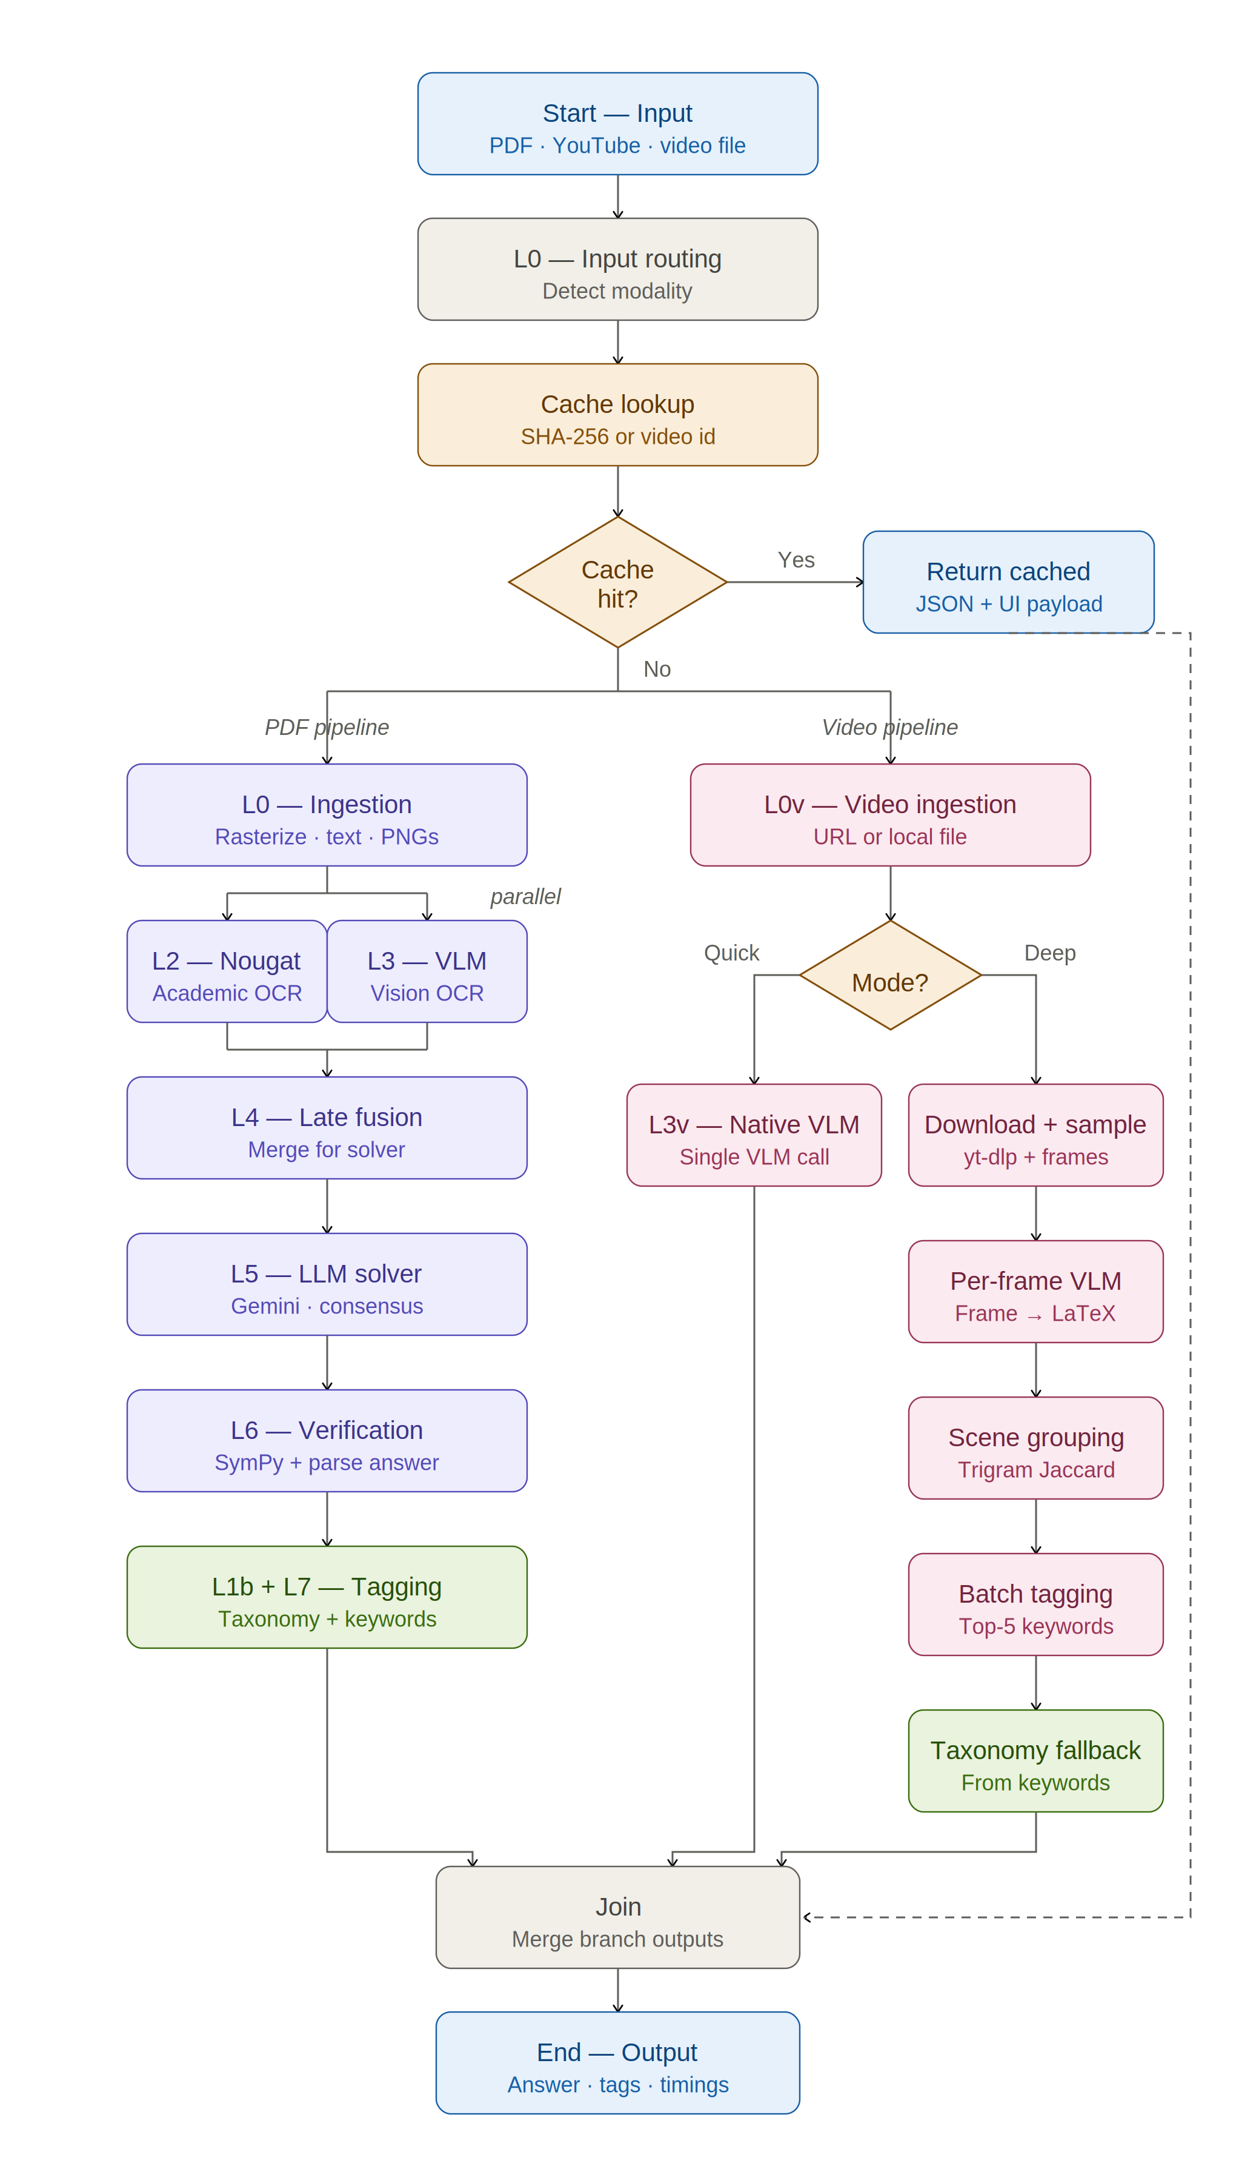

Keyword relevance and ordering
Not all keyword lists in the UI are produced by the same mechanism; therefore priority is not defined by one universal equation.

(i) Taxonomy keywords (rule‑based)
Topic, subtopic, and many highlighted labels are driven by hand‑crafted regular expressions. For each keyword rule, the system counts how many of its patterns match the extracted problem text. Keywords are sorted by descending match count, with alphabetical order as a tie‑break. This yields a transparent, reproducible ranking, but it is limited to what the patterns encode.

(ii) Layer 7 closed pool and free‑form keywords (model‑ordered)
Task 1 and Task 2 explicitly instruct the model to list keywords from most to least relevant in a single comma‑separated line at temperature zero. The implementation does not assign a separate numeric relevance score in code and does not re‑order the model’s reply; the output order is preserved after light parsing. This is deliberate for reproducibility under a fixed prompt, but it is not identical to a closed‑form scoring function.

(iii) Deep video grouping
Trigram Jaccard similarity is used only to decide which frames belong to the same on‑screen problem; it is not used to rank keywords. Per‑scene keyword order again follows (ii) in the batch tagging step.
Together, these rules explain which keywords appear first in each part of the interface and answer concerns about “mathematical” priority: explicit counts for taxonomy‑driven lists, model ordering under zero temperature for Layer 7 and batched video tags, and Jaccard solely for scene merging.

