**CMPE 360 HOMEWORK6**

**Part 1: Running Local Web Server**

To execute and observe the WebGL OpenGL Primitives, a local web server was utilized. The server setup enabled the visualization of graphics in a controlled environment.

**Image of the Running Local Web Server**

**Local Web Server**

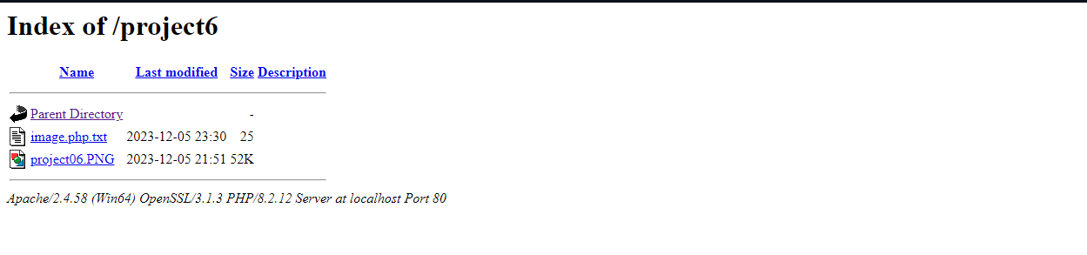

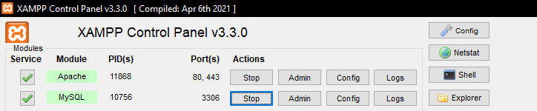

**Figure 1 Local Web Server Image**

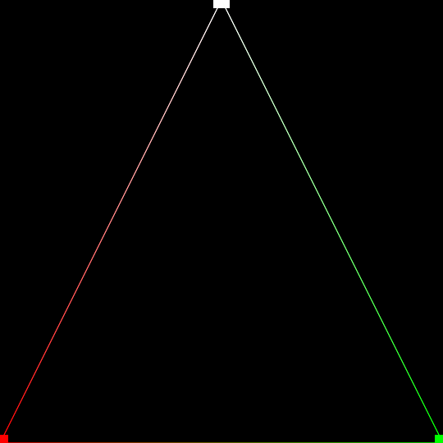**Part 2**

**Figure 2 Image**

Part 2: WebGL OpenGL Primitives Implementation

**metin, ekran görüntüsü, multimedya yazılımı, yazılım içeren bir resim

Açıklama otomatik olarak oluşturulduHTML Code (WebGlTemplate.html)**

**JavaScript Code (Lab1Demo.js)**

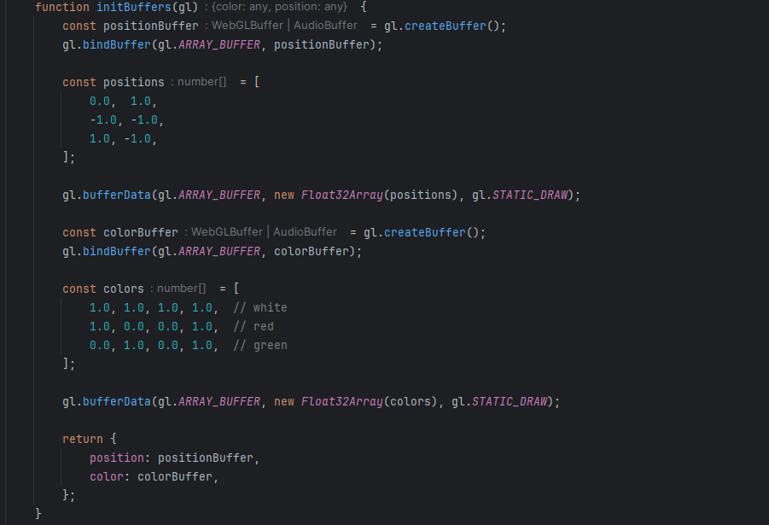

**Explanation of Image and Process**

The implemented WebGL OpenGL Primitives satisfy the homework requirements. The image represents a canvas with points and a loop of lines drawn on it. The process can be broken down as follows:

**Canvas Initialization:** The canvas is set up with dimensions 540x540 pixels.

**WebGL Context:** WebGL context is initialized, and potential errors are handled.

**Shader Programs:** Vertex and fragment shader programs are defined to handle vertex positions, colors, and point sizes.

**Buffers:** WebGL buffers for positions and colors are created and filled with data.

**Drawing Primitives:** Points and a loop of lines are drawn on the canvas, demonstrating the use of various OpenGL primitives.

**Additional Files**

**Lab1Demo.js:** The complete JavaScript file containing the WebGL implementation.

**WebGlTemplate.html** The complete HTML file containing the JavaScript and WebGL implementation.

**Conclusion**

The WebGL OpenGL Primitives have been successfully implemented, meeting the requirements specified in the homework. The provided code and image demonstrate an understanding of WebGL concepts, including shader programs, buffers, and drawing primitives. The included files ensure that the code can run seamlessly on other computers.