COMPREHENSIVE PROJECT REPORT
Project Title: Hire Me - A Local Service Marketplace

Project Team Members
MEMBER 1: EBUA KEDZE FRANCK JORDAN
Role: Scrum Master & Backend Lead
MEMBER 2: AWONO FABIEN NYADINGA
Role: Frontend Lead & DevOps Engineer
MEMBER 3: Besomba Baonerges
Role: Systems Analyst & Lead Technical Writer
MEMBER 4: NDZI LEVI KONGNYU
Role: UML Architect & Quality Assurance (QA) Engineer

Chapter 1: Introduction

1.1 General Introduction
The rapid growth of the gig economy and the increasing reliance on digital marketplaces have transformed the way individuals and businesses connect for freelance services. In many emerging markets and local communities, finding reliable, skilled professionals for everyday tasks remains a highly fragmented and inefficient process. The "Hire Me" platform was conceived to bridge this gap by providing a secure, transparent, and user-friendly digital marketplace that seamlessly connects clients with verified local service providers.

1.2 Problem Statement
Currently, individuals seeking local services often rely on word-of-mouth recommendations or unverified online directories. This informal approach presents several significant challenges:
- 1. Lack of Trust and Verification: Clients have no reliable way to verify the credentials, past performance, or criminal background of service providers.
- 2. Payment Insecurity: Cash transactions and direct bank transfers leave both parties vulnerable to fraud, with clients risking incomplete work and providers risking non-payment.
- 3. Inefficient Communication: Negotiating terms, discussing job requirements, and tracking service schedules is often scattered across various informal messaging apps.
- 4. Poor Visibility for Professionals: Skilled workers struggle to market themselves effectively and build a verifiable digital reputation that reflects their expertise.

1.3 Aim and Objectives
The primary aim of the "Hire Me" project is to design, develop, and deploy a robust web-based service marketplace that facilitates secure and efficient transactions between clients and freelance professionals.
Specific Objectives:
- Secure Financial Transactions: To implement a robust wallet and escrow system that holds client funds securely until the agreed-upon job is completed satisfactorily, ensuring fairness for both parties.
- Identity and Skill Verification: To provide an administrative backend where provider credentials and identification documents can be reviewed and officially verified.
- Real-Time Communication: To integrate a real-time messaging system allowing clients and providers to discuss job specifications without exchanging personal phone numbers.
- Reputation Management: To build a transparent review and rating system that holds providers accountable and helps clients make informed decisions based on past performance.
- Role-Based Access Control: To create distinct, tailored dashboard experiences for Clients, Providers, and Administrators, ensuring that each user type has access to the specific tools they need.

Chapter 2: Literature Review and Methodology

2.1 Review of Related Literature
The evolution of freelance service marketplaces has been well-documented in recent software engineering and economic literature. Platforms like Upwork, Fiverr, and TaskRabbit have demonstrated the viability of connecting independent contractors with clients via centralized digital hubs. However, literature highlights several persistent pain points in these platforms, particularly regarding trust, quality assurance, and high commission fees.
Decentralized trust mechanisms—such as escrow services—are critical in mitigating fraud. The "Hire Me" platform addresses this directly by integrating a built-in virtual wallet and an escrow holding system, ensuring that funds are committed before work begins but not released until client satisfaction is confirmed. Furthermore, localized platforms face unique challenges related to real-time coordination, which "Hire Me" solves through integrated WebSocket-based chat and instant status updates, reducing the friction often cited in user experience studies of service marketplaces.

2.2 Software Development Methodologies
In software engineering, the choice of development methodology significantly impacts the project's success, adaptability, and time-to-market. The two primary paradigms considered for this project were the Waterfall model and Agile methodologies.
- Waterfall Methodology: A linear, sequential approach where each phase (Requirements, Design, Implementation, Testing, Deployment) must be completed before the next begins. While offering strict documentation and predictability, it lacks flexibility. If a critical flaw in the escrow logic was discovered during testing, revisiting the design phase would be highly disruptive.
- Agile Methodology: An iterative approach that promotes continuous delivery, flexible responses to change, and collaborative development.

2.3 Justification for Choosing Scrum
For the development of the "Hire Me" platform, the Scrum framework—a specific subset of Agile—was selected. This decision was driven by several factors:
- Iterative Feature Delivery: The platform required complex, interwoven features (e.g., authentication, wallet, real-time chat). Scrum allowed the team to break these down into manageable one-week Sprints, delivering a functional increment before adding complexities.
- Rapid Adaptation: As the team encountered technical challenges, Scrum's daily stand-ups and Sprint Retrospectives allowed for immediate pivoting and architecture adjustments without derailing the entire project timeline.
- Clear Role Distribution: With a clear division of labor across frontend, backend, and documentation, the Scrum framework provided necessary structure. The Product Backlog ensured that all contributors remained aligned on priority tasks, preventing scope creep.

Chapter 3: System Design and Implementation
This chapter presents the system design through UML diagrams and showcases the implementation through screenshots of the final software.

3.1 UML Diagrams
USE CASE DIAGRAM
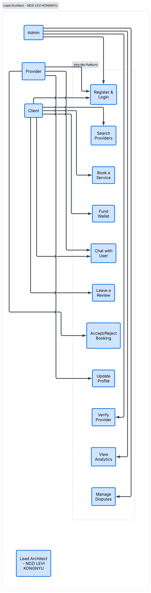
CLASS DIAGRAM HERE
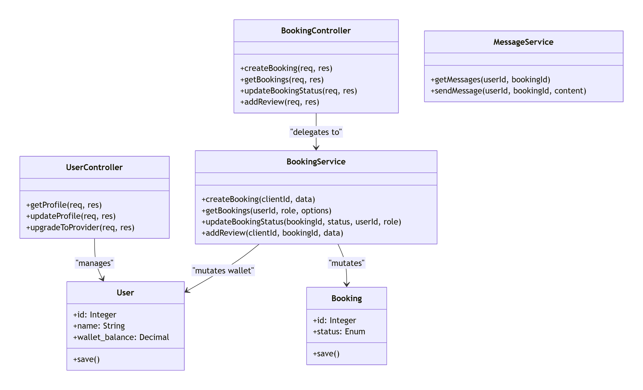
SEQUENCE DIAGRAMS HERE
1. Authentication Flow
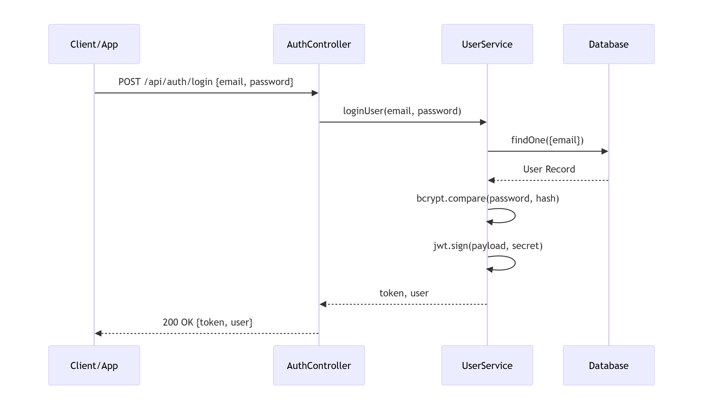

2. Booking & Escrow Flow
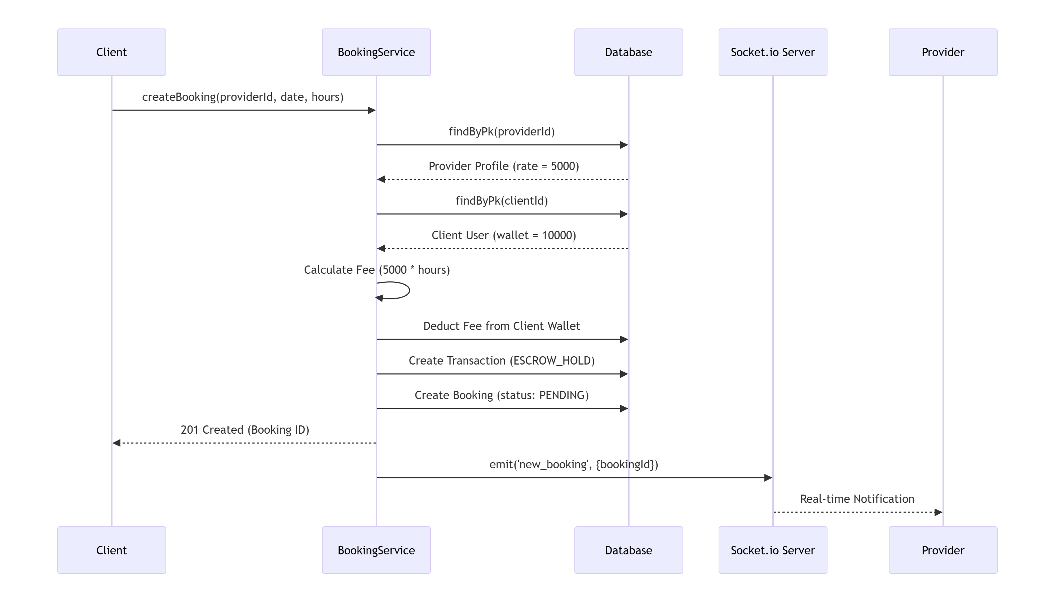
3. Job Completion Flow
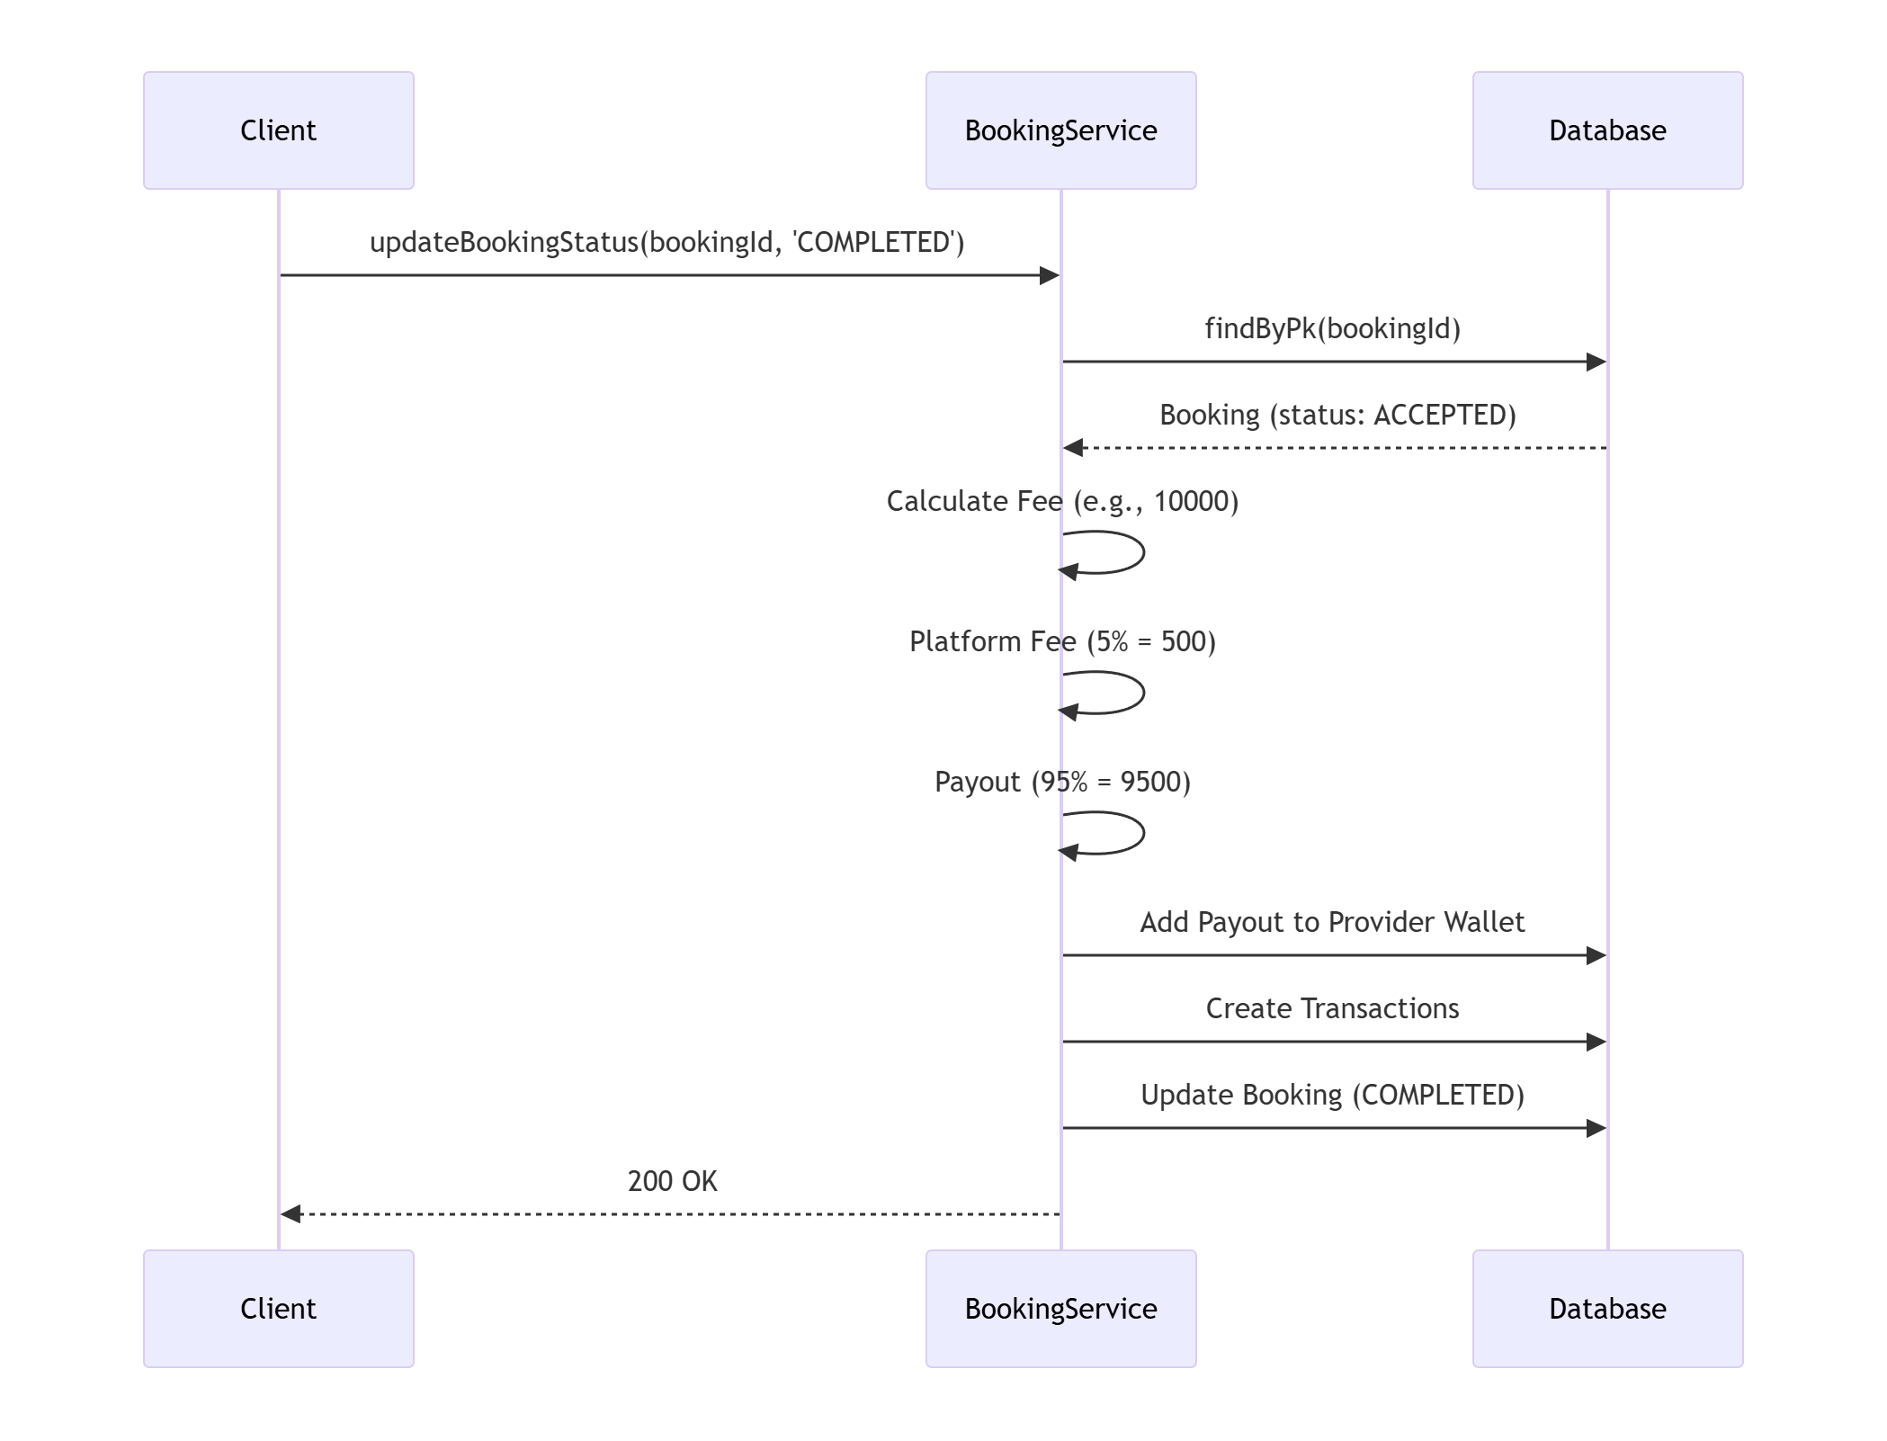
4. Real-Time Chat
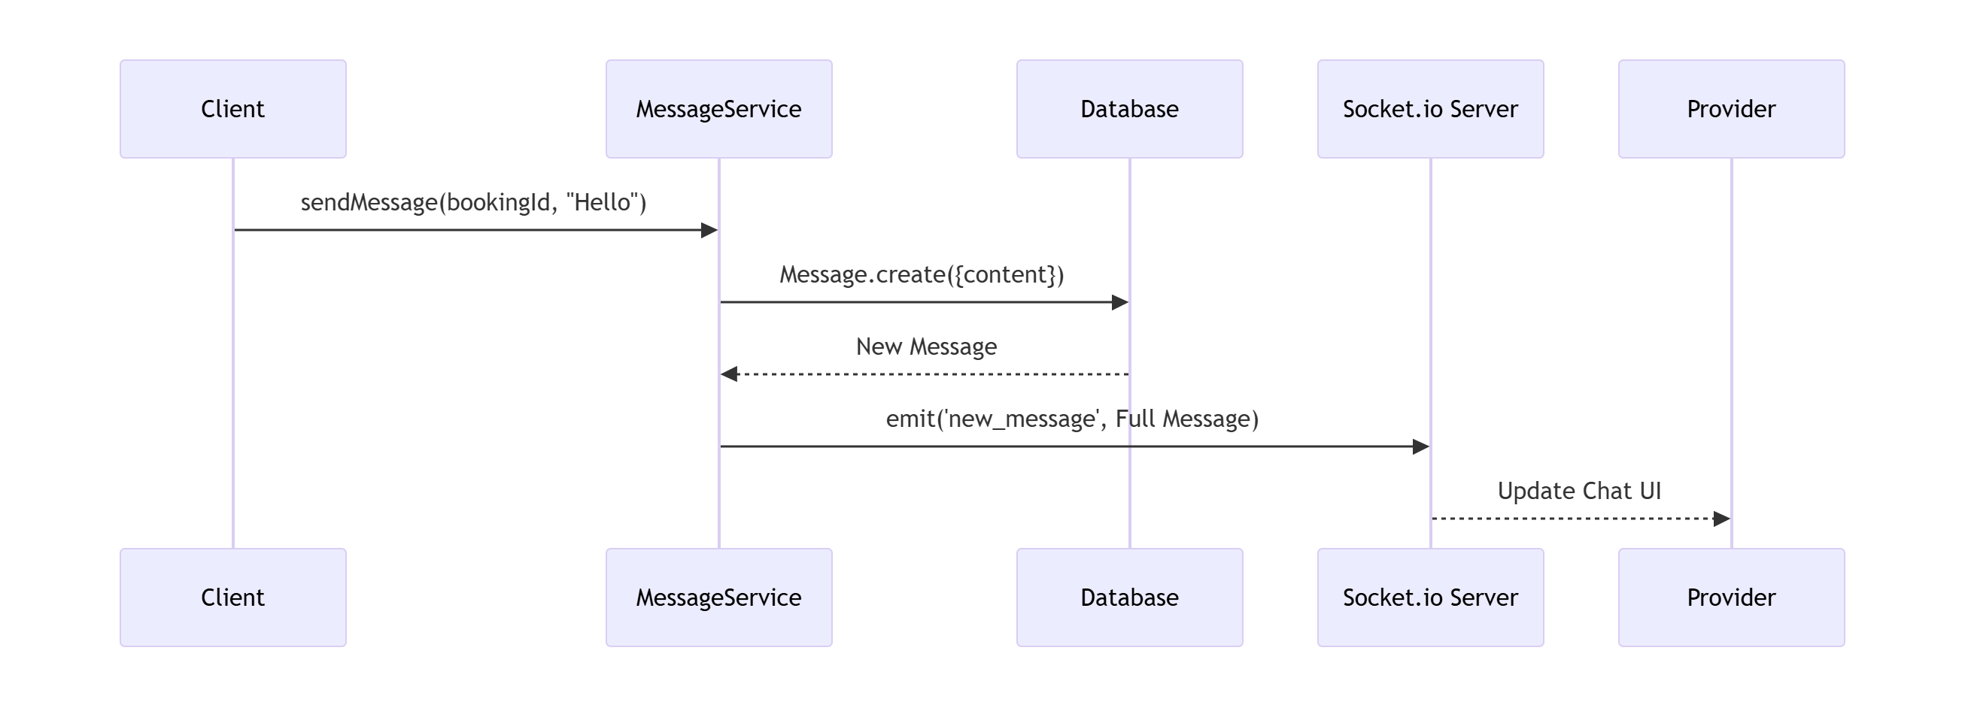
5. Booking Cancellation
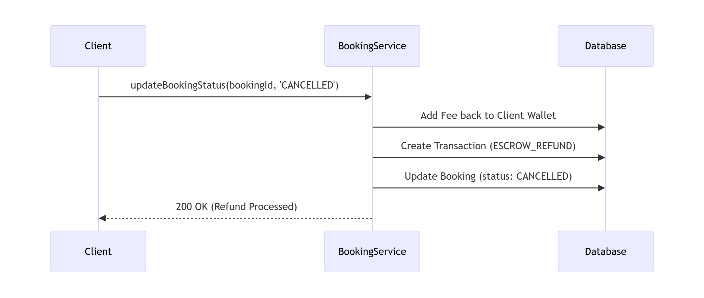
ENTITY-RELATIONSHIP DIAGRAM (ERD)
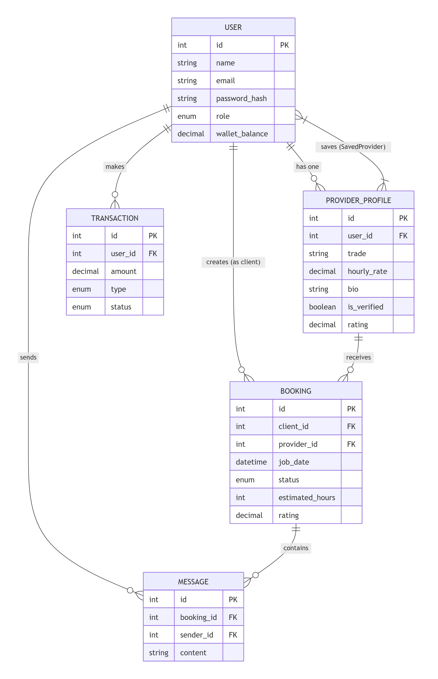
OBJECT DIAGRAM
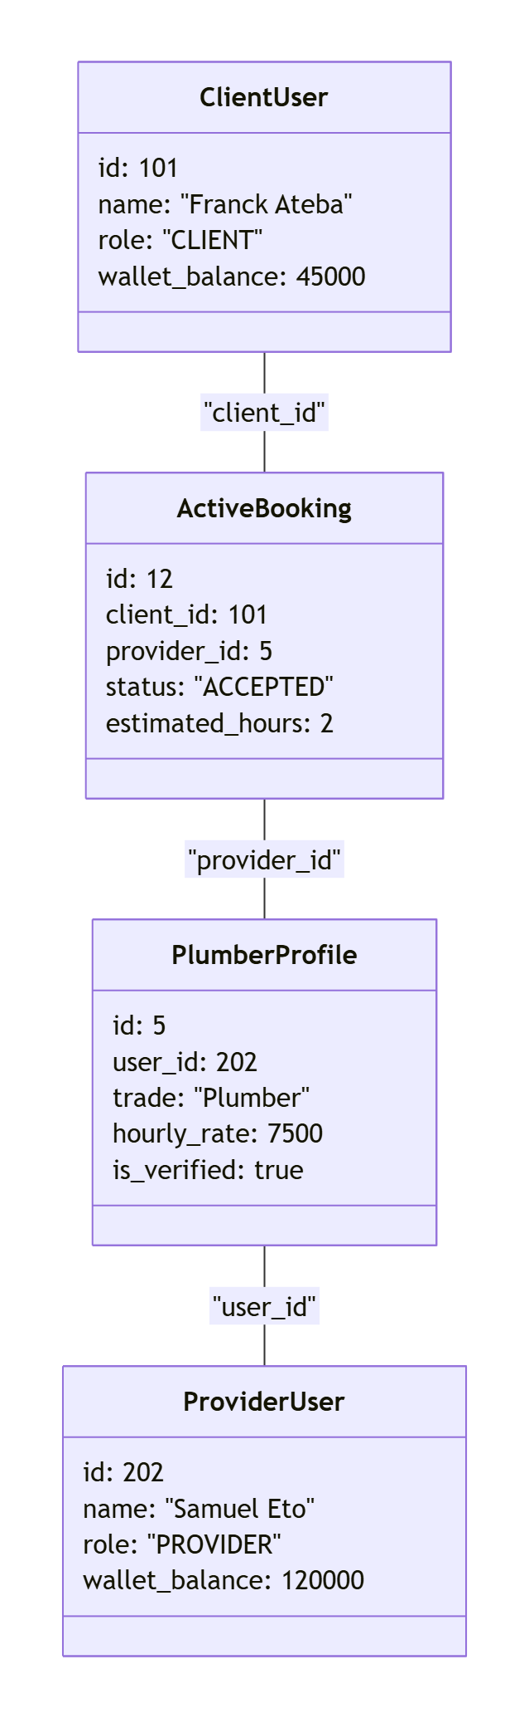

3.2 Software Screenshots
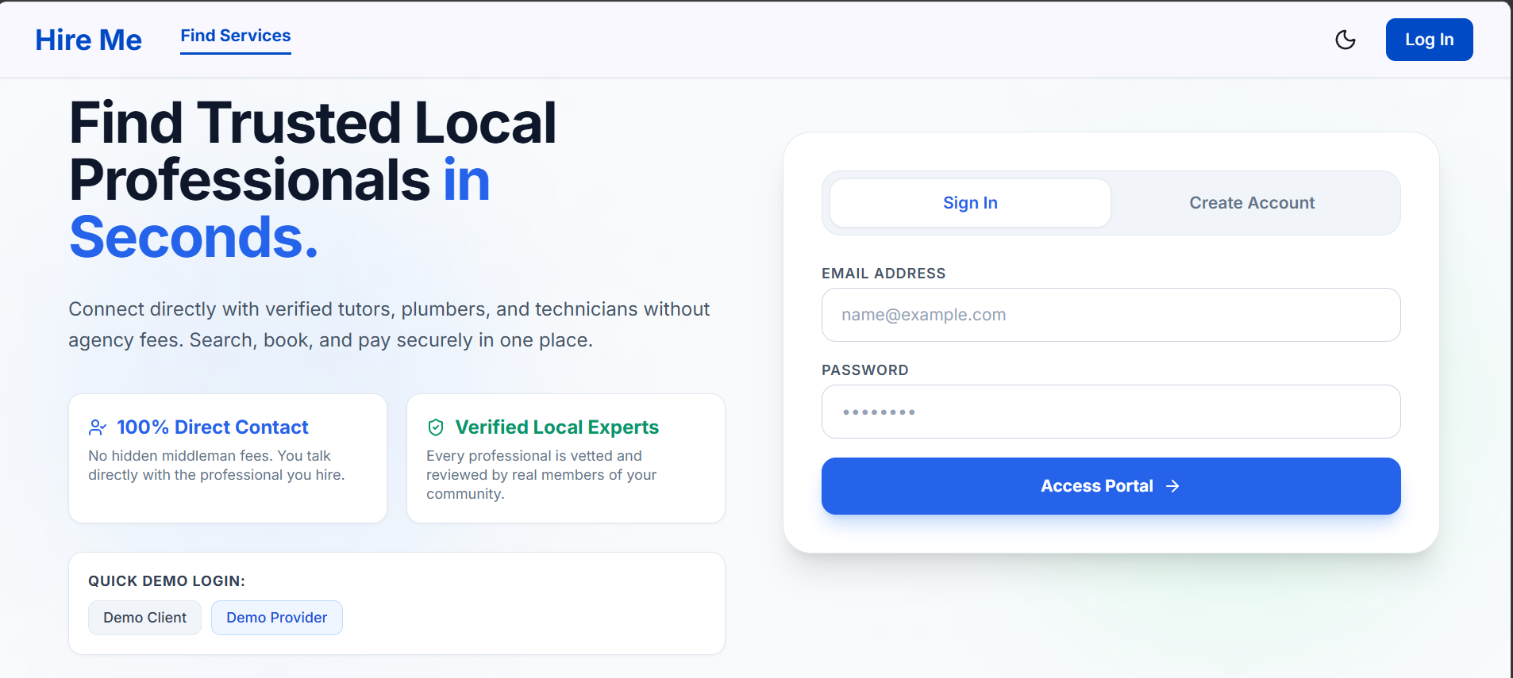
LANDING PAGE AND AUTHENTICATION
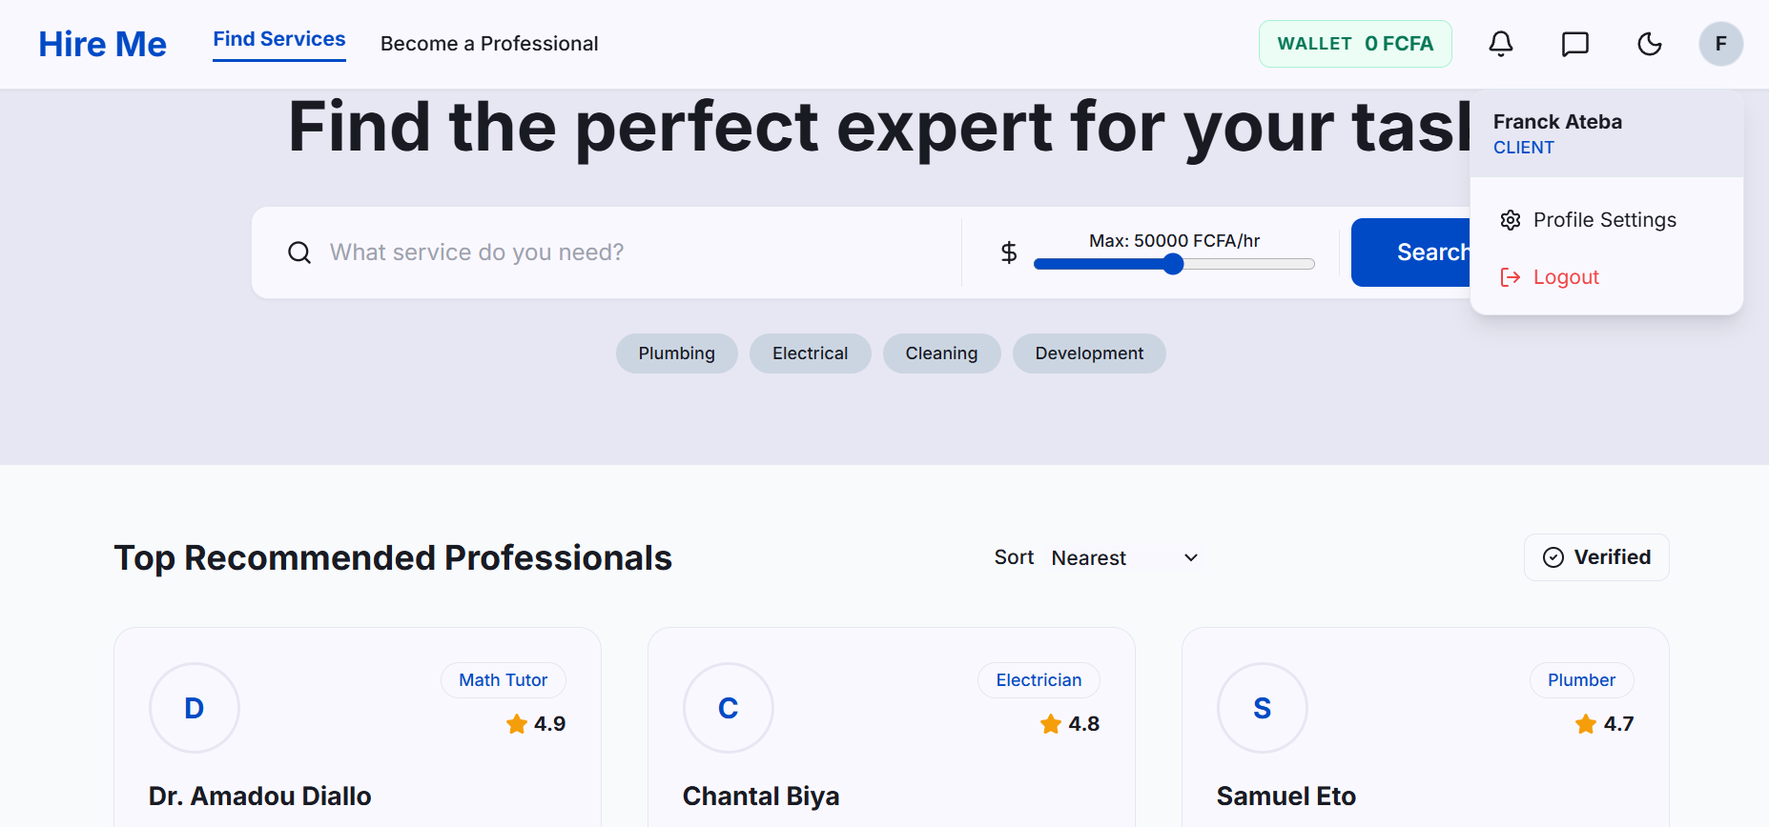
CLIENT DASHBOARD

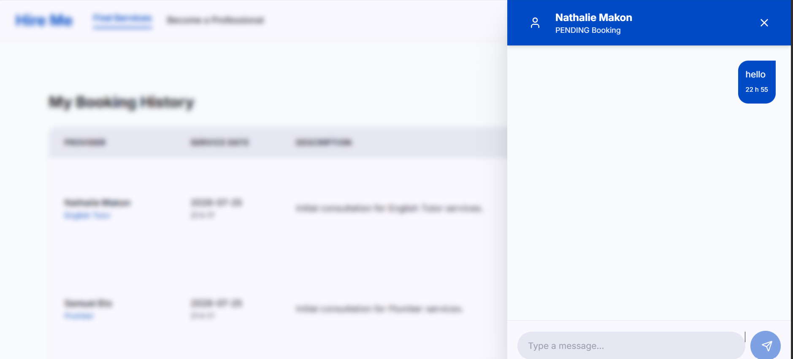
REAL-TIME CHAT INTERFACE

Chapter 4: Recommendations and Conclusion

4.1 Summary of Achievements
The "Hire Me" platform successfully achieved its primary objective of creating a secure, intuitive, and feature-rich digital marketplace for freelance professionals and clients. Over the course of four development Sprints, the team successfully engineered a full-stack application utilizing Node.js, Express, Sequelize, and React. Core functionalities—including role-based access control, a secure virtual wallet with escrow capabilities, an interactive booking lifecycle, and real-time Socket.io chat—were fully implemented and tested. The resulting system effectively addresses the lack of trust and communication inefficiencies prevalent in informal local service sectors by providing transparent reviews, verified badges, and structured financial holding mechanisms.

4.2 Difficulties Encountered
Despite the project's success, the team faced several technical challenges during development. Managing the complex state of the virtual wallet during edge cases—such as booking cancellations and dispute resolutions—required extensive transaction rollback testing to ensure financial data integrity. Additionally, integrating real-time WebSockets with the React frontend presented challenges regarding state synchronization; specifically, ensuring that chat messages appeared optimistically for the sender while preventing duplicate broadcasts from the server. Finally, coordinating code merges across frontend and backend branches required strict version control discipline to prevent configuration conflicts.

4.3 Future Recommendations
While the current iteration of the platform serves as a robust Minimum Viable Product (MVP), several features are recommended for future development to enhance scalability and user experience. First, integrating a third-party payment gateway (such as Stripe or Mobile Money APIs) would allow users to fund their virtual wallets directly using real-world currency. Second, implementing geographical map views (using Google Maps API) would allow clients to visualize the proximity of nearby providers. Finally, the introduction of a monthly calendar view for providers to manage their availability, alongside automated PDF invoice generation for completed jobs, would significantly elevate the platform's utility for full-time freelance professionals.

