

**Course: Internet Programming (BIM222)**

**Developer: Eren Karakaya**

**Project: Playlist Visualizer**

**Data Description: I used sample json files in the application files as dataset.**

**IMPORTANT!: There are several security problems about AJAX. If you try to open my html page via double click you cannot see the datas in the json files,**

**because as I mentioned in the readme file AJAX cannot reach local files without http protocol. One of the ways that you can do to open my html page in the right way is hosting a local server. You can do this with Visual Studio Code. There is an extension in Visual Studio Code named “Live Server”. You can host a local server with that extension easily.**



**First of all, I wanted to design pretty simple web site.**

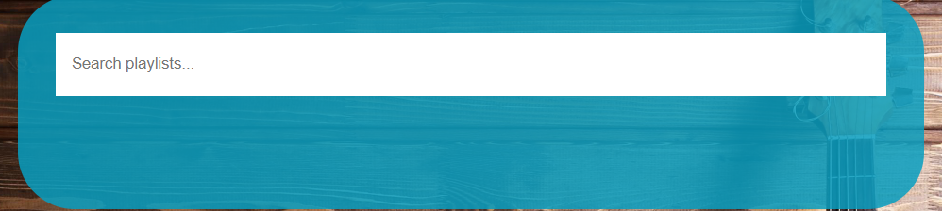

**On top of the site there is a search input for playlists. It searches instantly whenever the words change inside the search bar. It searches based on first letters and case insensitively.**

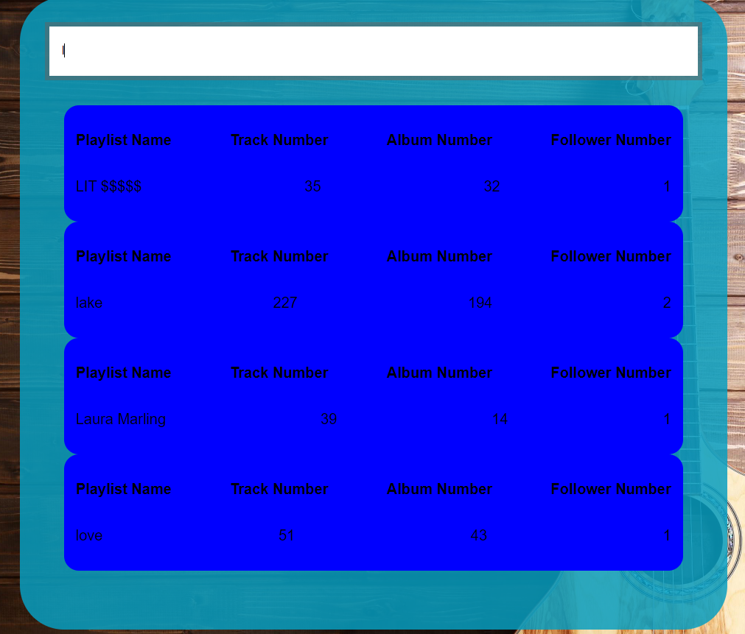

**When the value matches with playlist names, the playlists are listed under the input field.**

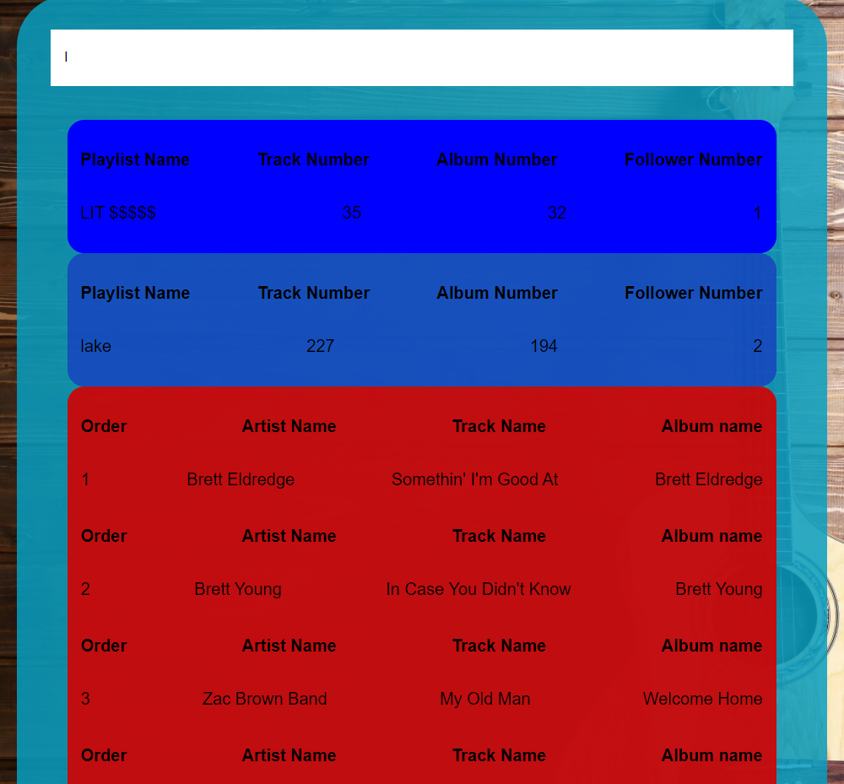

**When the user clicks a playlist the songs are displayed under the playlist that the user clicked.**