Methods and

Encapsulation
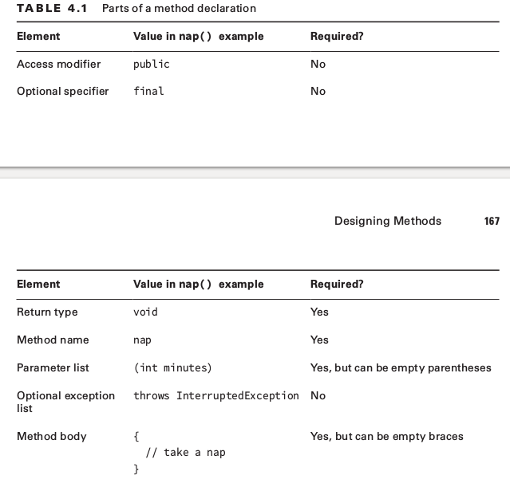
The exam creators like to trick you by putting elements in the wrong order or using incorrect values.
public void nap(){}
void public nap(){}
Optional Specifiers
return type must be before the method decleration other optional specifiers such as “final, static” can be change spaces each other.
Return Type
Return type have to return interested type from method if it does not exist return type must be void.
public String walk3() { return ""; }
public String walk4() { } // DOES NOT COMPILE
Method Name
Method names follow the same rules as we practiced with variable names in Chapter 1,
“Java Building Blocks.” To review, an identifi er may only contain letters, numbers, $ , or _ .
Also, the fi rst character is not allowed to be a number, and reserved words are not allowed.
By convention, methods begin with a lowercase letter but are not required to. Since this is a
review of Chapter 1, we can jump right into practicing with some examples:
Parameter List
Parameter list is not optional if you have no parameter with method you can pass with empty parentheses “()”
public void walk(){}
public void walk {} DOES NOT COMPILE
Optional Exception List
Exception List on method not require you can catch exception on method or you can throw away if you want to throw away you have to declare as throws on method also method throws many exception separated with commas
public void zeroExceptions() { }
public void zeroExceptions() throws Exception { }
Method Body
The final part of a method declaration is the method body (except for abstract methods and , but you don’t need to know about either of those until next chapter)
public void walk1() { }
public void walk1;

Working with Varargs

0: public static void walk(int a, int... aList){
1: System.out.println("aList length: "+aList.length);}
2: public static void main(String[] args){
3: walk(1);
4: walk(1,2);
5: walk(1,2,3);
6: walk(1,new int[]{1,2});}
With working args you can pass the list value without any value(line 1) and you can pass value instead of list you can type values by one by as you can see on line 4,5
Applying Access Modifiers
■ private : Only accessible within the same class
■ default (package private) access: private and other classes in the same package
■ protected : default access and child classes
■ public : protected and classes in the other packages

package pond.duck;
pond.goose.Goose;
class GooseWatcher {
public void watch() {
Goose goose = new Goose();
goose.floatInWater(); DOES NOT COMPILE
} }
This code doesn’t compile because we are not in the Goose class. The floatInWater()
method is declared in Bird . GooseWatcher is not in the same package as Bird , nor does it

package pond.shore;
public class Bird {
protected String text = "floating";
protected void floatInWater() {
System.out.println(text);
} }
package pond.goose;
import pond.shore.Bird;
public class Goose extends Bird {
public void helpGooseSwim() {
Goose other = new Goose();
other.floatInWater();
System.out.println(other.text);
}
public void helpOtherGooseSwim() {
Bird other = new Goose();
other.floatInWater(); // DOES NOT COMPILE
System.out.println(other.text); // DOES NOT COMPILE
} }
Calling a Static Variable or Method

5: Koala k = new Koala();
6:System.out.println(k.count);// k is a Koala
7:k = null;
8:System.out.println(k.count);// k is still a Koala

if count is a static member of Koala class jvm doesn’t care about Koala instance null or loaded on memory which care about k statically load on.
Koala.count = 4;
Koala koala1 = new Koala();
Koala koala2 = new Koala();
koala1.count = 6;
koala2.count = 5;
System.out.println(Koala.count);
Koala count is 5 because of loaded only one count all instance or static access changes that one count variable

Static vs. Instance

