CLASS DESIGN
Introducing Class Inheritance
Extending a Class
In Java, you can extend a class by adding the parent class name in the definition using the extends keyword. The syntax of defining and extending a class is shown in
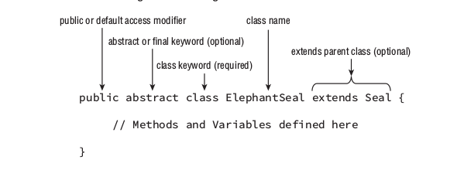
Defining Constructors
class will not compile because the call to the parent constructor must be the first statement of the constructor, not the second statement
Understanding Compiler Enhancements
The answer is that the Java compiler automatically inserts a call to the no-argument constructor super() if the first statement is not a call to the parent constructor.
Constructor Definition Rules:
1. The first statement of every constructor is a call to another constructor within the class using this() , or a call to a constructor in the direct parent class using super() .
2. The super() call may not be used after the first statement of the constructor.
3. If no super() call is declared in a constructor, Java will insert a no-argument super() as the first statement of the constructor.
4. If the parent doesn’t have a no-argument constructor and the child doesn’t define any constructors, the compiler will throw an error and try to insert a default no-argument constructor into the child class.
5. If the parent doesn’t have a no-argument constructor, the compiler requires an explicit call to a parent constructor in each child constructor.
Overriding a Method
Overriding a method is not without limitations, though. The compiler performs the following checks when you override a nonprivate method:
1.The method in the child class must have the same signature as the method in the parent class.
2. The method in the child class must be at least as accessible or more accessible than the method in the parent class.
3. The method in the child class may not throw a checked exception that is new or broader than the class of any exception thrown in the parent class method.
4. If the method returns a value, it must be the same or a subclass of the method in the parent class, known as covariant return types.
public class InsufficientDataException extends Exception {}
public class Reptile {
protected boolean hasLegs() throws InsufficientDataException {
throw new InsufficientDataException();
}
protected double getWeight() throws Exception {
return 2;
}
}
public class Snake extends Reptile {
protected boolean hasLegs() {
return false;
}
protected double getWeight() throws InsufficientDataException{
return 2;
}
}
that code compiles without problem exceptions are uses parent child relativity same as classes getWeight method throws insuffici… can be because insuffici… child of exception.
Hiding Static Methods
if you declare a static method to child class and that method also have parent class as a static parent static class hiding from user in the example of that package.staticinherit
just hidding if static hidding method used in somewhere else that runs without any problem
public class Marsupial {
public static boolean isBiped() {
return false;
}
public void getMarsupialDescription() {
System.out.println("Marsupial walks on two legs: "+isBiped());
}
}
public class Kangaroo extends Marsupial {
public static boolean isBiped() {
return true;
}
public void getKangarooDescription() {
System.out.println("Kangaroo hops on two legs: "+isBiped());
}
public static void main(String[] args) {
Kangaroo joey = new Kangaroo();
joey.getMarsupialDescription();
joey.getKangarooDescription();
}
}
//Marsupial walks on two legs: false
//Kangaroo hops on two legs: true

Creating final methods
We conclude our discussion of method inheritance with a somewhat self-explanatory rule: final methods cannot be overridden

Creating Abstract Classes
Abstract classes cannot get a final keyword. Because abstracts must be inherit from other classes final keyword means you do not inherit that class.
Methods accessor cannot be private ex: private abstract void blabla() not appropriate.
The subclass cannot reduce the visibility of the parent method
Abstract Class Definition Rules:
1. Abstract classes cannot be instantiated directly.
2. Abstract classes may be defined with any number, including zero, of abstract and nonabstract methods.
3. Abstract classes may not be marked as private or final.
4. An abstract class that extends another abstract class inherits all of its abstract methods as its own abstract methods.
5. The first concrete class that extends an abstract class must provide an implementation for all of the inherited abstract methods.
Abstract Method Definition Rules:
1. Abstract methods may only be defined in abstract classes.
2. Abstract methods may not be declared private or final .
3. Abstract methods must not provide a method body/implementation in the abstract class for which is it declared.
4. Implementing an abstract method in a subclass follows the same rules for overriding a method. For example, the name and signature must be the same, and the visibility of the method in the subclass must be at least as accessible as the method in the parent class.
Implementing Interfaces
public interface HasTail {
public int getTailLength();
}
public interface HasWhiskers {
public int getNumberOfWhiskers();
}
public abstract class HarborSeal implements HasTail, HasWhiskers {
}
public class LeopardSeal implements HasTail, HasWhiskers {
}
// DOES NOT COMPILE
In this example, we see that HarborSeal is an abstract class and compiles without issue. Any class that extends HarborSeal will be required to implement all of the methods in the HasTail and HasWhiskers interface. Alternatively, LeopardSeal is not an abstract class, so it must implement all the interface methods within its definition. In this example, LeopardSeal doesn’t provide an implementation for the interface methods, so the code doesn’t compile.

Interface Variables
interface variables default gets static final keyword;
Default Interface Methods
you can declare a method with body with default keyword
Static Interface Methods
** Is an method declared in interface without any accessor(public,protected) is marked by default accessor compiler add public to method accessor default.

Understanding Polymorphism
Object vs. Reference
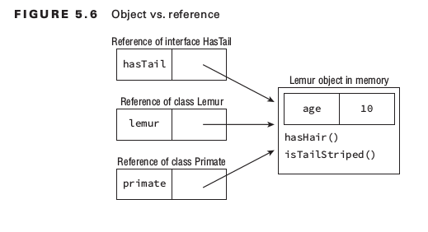
In Java, all objects are accessed by reference
We can summarize this principle with the following two rules:
1. The type of the object determines which properties exist within the object in memory.
2. The type of the reference to the object determines which methods and variables are accessible to the Java program.

Here are some basic rules to keep in mind when casting variables:
1. Casting an object from a subclass to a superclass doesn’t require an explicit cast.
2. Casting an object from a superclass to a subclass requires an explicit cast.
3. The compiler will not allow casts to unrelated types.
4. Even when the code compiles without issue, an exception may be thrown at runtime if the object being cast is not actually an instance of that class.
Polymorphic Parameters

