Understanding Exceptions
Understanding Exception Types

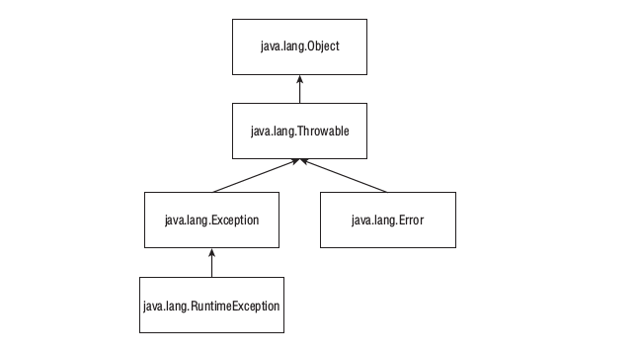
Error means something unrecover fatal error end program must be end such as hard drive couldn’t see from your program.
Throwing an Exception
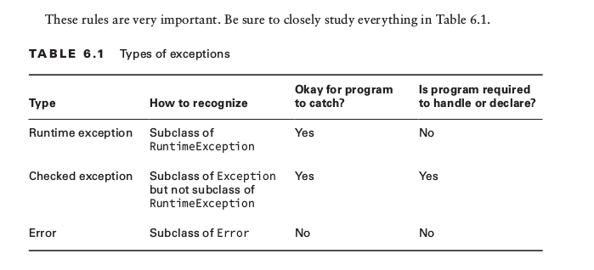

Using a try Statement
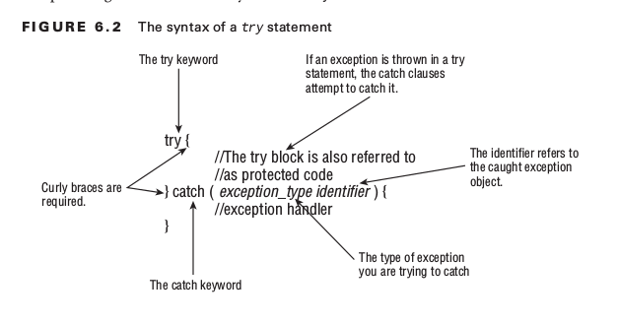
Adding a finally Block
System.exit
There is one exception to “the finally block always runs after the catch block” rule: Java defi nes a method that you call as System.exit(0); . The integer parameter is the error code that gets returned. System.exit tells Java, “Stop. End the program right now. Do not pass go. Do not collect $200.” When System.exit is called in the try or catch block, finally does not run.

Exam Essentials
Differentiate between checked and unchecked exceptions. Unchecked exceptions are also known as runtime exceptions and are subclasses of java.lang.RuntimeException . All other subclasses of java.lang.Exception are checked exceptions.
Understand the flow of a try statement. A try statement must have a catch or a finally block. Multiple catch blocks are also allowed, provided no superclass exception type appears in an earlier catch block than its subclass. The finally block runs last regardless of whether an exception is thrown.
Identify whether an exception is thrown by the programmer or the JVM. Illegal ArgumentException and NumberFormatException are commonly thrown by the program- mer. Most of the other runtime exceptions are typically thrown by the JVM.
Declare methods that declare exceptions. The throws keyword is used in a method decla- ration to indicate an exception might be thrown. When overriding a method, the method is allowed to throw fewer exceptions than the original version.
Recognize when to use throw versus throws. The throw keyword is used when you actu- ally want to throw an exception—for example, throw new RuntimeException() . The throws keyword is used in a method declaration.

