Eren Şenoğlu

CS-202 HW3

21702079

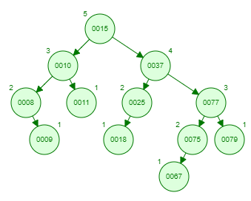1) Shape of the data structure after the insertion.

After deletion:

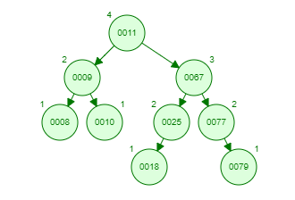

2) Final Tree

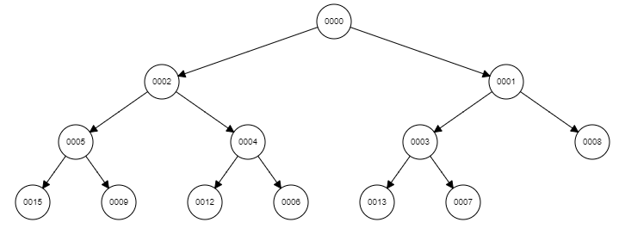

3)

A -> False. It might be, but binary search trees are not always complete. So that all binary search trees are not heaps.

B ->True. Heap condition requires heap to be a complete binary tree. Because of that depths of any two leaves in a max heap limited with 1 length difference.

C ->False.

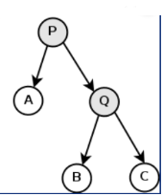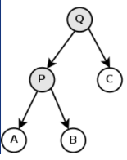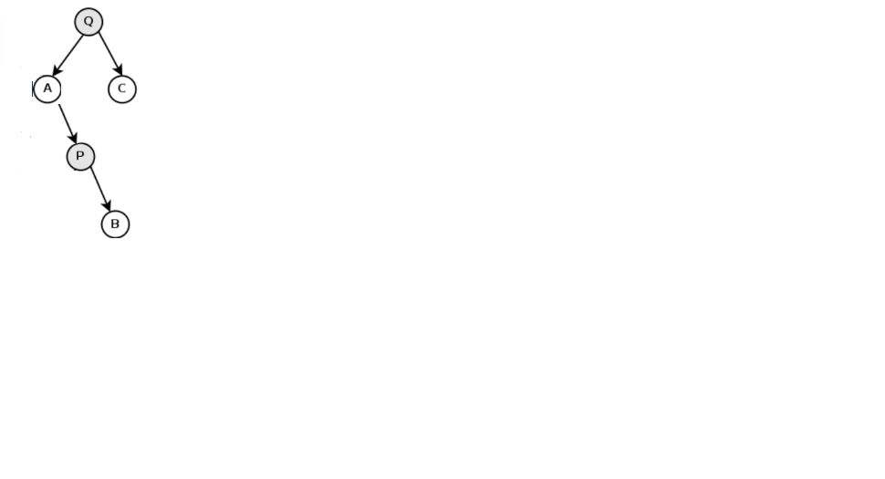Before applying left rot. on P Before applying right rot. on P Final Structure

As it can be seen from example, applying left and right rotation to the same node doesn't end up with the same shape.