AYDIN ADNAN MENDERES UNIVERSITY
ENGINEERING FACULTY
COMPUTER SCIENCE ENGINEERING

RECCOMENDATION SYSTEMS WITH SPARK

Term Project REPORT

Cavit Eren YILDIZ 201805001
Arda PALA 191805073

CSE-424 Big Data Analysis 2023-2024 Spring

Lecturer:
Asst. Prof. Dr. Hüeyin ABACI

Movie Reccomendation Systems with using Apache Spark, Python, and Jupyter Notebook
Term Project Includes

* Adding Necessary Libraries
* Creating a Spark Session
* Specify the directory of data files
* Load the data as DataFrame
* Print the dimensions of the data
* Check the data
* Versions Used
* Create a schema showing the data types and print it to the screen
* Descriptive Statistics
* Convert the Timestamp column and check its range
* Checking for missing values
* Select the necessary columns and drop the unnecessary ones
* Drop missing values
* Print the first 5 rows of the data set of screen
* Get a statistical summary of the data set and visualize it
* Rating Distribution Graphic
* Creating a Histogram, Data type converting, Filtering null values and erroneous entries
* Histogram Graphic

Term Project Includes

* ALS modeling, Printing to screen RMSE and MSE values.
* Choosing the best model
* Real values-predictions—Frequency Error Distribution Histogram Graph (small data)
* Real values- Prediction values Scatter Plot (small data)
* Real values-predictions—Frequency Error Distribution Histogram Graph (big data)
* Mapping the data
* Cosine Similarity
* Choice of 10 users who will like the movie the most
* Describing big data to DataFrame and mapping with a little data
* Counting big data rows
* Calculating mean value of rating and printing
* Controlling missing parts of data set and converting it to the clean data
* Calculating rows of data after cleaning
* ALS Modeling with Big Data, Calculating RMSE and MSE values
* Converting DataFrame to RDD, Calculating the mean value with using operate Reduce on RDD
* Host Name, Host IP
* Work Sharing Policy

Adding Necessary Libraries:
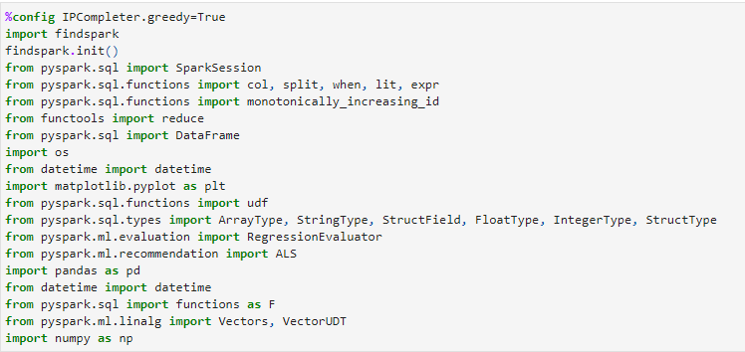
Creating a spark session:
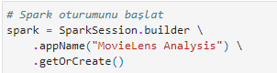
Specify the directory of data files:
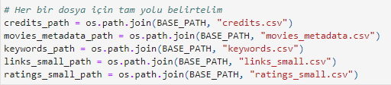
Load the data as DataFrame:
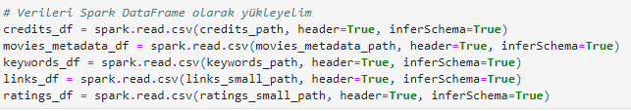
Print the dimensions of the data: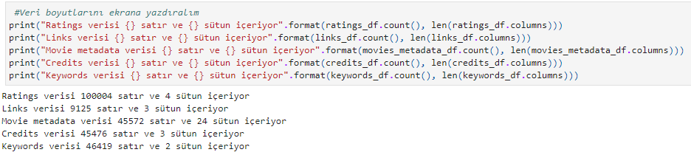
Check the data:
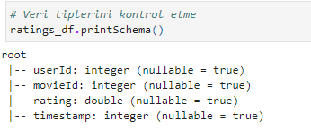
Versions Used:
Java: jdk 1.8.0_151
Python: python 3.7.4
Spark: spark 2.4.3
Jupyter notebook: 6.0.0
Create a schema showing the data types and print it to the screen: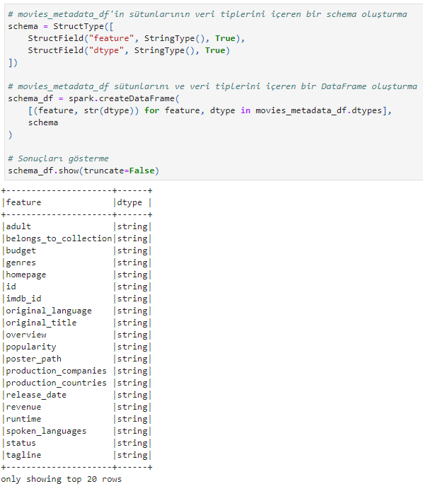
Descriptive Statistics: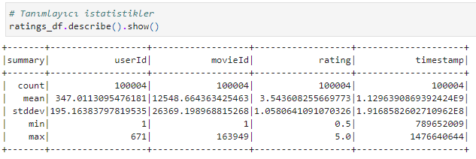
Convert the Timestamp column and check its range: 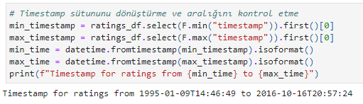
Checking for missing values: 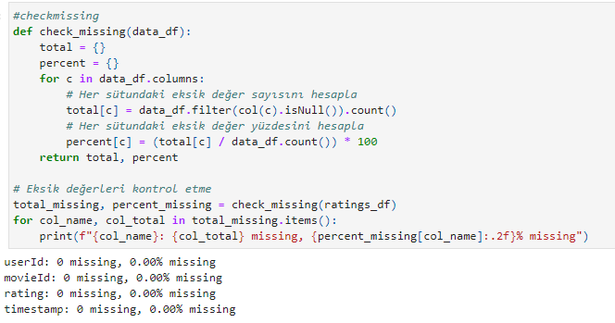
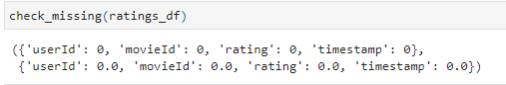

Select the necessary columns and drop the unnecesary ones:
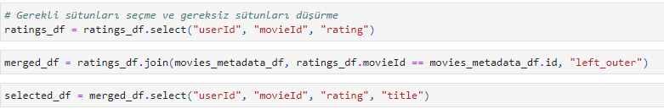
Drop missing values:
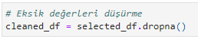
Print the first 5 rows of the data set of screen:
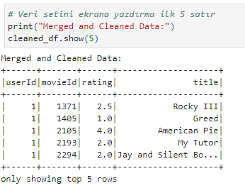
Get a statistical summary of the data set and visualize it: 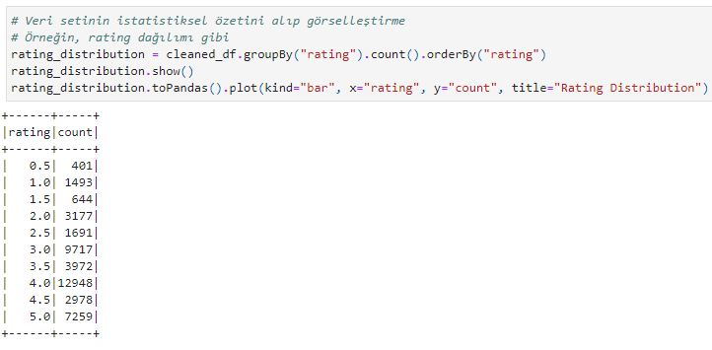

Rating Distribution Graphic: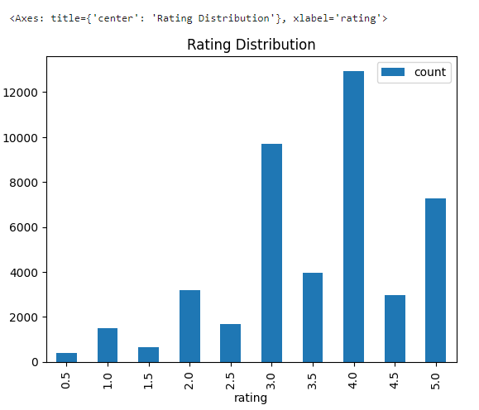
Creating a Histogram, Data type converting, Filtering null values and erroneous entries: 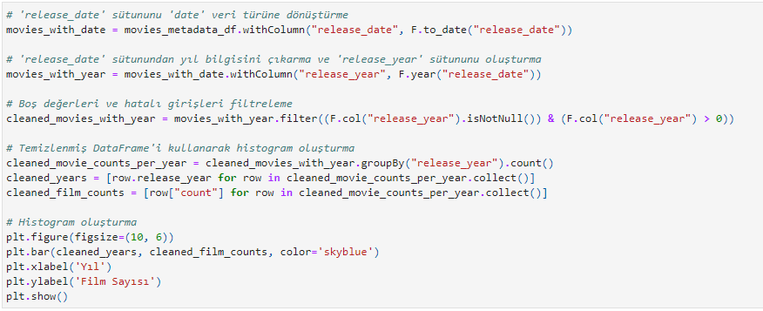

Histogram Graphic:

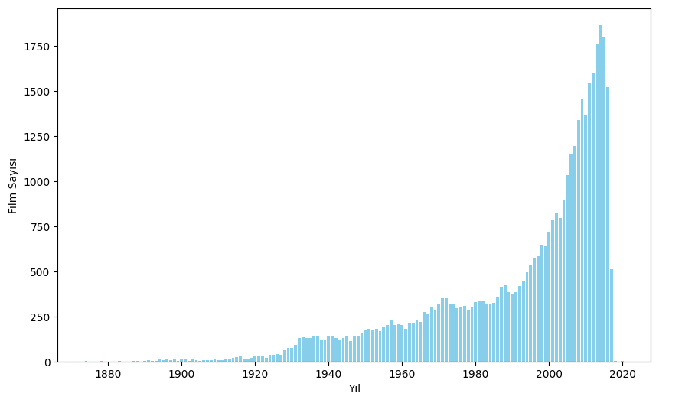

ALS modeling, Printing to screen RMSE and MSE values:

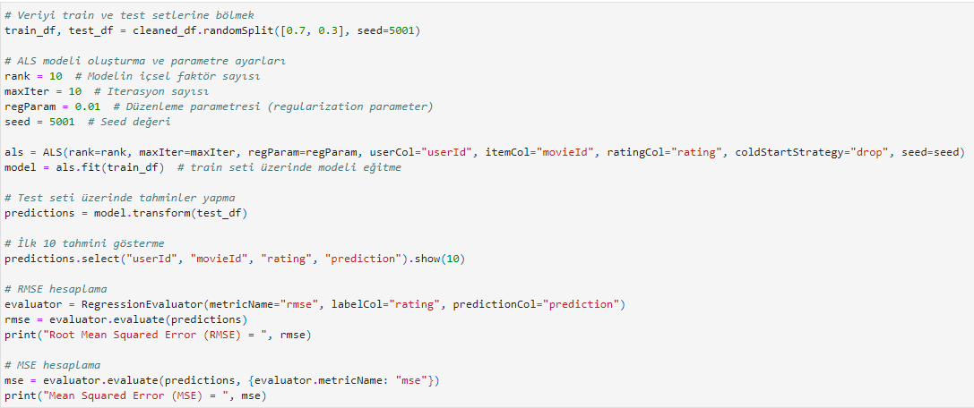

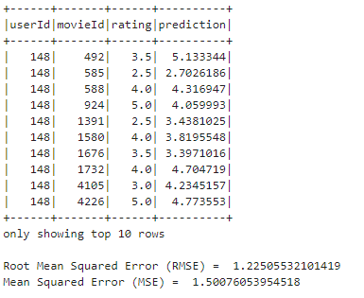

Choosing the best Model: Rank = 200, maxIter = 10, regParam = 0,1
This is the best model for our model
There was 18 models and we have to choose the best. First, we increase maxIter and regParam then noticed the RMSE value approaches the 1 value. For ALS modeling 1 is kind a good rate for the model. Then we kept these values constant (maxIter and regParam) and we started to increase rank and noticed RMSE value is decreasing. After that we decided it the best model values are Rank: 200, maxIter: 10 and regParam: 0,1
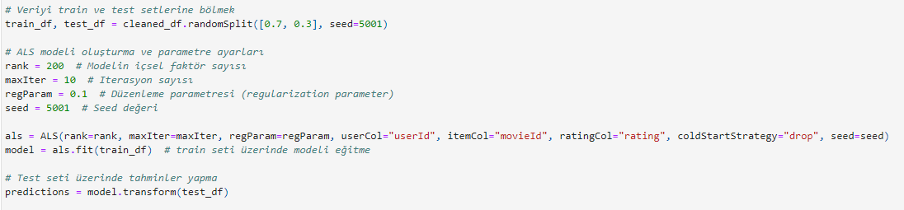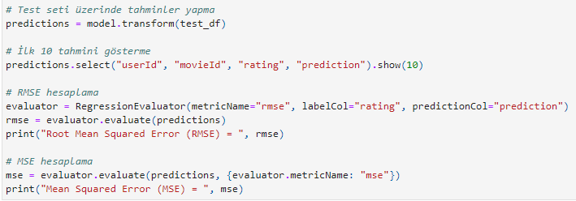
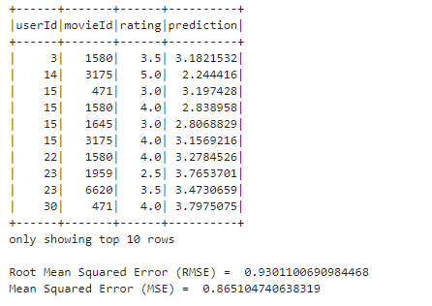

Real values-predictions – Frequency Error Distribution Histogram Graph
(the best model of small data’s data visualization):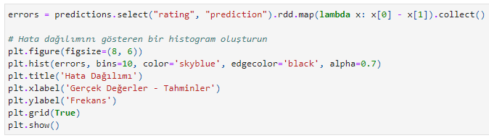
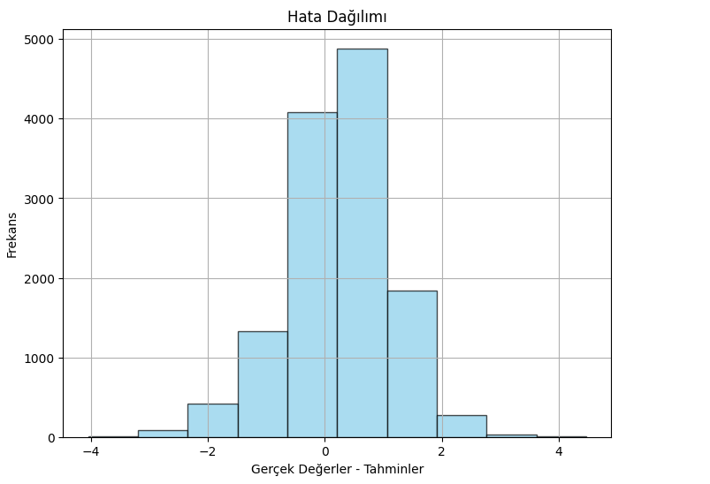

Real values – Prediction values Scatter Plot
(the best model of data visulation for small data):
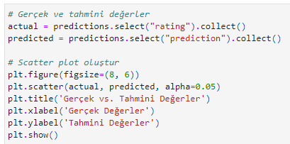
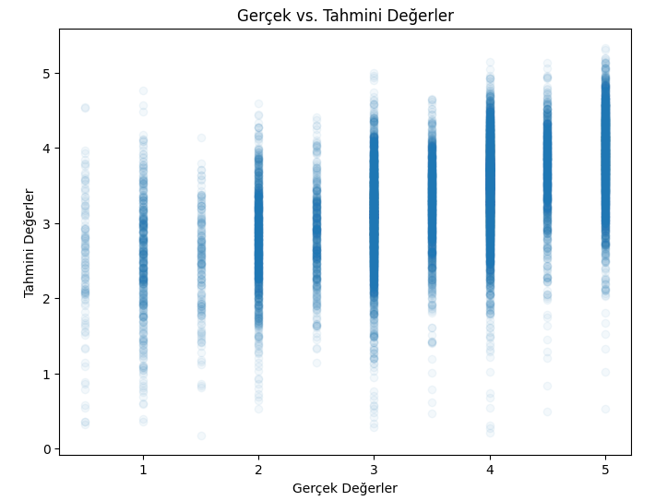

Real values – predictions – Frequency Error Distribution Histogram Graph
(the best model of big data’s data visualization): 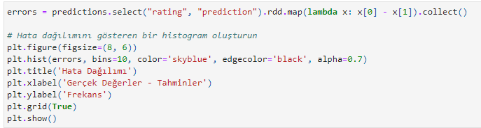
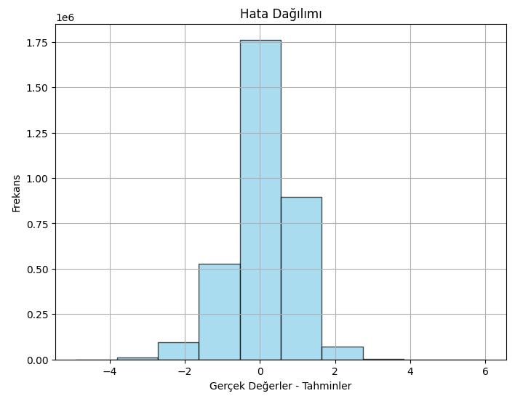
Mapping the data:

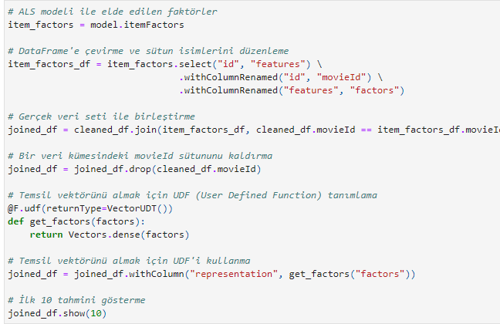

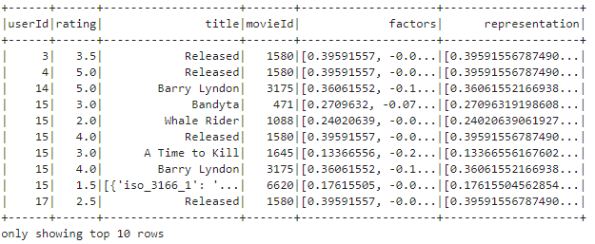

Cosine Similarity:

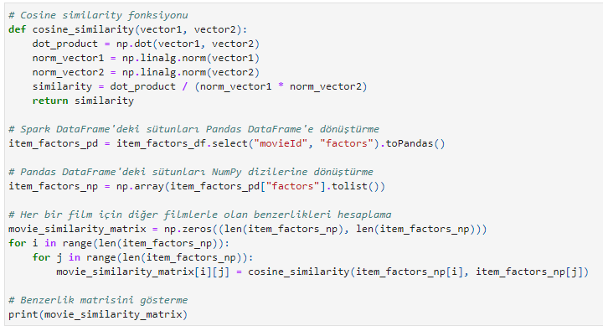

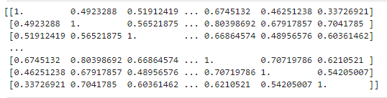

Choice of 10 users who will like the movie the most: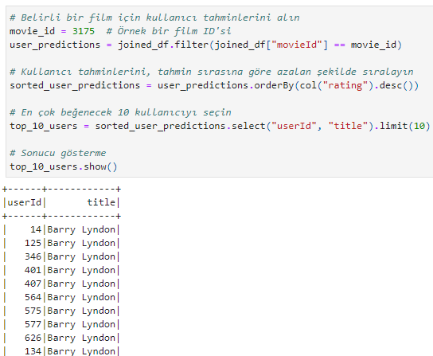

Describing big data to DataFrame and mapping with a little data:
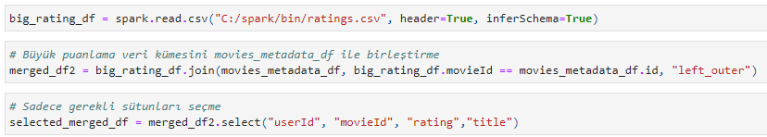
Couting big data rows:
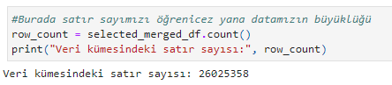

Calculating mean value of raing and printing:
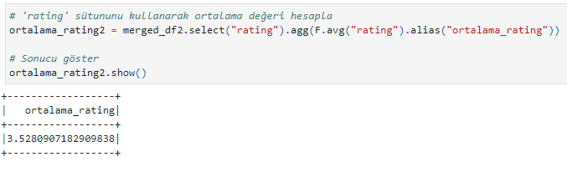
Controlling missing part of data set and converting it to the clean data:
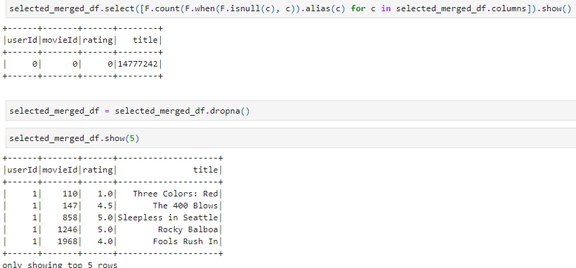

Calculating rows of data after cleaning:
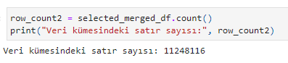

ALS modeling with Big Data, Calculating RMSE and MSE values: 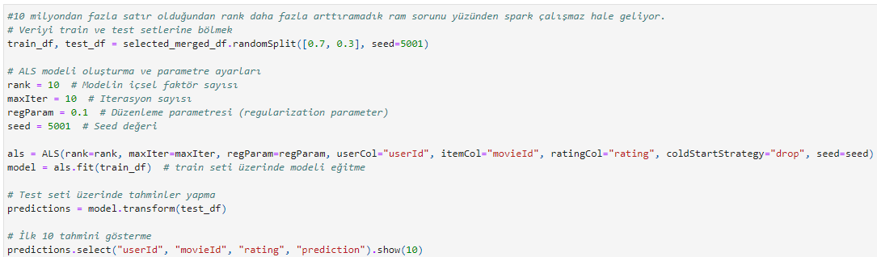
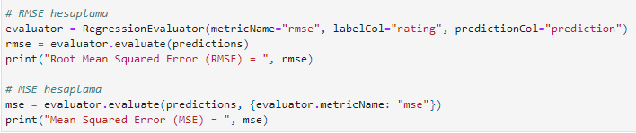
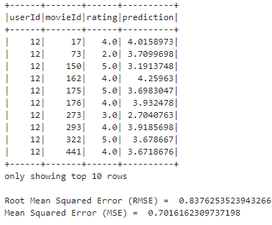
Converting DataFrame to RDD, Calculating the mean value with using operate Reduce on RDD: 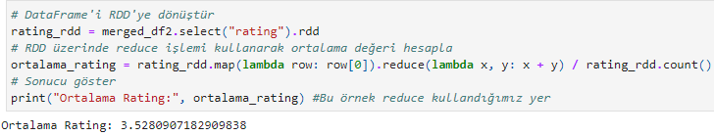

Host name, Host IP:
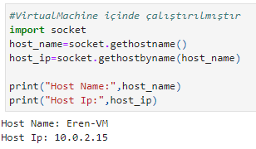

WORK SHARING POLICY
Name | Duty | Percent
Cavit_Eren_YILIZ_201805001 | Finding data set, Visualize the data, creating graphs and visualizing graphics, Creating Histogram, Calculating Cosine Similarity, Calculating mean value of big data, Converitng data to DataFrame | %50
Arda_PALA_191805073 | Installing Spark, Creating Spark Session, Creating ALS Models and Calculating RMSE and MSE value | %50

REFERENCES

[1] https://www.kaggle.com/code/gpreda/movie-recommendation-model
[2] https://www.github.com/
[3] https://www.python.org/
[4] https://spark.apache.org/
[5] https://www.oracle.com/
[6] https://www.chatgpt.com/
[7] https://stackoverflow.com/

