This code simulates critical values for the Gregory and Hansen (1996) residual-based cointegration test (ADF*, Za* and Zt* statistics; level shift, level shift with trend, and regime shift models) for any number of regressors m. It was written because the critical values published by Gregory and Hansen (1996) cover only m = 1 to 4. It is an independent implementation, not a peer-reviewed package.
To check the code, critical values were simulated for m = 1, …, 4 at n = 1,000 (10,000 replications, 15% trimming, ADF lag length chosen by AIC with at most four lags) and compared with Table 1 of Gregory and Hansen (1996). For m = 1, the simulated 5% values were close to the published ones (absolute differences of at most 0.05 for ADF* and Zt*, and 0.54 for Za*). For m = 2 to 4, the simulated values were systematically more negative than the published ones. At the 5% level, differences did not exceed 0.13 for ADF*, 0.09 for Zt* and 2.0 for Za*, and the Za* differences grew with m. The published values are asymptotic estimates from response-surface regressions on simulations at n = 50 to 300, and the cause of the remaining differences has not been established. Possible causes are the lag selection rule, the bandwidth of the long-run variance estimator used for Za* and Zt*, and approximation error in the published values.
Users should be aware of three points. First, critical values depend strongly on the sample size, and the direction differs by statistic: in these runs, the ADF* and Zt* cutoffs became less negative as n increased, while the Za* cutoffs became more negative. Critical values should therefore be simulated at the sample size of the data being tested, and values for a different n should not be reused. Second, no published values exist for m ≥ 5, so results for m = 5 cannot be checked against the original paper; they are the same procedure applied to a case the validation does not cover. Third, because the Za* differences from the published table are larger and less stable than those for ADF* and Zt*, ADF* and Zt* are the more reliable statistics when using these values. All simulations use independent driftless random walks as the null. Results should be described as simulated critical values, not as values from the original paper.

Seed Stability Checks
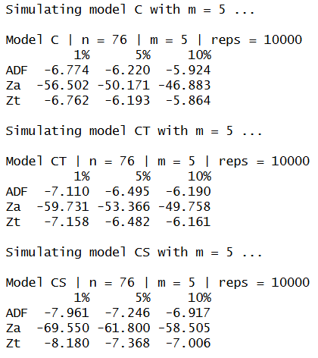
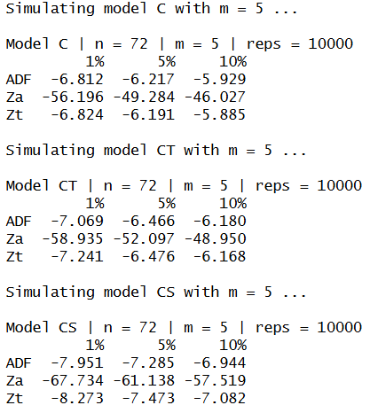
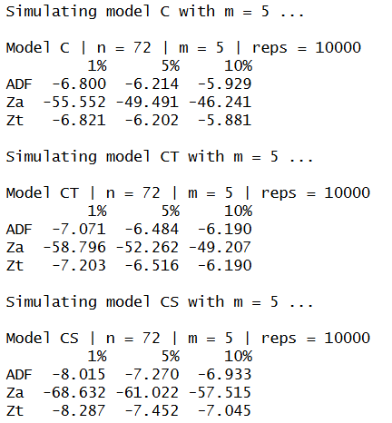
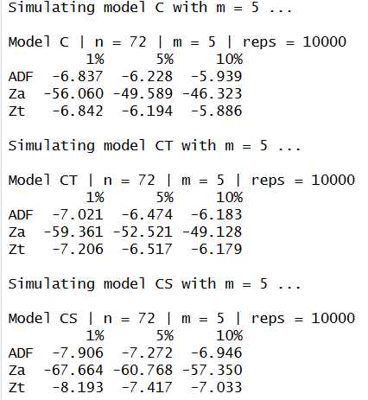

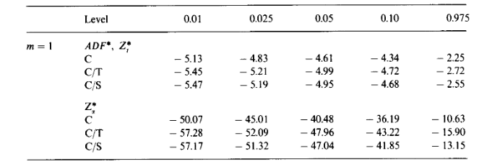
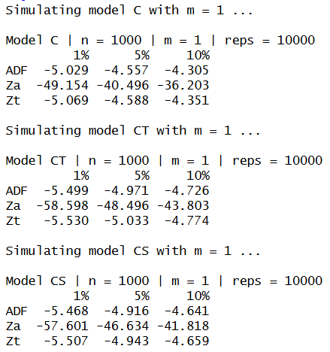
Comparison to the Original Paper

