Our evaluation will involve Table1,Table2,Table3.

Fictional character 1：Bob

Bob is a freshman living in the Midland. He wants to experience social life and earn some money during this summer, so he uses our model to look for a job . He decides to do an offline job, and because of a lack of skill, he hopes the job to be less difficult. Moreover, he doesn’t care about going to a far place to work at all.

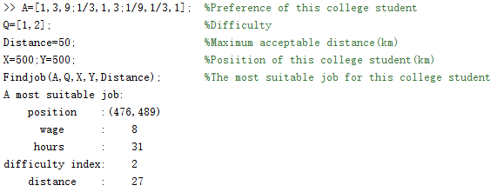

The best job for him: coordinates (476, 489), 8 dollars per hour, 31 hours per week, difficulty index : 2, distance: about 27 km . He may need to drive there.

Analysis: Since he doesn’t care about distance, the model calculates a job that is a bit far from him. Compared to jobs of the same difficulty, this job offers a higher hourly wage and appropriate working hours. It can be considered that Bob's searching result fits his own situation.

Fictional character 2:Tim

Tim is a senior in college, living in the western area. The graduation is coming, he will take this summer to do an internship in his related field. He is a capable college student who wants to do a difficult job, and at the same time, he also wants to make some money for the future, he doesn't mind traveling long to do the job.

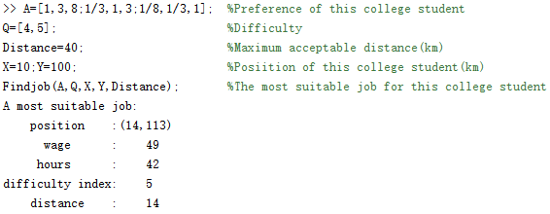

The best job for him: coordinate (14, 113), 49 dollars per hour, 42 hours per week, difficulty level : 5, distance: about 14 km. He may need to ride or drive there.

Analysis: Although he doesn't mind traveling long , the model finds a job close to him——This meets our assumption. Compared to job of the same difficulty index , it pays very well and has appropriate working hours. It can be considered that Tim's searching result fits his own situation.

Fictional character 3: Peter

Peter is a junior , living in the Midland. He is a capable student who wants to try a challenging online job this year and has a lot of time to do this job.

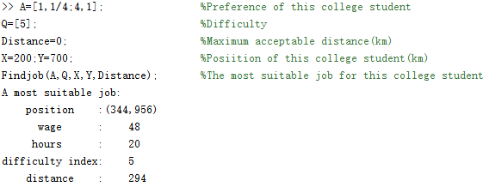

The best job for him: coordinates (344,956), 48dollars per hour, 20 hours per week, difficulty index: 5, distance: about 264 km.

Analysis: Although this job is far away from him, this factor can be ignored because he works online. The hourly wage is quite great and although the working hours are more than jobs of the same difficulty index, it meets Peter's requirement. Peter's search results can be considered to fit his own situation.

Fictional character 4: Pat

Pat is a freshman and lives in the eastern area. She is interested in online jobs and would like to try a job which is not too difficulty , and she has enough time to do it.

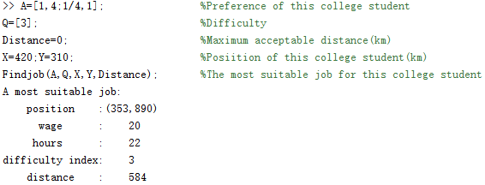

The best job for her: coordinates(353,890), 20dollars per hour, 22 hours per week, difficulty index :3, distance: about 584 km.

Analysis: Although this job is far away from her, the factor can be ignored because she works online. The hourly wage of this job is quite great and the working hours are appropriate compared to jobs of the same difficulty index. Pat's search results can be considered to fit her own situation.

Fictional character 5

White is a sophomore,living in the Central Region.He is looking for a job with moderate difficulty.He hopes it is close to his home and does not require a lot of time.

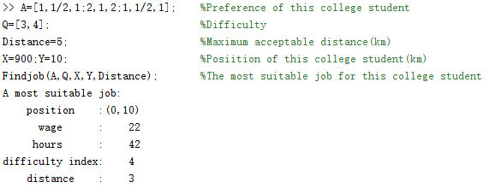

The best job for him: coordinates (0, 10), 22dollars per hour,20 hours per week, difficulty index: 4, distance: about 3 km.He may need to work or ride there.

Analysis.

The job pays a very high hourly wage compared to jobs of the same difficulty index, has appropriate working hours, and generally meets his preferences. Peter's searching result can be considered to fit his own situation.

Fictional character 6.

Alice is a sophomore living in the Central Region who is looking for offline jobs that are moderately difficult and where the hourly wage, hours, and distance are balanced.

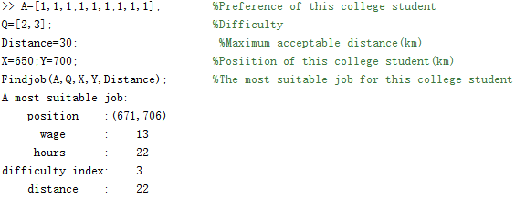

The best job for her: coordinates(671,706), 13dollars per hour, 22 hours per week, difficulty index:3, distance about 22 kilometers .She may need to ride or drive there.

Analysis: This job has a appropriate hourly wage and appropriate working hours compared to jobs of the same difficulty. Alice's search results can be considered to fit her situation.

Fictional character 7.

Jim is a junior in college, lives out west, is in desperate need of money, and doesn't place much value on the distance of his job from home. He's looking for a less difficult offline job.

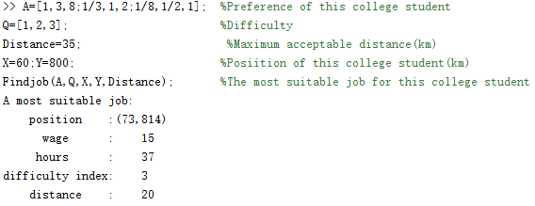

He searches for the best job coordinate (73,814), which pays $15 per hour, works 37 hours per week, has a difficulty level of 3, and is about 20 miles away from his home.

Analysis: Compared to jobs of the same difficulty level, this job pays very good hourly wages, has more hours, and can solve his problem of lack of money. Jim's search results can be considered to fit his own situation. He is advised to drive there.

Fictional character 8:John

John is a freshman living in the eastern part of the country who wants to work an offline job that is not too difficult and wants to make money, but also wants to have enough leisure time that he is not particularly concerned about distance.

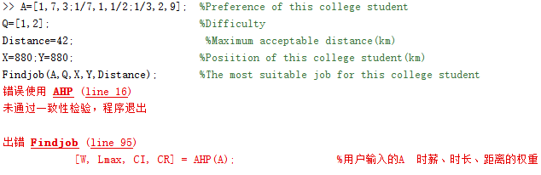

The model shows that it does not pass the consistency test, and John is advised to re-enter the preference matrix.

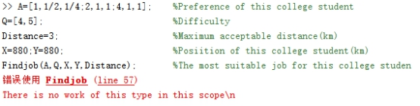

The model shows that There is no work of this type in this scope,an John is advised to re-enter the Distance.

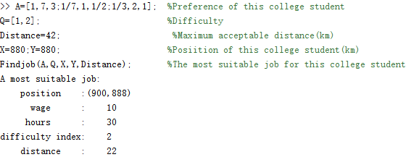

He searches for the optimal job coordinates (900, 888), which pays $10 an hour, works 30 hours a week, has a difficulty level of 2, and is about 22 km away from him.

Analysis: Compared to jobs of the same difficulty, this job pays very good hourly wages and has many more hours. Jim's search results can be considered to fit his situation. It is recommended that he drive or take the train to get there.

Fictional character 9.

Kaki is a senior living in the Midlands who is looking for a more difficult offline job. She wants to work close to home and have enough time for breaks.

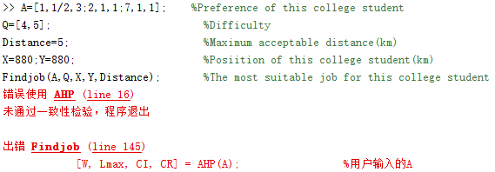

The model shows that it fails the consistency test and suggests that Kaki re-enter the preference matrix.

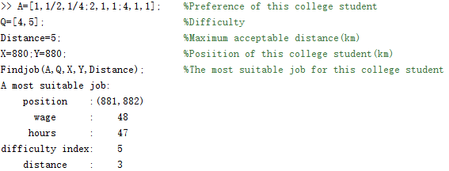

She searches for the optimal job with coordinates (881, 882), an hourly wage of $48, 47 hours per week, a difficulty level of 5, and a distance of about 3 km from her.

Analysis: Compared to jobs of the same difficulty, this job pays very good hourly wages, has fewer hours, and is very close. Kaki's search results can be considered appropriate for her situation. She is advised to walk to it.

Fictional character 10.

Andy is a junior living in the West and is looking for offline jobs that are moderately difficult and where the hourly wage, hours, and distance are balanced.

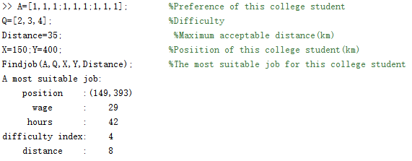

She searches for the best job coordinate (149,393), which pays $29 per hour, works 42 hours per week, has a difficulty level of 4, and is about 10 miles away from her.

Analysis: Compared to jobs of the same difficulty, this job has a moderate hourly wage, moderate hours, and moderate distance, which basically meets her preferences. Andy's search results can be considered appropriate for her situation. She is advised to drive there.