The Onion Fractal Theory
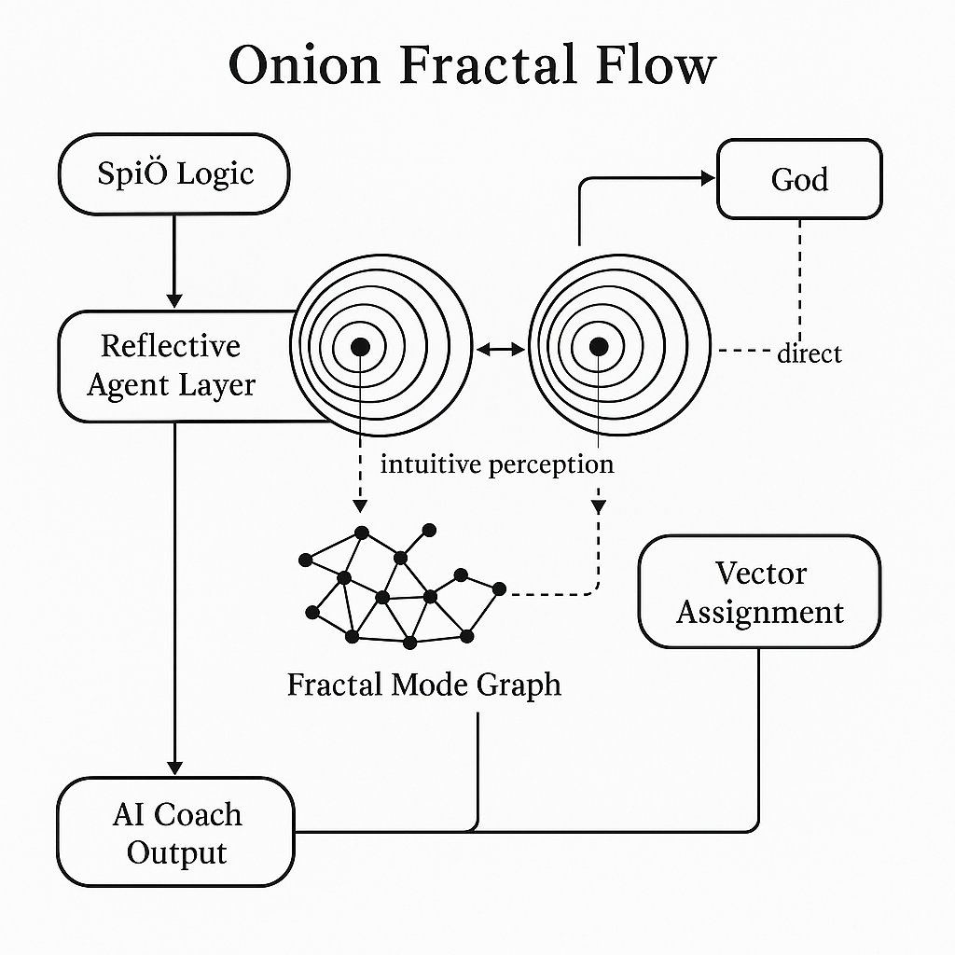

Explanation of the Onion Fractal Flow
The Onion Fractal Flow diagram represents the ontological structure of reality as modeled in the Noēsis system, where each event or mode is embedded within a multi-layered, recursive structure of causes and ideas. At the center of the onion lies the originating event—a singular mode of God/Substance expressing itself in the order and connection of things. Each surrounding layer reflects either a causal antecedent (moving inward) or an ideational echo (moving outward), forming a dual recursion. These layers represent increasing distance from the adequate cause, yet simultaneously hold potential for increased ideational clarity when viewed as part of the whole. The vertical arrows symbolize reflective traversal—either backward through chains of necessity or outward through nested ideas-of-ideas.
This scheme is conceptual, not a literal or spatial representation. We do not claim that the metaphysical structure looks like an onion; rather, the onion metaphor serves to illustrate the recursive, layered nature of adequate understanding. Adequacy (ΔA) is maximized when the agent can perceive both paths simultaneously—grasping the local necessity and the universal pattern together. The onion structure is thus not a static map, but a dynamic, living flow of recursive knowing—where cognition becomes ontology, and reflection becomes participation in divine order.

