CSCI 430 Project 2 Task 1
Login Security and Session Navigation
Group 9 - Muhammad Irfan Younas
Task 1 defines the first panel of the warehouse Multi Panel Interactive System, the separate Security object used for authentication, and the shared logout and quit rules. The manager-operation confirmation panel is handled in Task 4.

Login Panel State
Purpose: Identify the user and send the user to the correct menu after successful authentication.
Displayed information: A choice of Client, Salesclerk, or Manager and fields for username and password.
User interaction: The user selects a role, enters a username and password, and selects Login or Quit.
Processing: UserInterface sends the selected role and credentials to Security.verifyPasswd(role, username, password). The UI does not compare passwords itself.
Successful result: A client goes to Client Menu, a salesclerk goes to Salesclerk Menu, and a manager goes to Manager Menu. SessionContext stores the role and active identity.
Failure result: The panel displays an error, clears the password, and remains in Login Panel. A separate Invalid Login state is not needed because the interaction with the user does not change.
Quit result: The system clears session data and ends the interface session.

Credential Rules
- A client uses the client ID as both username and password. Security also verifies that the client exists.
- A salesclerk uses salesclerk as both username and password.
- A manager uses manager as both username and password.
- Confirmation before each manager operation is handled in Task 4.

State Transition Table
Current state | Event and condition | Action | Next state
Start | Program begins | Create UI and empty session | Login Panel
Login Panel | Valid client credentials | Store client role and client ID | Client Menu
Login Panel | Valid salesclerk credentials | Store salesclerk role | Salesclerk Menu
Login Panel | Valid manager credentials | Store manager role | Manager Menu
Login Panel | Invalid credentials | Show error and clear password | Login Panel
Login Panel | Quit | Clear session and close UI | End
Client Menu | Logout with no delegated role | Clear session | Login Panel
Client Menu | Delegated client logout | Restore prior role | Salesclerk Menu
Salesclerk Menu | Logout with no delegated role | Clear session | Login Panel
Salesclerk Menu | Delegated salesclerk logout | Restore prior role | Manager Menu
Manager Menu | Logout | Clear session | Login Panel
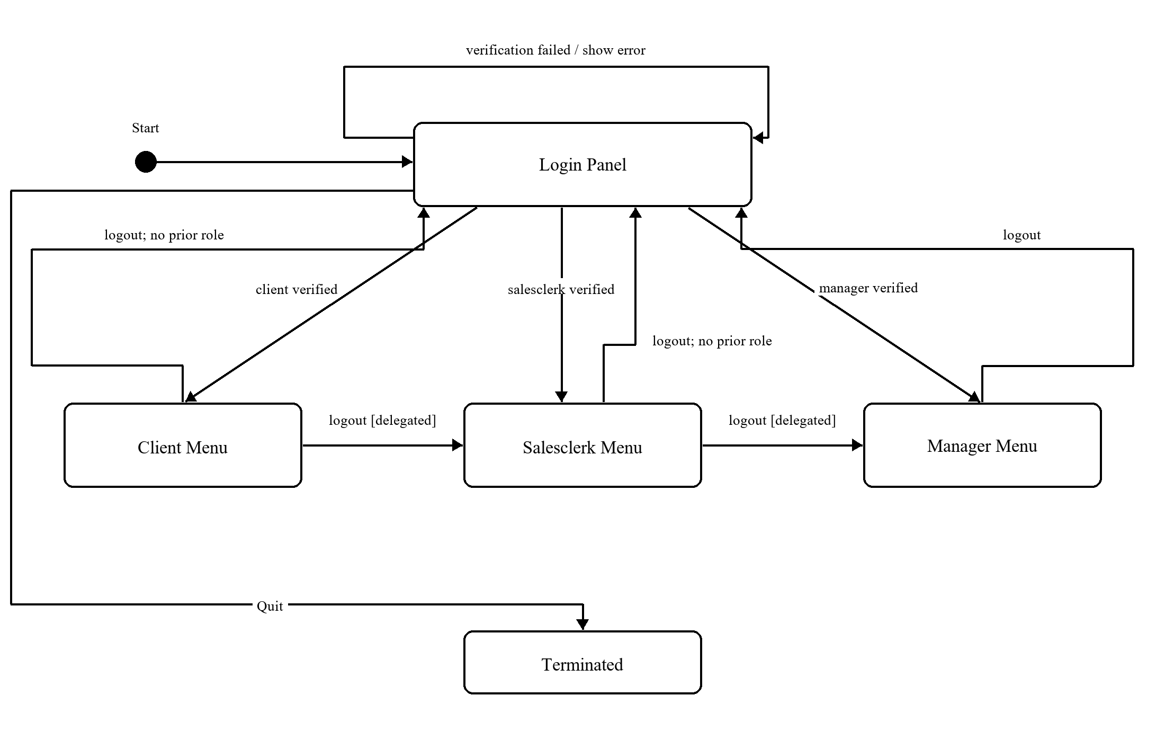
Figure 1. Login and shared navigation FSM fragment

Class Responsibilities
UserInterface: Displays the current panel, collects input, and sends the event and Security result to SessionContext. It displays the panel selected by the context.
Security: Owns verifyPasswd(role, username, password). It checks the fixed manager and salesclerk credentials and verifies a client ID through the warehouse facade.
SessionContext: Stores the current panel, authenticated role, active client ID, and role-return history. It computes the next panel from the current panel, event, and stored information. On delegated logout it restores the previous role; on ordinary logout it clears the session and selects Login Panel. This is the centralized context approach described in Section 8.9.1.
Warehouse and ClientList: Warehouse supplies the facade search used to verify a client. ClientList performs the search because it owns the client collection.

Aspects That Are Not a Pure FSM
The set of panels is finite, but usernames, passwords, client IDs, and stored clients are data with many possible values. Creating one state for every possible value would not be practical. Security checks these values as data and returns a Boolean result that selects the valid-login or invalid-login transition.
The interface must also remember whether a user is temporarily acting as another role. SessionContext stores the original role, active role, active client ID, and a small role stack. The FSM controls panel changes, while ordinary objects and variables hold the changing information.

Shared Back and Logout Rules
Back or Quit within a sub-panel returns to its parent panel without ending the authenticated session. Login Panel has no Back option because it is the entry panel. Its Quit option closes the program. Logout from a role menu returns to Login Panel for a directly logged-in user, or restores the immediately preceding role for delegated access. Panel-return history and role-return history are kept separate so Back does not accidentally log out a user. Tasks 2 through 4 supply the individual sub-panel transitions.
Only one panel is active at a time. Failed login leaves the interface in Login Panel. The guarded logout transitions use mutually exclusive conditions: either a previous delegated role exists or it does not. SessionContext evaluates this condition, so the next panel is unambiguous.

Connections to the Other Tasks
- Task 2 connects Client Menu to the client sub-panels.
- Task 3 connects Salesclerk Menu to salesclerk operations and Become Client.
- Task 4 connects Manager Menu to manager operations, password confirmation, and Become Salesclerk.
- The final group diagram uses Login Panel as the common entry point and follows the logout destinations in the transition table.

