“HELLO” FSM
The final part of the lab focuses on implementing a finite state machine that scrolls the word “HELLO” across six 7-segment displays on the DE1 board. Characters shift from right to left at one-second intervals using a pipeline of six 7-bit registers, each representing one display. The register structure follows the same design principles used in earlier labs. The FSM initially loads the characters “HELLO ” into the pipeline and then loops continuously to maintain the scrolling effect. The following module defines the 7-bit register used in this pipeline.
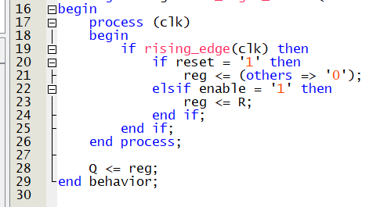
The one_hz_counter module was used to generate a 1 Hz pulse from the 50 MHz clock by counting up to 49,999,999. Once the counter reaches this value, it resets and produces a one cycle pulse on the TC output, which is used to trigger the FSM and pipeline registers every second. The counter also includes a synchronous reset and an enable input. For simulation purposes, the counter value was temporarily reduced to speed up the scrolling and make the waveform easier to observe.
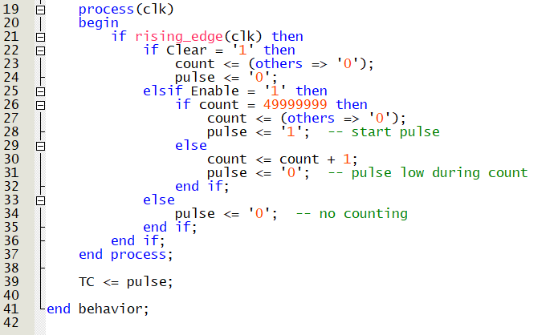
The Hello_FSM module controls the scrolling of the word “HELLO” across the six 7-segment displays on the DE1 board. It uses a state machine that steps through each character—H, E, L, L, O, and a blank space—and then enters a loop state to keep the word moving continuously. A 1 Hz pulse, generated by the one_hz_counter, controls the timing so that the characters shift left once per second. Each character is passed through a pipeline of six seven_bit_registers, with one register per display. After the initial sequence is loaded, the last register's output is fed back into the pipeline to maintain the scrolling effect. The 7-segment encodings for each character are stored as constants and selected based on the FSM state. Each register stage is then connected to one of the six HEX display outputs.
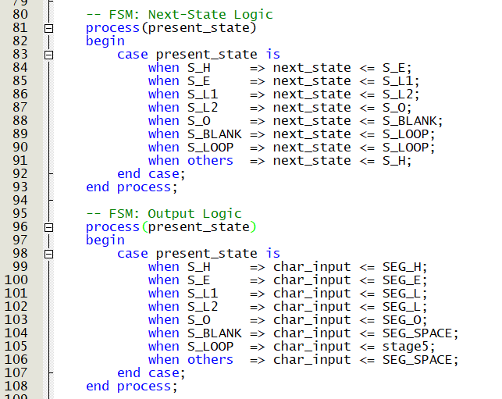
To verify the functionality of the scrolling “HELLO” FSM, a testbench was created to simulate the clock, reset, and output behavior. A 50 MHz clock was generated using a simple process, and an active low reset was applied through KEY(0) for 100 ns before being released. The simulation was run long enough to observe the scrolling effect on the six 7-segment display outputs (HEX0 to HEX5). All outputs were connected to signals for waveform observation, confirming the FSM transitions and character shifting over time. The design was also successfully programmed onto the DE1 board, where the word “HELLO” scrolled smoothly across the displays, matching the expected behavior seen in simulation.
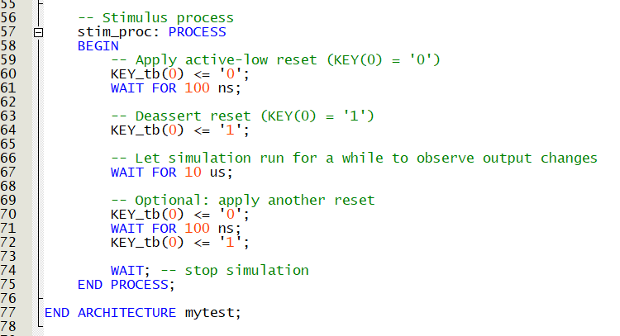
To make the simulation easier to observe, the terminal count in the one_hz_counter was reduced. Instead of counting to 49,999,999 to generate a 1 Hz pulse (as used in actual hardware), the value was changed to 9. This allowed the output pulse to occur more frequently during simulation, making it easier to view the scrolling behavior of the word “HELLO” within a shorter time frame.
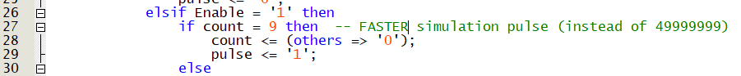

The waveform confirms the correct operation of the HELLO FSM, showing the characters “H”, “E”, “L”, “L”, “O”, and a blank scrolling across HEX0 to HEX5. Each register updates every second, driven by the 1 Hz pulse, and shifts the characters through the pipeline. The FSM transitions and output logic work as expected, with the loop continuing seamlessly after the full word scrolls off the display.as shown in Figure 6.
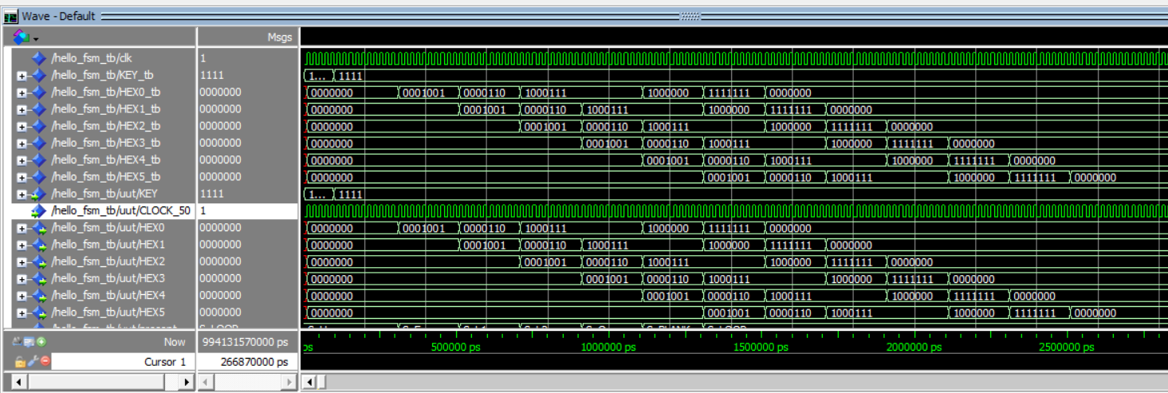
Figure 6. Simulation waveform showing the scrolling "HELLO" pattern across the 7-segment displays.

