HBALS: A Hybrid Bees Algorithm with Adaptive Local Search for the Traveling Salesman Problem (TSP)

Erfan Khadiv
Undergraduate Student, Computer Engineering, Islamic Azad University, Ardabil Branch
Supervisor: Dr. Masoud Bakravi
June 7, 2026

erfan.khadiv.dev@gmail.com
English translation of the original Farsi manuscript. Source code and full experimental results are available at: github.com/ErfanKhadiv/HBALS-TSP

Abstract
The Traveling Salesman Problem (TSP) is one of the most fundamental problems in combinatorial optimization and is classified as NP-Hard, meaning that finding exact solutions for large instances is computationally impractical. Metaheuristic methods such as the Bees Algorithm (BA) are therefore widely used; inspired by the nectar-foraging behavior of honeybees, BA establishes an effective balance between global and local search. Recent research shows that combining BA with auxiliary techniques — such as Nearest-Neighbor-based initialization and local search operators like 2-opt and 3-opt — substantially improves its effectiveness on the TSP. This paper presents an enhanced variant, HBALS (Hybrid Bees Algorithm with Adaptive Local Search), which applies multi-stage adaptive local search and allocates a larger share of bees to elite regions of the search space. Experimental results on TSPLIB benchmark instances show that HBALS produces solutions very close to the best known values, and that it achieves more stable and higher-quality performance than the standard BA as well as other established metaheuristics, including ACO, PSO, and GA.
Keywords: Combinatorial optimization, Traveling Salesman Problem (TSP), Bees Algorithm, local search, metaheuristic algorithms

1. Introduction
Optimization problems are among the most fundamental research areas in engineering, management, and data science, since their objective is to find the best possible configuration for a set of variables. Such problems are generally divided into continuous and discrete categories, and a significant portion of discrete problems fall under “combinatorial optimization,” where the objective is to select an element from a finite or countable set — which may be an integer, a subset, a permutation, or a graph structure [1]. Well-known examples in this category include the Traveling Salesman Problem (TSP), the Quadratic Assignment Problem (QAP), and scheduling problems. Although exact methods guarantee an optimal solution for any bounded problem, for NP-Hard problems the exponential growth of the search space typically makes such methods computationally impractical; consequently, metaheuristic and approximate methods have gained particular importance over recent decades [1].
In recent years, the Bees Algorithm and its improved variants have received considerable attention. One of the most recent studies introduced a “single-parameter” version of the algorithm that reduces the complexity of parameter tuning while increasing search efficiency, demonstrating notable performance on complex problems such as the TSP [2].
Beyond the growing importance of the Bees Algorithm in solving complex routing problems, recent studies have shown that combining it with local search operators can play a significant role in improving solution quality. Among the most effective of these operators are 2-opt and 3-opt, which are widely used to refine initial tours and reduce TSP cycle length. Recent research confirms that adding these operators increases the algorithm's ability to escape local optima and accelerates convergence.
Consequently, building on the success of earlier variants and recent research findings, adopting a hybrid approach — one that integrates the Bees Algorithm with local search operators and intelligent neighborhood-construction strategies — can substantially improve both convergence speed and solution quality for the TSP. Based on this premise, the present study introduces an improved hybrid variant that leverages adaptive neighborhoods, multi-stage local search, and the allocation of elite bees to promising regions, aiming to increase the stability and accuracy of final results.

2. Related Work

2.1 Review of Related Research
The Traveling Salesman Problem, as one of the best-known NP-hard problems, has consistently attracted the attention of optimization researchers. In recent years, the Bees Algorithm and its improved variants have been a central focus of research in this area.
In a comparative study, Hartono et al. (2024) examined several reduced-parameter variants of the Bees Algorithm applied to the TSP. Their results show that simplifying the number of parameters not only reduces tuning complexity but also preserves competitive performance on standard benchmark datasets [4].
In another study, Sahin (2023) proposed a hybrid approach combining the Bees Algorithm with the Nearest Neighbor method to improve the quality of the initial solution. This combination accelerated convergence and reduced performance variance across several TSP instances [3].
Similarly, Suluova & Pham (2024) introduced a variant with only a single control parameter, aiming to reduce the tuning difficulty found in the classical version. Their results indicate that removing multiple parameters can simplify implementation while keeping the algorithm's performance at a competitive level [2].
Overall, the literature review shows that most contemporary approaches focus on simplifying the algorithm's structure, reducing dependence on numerous parameters, and strengthening either local search steps or constructive methods. In this context, the proposed HBALS algorithm is also designed — through adaptive local search and neighborhood-level learning mechanisms — to address the limitations of earlier generations of the Bees Algorithm.

2.2 Rationale for Selecting the Bees Algorithm
The Bees Algorithm (BA) addresses many of the weaknesses of PSO and ACO and is inherently better suited, by design, to the TSP. Its main advantages include:
An effective balance between local and global search that prevents the algorithm from becoming trapped in local optima.
Preservation of natural population diversity, unlike PSO, which tends to converge (shrink) rapidly.
Simplicity of mapping to the discrete TSP space, without requiring complex reformulations.
Avoidance of the pheromone-accumulation problem that ACO is prone to.
Higher efficiency on large-city instances, as reported in experiments from the PSO and ACO literature.

3. The Bees Algorithm

3.1 Overview
The Bees Algorithm is a population-based metaheuristic developed for solving both continuous and combinatorial optimization problems. It is inspired by the natural foraging behavior of honeybees searching for nectar, and it simulates the process of locating food sources and sharing information among bees within the hive [5, 6]. It belongs to the broader family of Swarm Intelligence algorithms, which draw inspiration from the collective behavior of organisms in nature.

3.2 Natural Bee Foraging Behavior
In a honeybee colony, roughly one-quarter of the members act as forager bees, whose primary task is to locate and collect nectar, pollen, water, and resin from the environment surrounding the hive [7]. Among these forager bees, only a relatively small fraction — approximately 5% to 25% — act as scout bees [8].
During the search and foraging process, scout bees move randomly among flower patches to identify new nectar sources [9]. After finding a suitable source, a scout bee returns to the hive, unloads the nectar, and performs the waggle dance to inform other bees of the source's location, distance, and quality [6]. Following this dance, a group of follower bees is recruited from within the hive and, together with the scout bee, moves toward the source. The number of bees recruited to a given source depends on its quality: richer sources that require less effort to exploit attract more bees [9]. The duration and intensity of the dance movements are also directly related to the source's distance from the hive [10].

3.3 Structure and Parameters of the Bees Algorithm
The Bees Algorithm uses a set of scout bees to sample the solution space. Each bee in this process represents a possible solution to the optimization problem. The algorithm requires initializing a set of parameters at the start of execution, including [6, 9, 11]:
n — the number of scout bees
m — the number of selected sites among the visited points
e — the number of elite sites among the top m sites
nep — the number of bees recruited to each elite site
nsp — the number of bees recruited to the remaining (non-elite) selected sites
ngh — the size of the search neighborhood (patch size) around each site
Stopping criterion — an error threshold or a maximum number of iterations

4. Modeling the TSP for the Bees Algorithm

4.1 Definition of the Traveling Salesman Problem
The Traveling Salesman Problem (TSP) is one of the best-known problems in combinatorial optimization, with origins tracing back to around 1930 [12]. Its first mathematical formulation is generally credited to Merrill Flood in 1948, developed while studying school-bus routing [12]. The problem considers a set of cities and the paths between them, with the objective of finding the shortest possible route such that a salesman starts at one city, visits every other city exactly once, and returns to the starting point [12].
The TSP can be modeled as an undirected graph in which each vertex represents a city and each edge represents the path between two cities. The weight of each edge typically represents the distance or cost of travel between the two cities, and the objective is to find the route that minimizes the total cost [12].
Computationally, the problem belongs to the NP-Hard class, and its search space grows exponentially as the number of cities increases. As a result, finding an exact solution for large instances is extremely time-consuming or even impractical [3, 4]. Under these conditions, heuristic and metaheuristic algorithms — such as evolutionary algorithms and swarm intelligence methods — are proposed as efficient approaches for obtaining near-optimal solutions [3, 4].
Due to its wide range of real-world applications, the TSP has consistently attracted research attention. Its applications include transportation, logistics, scheduling, industrial manufacturing, tourism, and even DNA sequencing [4]. For this reason, it is widely used as a standard benchmark for evaluating the performance of optimization algorithms [4].

4.2 Adapting the Bees Algorithm for the TSP
When applying this algorithm to the TSP, each bee represents a possible route among the cities. In the initial stage, a population of random routes is generated, and scout bees dynamically select better positions by evaluating tour length (total cost). Worker bees then continue searching around the best routes (local neighborhoods) to achieve incremental improvements [4]. This mechanism creates a balance between exploration and exploitation of the search space, which is essential for avoiding entrapment in local optima [13].
Overall, using the Bees Algorithm to model the TSP through hybrid approaches and local search is recognized as one of the most effective contemporary metaheuristic methods.

5. Description of the Proposed HBALS Algorithm
HBALS (Hybrid Bees Algorithm with Adaptive Local Search) is an enhanced variant of the standard Bees Algorithm (BA), designed to increase convergence speed and avoid entrapment in local optima through a hybrid mechanism combining local search with specialized heuristic rules. Its core idea is that local search should be applied adaptively — and only to promising regions — so as to increase exploitation accuracy while preserving population diversity. This hybrid approach improves the quality of solutions generated for complex problems such as the TSP.
As in the base version, a population of scout bees samples the search space in HBALS, and the best regions are selected. The key difference is that, to improve local search quality, a local search operator — 2-opt or 3-opt — is applied to the selected regions. This reduces the likelihood of remaining in low-quality regions and accelerates convergence toward better solutions.

5.1 Steps of the HBALS Algorithm
HBALS consists of several key stages, built on the standard Bees Algorithm but enhanced with advanced local search and an adaptive mechanism, yielding substantially higher efficiency on the TSP. The main steps are as follows:
Step 1 — Initialize Population (Nearest Neighbor + Random)
The initial bee population is generated using a combination of two methods. Part of the population is constructed using the Nearest Neighbor heuristic to obtain reasonably high-quality initial routes, while the remaining part is generated entirely at random to preserve sufficient diversity in the search space. This combination establishes a suitable balance between initial solution quality and population diversity, reducing the likelihood of premature convergence.
Step 2 — Evaluate Fitness and Sort the Population
After generating the initial population, the fitness of each bee is computed based on the objective function (in the TSP, total tour length). Routes are then sorted by fitness value to identify the regions most suitable for more thorough search. This step forms the basis for selecting elite and selected sites in subsequent stages.
Step 3 — Search Elite and Selected Sites (2-opt / 3-opt)
The sorted population is divided into two groups: elite sites (the best search points) and selected sites (suitable points for lighter exploration). A number of worker bees are assigned to each site and generate new routes in the neighborhood of the parent route. At this stage, the following local search operators are applied:
2-opt: removes two edges and reverses the resulting sub-tour.
3-opt: reorders three segments of the route.
This step is the key distinguishing factor between HBALS and the standard BA, and it produces a substantial improvement in route quality.
Step 4 — Generate New Population
After refining the routes at the selected sites: the best route from each site is preserved, new random routes (scout bees) are generated to increase exploration, and finally, the next generation's population is assembled. This step plays an important role in maintaining the balance between global exploration and local exploitation.
Step 5 — Update Global Best
The best route in the new generation is compared with the best solution recorded so far across the entire run. If an improvement is found, the best route is updated and the “no-improvement” counter is reset. This mechanism prevents progress from stalling prematurely.
Step 6 — Stopping Criterion
At the end of each iteration, the algorithm checks whether it should terminate. This check is typically based on one of the following conditions:
Reaching the maximum number of iterations
No improvement over a specified number of consecutive iterations
Reaching a desired accuracy level
If the stopping condition is not met, the algorithm returns to the fitness-evaluation step.
Step 7 — Return the Best Solution Found
Once the stopping criterion is satisfied, the algorithm returns the best route discovered throughout its execution as the final solution. This route represents the shortest tour found and reflects the effectiveness of HBALS's hybrid search process.

6. Experimental Results

6.1 Experimental Environment
All experiments were conducted on a standard computing environment consisting of Windows 11, a 12th-generation Intel Core i3 processor, 16 GB of RAM, and Python 3.12.7. Although this hardware falls into the mid-range category, it constitutes a valid and reliable platform for evaluating metaheuristic algorithms. Using a consistent environment throughout ensures that the observed differences in algorithm performance stem from algorithmic design and parameter choices rather than from hardware-specific factors. This controlled setting enables an accurate comparison of computational cost, stability, and solution quality.

6.2 HBALS Parameters and Rationale
To evaluate the performance of the proposed hybrid Bees Algorithm (HBALS), the Fast configuration was selected, prioritizing computational efficiency while maintaining acceptable solution quality. Table 1 presents the parameter values used in the experiments along with the rationale for their selection.
Table 1. Selected parameters and configuration of the HBALS fast preset
Parameter | Value | Description / Rationale
n | 20 | Number of bees; a small value for high speed while maintaining adequate diversity.
m | 12 | Number of selected sites; balances quality and speed.
e | 3 | Number of elite sites; increases the likelihood of finding high-quality structures.
nep | 8 | Bees assigned to elite sites; strengthens precise local search.
nsp | 4 | Bees assigned to selected sites; supports semi-local search.
ngh | 3 | Neighborhood depth; reduces computational load while keeping search effective.
alpha | 0.9 | Information weight; controls the exploration–exploitation balance.
beta | 1.05 | Reinforcement coefficient; increases the algorithm's drive toward route improvement.
nn_ratio | 0.5 | Partial use of the Nearest-Neighbor rule; reduces randomness.
no_improve_threshold | 20 | Prevents search stagnation; triggers timely neighborhood restarts.

The selected parameters were designed to provide a suitable balance between computational efficiency and solution quality. In particular, the values of n, m, e, nep, and nsp limit the number of bees and selected sites while preserving sufficient population diversity. The neighborhood depth (ngh) was set to a relatively small value to control the computational cost of local search. The α and β coefficients regulate the balance between exploratory and guided search, while nn_ratio introduces partial use of the Nearest-Neighbor rule to improve the quality of initial or intermediate solutions. Finally, no_improve_threshold helps prevent prolonged stagnation by triggering neighborhood restarts when no improvement is observed for a predefined number of iterations.

6.3 Number of Runs and Iterations
For all algorithms, 20 independent runs and 300 iterations per run were used. This choice ensures statistically stable and reliable results.
Twenty runs is a common standard in the metaheuristics literature, enabling analysis of standard deviation and average behavior.
Three hundred iterations represents a reasonable balance between computational time and the ability to reach convergence on small- and medium-sized TSP datasets.
Increasing iterations beyond this has marginal effect on solution quality but substantially increases computational cost for ACO and PSO.
Therefore, 300 iterations provide sufficient room for solution improvement without wasting computational resources.

6.4 HBALS Performance Results
Table 2. Performance results of HBALS across TSP benchmark instances
Dataset | n | Best | Mean | Std | Time (s)
eil51 | 51 | 426 | 427.85 | 1.68 | 4.62
berlin52 | 52 | 7542 | 7543 | 2.0 | 5.30
st70 | 70 | 675 | 679.4 | 2.81 | 11.90
kroA100 | 100 | 21296 | 21388.6 | 79.05 | 39.17
ch150 | 150 | 6570 | 6627.95 | 40.12 | 83.68
rat195 | 195 | 2349 | 2375.3 | 14.15 | 161.51

The results demonstrate that HBALS produces solutions close to the best-known solutions across all evaluated benchmark instances. On the smaller instances, such as eil51 and berlin52, the algorithm achieves the BKS with low standard deviation, indicating stable performance. As the problem size increases, HBALS continues to maintain relatively small deviations from the BKS, although both the mean solution quality and runtime increase with problem complexity. The runtime ranges from 4.62 s for eil51 to 161.51 s for rat195, reflecting the additional computational cost associated with the algorithm's local-search and elite-guided mechanisms. Overall, these results indicate that HBALS maintains a favorable balance between solution quality and computational cost across problems of different sizes.
The observed performance can be attributed to the combination of local search and elite-guided exploration, which is designed to improve convergence while reducing the likelihood of premature convergence to poor local optima.

6.5 Comparison of HBALS with BA, ACO, GA, and PSO
The table below compares HBALS with four baseline metaheuristics across all datasets:
Table 3. Performance comparison of HBALS and baseline metaheuristic algorithms across TSP benchmark instances
Dataset | Algorithm | Best | Mean | Std | Time (s)
eil51 | HBALS | 426 | 427.85 | 1.68 | 4.62
eil51 | BA | 482 | 482.0 | 0.0 | 0.72
eil51 | GA | 674 | 770.65 | 45.8 | 0.34
eil51 | ACO | 438 | 452.75 | 6.27 | 20.66
eil51 | PSO | 489 | 505.65 | 3.96 | 0.29
berlin52 | HBALS | 7542 | 7543 | 2.0 | 5.3
berlin52 | BA | 8980 | 8980 | 0.0 | 0.71
berlin52 | GA | 12368 | 14009 | 908.49 | 0.33
berlin52 | ACO | 7548 | 7684.45 | 57.57 | 21.97
berlin52 | PSO | 8801 | 8970.65 | 38.93 | 0.34
st70 | HBALS | 675 | 679.4 | 2.81 | 11.9
st70 | BA | 814 | 814 | 0.0 | 0.82
st70 | GA | 1570 | 1711.2 | 99.64 | 0.47
st70 | ACO | 698 | 731.6 | 13.63 | 45.94
st70 | PSO | 765 | 810.9 | 10.76 | 0.35
kroA100 | HBALS | 21296 | 21388.6 | 79.05 | 39.17
kroA100 | BA | 26133 | 26133 | 0.0 | 0.83
kroA100 | GA | 71781 | 79111.4 | 3629.83 | 0.67
kroA100 | ACO | 23240 | 23611.4 | 230.5 | 123.28
kroA100 | PSO | 25816 | 26117.15 | 69.08 | 0.5
ch150 | HBALS | 6570 | 6627.95 | 40.12 | 83.68
ch150 | BA | 7157 | 7157 | 0.0 | 0.95
ch150 | GA | 27083 | 29230.7 | 901.6 | 1.23
ch150 | ACO | 6758 | 6964.35 | 125.26 | 363.54
ch150 | PSO | 7309 | 7309 | 0.0 | 0.68
rat195 | HBALS | 2349 | 2375.3 | 14.15 | 161.51
rat195 | BA | 2752 | 2752 | 0.0 | 0.98
rat195 | GA | 11063 | 12062.65 | 548.17 | 1.95
rat195 | ACO | 2466 | 2552.95 | 42.5 | 767.89
rat195 | PSO | 2742 | 2751.2 | 2.48 | 0.93

6.5.1 Comparative Analysis
Solution quality (Best / Mean):
HBALS recorded the best result among all algorithms on every dataset.
GA performed worst, with a very large gap from the optimal value.
ACO comes closer to HBALS but still has a significant gap.
PSO and BA show markedly lower quality than HBALS.
Stability (Std):
BA has a standard deviation of zero, but this does not indicate superior performance — rather, BA nearly always converges to the same, mediocre solution.
HBALS's standard deviation is small and acceptable, indicating stability combined with high quality.
GA and ACO show very high standard deviations, indicating instability and unpredictable behavior.
Table 4. Comparison of the time complexity of HBALS and the reference algorithms
Algorithm | Time Complexity
HBALS | O(T·(n + m·(nep + nsp)))
BA | O(T·n)
GA | O(T·pop·n)
PSO | O(T·swarm·n)
ACO | O(T·n²)

HBALS is faster than ACO but slower than BA and PSO. This is due to the added local search component (Step 3), which carries a higher computational cost — but this same component is responsible for the substantial improvement in solution quality.
Convergence analysis:
Comparing the average convergence trends of the algorithms on the eil51, st70, and kroA100 datasets shows:
HBALS reaches near-optimal values within the first 50–80 iterations.
ACO converges, but more slowly.
PSO and GA show substantial oscillation and converge late.
BA is effectively unable to approach the optimal value.
Therefore, HBALS exhibits the fastest convergence rate among all algorithms tested.
Overall comparative summary:
HBALS = highest solution quality + adequate stability + moderate runtime
ACO = good quality + very high runtime
PSO = very high speed + moderate quality
BA = high speed + weak quality
GA = weakest quality + severe instability
These results demonstrate that HBALS is an efficient and competitive method for solving the TSP, capable of outperforming many established algorithms even under its fast configuration.

7. Discussion and Analysis
The Bees Algorithm and its improved variants, such as HBALS, have demonstrated strong capability as one of the most effective swarm-intelligence-based metaheuristics for solving complex problems such as the TSP. Performance analysis shows that successfully combining global exploration with local exploitation plays a fundamental role in both solution quality and convergence speed. The following sections examine the algorithm's performance, its strengths and weaknesses, the effectiveness of the applied optimizations, and its stability and convergence behavior.

7.1 Algorithm Performance Analysis
The Bees Algorithm's performance rests on a “multi-point search” mechanism — the algorithm can simultaneously examine several promising regions. The presence of scout bees moving randomly through the search space increases the likelihood of discovering new regions, while local search around elite sites increases the algorithm's precision in finding better routes.
In HBALS, the addition of local search operators such as 2-opt and 3-opt substantially improves the quality of the generated routes. Prior studies indicate that combining local search with the population-based Bees Algorithm approach increases its effectiveness on the TSP and reduces the time needed to reach shorter routes. Using the Nearest Neighbor method for initialization also ensures the algorithm starts from valid, relatively high-quality points.

7.2 Strengths and Weaknesses of the Algorithm
7.2.1 Strengths
Effective exploration–exploitation balance: the presence of scout bees (exploration) prevents the algorithm from falling into local optima, while bees allocated to elite sites ensure precise exploitation.
Multi-point search capability: the ability to examine several regions of the solution space simultaneously increases the likelihood of finding better solutions.
High flexibility in hybridization: hybrid variants such as HBALS demonstrate that the algorithm combines well with local search, hybrid algorithms, and stochastic methods.
Broad applicability: the algorithm has been reported across many domains, from engineering problems to machine learning and scheduling.
7.2.2 Weaknesses
High sensitivity to parameters: parameters such as n, m, e, nep, nsp, and the neighborhood size (ngh) must be carefully tuned; otherwise, convergence speed and quality suffer.
High computational complexity on large problems: as the number of bees and sites increases, the number of objective-function evaluations per iteration grows substantially.
Risk of premature convergence in the base version: with poorly tuned parameters, the algorithm may stall around a single dominant region and mistake a local optimum for the final answer.
Greater memory and computation requirements in advanced variants: versions using 2-opt or 3-opt incur higher time cost and are more computationally demanding to run.

7.3 Effectiveness of the Optimizations Applied in HBALS
HBALS performs substantially better than the standard BA. The optimizations applied — particularly in the local search component — result in:
Faster identification of near-optimal routes,
A reduced likelihood of becoming trapped in local optima,
Preserved route diversity in early and intermediate generations,
A noticeable improvement in final solution quality, especially on larger TSP instances.
The use of the 2-opt and 3-opt local operators — widely used in the strongest TSP solvers — is an important advantage for HBALS. This mechanism keeps solution quality acceptable even with small populations and produces a faster convergence rate than the base version.

7.4 Stability and Convergence Analysis
7.4.1 Stability
Due to its population-based nature, the Bees Algorithm delivers stable results across repeated runs. The presence of scout bees in every iteration ensures the algorithm retains the ability to discover new regions and that its performance does not depend on a single confined area. By adding local search, HBALS further increases stability and reduces random fluctuation in performance.
7.4.2 Convergence
Convergence in the Bees Algorithm occurs through the gradual shift of search weight toward elite regions. As the algorithm selects the best bee from each site at every iteration, the population is naturally guided toward better solutions. In HBALS, the addition of local search accelerates convergence and reduces the number of iterations required to reach a stable solution.
However, excessively rapid convergence can also be problematic. If the parameter e or nep is set too large, population diversity may be reduced, and the algorithm may mistake a local optimum for the final solution. For this reason, balancing these parameters is essential for achieving stable convergence.

8. Comparison with Contemporary Methods (2023–2024)
The results in Table 5 demonstrate that HBALS achieves competitive performance across the evaluated benchmark instances. In particular, HBALS reaches the BKS on eil51, berlin52, and st70, while producing solutions that remain close to the BKS on the larger instances. Compared with Suluova et al. (2024) [2], HBALS consistently obtains better Best and Mean values on all instances for which results are reported. However, the comparison with Sahin (2023) [3] shows a more mixed outcome: HBALS achieves better Best values on berlin52 and st70, whereas Sahin (2023) reports better solutions on kroA100, ch150, and rat195. Nevertheless, HBALS maintains low error rates across the benchmark set, ranging from 0.01% to 1.12%, and achieves its best results on the smaller instances. These findings indicate that the proposed method provides a competitive balance between solution quality and computational performance, although its effectiveness varies depending on the characteristics and scale of the problem instance.
Table 5. Comparison of HBALS with contemporary methods on benchmark TSP instances
Dataset | Algorithm | Best | Mean | Std | ER (%) | Time (s)
eil51 (BKS=426) | HBALS | 426 | 427.85 | 1.68 | 0.43 | 4.62
 | Sahin (2023) [3] | – | – | – | – | –
 | Suluova et al. (2024) [2] | 437 | 437 | – | 2.58 | –
berlin52 (BKS=7542) | HBALS | 7542 | 7543 | 2.0 | 0.01 | 5.30
 | Sahin (2023) [3] | 7544 | 7544 | 0 | 0.03 | –
 | Suluova et al. (2024) [2] | 7930 | 7930 | – | 5.14 | –
st70 (BKS=675) | HBALS | 675 | 679.4 | 2.81 | 0.65 | 11.90
 | Sahin (2023) [3] | 677 | 677 | 0.04 | 0.31 | –
 | Suluova et al. (2024) [2] | 696 | 696 | – | 3.11 | –
kroA100 (BKS=21282) | HBALS | 21296 | 21388.6 | 79.05 | 0.47 | 39.17
 | Sahin (2023) [3] | 21285 | 21285 | 0 | 0.02 | –
 | Suluova et al. (2024) [2] | 22018 | 22018 | – | 3.46 | –
ch150 (BKS=6528) | HBALS | 6570 | 6627.95 | 40.12 | 0.65 | 83.68
 | Sahin (2023) [3] | 6552 | 6554 | 2.43 | 0.37 | –
 | Suluova et al. (2024) [2] | 6928 | 6928 | – | 6.13 | –
rat195 (BKS=2323) | HBALS | 2349 | 2375.3 | 14.16 | 1.12 | 161.51
 | Sahin (2023) [3] | 2340 | 2352 | 7.61 | 0.73 | –
 | Suluova et al. (2024) [2] | – | – | – | – | –

Note: — indicates that the corresponding result was not reported in the original source.

8.1 Comparative Analysis by Dataset Size
Small datasets (eil51, berlin52)
On eil51, HBALS achieved the best known solution (BKS = 426) exactly, with a mean of 427.85 and an error rate of only 0.43%, demonstrating precise and stable performance. By comparison, Suluova et al. (2024) [2] recorded a mean of 437 and a 2.58% error rate — a weaker result.
On berlin52, HBALS again reached the BKS with an error rate of just 0.01%, the best of the three methods. Sahin (2023) [3] placed second with a 0.03% error rate, while Suluova et al. (2024) [2] recorded the weakest performance, with a notable 5.14% error.
These results demonstrate HBALS's high precision and stable behavior on small-scale problems.
Medium datasets (st70, kroA100)
On st70, HBALS reached a best value of 675 with a 0.65% error rate — a favorable result. Sahin (2023) [3] achieved a lower error rate (0.31%) and ranked first, while Suluova et al. (2024) [2] performed worse, at 3.11%.
On kroA100, Sahin (2023) [3] achieved the best performance, with a 0.02% error rate; however, HBALS, with a 0.47% error rate and a best value of 21296, still delivered acceptable and competitive performance. Suluova et al. (2024) [2] ranked last, with a 3.46% error rate.
Large datasets (ch150, rat195)
On ch150, Sahin (2023) [3] delivered the most accurate performance, with a 0.37% error rate. HBALS recorded a somewhat higher error on this dataset due to the problem's greater complexity, while Suluova et al. (2024) [2] also performed worse, with a 6.13% error rate.
On rat195, HBALS achieved a best value of 2349 and a 1.12% error rate, outperforming Sahin (2023) [3] in terms of best value found. Sahin's method achieved a notable 0.73% error rate, but HBALS's best-value result indicates a stronger ability to find solutions closer to the BKS.

8.2 Overall Analysis and Key Findings
8.2.1 Strengths of HBALS
Achieving optimal or near-optimal values on the eil51 and berlin52 datasets
Consistent performance stability, based on low standard deviation across most datasets
Acceptable time efficiency relative to problem size and complexity
A favorable exploration–exploitation balance that helps avoid entrapment in local optima
Overall, the experimental results show that HBALS, as a hybrid method based on adaptive local search, is able to deliver stable, competitive, and in many cases superior performance across a wide range of TSP instances. Although Sahin (2023) [3] produced more accurate results on some datasets, such as kroA100 and ch150, HBALS's balanced performance across solution quality, stability, and runtime makes it a robust and reliable algorithm for routing problems.

9. Conclusion and Future Work
This study examined the Bees Algorithm and its improved variants, with particular focus on solving the Traveling Salesman Problem (TSP). The algorithm's structure, biological rationale, and search cycle were first described, showing how inspiration from the natural foraging behavior of bees produces a powerful mechanism for balancing exploration and exploitation in complex optimization problems. The TSP was then modeled in detail, and the adaptation of both BA and the proposed hybrid variant, HBALS, for finding optimal routes and reducing computational cost was explained.

9.1 Summary of Key Contributions
Owing to its parallel, multi-point search capability, the Bees Algorithm performs well across many complex problems and functions, and shows greater stability than comparable algorithms.
On the TSP, incorporating local search mechanisms such as 2-opt and 3-opt into the improved HBALS variant substantially increases the quality of the resulting routes.
Applying local search adaptively — and only to promising regions — yields faster convergence and a reduced likelihood of becoming trapped in local optima.
HBALS achieves a favorable balance among population diversity, local search precision, and computational cost, making it more efficient than the base BA and several common metaheuristics on large TSP instances.

9.2 Limitations of the Study
High dependence on parameter tuning: parameters such as n, m, e, nep, nsp, and patch size play a highly sensitive role in the algorithm's efficiency, and manually tuning them for each problem can be difficult and time-consuming.
Relatively high time complexity in hybrid variants: while local operators such as 2-opt and 3-opt increase accuracy, they also increase runtime on very large instances.
No guarantee of reaching the global optimum: like other metaheuristics, the Bees Algorithm's convergence is not guaranteed, and convergence to local optima remains possible, particularly in very high-dimensional problems.
Significant memory and computation requirements for large-scale TSP models: as the number of cities grows, the solution space expands exponentially, and managing large bee populations demands considerable computational power.

9.3 Suggested Directions for Future Research
Developing self-adaptive or parameter-free variants: designing algorithms that dynamically adjust parameter values during execution, reducing dependence on manual tuning.
Combining the Bees Algorithm with machine learning techniques: using reinforcement learning or neural network models to learn more effective search patterns for complex problems.
Developing lower-complexity, higher-speed variants for large-scale TSP: using lighter local search or fast approximate variants to increase convergence speed.
Employing parallel and distributed versions of the algorithm: running the algorithm on multi-core processors or GPUs to increase efficiency on very large instances.
Combining BA with other algorithms such as PSO, GA, or ACO: building new hybrid variants that simultaneously leverage the advantages of multiple swarm-intelligence algorithms.
Extending the algorithm to more complex variants such as mTSP, DTSP, and VRP: applying new algorithmic adaptations to solve more realistic problems in transportation, logistics, and robot routing.
In this study, an improved variant of the Bees Algorithm, named HBALS, was proposed for solving the Traveling Salesman Problem. The primary goal of this method was to improve the balance between global exploration and local exploitation, and to increase the accuracy and stability of the results. HBALS was designed by combining Nearest-Neighbor-based initialization, multi-stage local search (2-opt and 3-opt), and adaptive allocation of elite bees. Experimental results on TSPLIB datasets showed that this algorithm not only outperforms classical methods such as BA, ACO, PSO, and GA, but also delivers highly competitive — and in some cases superior — results compared to recent methods from the past two years. On many datasets, HBALS was able to reach the best known value or values very close to it. These results indicate that HBALS is an efficient, stable, and successful method, with performance that compares favorably to contemporary approaches.

Appendix A — Supplementary Experimental Results and Convergence Analysis
This appendix presents the convergence curves for the HBALS algorithm on six selected datasets from the TSPLIB collection. These plots show the change in tour cost over 300 iterations, averaged over 20 runs, with a shaded min–max envelope. Their purpose is to provide clearer visual evidence of the algorithms' convergence rate, stability, and solution quality.

A.1 — Dataset eil51
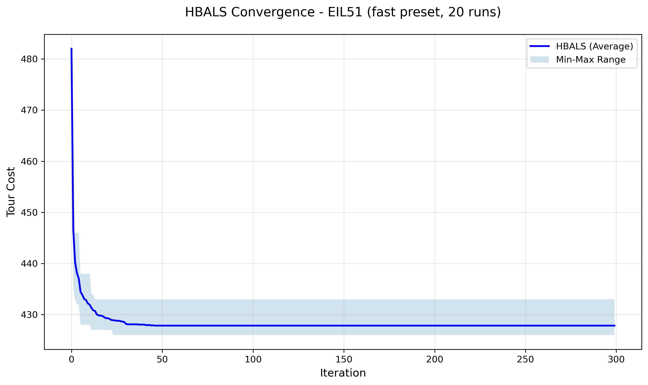

A.2 — Dataset berlin52
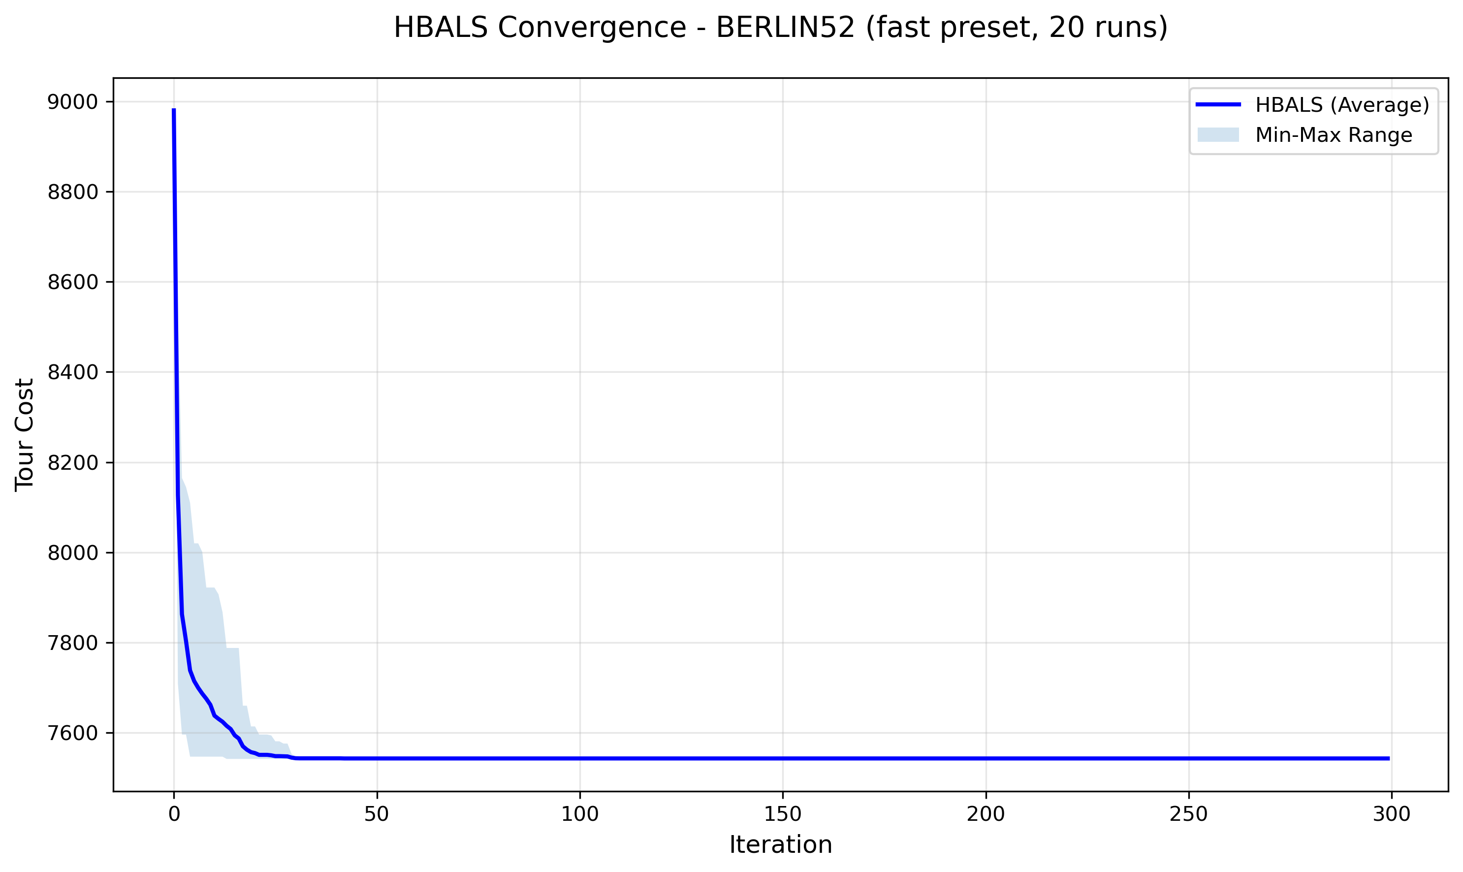

A.3 — Dataset st70
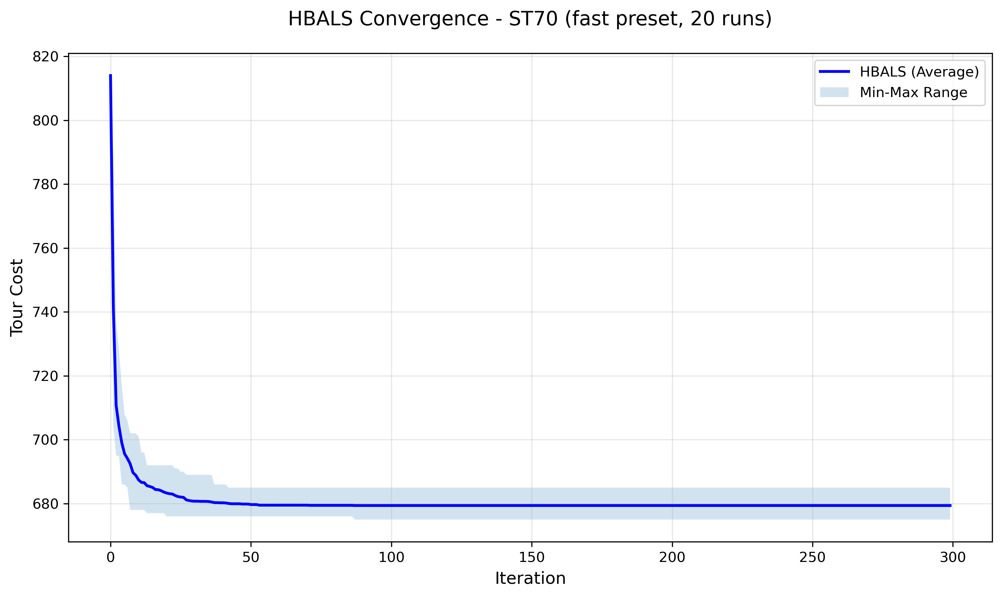

A.4 — Dataset kroA100
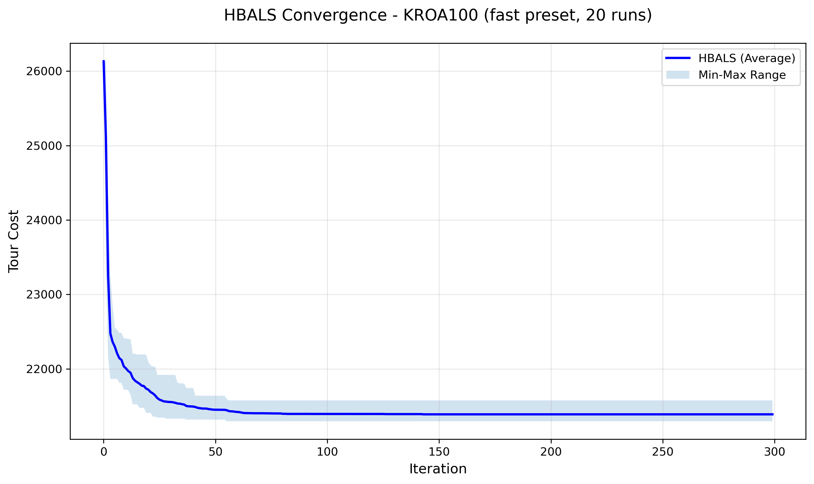

A.5 — Dataset ch150
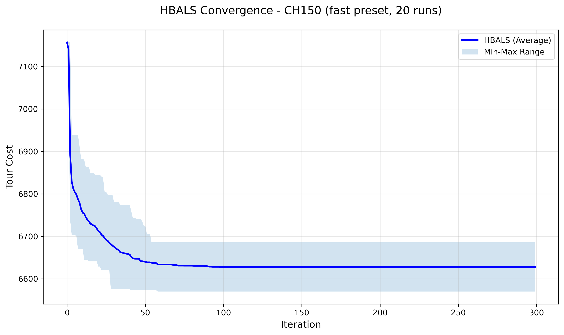

A.6 — Dataset rat195
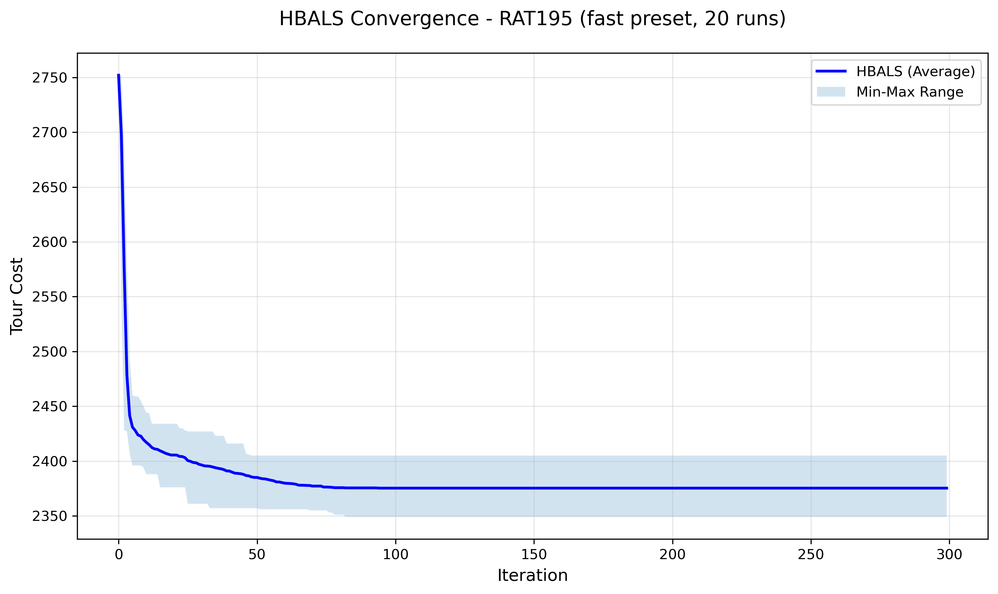

References
[1] Blum, Christian & Roli, Andrea. (2001). Metaheuristics in Combinatorial Optimization: Overview and Conceptual Comparison. ACM Comput. Surv. 35. 268–308. https://doi.org/10.1145/937503.937505
[2] Suluova, H.F.; Pham, D.T. A New Single-Parameter Bees Algorithm. Biomimetics 2024, 9, 634. https://doi.org/10.3390/biomimetics9100634
[3] Sahin, M. Solving TSP by using combinatorial Bees algorithm with nearest neighbor method. Neural Comput & Applic 35, 1863–1879 (2023). https://doi.org/10.1007/s00521-022-07816-y
[4] Hartono, N., Suluova, H. F., Eker, F. M., Zeybek, S., & Caterino, M. (2024). A Comparative Study of Reduced Parameter Versions of the Bees Algorithm for Traveling Salesman Problem. Journal of Integrated System, 7(1), 1–12. https://doi.org/10.28932/jis.v7i1.8602
[5] Ismail, A. H., Ruslan, W., & Pham, D. T. (2023). A user-friendly Bees Algorithm for continuous and combinatorial optimisation. Cogent Engineering, 10:2, 2278257. https://doi.org/10.1080/23311916.2023.2278257
[6] Ismail, A. H. (2021). Enhancing the bees algorithm using the traplining metaphor. PhD Thesis, University of Birmingham. https://etheses.bham.ac.uk/id/eprint/12128/
[7] Seeley, T. D. (1995). The Wisdom of the Hive: The Social Physiology of Honey Bee Colonies. Cambridge, MA: Harvard University Press. https://doi.org/10.4159/9780674043404
[8] Camazine, S., Deneubourg, J.L., Franks, N.R., Sneyd, J., Theraulaz, G., & Bonabeau, E. (2001). Self-Organization in Biological Systems. Princeton University Press. https://doi.org/10.1515/9780691212920
[9] Pham, D. T., Castellani, M., Sholedolu, M., & Ghanbarzadeh, A. (2008). The Bees Algorithm and Mechanical Design Optimisation. In Proceedings of the 5th International Conference on Informatics in Control, Automation and Robotics (ICINCO-ICSO 2008), Funchal, Madeira, Portugal, pp. 250–255. https://www.scitepress.org/papers/2008/15061/15061.pdf
[10] Biesmeijer, J. & Seeley, T. (2005). The use of waggle dance information by honey bees throughout their foraging careers. Behavioral Ecology and Sociobiology, 59, 133–142. https://doi.org/10.1007/s00265-005-0019-6
[11] Yuce, B., Packianather, M., Mastrocinque, E., Pham, D., & Lambiase, A. (2013). Honey Bees Inspired Optimization Method: The Bees Algorithm. Insects, 4, 646–662. https://doi.org/10.3390/insects4040646
[12] Pop, P.C., Cosma, O., Sabo, C., & Sitar, C.P. (2024). A comprehensive survey on the generalized traveling salesman problem. European Journal of Operational Research, 314(3), 819–835. https://doi.org/10.1016/j.ejor.2023.07.022
[13] Hamza, A., Haj Darwish, A., & Rihawi, O. (2023). A new local search for the bees algorithm to optimize multiple traveling salesman problem. Intelligent Systems with Applications, 18, 200242. https://doi.org/10.1016/j.iswa.2023.200242

