Data Transmission via Li-Fi (Light Fidelity) Technology

Erfan Khadiv
Undergraduate Student, Computer Engineering, Islamic Azad University, Ardabil Branch
Supervisor: Dr. Masoud Bekravi
Academic Year 2025
erfan.khadiv.dev@gmail.com
Prepared as a research report for the " Research method and presentation" course.
Full text and figures: github.com/ErfanKhadiv/LiFi-Report

Abstract
In today's world, wireless connections play a vital role in daily life. Technologies such as Wi-Fi and Bluetooth have become an inseparable part of how people communicate and access information. However, as technology continues to advance, the need for safer, faster, and more efficient alternatives is increasingly evident. Li-Fi (Light Fidelity) is one such emerging wireless communication technology, operating on the principle of data transmission through light. Introduced in the early 21st century by German engineer Harald Haas, Li-Fi transmits data by modulating the light output of an LED lamp at speeds imperceptible to the human eye. The technology holds considerable potential to complement Wi-Fi and, in some contexts, to replace it, offering numerous advantages for the future of wireless communication. This report examines the operating principles of Li-Fi, its advantages and limitations, and its potential impact on the future of wireless networking.
Keywords: Li-Fi, Light Fidelity, Wireless Networks, Visible Light Communication, Wireless Data Transfer

1. Introduction
Professor Harald Haas is a distinguished engineer and researcher in the field of wireless communications. A professor at the University of Edinburgh, Scotland, he is widely credited with introducing Li-Fi technology. In 2011, at a TED conference, Haas presented the concept of Li-Fi to the world for the first time [1]. He demonstrated that visible light could be used to transmit data, showing that LED lamps could serve not only for illumination but also as the basis for high-speed wireless networks.
Haas is also the founder and CEO of pureLiFi, one of the leading companies in the development and commercialization of Li-Fi technology. Li-Fi can be thought of as Wi-Fi based on light rather than radio waves: instead of using radio-frequency signals to transmit data, it uses visible light.
Li-Fi addresses several limitations of Wi-Fi, including:
- Capacity: The frequency bands used by Wi-Fi for data transmission are limited. Despite significant advances with Wi-Fi 6 and Wi-Fi 7 in recent years, infrastructure constraints and the need for powerful, costly processors to support them remain a persistent challenge [2].
- Energy consumption: Because Wi-Fi radiates in all directions, continuous router power draw and the energy demands of connected devices result in considerable consumption and a larger environmental footprint.
- Accessibility: Radio waves cannot be used freely in every setting; for example, Wi-Fi use is heavily restricted on aircraft, in nuclear power plants, and in hospitals [1].
- Security: Radio signals pass through walls and can be intercepted outside the intended coverage area, so Wi-Fi security depends on encryption and on continual software and firmware updates, which older devices may not receive.

2. Structure of Li-Fi Technology
In a Li-Fi system, optical signals are converted into Ethernet-compatible electrical signals, which are then encoded into switching signals. These switching signals are sent to a high-speed LED driver. The lamp used in this technology houses an LED engineered with signal-processing circuitry, which transmits modulated light to a photodetector. The detector converts the resulting amplitude variations back into electrical signals, and a control unit then converts these electrical signals into a data stream, delivering the final information to a computer or mobile device [3]. Figure 1 illustrates the operating architecture of a Li-Fi system.
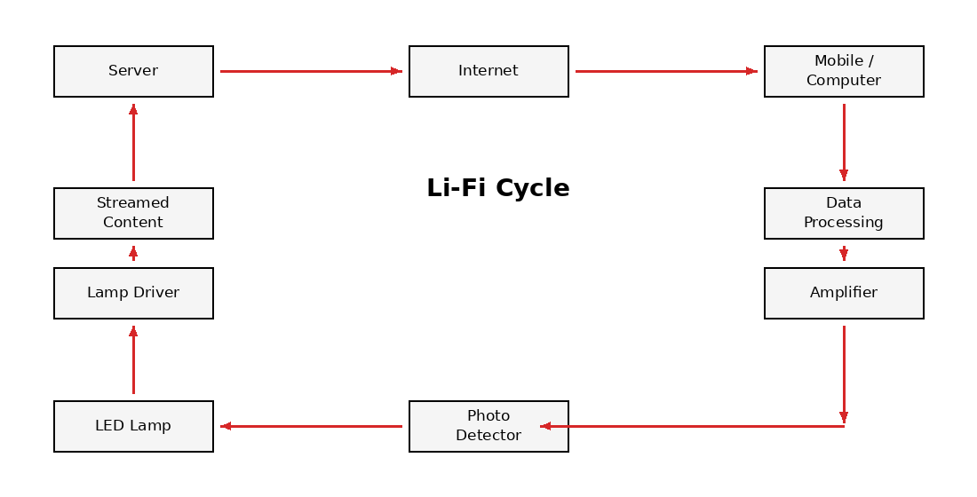
Figure 1. Li-Fi system architecture

3. How Li-Fi Works
The core components of this technology are specialized LED lamps capable of varying their brightness at extremely high frequency, switching on and off so rapidly that the change is imperceptible to the human eye.
When the LED is on, it represents transmission of the digital signal 1; when it is off, it represents transmission of the digital signal 0 [4]. This process repeats continuously to produce a stream of 0s and 1s, which is captured by a sensitive photodetector and converted back into the original data [1]. Figure 2 illustrates how Li-Fi operates end to end.
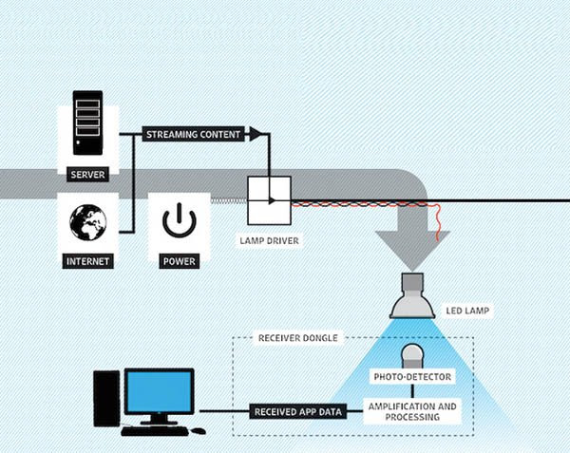
Figure 2. How Li-Fi operates, from server to receiving device. Image credit: pureLiFi (purelifi.com).

4. Li-Fi Modulation Techniques
Radio waves and light waves are both part of the electromagnetic spectrum, which means modulation schemes developed for radio-frequency communication can also be adapted for Li-Fi [3]. Both single-carrier and multi-carrier modulation schemes are used.

4.1 SCM (Single Carrier Modulation)

4.1.1 On-Off Keying (OOK)
The IEEE 802.15.7 standard uses Manchester coding, in which the duration of positive pulses equals the duration of negative pulses. This coding doubles the bandwidth required for data transmission. For higher bit rates, RLL (Run-Length Limited) coding is used instead, offering greater spectral efficiency. Dimming support is achieved by adding an OOK extension that adjusts the overall output to the correct brightness level [1].

4.1.2 VPPM (Variable Pulse Position Modulation)
Variable Pulse Position Modulation (VPPM) is proposed in the IEEE standard and adopted as one of the modulation schemes for Visible Light Communication (VLC) [5]. It combines Pulse Width Modulation (PWM) with Binary Pulse Position Modulation (Binary-PPM): PWM plays the key role in controlling the dimming level, while Binary-PPM manages data modulation and prevents visible flicker in the signal [1], [6]. This combination optimizes system performance and enables data transmission without degrading light quality.

4.2 MCM (Multi Carrier Modulation)
Multi-Carrier Modulation (MCM) uses multiple frequencies simultaneously, enabling multiple parallel channels and increasing both flexibility and spectral efficiency [3]. One advantage of MCM over SCM is reduced signal attenuation along the transmission path, which improves signal quality, increases transmission range, and reduces sensitivity to channel noise and interference, contributing to its popularity among communications engineers.

4.2.1 OFDM (Orthogonal Frequency Division Multiplexing)
OFDM is a multi-carrier scheme considered one of the leading options for Li-Fi systems. It improves system performance by providing high data rates, increasing channel capacity, and resisting dispersion and inter-symbol interference (ISI), making it a key technique in Li-Fi development [7]. In optical communication systems specifically, modified variants such as ACO-OFDM, DCO-OFDM, and ADO-OFDM have been developed for compatibility with optical signals [3]. These variants play an important role in optimizing both Li-Fi and free-space optical (FSO) communication.

4.3 Specialized Li-Fi Modulation Techniques
All of the modulation techniques discussed above are baseband intensity-modulation schemes: the data directly modulates the intensity of the LED light rather than a radio-frequency carrier [8]. The techniques below additionally exploit the color of the light.

4.3.1 CSK (Color Shift Keying)
In RGB LED lighting systems, combinations of colors enable data transmission through variation in light color while overall output intensity remains approximately constant [1]. This modulation scheme is challenging to implement because of the complexity of the required transmitter and receiver design, which is generally regarded as its most significant limitation [8].

4.3.2 CIM (Color Intensity Modulation)
Color Intensity Modulation (CIM) has been proposed as an effective method for improving communication capacity. It is designed so that the intensity of different LED colors varies while the perceived color remains constant, increasing data transmission capacity [8]. It is generally considered a simplified version of CSK, and is used to balance color-matching requirements with improved transmission efficiency [3].

5. Advantages of Li-Fi Technology
Because Li-Fi's data transmission is LED-based, it can operate using various types of light and is not confined to a specific frequency spectrum [4]. During periods of high network traffic, Wi-Fi often struggles due to limited bandwidth, whereas Li-Fi's wide bandwidth has been reported to allow up to 100 times the performance of Wi-Fi under favorable conditions [3]. According to [9], the type of light used affects achievable speed: blue LED light can support transmission speeds of up to 28 Gbps, and white light up to 13 Gbps. Theoretically, researchers suggest the technology could reach speeds as high as 224 Gbps [9].
Table 1. Advantages of Li-Fi technology.
Aspect | Advantage
Security | Because light cannot pass through walls, data transmitted through lamps is inherently harder to intercept from outside the room.
Speed | Not being limited to the radio-frequency spectrum allows substantially higher achievable speeds.
Energy | Li-Fi can reuse existing LED lighting, so less additional energy is required for data transmission.
Air travel | Unlike Wi-Fi, Li-Fi can be used on aircraft without interfering with flight signals [1].
Underwater use | Radio waves are strongly attenuated in water, whereas Li-Fi enables communication below the surface.
Streetlights | Existing streetlights can be repurposed as access points, offering low-cost, convenient coverage.
Spectrum relief | Li-Fi helps address the growing scarcity of available radio frequencies.

6. Applications of Li-Fi

6.1 Hospitals and Healthcare
Due to concerns about radio-frequency interference, operating rooms generally avoid Wi-Fi, and in some hospitals, signals from computers and mobile phones can disrupt sensitive medical equipment [1]. Li-Fi's high speed improves medical communications, facilitates the transfer of large data volumes, and, paired with specialized sensors, enables real-time patient monitoring [10].

6.2 Airlines and Aviation
Passengers are typically required to enable airplane mode to reduce radio-frequency interference, but cabin lighting can instead be used to provide Li-Fi connectivity. The first in-flight use of Li-Fi was demonstrated by Air France in partnership with Latecoere and Ubisoft in 2019, a successful early trial [11], [12].

6.3 Underwater Exploration and Communication
Radio waves are strongly attenuated by water, which limits their usefulness underwater. Using Remotely Operated Vehicles (ROVs), Li-Fi provides greater freedom for underwater exploration and communication [1], [13].

6.4 Green Technology
Li-Fi does not emit radio-frequency radiation and reuses ordinary LED lighting, which avoids radio-frequency exposure and interference concerns and supports more energy-efficient wireless networks.

6.5 Military Applications
By offering strong security, underwater operability, and high speed, Li-Fi presents numerous opportunities for military applications [4].

7. Limitations of Li-Fi

7.1 Weather Conditions
Li-Fi does not function reliably under adverse weather conditions or intense ambient light, since photodetectors cannot accurately distinguish the intended light-wave variations under such conditions; the technology depends on a relatively controlled lighting environment [14]. Wi-Fi and cellular networks therefore remain necessary as a complement, since Li-Fi is ineffective for fast-moving users or in remote areas [1].

7.2 Inability of Light to Pass Through Obstacles
Because light cannot pass through solid obstacles, an unobstructed line of sight is required between transmitter and receiver [3]. While this property is a security advantage in some contexts, it is also a fundamental limitation of the technology.

7.3 Infrastructure Cost
This technology requires new investment in lighting systems and wiring to install suitable LED fixtures [14], which introduces its own set of implementation challenges.

7.4 No Light, No Connectivity
Since the technology fundamentally depends on light, no connection is possible in the absence of adequate lighting.

8. Recent Developments in Li-Fi

8.1 TAARA
Taara is a project that originated at X (Alphabet's "moonshot factory") and was spun out as an independent company in March 2025 [16]. It aims to deliver affordable high-speed connectivity using free-space optical (FSO) communication. FSO is closely related to Li-Fi as a form of optical wireless communication, but it is a different application: narrow, invisible light beams link two fixed terminals over long distances, rather than room lighting serving nearby devices. Taara's terminals transmit data at speeds of up to 20 Gbps across distances of up to 20 kilometers [15].
Originally, Taara's Lightbridge technology relied on mechanical systems (mirrors and sensors) to physically steer light beams in a specific direction. With the introduction of Taara's new chip, this process is now performed in software, without bulky mechanical components. This fingernail-sized silicon chip uses optical phased arrays to steer, track, and correct light beams with high precision.
In trials conducted at X's Moonshot Factory labs, the Taara team successfully transmitted data at 10 Gbps over a distance of 1 kilometer using two Taara chips, a notable demonstration of progress in using silicon photonic chips for high-capacity, long-distance data transmission [15].

9. The Future of Li-Fi
As technology continues to advance, nearly all mobile phones and many of the devices people interact with daily will soon be internet-connected. This raises the question of whether Wi-Fi alone can meet all future wireless connectivity needs, and it is unlikely that it can.
As demand for connectivity grows, Li-Fi, by combining lighting infrastructure with wireless data transmission, can increase overall data transfer capacity and serve as an excellent complement to Wi-Fi [17]. Numerous companies have invested in Li-Fi technology, and ongoing research and development continue to drive broader adoption and commercialization.

10. Recommendations
Many years have passed since Li-Fi was first introduced, yet the technology has still not secured a firmly established place in the broader technology landscape. Nonetheless, its future holds considerable opportunity, as development is ongoing.
Replacing Wi-Fi entirely with Li-Fi may be unrealistic in the near term, but Li-Fi can be viewed as a strong complement to Wi-Fi. With very high speed, low energy use, and environmental friendliness, it can address many of the limitations of current wireless technology.
One particularly important area where Li-Fi could drive substantial change is the Internet of Things (IoT) and Artificial Intelligence (AI). Given its high speed and stronger security relative to Wi-Fi, it is well suited for wireless connectivity among IoT devices, particularly in environments such as hospitals and factories that require fast, secure, low-power connections.
Furthermore, AI can play a key role in optimizing Li-Fi networks, for example by using machine learning algorithms to manage signal interference, optimize energy consumption, and predict network demand. Combining Li-Fi with IoT and AI could contribute to the development of smart cities, resilient wireless communication, and efficient automated systems.

11. Conclusion
Li-Fi technology still has considerable ground to cover, and substantial further research and optimization are needed in this field. It offers high speed, strong security, and reduced energy consumption, while also presenting challenges such as implementation cost, the need for line of sight, and disruption under adverse weather or strong ambient light. Integrating this technology with complementary technologies such as 5G, artificial intelligence, and the Internet of Things creates a pathway toward more advanced wireless communication systems.
Overall, Li-Fi has strong potential to become a practical complement to Wi-Fi within wireless networking, particularly in environments where radio-frequency communication is restricted or where higher security is required.

References
[1] A. Sarkar, S. Agarwal, and A. Nath, "Li-Fi technology: Data transmission through visible light," Int. J. Adv. Res. Comput. Sci. Manag. Stud. (IJARCSMS), vol. 3, pp. 1–10, 2015. [Online]. Available: https://www.researchgate.net/publication/279530585_Li-Fi_Technology_Data_Transmission_through_Visible_Light
[2] C. Deluisio, "The pitfalls of 6 GHz in WiFi: What you need to know," Cody Deluisio's Blog, Aug. 19, 2024. [Online]. Available: https://deluisio.com/networking/wifi/2024/08/19/the-pitfalls-of-6-ghz-in-wi-fi-what-you-need-to-know/
[3] G. Devi, N. Jayanthi, S. Rahul, M. Saran Karthick, S. Gokul Raghavendra, and M. Anand, "A critical review on Li-Fi technology and its future applications," AIP Conf. Proc., vol. 2690, 2023, doi: 10.1063/5.0121967.
[4] R. Karthika and S. Balakrishnan, "Wireless communication using Li-Fi technology," SSRG Int. J. Electron. Commun. Eng., vol. 2, no. 3, pp. 7–14, 2015, doi: 10.14445/23488549/IJECE-V2I3P107.
[5] J. H. Yoo and S. Y. Jung, "Modeling and analysis of variable PPM for visible light communications," EURASIP J. Wireless Commun. Netw., vol. 2013, Art. no. 134, 2013, doi: 10.1186/1687-1499-2013-134.
[6] S. Lee, B.-G. Ahn, M. Ju, and Y. Park, "A modified VPPM algorithm of VLC systems suitable for fast dimming environment," Opt. Commun., vol. 365, pp. 43–48, 2016, doi: 10.1016/j.optcom.2015.11.065.
[7] M. J. Mohsin and I. A. Murdas, "Performance analysis of an outdoor Li-Fi system-based AO-OFDM architecture under different FSO turbulence and weather conditions," Optik, vol. 273, Art. no. 170427, 2023, doi: 10.1016/j.ijleo.2022.170427.
[8] M. S. Islim and H. Haas, "Modulation techniques for Li-Fi," ZTE Commun., 2016. [Online]. Available: https://www.researchgate.net/publication/313891612_Modulation_Techniques_for_Li-Fi
[9] pureLiFi, "How fast is Li-Fi?," Mar. 13, 2025. [Online]. Available: https://lifi.co/lifi-speed
[10] B. Johnson, "Light-Fidelity (LiFi) — Innovative technology to transform healthcare industry," BMH Med. J., vol. 10, no. 4, pp. 95–97, 2023. [Online]. Available: https://www.babymhospital.org/BMH_MJ/index.php/BMHMJ/article/view/372
[11] U. Shah and P. Jain, "LiFi: Introduction, advantages, drawbacks and applications," Int. Res. J. Eng. Technol. (IRJET), vol. 6, no. 11, 2019.
[12] Latecoere, "LiFi technology by Latecoere takes off," Oct. 30, 2019. [Online]. Available: https://www.latecoere.aero/en/lifi-technology-by-latecoere-takes-off/
[13] B. Sivakumar, G. Pooja, S. Ranjitha, S. Ruchitha, and V. Chavan, "IoT implementation of underwater communication using Li-Fi," Glob. J. Eng. Technol. Adv., vol. 12, no. 1, pp. 92–101, 2022, doi: 10.30574/gjeta.2022.12.1.0111.
[14] S. Bin Ali, "Implementation issues of Li-Fi," Int. J. Eng. Res. Technol. (IJERT), vol. 6, no. 9, SETS-2018. [Online]. Available: https://www.ijert.org/implementation-issues-of-li-fi
[15] M. Krishnaswamy, "Taara chip," X Blog, Feb. 28, 2025. [Online]. Available: https://x.company/blog/posts/taara-chip/
[16] X, "Introducing the Light Generation," X Blog, Mar. 2025. [Online]. Available: https://x.company/blog/posts/taara-graduation/
[17] F. Rasool, "Li-Fi: The future of internet," Medium, Jan. 2, 2019. [Online]. Available: https://medium.com/acmvit/li-fi-the-future-of-internet-e573eab6bd0d

