**MAS – Ex3**

**Erfan Moosavi Monazzah - 401722199**

**April 23, 2023**

**Introduction:**

The vacuum agent problem involves designing an agent that can navigate a 4*4 room and clean all the dirt present in it. The agent is equipped with sensors that allow it to detect the presence of dirt in the tile it hovered. The agent can perform four actions - move forward, rotate 90 degrees, check for dirt, and suck dirt. This problem can be generalized as a multi-agent problem by increasing the number of vacuum agents. In this sense, agents are competing to each other. One course of competition can be the number of dirty tiles that got cleaned by each agent.

**Problem Statement:**

We have two agents presented in a 4*4 room, the task for the agents are that they should clean the room by cooperating with the other agents, to do so they equipped special form of communication, they can propagate their current tile and whether they sucked the tile or not.

**Proposed Solution:**

At the beginning of each run, each agent knows the starting location of the other agent. (This is considered OK by the problem statement). Now each agent separately and without ANY co-planning or brain storming with other agent, run a DFS algorithm to find all the path from its current location to the other agent’s location. The agent also tries to guess the other agent path by running another DFS from the other agent starting tile to its starting tile. Since both agents use the same algorithm, they manage to find the exact same path for each other without ANY FURTHER brain-storming. Now each agent knows what nodes the other agent can traverse, using this knowledge it finds the best routing by considering the following criteria: Each agent tries to find the first route which is the exact reverse of its own route that the other agent may take. Since both agent uses the same algorithm they end up selecting the same route. Now both agents are on the same route, they start from they starting position until they reach each other.

This route is selected in a way that maximize the number of dirt sucked and minimize the costs.

**Algorithm:**

1. Start positioning agents facing a random direction in a random tile
2. Each agent knowing its starting position and the other agent’s position, create a list of all possible routes to that agent position.
3. Each agent do the same but this time it generates all the possible routes for the other agent to its current location.
4. Both agents try to find the route that is the same for both side, SEPARATELY and without ANY PLANNING.
5. Since both use the same algorithm they end up selecting the same route.
6. They traverse the selected route until they reach the other agent.

**Evaluation:**

We evaluated our proposed solution by running simulations of the agents in various room configurations. The results show that our solution is effective and efficient in cleaning the entire room.

*You can visit the attached GIF files to this report to better understand the algorithm:*

*Brown squares: Dirt*

*White squares: Clean*

*Bot at left: (Alice)*

*Bot at right: (Bob)*

*In these pictures, the agents are facing north.*

**Analysis of Vacuum Cleaner Simulation Results**

We ran the simulation of the vacuum cleaner problem three times, each time with different inputs. The cost of sucking a dirty tile is 2 and the cost of moving to a new tile is 1. No cost is defined for rotating.

The results of the simulations are as follows:

**Simulation 1:**

**Found 118 valid way to reach Agent B from Agent A.**

**Found 118 valid way to reach Agent A from Agent B.**

**Alice sucked 4 for 13 costs**

**Bob sucked 5 for 18 costs**

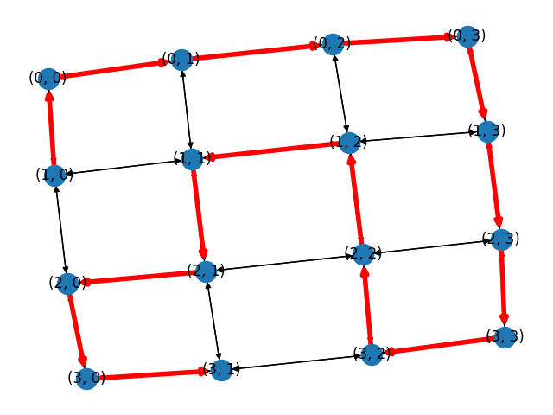

Alice decided to go on this route:

**Bob goes on this route:**

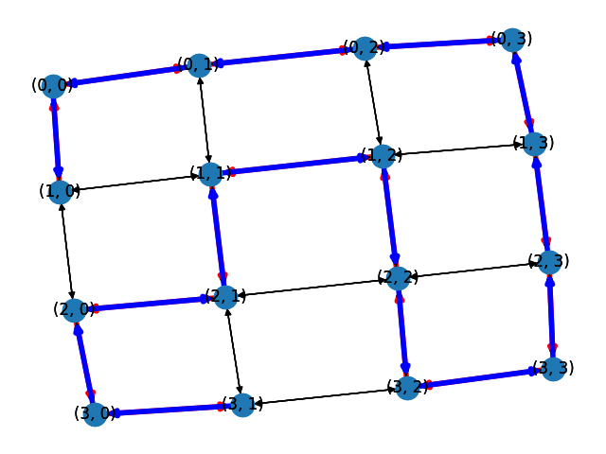

**Simulation 2:**

**Found 105 valid way to reach Agent B from Agent A.**

**Found 105 valid way to reach Agent A from Agent B.**

**Alice sucked 2 for 11 costs**

**Bob sucked 2 for 10 costs**

**Alice:**

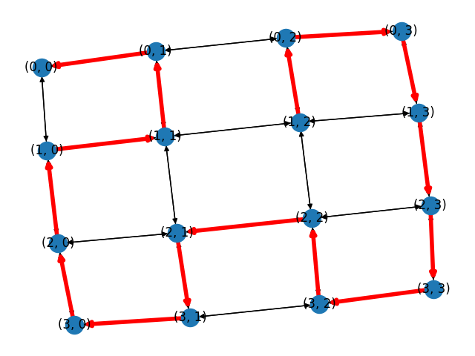

**Bob:**

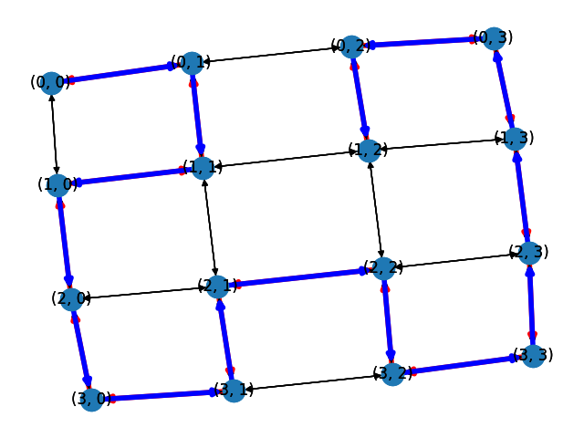

**Simulation 3:**

**Found 117 valid way to reach Agent B from Agent A.**

**Found 117 valid way to reach Agent A from Agent B.**

**Alice sucked 5 for 17 costs**

**Bob sucked 3 for 13 costs**

**Alice:**

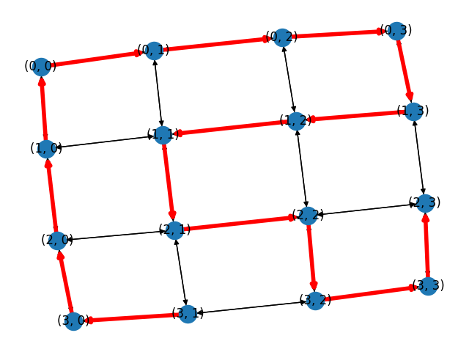

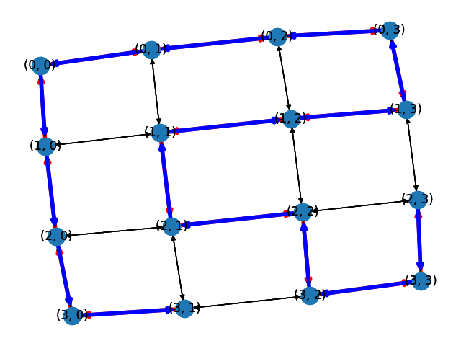Bob

There is another set of experiemtns where the dirt detector sensor has 10% error, so it may declare a clean tile as dirty or vice versa.

**Simulation 4:**

Found 98 valid way to reach Agent B from Agent A.

Found 98 valid way to reach Agent A from Agent B.

Alice sucked 5 for 16 costs

Bob sucked 7 for 22 costs

Total dirt: 6

Extra Sucking: 6

Remaining dirt: 1

**Simulation 5:**

Found 146 valid way to reach Agent B from Agent A.

Found 146 valid way to reach Agent A from Agent B.

Alice sucked 4 for 13 costs

Bob sucked 4 for 17 costs

Total dirt: 8

Extra suck: 1

remaining dirt: 1

**Simulation 6:**

Found 125 valid way to reach Agent B from Agent A.

Found 125 valid way to reach Agent A from Agent B.

Alice sucked 4 for 15 costs

Bob sucked 5 for 17 costs

Total dirt: 8

Extra suck: 3

remaining dirt: 2

As it was expected, introducing error to dirt sensor increased the cost since the vacuum cleaners propagate false information to each other, so if a dirty tile declared as clean, the other agent will not check it, so it remains dirty.

***Since the lines of codes for this exercise is large, the code explanation is done through commenting in the simulation.py file.***