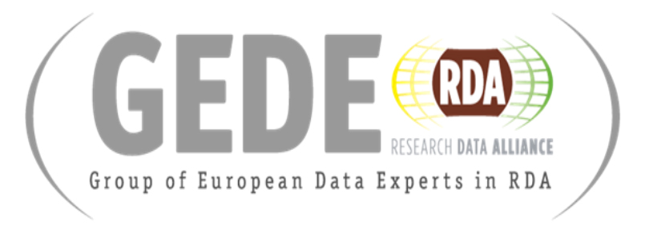

# GEDE Webinar on the EOSC Process

# with the Chairs of two EOSC Working Groups

**7. November 2019, 15.00 CEST**

<https://global.gotomeeting.com/join/359097749>

The EOSC governance has been put in action, i.e. the Governance and Executive Boards are operating and five EOSC Working Groups have been setup (<https://www.eoscsecretariat.eu/eosc-working-groups>): Landscape WG to map existing RIs, FAIR WG to implement FAIR principles, Architecture WG to define a technical framework, Rules of Participation WG to define obligations of participants and Sustainability WG to make suggestions for an EOSC federation after 2020. The pressure for these WGs is high since they are asked to develop recommendations by 2020 to design the steps for the next phase of EOSC. This raised a lot of questions in the various research infrastructures (RI) about

* what kinds of recommendations can be made in such a short time,
* how will the experience of the RIs be integrated,
* what are the plans are to consider such varied knowledge,
* how will the WGs work together given the overlap between them
* and many others.

We are happy to have

**Sarah Jones, chair of the FAIR WG, and**

**Jean-Francois Abramatic, chair of the Architecture WG,**

as speakers in this webinar and to answer all possible questions which come from the audience.

In particular these two WGs will be relevant for the continuation of the RI in future and their integration into the EOSC Framework of a distributed eco-system built on top of what has been established already - for example, in the ESFRIs & ERICs. Abstracting from the different solutions found in the different RIs towards a common core system is not trivial as the experience from RDA has shown.

Agenda

15.00 Carlo Maria Zwölf (GEDE, VAMDC) Introduction

15.05 Sarah Jones (EOSC FAIR WG) FAIR

15.30 Jean Francois Abramatic (Architecture) Role, Processes Topics

15.55 Open Discussion (Moderator: Edit Herzcog (GEDE, RDA))

Responsible: Peter Wittenburg, GEDE Co-Chair

<https://www.rd-alliance.org/groups/gede-group-european-data-experts-rda>

# Presenters

## https://www.eoscsecretariat.eu/sites/default/files/sjones.jpgSarah Jones

Sarah coordinates work on the DCC’s Data Management Planning tool - DMPonline - and undertakes research on data policy and data management planning. She has written several articles and book chapters on these topics, and co-edited Delivering Research Data Management Services: fundamentals of good practice. Sarah provides advisory services, training and consultancy via the DCC. Sarah is involved in several European Commission funded projects including, FOSTER+, OpenAIRE, the Research Data Alliance Europe 4.0 and FAIRsFAIR. Her work in a European context focuses primarily on training, data management planning and network building to facilitate open science. She co-chairs the RDA Active DMP Interest Group and the CODATA Working Group on Research Data Science schools. In a personal capacity, she was rapporteur on the European Commission’s FAIR Data Expert Group and a member of the Open Science Transport Research Cloud Expert Group. She is currently an individual expert on the EOSC Executive Board.

### https://www.eoscsecretariat.eu/sites/default/files/jfa.jpgJean-Francois Abramatic

Jean-François Abramatic is Emeritus Senior Scientist at Inria, the French research institute in computer science and applied mathematics. Jean-François's career has been shared between research and industry. Jean-François's research activities were focused to Digital Image Processing. Jean-François was also engaged in the development of the Internet and the World Wide Web. He has been Chairman of W3C, the World Wide Web Consortium from 1996 to 2001. From 2001 to 2009, he was Chief Product Officer of ILOG, a French software company which was acquired by IBM in 2009. From 2009 to 2013, Jean-François was in charge of Development Innovation & Productivity in the Enterprise Transformation division of IBM headquarters. Jean-François holds a PhD from University of Paris VI.