Wye V0.9 Alpha Test Release Notes

Eben Gay, 3/30/2025

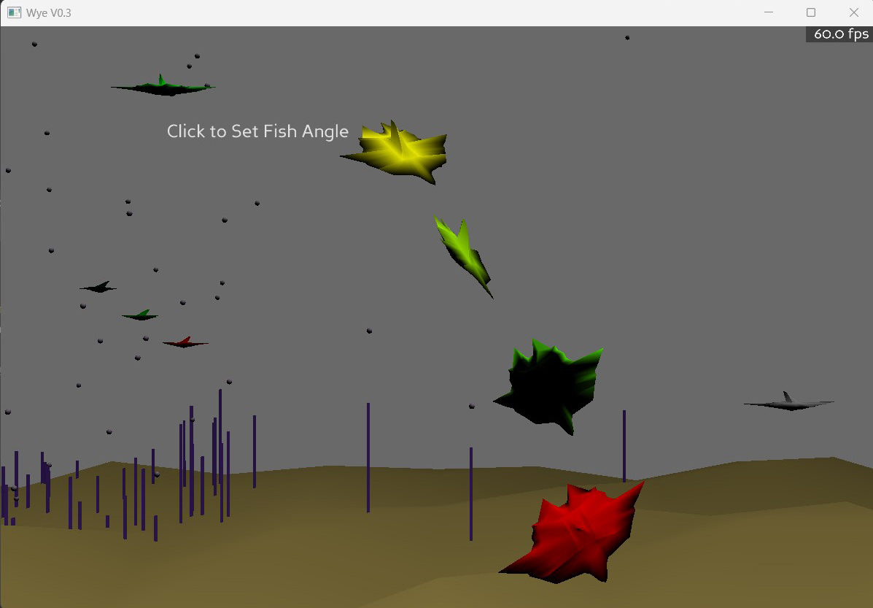

Overview:

The main sections of the Wye environment are sketched in:
- runtime engine
- editing Wye library “verbs”,
- debugging running objects.

The libraries are absolutely minimal. However, the action you’re seeing is testing many different core functions (such as finding objects, getting and changing their position/orientation in many different ways (absolute, relative to the object, relative to another object, changing their color, generating a sound when they are touched or do an action). Also 3d sound. Midi sound.

This layer is the engine that the goal-directed objects will be built from.

There is no immersion yet. This is PC screen only. That’s a whole ‘nuther 3d library I have to get working. Later.

User interface:

Moving with the mouse:
- Left mouse button turns and goes fwd/back.
- Shift-Left mouse slides sideways and tilts up/down
- Right mouse button slides left/right, up/down
- Center button (press on scroll wheel) resets to start position and orientation.
- Shift center button keeps the current position and resets orientation.

Clicking on an object may cause it to do something (change direction, make a sound, wiggle).

Control-clicking on an object will open the object in the editor dialog.
Alt-clicking an object will open the object in the debugger dialog.

Note that dialogs open relative to where you are. If you move, they will stay where they are.

You can drag a dialog around by clicking on any of the gray background and dragging.
You can move a dialog closer or push it away by shift-click and dragging up/down.

The shift-click library and debugger windows will reposition themselves relative to you if you move and then shift-click again.

Shift-Control clicking on empty space brings up a dialog with a list of all the libraries. Click on one to show all the verbs. Click on a verb to edit it. You can also load, create new, save, and delete libraries from this dialog.

Alt-clicking on an object will pause it and show its parameters and variables and allow editing of live values. You can also stop the object, which will also remove any graphic objects it has.
- Changing ints, floats, works pretty reliably, strings sometimes, arrays sometimes. It’s not handling all the cases yet..
- Step will execute one computation cycle and refresh the displayed values.
- Run will toggle execution on/off
- Refresh Values refreshes the variable values. Useful if run toggled on.

Shift-Alt-clicking on empty space brings up the list of all the currently running objects and lets you debug or stop them. You can also pause the entire world. If you have a single object debugger open when the world is paused you can step or run just that object.

Control-Alt clicking brings up the Wye main menu dialog which has a varied selection of functions like turning off the in-world Wye version, bringing the cut-paste menu to the front, and exiting Wye.

What to try?

First, fly around the world and check it out. Try sliding up high with the left mouse and then tilting down with shift right-mouse to look at the world from above. Note for later: this is particularly enjoyable after you’ve opened a bunch of fish libraries so there’s lots going on.

Second, some things to poke:
> Interactive elements:

- Click on the static green fish to make it wiggle and say “pew”
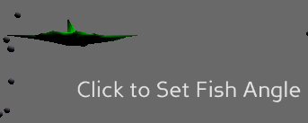
- “Click to set fish angle” lets you change the angle of the green fish AND the angle of the “sun”. You can click on a number and edit it (left/right arrows, delete key). You can also click on a number and use the up/down arrow keys or scroll wheel to change it.
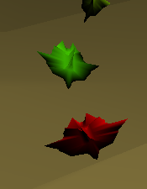
- Click on the red leader fish leading a little flock of colored fish. It will change direction and say “pop”

> Debugging:
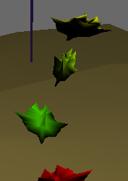
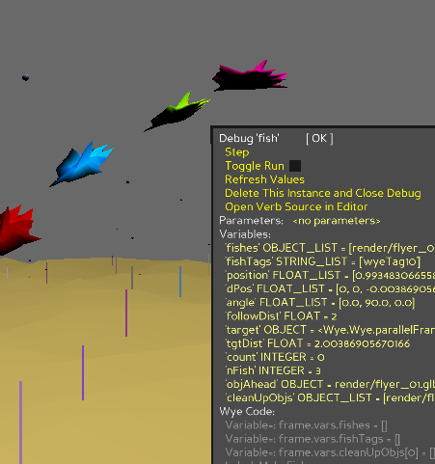
Check out the debugger by alt-clicking on any of the three fish following the red leader (not the leader itself).

Try clicking Step and toggling Run on/off.

In the “Debug fish” dialog, click on the variable “followDist”. Change it from 1 to 2 or to .5. Then click Run and the fish will change the distance they follow each other at.

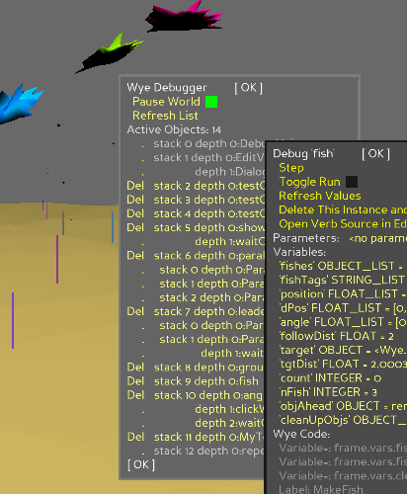
You can alt-click on the red leader and click on the Variable “posStep” to change its value. Make it something bigger. When you click OK the fish will zoom.

You can see everything that is running by alt-clicking empty space to bring up the list of all running objects.

You can delete running objects. Note that critical system objects are not debuggable or deletable.

If you stop objects in the default TestLib world you can start new copies by opening TestLib and clicking Start next to them. Note that the “ground” object includes all the weeds and bubbles.
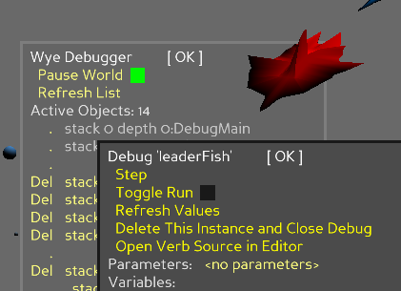
Click Pause World to pause the entire world.

Alt-click an object and click the Run checkbox in its debug dialog to run just that object.

> Editing:
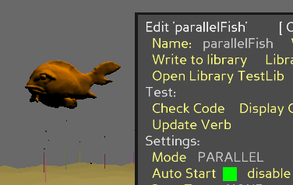
Check out the editor. Ctrl-Click on any of the fish objects to see their code. You can edit the parameters, verbs, and code. If you change the verb name it will create a new verb when you click Update or close the editor with OK. If you change the library the verb will be created in the library you selected. You can also write the verb out to a library file.

Note that once a verb is running, editing its source will not change that running instance. You can even delete the verb from the library and that instance will stay running.
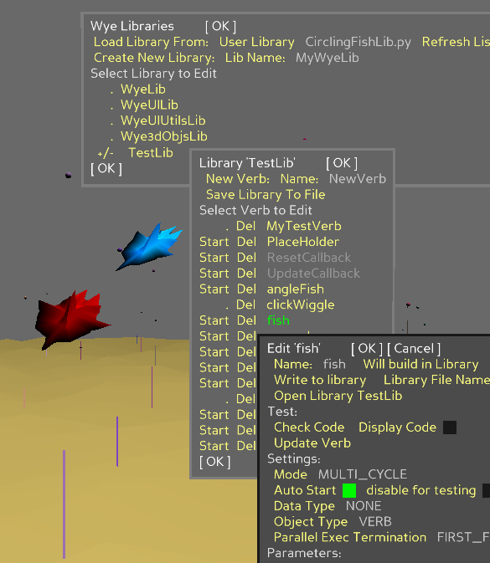
Shift-click to bring up the library list menu. Click on TestLib and poke around the verbs defined there. Note that some libraries, such as WyeUILIb have verbs that are coded directly in Python rather than Wye so they are not editable in Wye and show in gray.

Click on the file name next to User Library name to get a drop down list of user libraries.

Click Load Library From: to load the selected library and start any auto-start objects in the library.

If you save a library to a new name, click Refresh List to show the new library in the drop down list.

When you load the library it will update any in-memory version of that library and start all library verbs that have AutoStart set on.

You can manually start a verb by clicking Start. For instance, if you open up MyFlashingFishLib.py you can start loads of fish by repeatedly clicking on Start next to individual fish verbs.

> Have fun!

Don’t worry about breaking anything. The world is supposed to be resilient and if you find a bug that takes out the whole world, you can always restart it.
- If an object crashes, the world will put up a crash message and stop just that object. If you are editing the object you should still be able to find it in its library and continue to edit and test it.

- If the crashed verb left a graphic in the world, alt-click it to bring up the debugger menu and click Delete This Instance and Close Debug to make it go away. If you’ve crashed a lot, you may have to repeat this many times to get rid of all the copies!

- If you write out to a library file that already exists, Wye will ask if you want to overwrite or write to a new revision of the file. Currently there’s no way to delete files from Wye. You’ll have to do that in the UserLibraries folder outside of Wye.

Note: Don’t rename library files. Wye expects the file name to match the internal library object name.

- The demo TestLib is built into the executable. If you delete the library while in Wye it will return the next time you start Wye.

- Note that TestLib is not saveable to a file. If you modify verbs in TestLib, save them out to a new library name. You can do this directly while editing the verb or you can use the library menu to create a new library, save the verbs to it (when editing the verb), and then save that library out from either the verb editor or the library menu.

- If you find a nice reproduceable bug, please let me know so I can fix it. Thanks!

- If you find random unreproduceable bugs, I guess I want to know about them too so I can worry about when they will show up next.

