Wye V0.9.1 Alpha Test Release Notes

Eben Gay, 4/7/2025
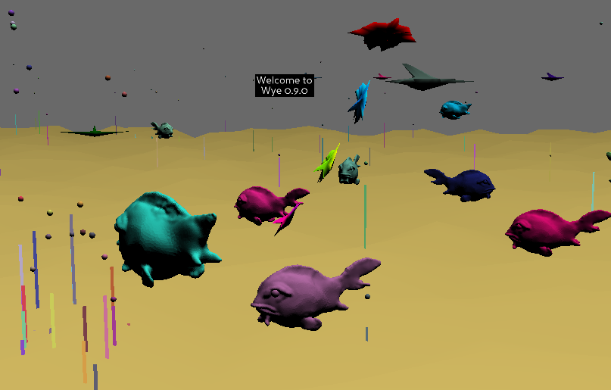

Overview:

Wye will be an IDE for interactive VR characters.

This Alpha release is testing the underlying runtime engine that the goal-directed objects will be built on and is a first pass at an edit and debug UI.

If you just want to check ths release out, read the User Interface half-page below then skip to I Want To Play at the end of this document.

When the alpha starts it loads the demo library TestLib.py. You can also load, edit, and save user defined libraries. The alpha release ships with several example libraries loadable from the Wye Libraries dialog.

The current level of Wye code editing requires a detailed understanding of the underlying engine. In other words, in-world editing is not recommended without a tutorial from someone who knows how it works. In the future, this level of detail will only be available to wizards who enjoy breaking things at the core level.

The main sections of the Wye environment are sketched in:
- runtime engine
- editing Wye library “verbs”,
- debugging running objects.

The libraries are absolutely minimal. However, the action you’re seeing in the test world is exercising different core functions such as finding objects, getting and changing their position/orientation in many different ways (absolute, relative to the object, relative to another object, changing their color, generating a sound when they are touched or do an action). Also 3d sound and Midi sound.

There is no HMD immersion support yet. This is PC screen only. That’s a whole ‘nuther 3d library I have to get working. Later.
User interface:

Moving with the mouse:
- Left mouse button turns and goes fwd/back.
- Shift-Left mouse slides sideways and tilts up/down
- Right mouse button slides left/right, up/down
- Center button (press on scroll wheel) resets to start position and orientation.
- Shift center button keeps the current position and resets orientation.

Clicking on an object may cause it to do something (change direction, make a sound, wiggle).

Control-clicking on an object will open the object in the editor dialog.

Alt-clicking on an object will open the running object instance in the debug dialog.

F11 will cycle between full screen, maximum window size, and small window size.

In a dialog box anything yellow is interactive (clickable).
When a text/number field is green it is ready for you to type text into it.

Wye user interface Dialogs

The Wye HUD dialog stays on-screen as you move. All the rest of the dialogs open in a position in the world and hold their position unless moved.

The Wye Help dialog has a short summary of the controls and an even shorter summary of what Wye is.

Dialogs open in front of where you are at the moment. (Other than the HUD dialog) When you move they will stay where they are. If a dialog has a keyboard shortcut, you can move elsewhere in the world and press the keyboard shortcut to reposition the dialog in front of where you have moved to.

Repositioning dialogs:
You can drag a dialog around by clicking on any of the gray background and dragging.
You can move a dialog closer or push it away by shift-click and dragging up/down.

Escape will close the current dialog without saving unsaved changes.
Carriage Return will terminate a dialog that has only an [ OK ] button.
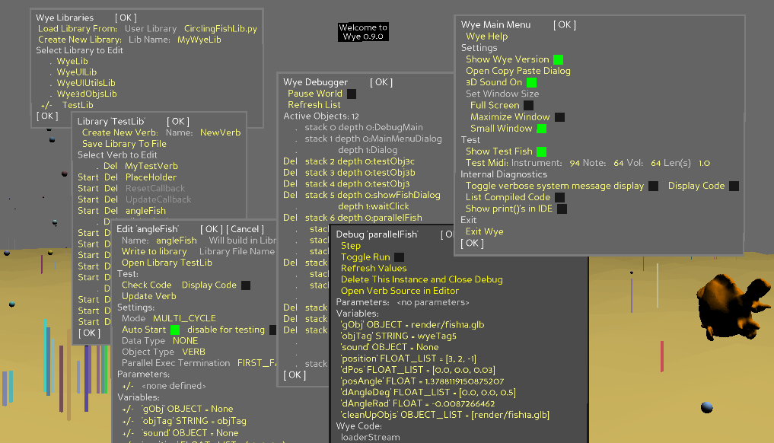

Wye HUD dialog:
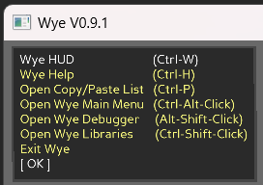
The HUD default position is the top left corner of the display. You can drag it to any part of the display you prefer.

The main Wye menus are all available from the HUD, including the Help, Copy/Paste, Wye Main Dialog, Wye Debugger, and Wye Libraries editor dialogs. In addition there is a button to exit Wye.

The HUD also shows the shortcut key/mouse combinations to bring up each dialog.

Note that if you have edited a library, clicking Exit Wye will let you know there are unsaved libraries and ask if you want to close without saving them.

Wye Main Menu dialog:

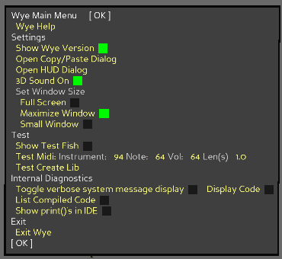
Control-Alt-click brings up the Wye main menu dialog which has a varied selection of functions like turning off the in-world Wye version, bringing the cut-paste dialog to the front, and exiting Wye.

Note that you can turn off the 3d sound. This can be useful if the TestLib bubble popping noise is driving you to distraction.

One important feature is the button to reopen the Wye HUD if it is closed. You can also open the Wye HUD by pressing control-W

If the Copy/Paste window is closed, you can open it here. You can also open it with Control-P

You can resize the Wye window from here. You can also cycle between window sizes by pressing F11.

Debugging dialogs:

Alt-clicking on an object will pause that running object instance bring it up in a Debug dialog showing its parameters and variables and allows live editing of values. You can also stop the object, which will stop that running instance and remove any graphic objects it has from the active world.
- Changing ints, floats, and strings works reliably. Editing arrays of ints, floats and strings works reliably but the object may have issues if you add or delete entries. Editing objects or lists of objects doen’t work well as internal object lookup is not yet supported by the debug dialog.
- Step will execute one computation cycle and refresh the displayed values.
- Run toggles running the object on and off.
- Refresh Values is useful to see variable value changes as the object is running.

Alt-Shift-clicking on empty space brings up the list of all the currently running objects and lets you debug or stop them. You can also pause the entire world. When the world is paused, a debug window for an object will step or run just that object.

Library and Verb dialogs:

Control-clicking on an object in the world or clicking on a verb in the Wye Libraries dialog will bring up the verb editing dialog. This edits the source for the verb in the library. It does not modify the running objects.

The current level of code editing requires a detailed understanding of the underlying engine. In other words, editing is not recommended without a tutorial from someone who knows how it works. In the future, this level of detail will only be available to wizards who enjoy breaking things at the core level.

Control-Shift-clicking brings up the Wye Libraries dialog that shows all the libraries currently loaded. From here you can load user defined libraries. The Alpha release comes with several fun example libraries. You can save a library to a file and create a new library from here.

Click on a library in the Wye Libraries dialog to open the Library dialog that shows all the verbs in the library. From here you can create new verbs in the library, delete verbs from the library, save the library to a file.

Verbs that have Wye code are yellow, indicating you can edit them. Internal verbs implemented in Python are not editable and show in gray.

Verbs that have no parameters can be run
Click on a verb to bring it up in the Edit dialog.

I want to play. What to try?

First, fly around the world and check it out. Try sliding up high with the left mouse and then tilting down with shift right-mouse to look at the world from above. Note for later: this is a particularly good viewpoint after you’ve opened a bunch of fish libraries so there’s lots going on.
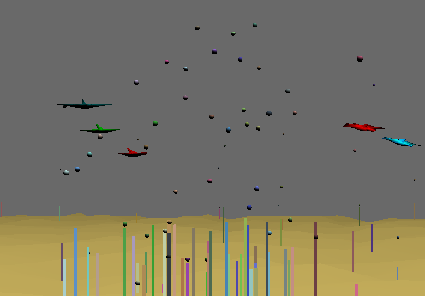
Fly over the grove of bubble plants. When you get close to the bubbles you can hear them “pop”.

Now let’s explore the things you can click on.

Interactive elements:

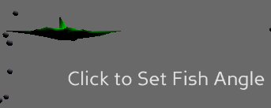
- Click on the static green fish to make it wiggle and say “pew”

- “Click to set fish angle” lets you change the angle of the green fish AND the angle of the “sun”. You can click on a number and edit it (left/right arrows, delete key). You can also click on a number and use the up/down arrow keys or scroll wheel to change it.
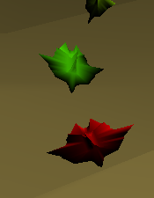
- Click on the red leader fish leading a little flock of colored fish. It will change direction and say “pop”

Changing world settings:
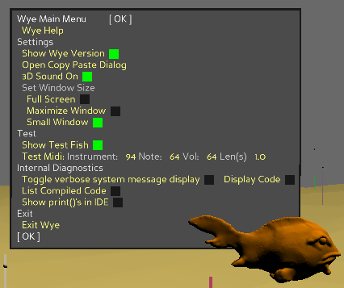
Ctrl-Alt-click the mouse to bring up the Wye Main Menu.

The most useful setting is the window size.

You can also show/hide the version number and the light-angle fish, and turn the 3d sound on and off. You can bring up the cut/paste menu if it’s not already showing (useful when editing).

The most fun setting here is playing midi notes. Type in values between 0 and 127 (or use the scroll wheel or up/down arrows) and click Test Midi to play the note.

Debugging:
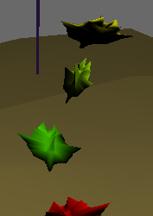
Object Debug:

Check out the object debugger by alt-clicking on any of the three fish following the red leader (not the leader itself).

Try clicking Step and toggling Run on/off.

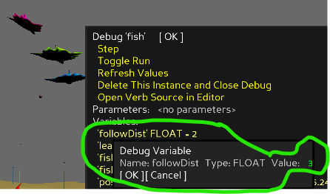
In the “Debug fish” dialog, click on the variable “followDist”. Change it from 1 to 3. Then click Run and the fish will space out the distance they follow each other at.

You can alt-click on the red leader and click on the Variable “posStep” to change its value. Make it something bigger. When you click OK the fish will zoom.

Wye Debugger:

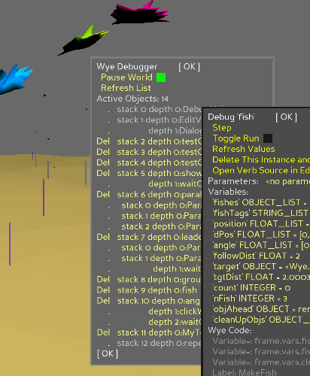
Now open the Wye Debugger, either from the HUD or by Alt-Shift-clicking anywhere.

You can see everything that is running by alt-clicking empty space to bring up the list of all running objects.

You can delete running objects. Don’t worry. Critical system objects are not debuggable or deletable.

If you stop objects in the default TestLib world you can start new copies by opening TestLib and clicking Start next to them. Note that the “ground” object includes all the weeds and bubbles.

Click Pause World to pause the entire world.

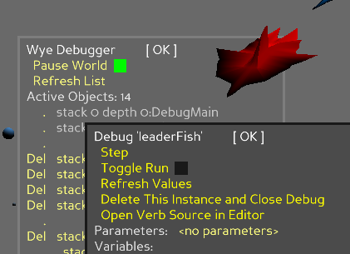
When the world is paused, Alt-click an object and click the Run checkbox in its debug dialog to run just that object.

Editing:

Wye Libraries dialog:

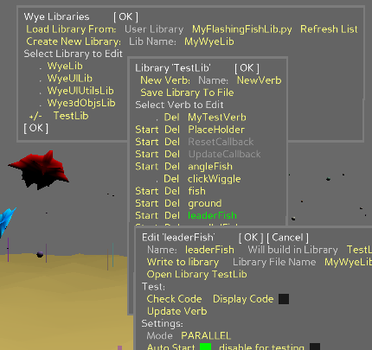
Control-Shift-click to bring up the Wye Libraries dialog listing all the currently loaded libraries. Click on TestLib to see the verbs that make up the current active world. Note that some libraries, such as WyeUILIb have verbs that are coded directly in Python rather than Wye so they are not editable in Wye and show in gray.

Click on the file name next to User Library to get a drop down list of user libraries on disk in the WyeUserLibraries folder.

Click Load Library File: to load the selected library.

When you load a library it will update any in-memory version of that library and start new instances of any library verbs that have AutoStart set on. Repeatedly loading a library will start many instances of the verbs. Repeatedly loading a library is one way to create a school of fish!

You can manually start an individual verb by clicking Start next to the verb. For instance, if you select MyFlashingFishLib.py, every time you click Load Library File: you will start three more fish. You can create schools of fish by repeatedly clicking on Start.

If a verb has input parameters then it is intended to be called from another verb’s code. The library will not show a Start button for this verb since it is not a stand alone object.

Verb Editor dialog:

Wye code editing requires a detailed understanding of the underlying engine. In other words, in-world editing is not recommended without a tutorial from someone who knows how it works.

That said, here are some fun things you can try:

The red leaderFish swims random loops around a target point. The three following fish follow in line at a fixed distance from the one ahead.
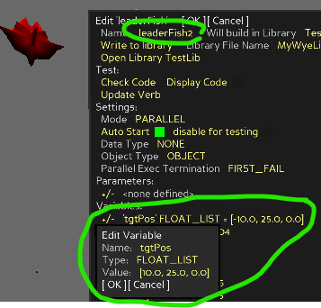
Control-Click on the red leader fish to edit it’s library source. If you find the fish is hard to catch, you can cheat by opening the Wye Debugger (HUD menu or Alt-Shift-Click) and clicking Pause World.

We can edit the current leaderFish to create a new leaderFish2 that circles a different point.

On the second line from the top of the dialog click on the Name: leaderFish field and arrow to the end of the name and change it to leaderFish2.

Under Variables: click on ‘tgtPos’ and change the Value from (0, 25, 0) to (10, 25, 0) and click OK to update it. This moves leaderFish2’s target 10 units to the right of leaderFish’s target.

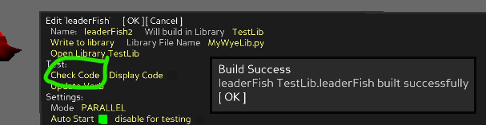
To make sure we typed everything correctly, toward the top of the dialog, under Test, click Check Code. Click OK on the Build Success message.

At the top of the Edit LeaderFish dialog click on OK to save leaderFish2 You will see the new leaderFish2 swim off to the right and start swooping around. All alone. Poor thing! Lets provide some friends!
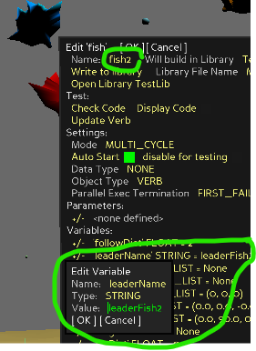
Control-Click on any of the follower fish behind leaderFish. In the second line of the Edit dialog, change the name from fish to fish2. Note that the fish verb runs all three follower fish at the same time.

Down under Variables, click on the second variable, leaderName.
This is the leader that the fish will look for. Change the Value to leaderFish2 and click OK.

If you want to go even further, change the followDist variable to something in the .5 to 3 range. This is the distance that the fish will keep between each other.

A the top of the dialog click OK to save fish2 to the library and start an instance of three fish following after leaderFish2.

If the world is still paused, this would be a good time to go to the Wye Debugger menu and unclick Pause World!

You will see there are now two sets of fish swimming in loops.

Wouldn’t it be fun to have lots of fish?
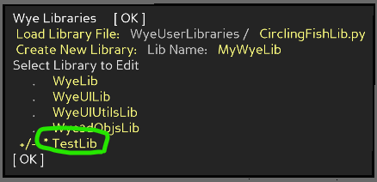
Go back to the Wye Libraries dialog. If it’s closed, reopen it from the HUD or by Ctrl-Shift-clicking anywhere.

At the bottom is TestLib with an asterisk next to it. This is the library that your leaderFish2 and fish2 were added to. The asterisk indicates that the library has changed.

Click on TestLib. This opens the Library ‘TestLib’ dialog showing all the verbs defined in the test library. You can see leaderFish and leaderFish2 and fish and fish2.
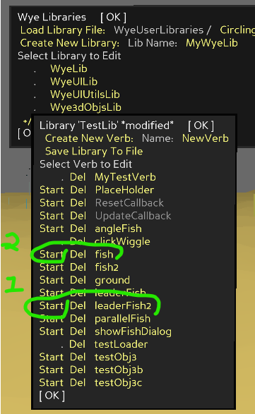
Click on Start next to leaderFish2. This creates another instance of leaderFish2 who will swim over to the right and start circling.

Click on Start next to fish2. This creates another instance of fish2 which will find the most recently created leaderFish2 and swim after it.

Alternate starting leaderFish2 and fish2 to create a school of fish all swarming around the 10, 25, 0 target point. (You can click leaderFish and fish to add more to the other school too.)

If you click Start fish2 twice in a row, two sets of fish will chase after the same leaderFish2. When the second fish2 catches up they will overlap with the first fish2 and you won’t be able to tell them apart.

But you know how to fix that! Alt-Click one of the fish2 to bring up the Debug ‘fish2’ dialog. Change the Variable followDist to 2 or 3 and the second group of fish2 will space themselves out so you can see them.

Saving your fish.

TestLib is loaded from inside the Wye image. If you save TestLib, a second TestLib will be put into WyeUserLibraries which will cause massive duplication of objects in the world if you to load it and will slow everything down and cause confusion.
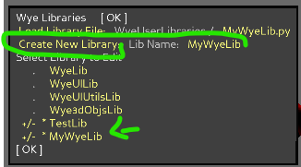
The solution is to copy your modified fish to new library.

Create a new library:

In the Wye Libraries editor, create a new library. The default is MyWyeLib, but you can name it anything you want as long as it’s different from the other libraries. Click on Create New Library and the library MyWyeLib will appear at the bottom of the library list.
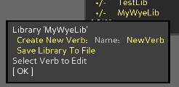
Click on MyWyeLib. The library will be empty. Drag the Library MyWyeLib dialog to the side so it’s out of the way, but still visible.

Copy your fish from TestLib to MyWyeLib:

If you don’t still have the Library ‘TestLib’ dialog open, go to the Wye Libraries dialog click on TestLib to open it up again. Click on Fish2 to open the Edit ‘leaderFish2’ dialog.
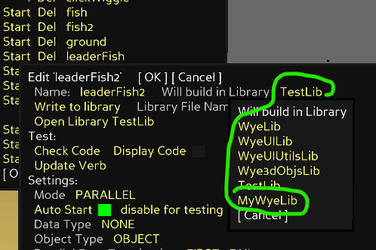
At the top of the Edit ‘leaderFish2’ dialog, in the 2nd row, where it says Will build in library TestLib, click on TestLib and choose MyWyeLib from the dropdown list. Then click OK.

You will see leaderFish2 appear in the Library MyWyeLib dialog you pushed to the side.

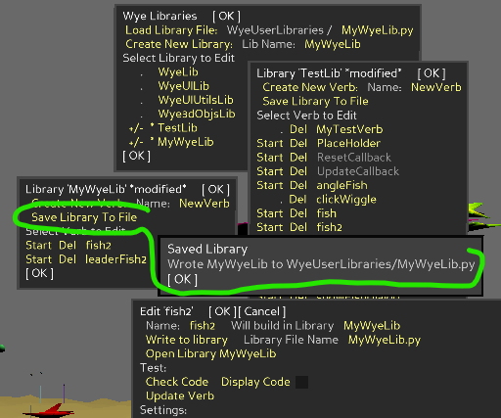
Edit fish2 in TestLib and save it to MyWyeLib also.

Save the new library:

In the Library MyWyeLib dialog click Save Library To File.

Your file is saved in the WyeUserLibraries folder in the same location as the Wye executable.

Have fun!

Don’t worry about breaking anything. Wye is pretty resilient. Worst case, you can restart the world and it will bring up a clean copy of TestLib. If you saved your work to a user library, you can reload the library and continue.

- If an object crashes, the world will put up a crash message and stop just that object. If you are editing the object you should still be able to find the most recent version in your library and continue to edit and test it.

- If the crashed verb left a graphic in the world, alt-click it to bring up the debugger menu and click Delete This Instance and Close Debug to make it go away. If you’ve crashed a lot, you may have to repeat this many times to get rid of all the copies!

- If you write out to a library file that already exists, Wye will ask if you want to overwrite or write to a new revision of the file. Currently there’s no way to delete files from within Wye. You’ll have to step out to the operating system and delete unwanted user library files from WyeUserLibraries in the folder that Wye is running from.

Note: Don’t rename library files. Wye expects the file name to match the internal library object name and will fail to load the file if the file name doesn’t match the library name. When Wye saves a library to a file with a different name, it changes the library name in the file to match the file name.

- The demo TestLib is built into the executable. If you delete or modify the library while in Wye it will return to its original contents the next time you start Wye.

- Note that TestLib is built into the Wye executable. If you modify verbs in TestLib, copy them out to a new library. Use the library menu to create a new library. Save the verbs to it from the Edit dialog. Then save the new library out from the library menu.

- If you find a nice reproduceable bug, please let me know how to reproduce it so I can fix it. Thanks!

- If you find random unreproduceable bugs, I guess I want to know about them too so I can worry about when they will show up next..

