Wye V4.0 Release Notes

Eben Gay, 12/30/2024

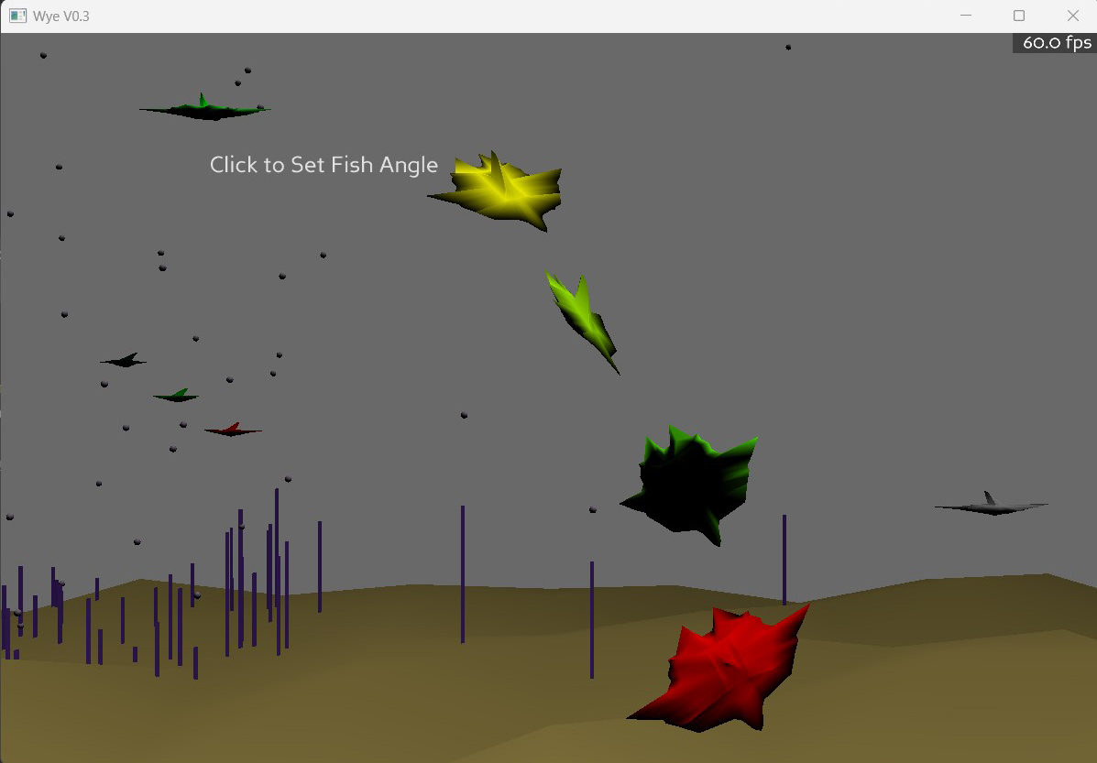

Overview:

The main sections of the Wye environment are sketched in:
- runtime engine
- editing Wye library “verbs”,
- debugging running objects.
Note: “sketched in”. Editing only does parameters and variables, not code yet. And though OK saves the object, it’s not rebuilt so no changes take effect. Debugging allows editing running objects – changing values usually works correctly for ints, floats, and sometimes text, some arrays of anything, but not objects. And the dialog positioning is only partly functional – the dialogs always come up facing one way, no matter where the user is relative to them. You can drag the title bar of a dialog and drag it around. This is necessary since they tend to pile up on each other…

The libraries are absolutely minimal. However, the action you’re seeing is testing many different core functions (such as finding objects, getting and changing their position/orientation in many different ways (absolute, relative to the object, relative to another object, changing their color, generating a sound when they are touched or do an action).

This layer is the engine that the goal-directed objects will be built from. I expect goals to show up shortly after being able to actually use the changes made to the libraries. Then I can start to use Wye to build the next level of Wye!!!

There is no immersion yet. This is screen only. That’s a whole ‘nuther 3d library I have to get working. Later.

User interface:

Moving with the mouse:
- Left mouse button sideways turns, up/down goes fwd/back.
- Shift left mouse slides sideways, shift up/down tilts up/down
- Right mouse button slides left/right, up/down
- Center button (press on scroll wheel) resets to start position and orientation.
- Shift center button resets orientation but keeps the current position.

Clicking on an object may cause it to do something (change direction, make a sound, wiggle).

Control-clicking on an object will edit it. Except for the ground, weeds, and bubbles. I was testing raw graphics creation and they aren’t registered with the Wye world. Will fix that later.

Shift-Control clicking on empty space bringa up a list of all the libraries. Click on one to show all the verbs. Click on one to edit it.

Alt-clicking on an object will pause it and show its parameters and variables and allow editing of live values.
- Changing ints, floats, works pretty reliably, strings sometimes, arrays sometimes. It’s not handling all the cases yet..
- Refresh Values does just that, but since the object is stopped, it’s not usually interesting.
- Step will execute one computation cycle and refresh the displayed values.

Shift-Alt-clicking on empty space brings up the list of all the currently running objects and lets you debug them.

What to try?

First, fly around the world and check it out.

Second, some things to poke:
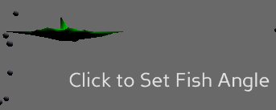
- Click on the static green fish to make it wiggle and say “pew”

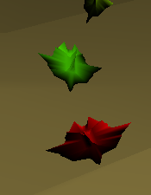
- “Click to set fish angle” lets you change the angle of the green fish (woo! Exciting…). You can click on a number and edit it. You can also click on a number and use the scroll wheel to change it.

- Click on the red leader fish leading a little flock of colored fish. It will change direction and say “pop”

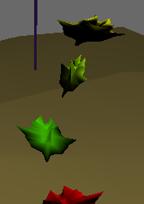
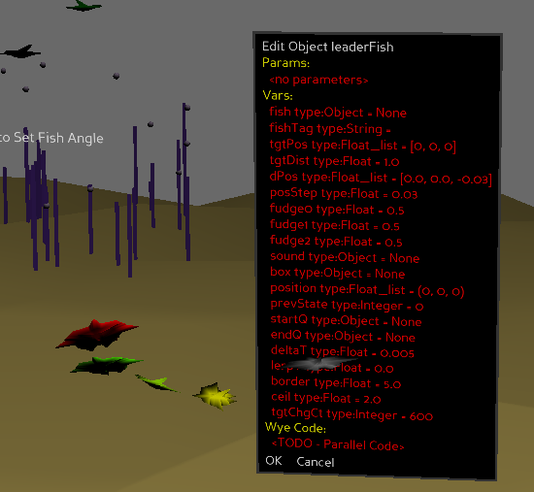
Third, check out the debugging by alt-clicking on any of the three fish following the red leader (not the leader itself). In the “Debug fish” dialog, click on “followDist”. It is currently 1. Change it to something else (2 or .5) and click OK. The fish will change the distance they follow each other at.

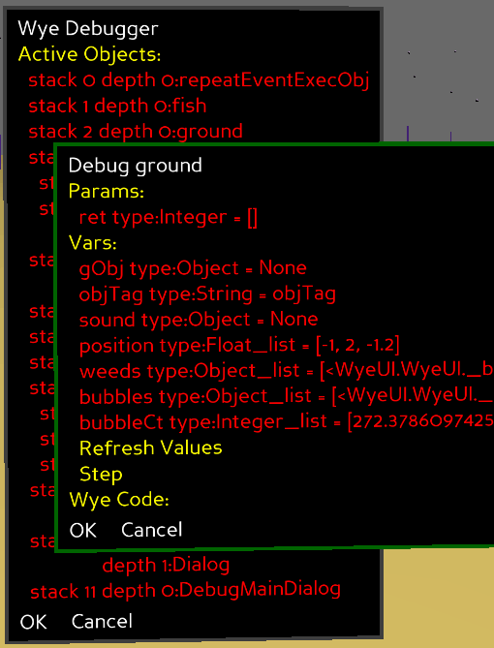
You can see everything that is running by alt-clicking empty space to bring up the list of all running objects. Note that you can debug the ground from here, not that it’s very interesting. NOTE: this dialog currently comes up in the middle of the world. If you’re not in the area, middle click (or press the scroll wheel) to center your viewpoint.

Very obscure bug: debugging any object causes the Red Leader fish to stop updating its position. I don’t know why and I’ve looked.
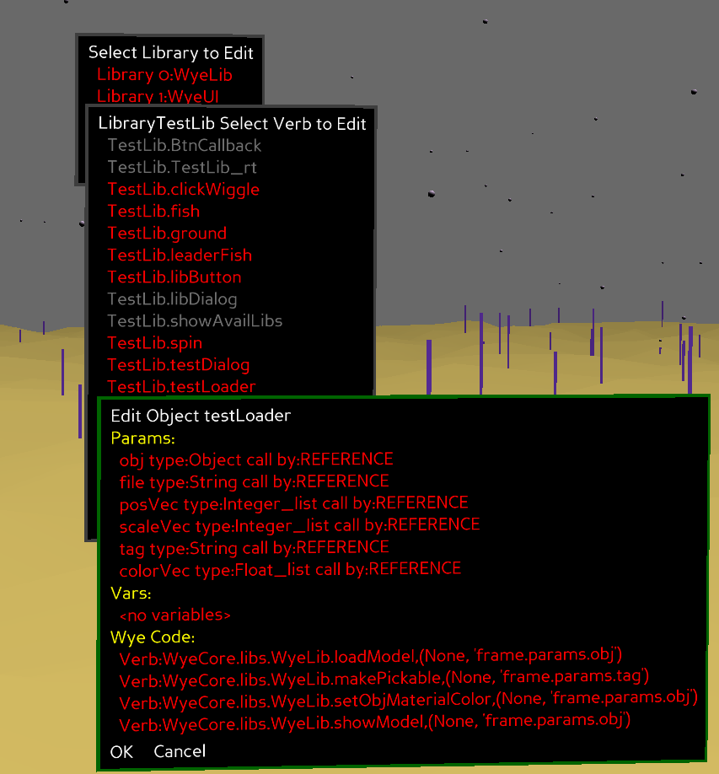

Fourth, check out the editor. Click on any of the fish objects to see what they look like. Shift-click to see the libraries. Click on WyeLib or TestLib and poke around the verbs defined there. Note that some verbs are coded directly in Python rather than Wye, and show in gray. In particular, the WyeUI is currently all low level Python.

