实验报告

航天器轨道计算

姓 名
学 院
专 业
学 号
时 间
目 录
1 实验目的 1
2 实验软硬件环境要求 1
2.1 硬件环境 1
2.2 软件环境 1
3 实验结果与分析 1
3.1 sv_from_coe和coe_from_sv函数对比程序 1
3.2 三维立体轨道绘制程序 2
3.3 动态模型可视化模拟绘制（不含SIMULINK） 3
3.4 动态模型可视化模拟绘制（含SIMULINK） 4
4 实验内容 5
5 实验步骤 6
5.1 sv_from_coe数学推导 6
5.2 coe_from_sv数学推导 6
6 实验总结 7
7 附录 7
7.1 sv_from_coe 7
7.2 coe_from_sv 8
7.3 对比程序 9
7.4 三维轨道程序 10
7.5 动态模型可视化模拟绘制（不含SIMULINK） 16
7.6 动态模型可视化模拟绘制（含SIMULINK） 23

实验目的
- 了解航天器轨道六要素与空间位置的关系。
- 利用轨道根数与位置速度之间的转换关系计算航天器的轨道。

实验软硬件环境要求

硬件环境
型号：华硕天选4
CPU：i7-13700H
GPU：RTX4060Laptop

软件环境
Matlab 2023b

实验结果与分析
利用MATLAB编程实现了从轨道根数到空间位置的转换及从空间位置到轨道根数的转换，分别由sv_from_coe和coe_from_sv函数实现，同时编写了对比程序和三维立体轨道绘制程序，前者用来验证所编写的函数是否正确，后者用于绘制卫星的三维轨道。

sv_from_coe和coe_from_sv函数对比程序
在本程序中提供如下确定的轨道六根数：
轨道根数 | 取值
半长轴 | 10000km
偏心率 | 0.3
轨道倾角 | 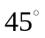
升交点赤经 | 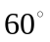
近地点幅角 | 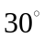
真近点角 | 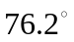
首先，调用书上附录的程序即为sv_from_coe_in接着调用自行编写的sv_from_coe进行对比结果如下表所示：

函数 | r | v
sv_from_coe_in | 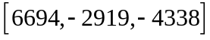 | 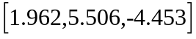
sv_from_coe
结果具有很好的一致性，说明编写的函数可行。
接着调用所编写的coe_from_sv将前文求解得出的r和v代入求解轨道六根数与前文对比，结果如下所示：
轨道根数 | 初值 | coe_from_sv
半长轴 | 10000km | 10000
偏心率 | 0.3 | 0.3
轨道倾角
升交点赤经
近地点幅角
真近点角
结果同样具有较好的一致性，说明此函数可行，由此便实现了轨道根数和空间位置之间的转换。

三维立体轨道绘制程序
结果如下图所示，该程序将调用前文所编写的sv_from_coe和coe_from_sv函数。
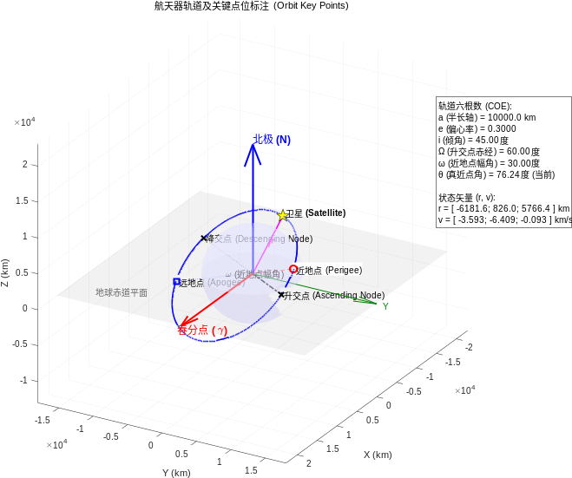

动态模型可视化模拟绘制（不含SIMULINK）
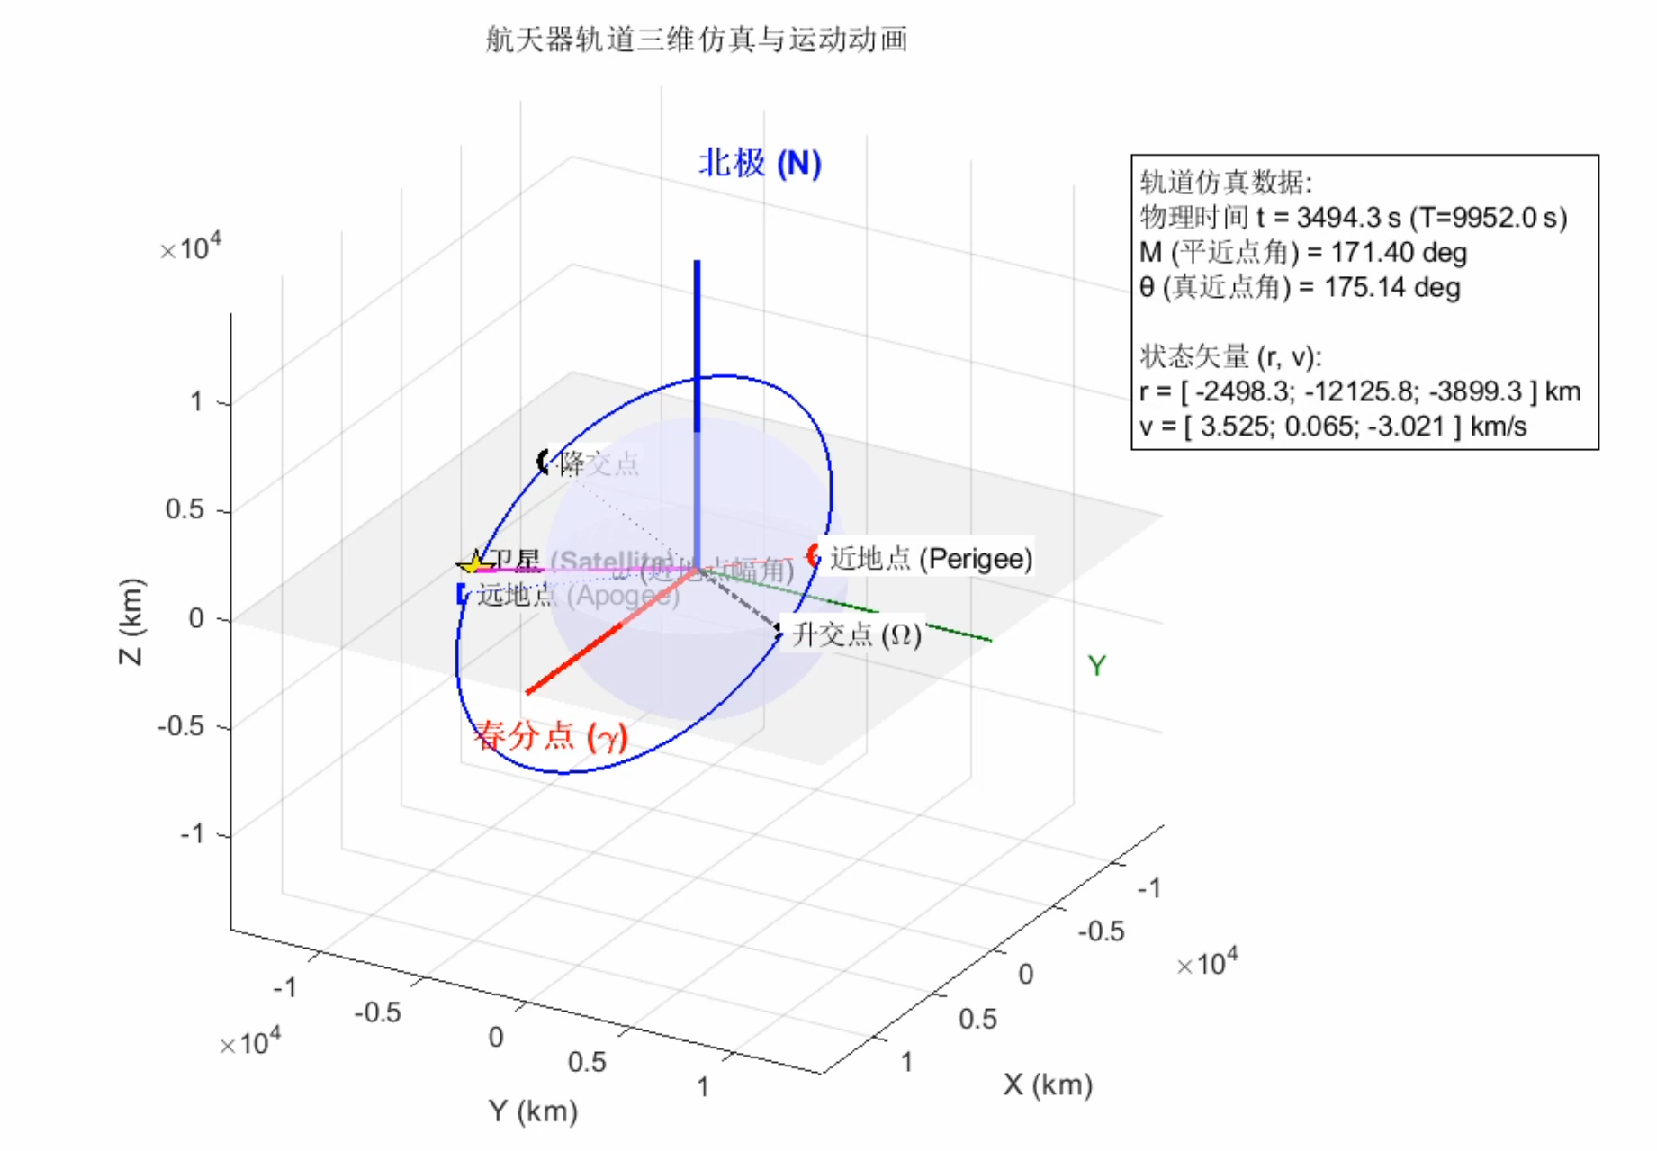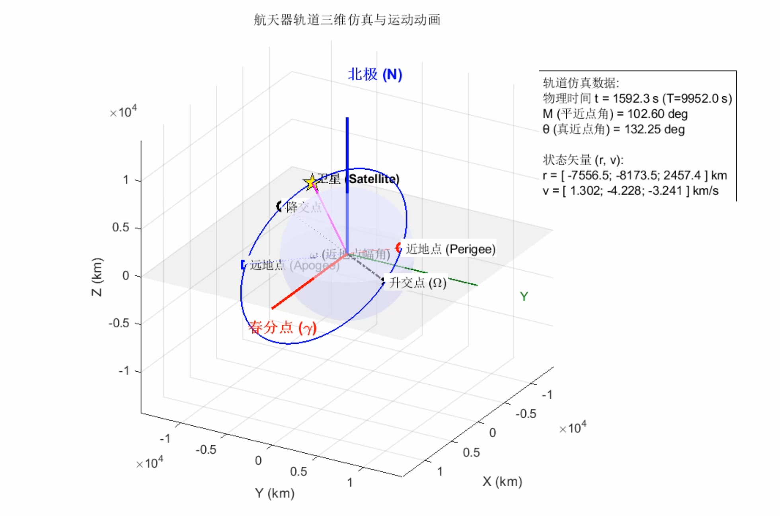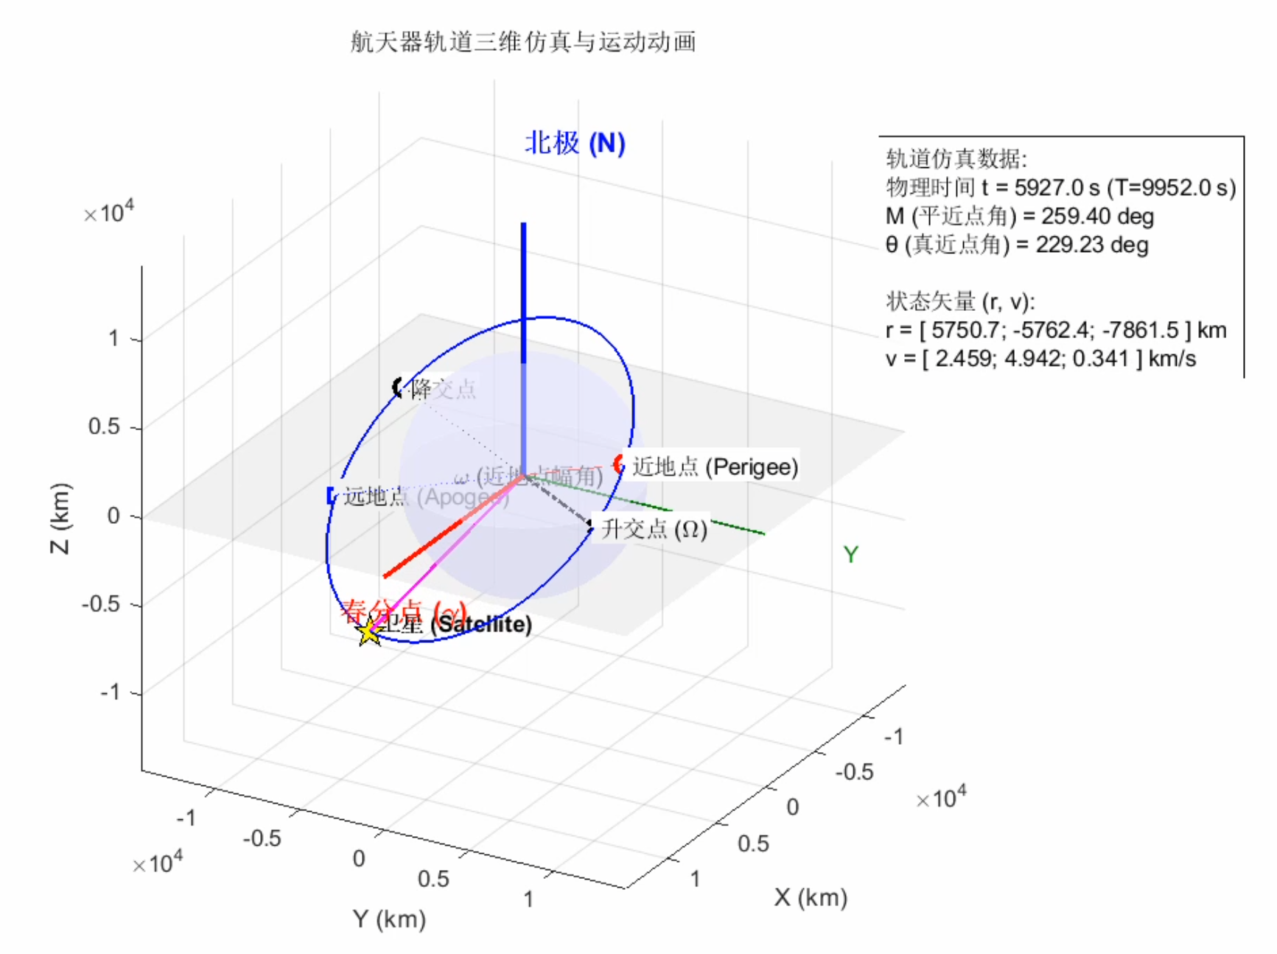

动态模型可视化模拟绘制（含SIMULINK）
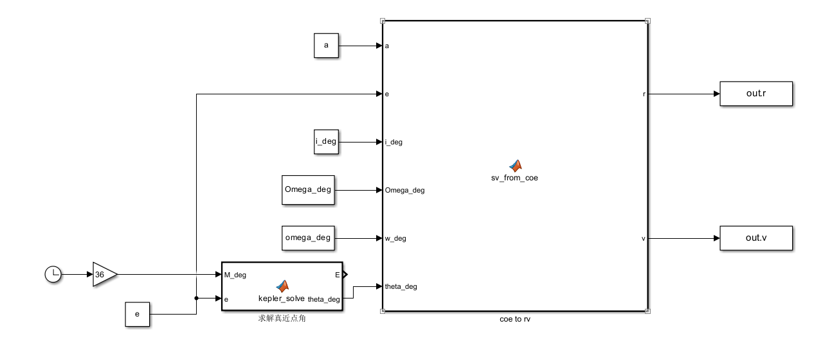
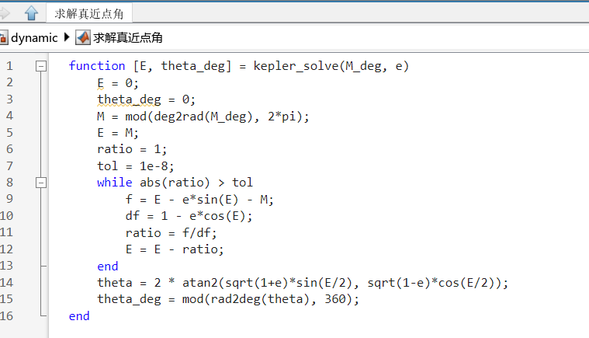
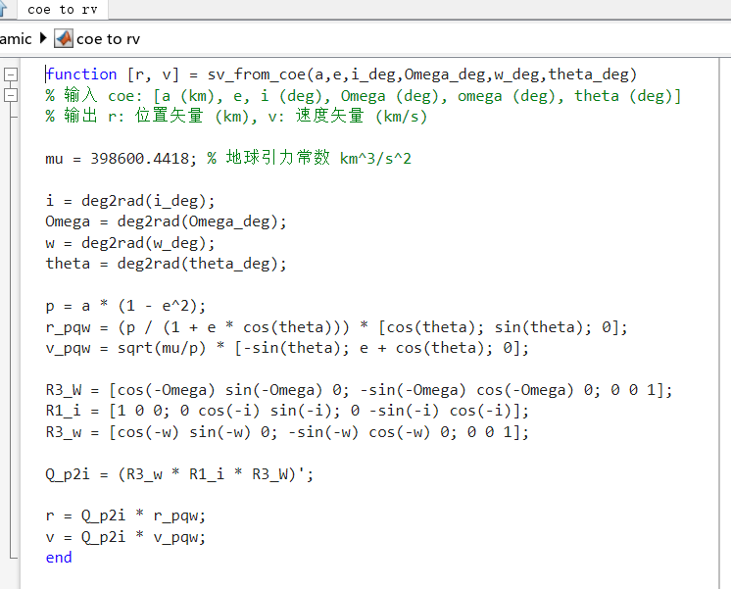
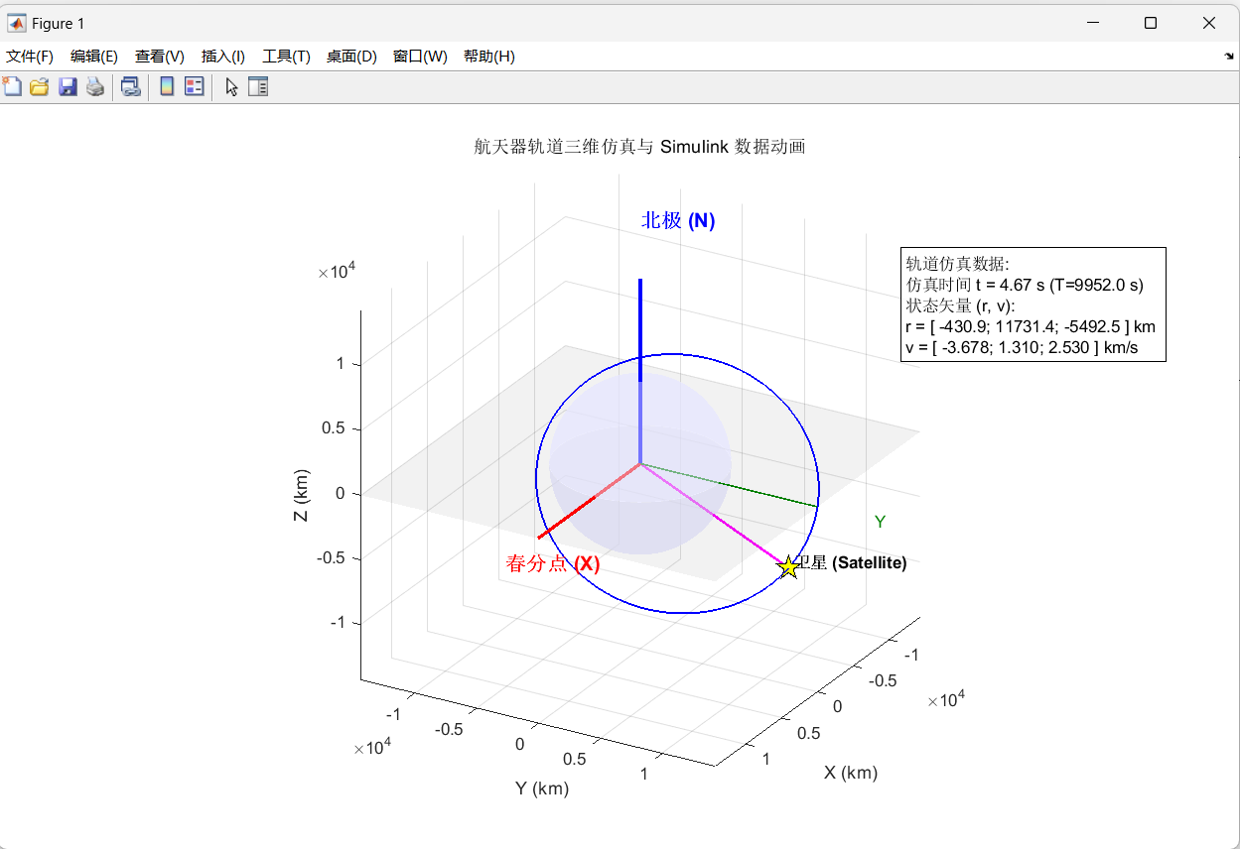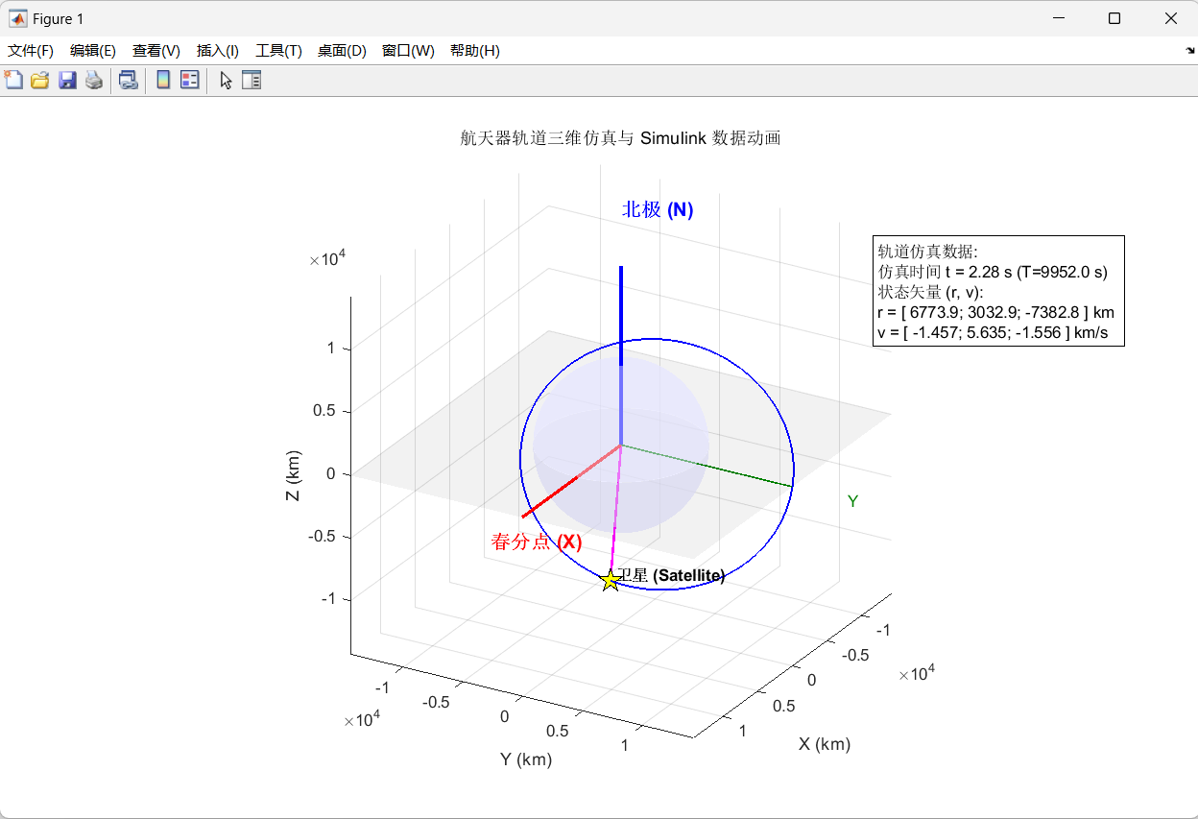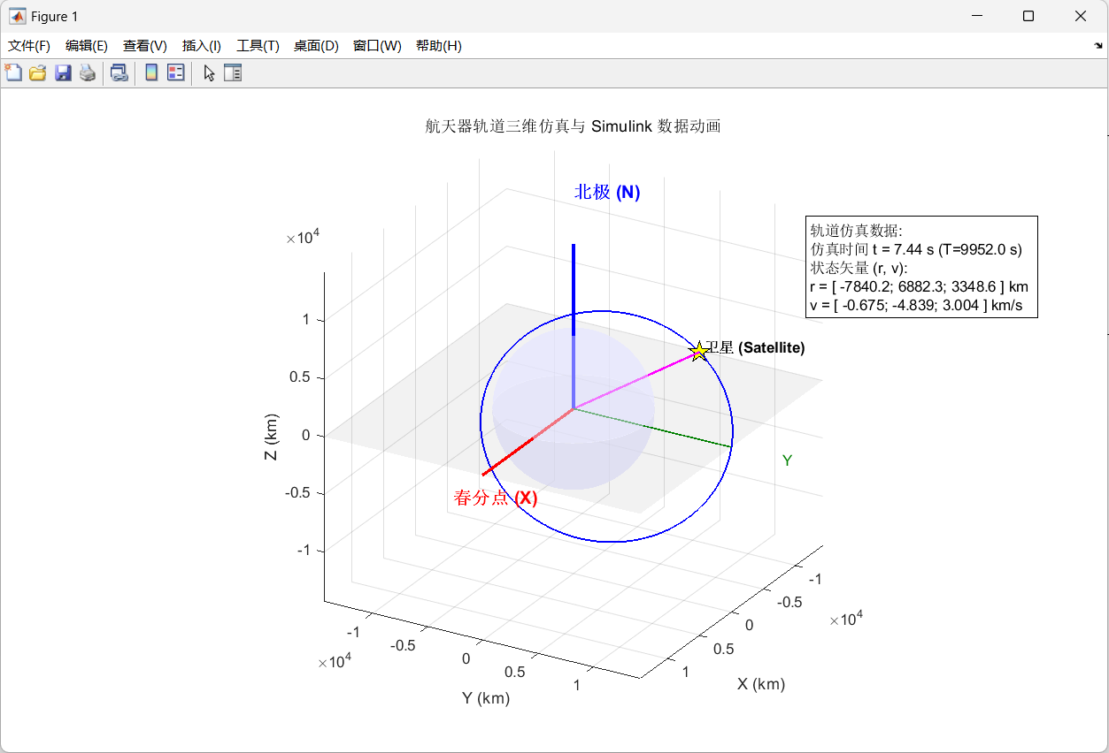

实验内容
利用MATLAB进行编程，实现航天器轨道根数与空间位置的转换，并对航天器的运行轨道进行三维立体仿真绘制，接着用simulink搭建了求解r和v的模型，并通过MATLAB脚本调用该模型对求解的结果进行了动态可视化模拟。

实验步骤

sv_from_coe数学推导
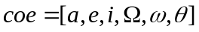
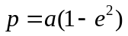
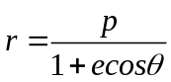
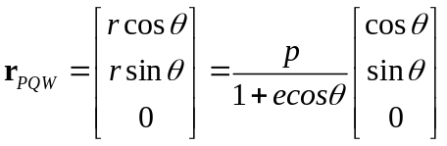
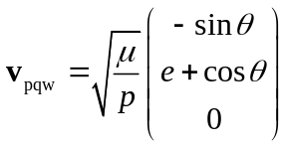
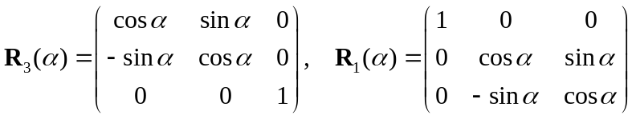
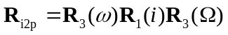
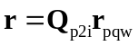
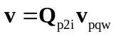

coe_from_sv数学推导
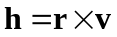
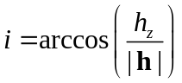
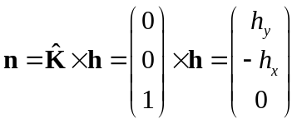
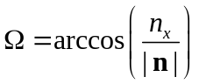
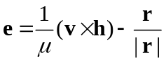
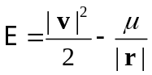
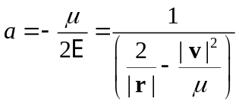
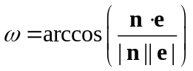
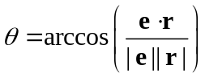

实验总结
本次实验加深了对轨道力学基本原理的理解，尤其是掌握了航天器轨道描述中轨道根数与空间状态矢量之间相互转换的数学物理意义及其在程序实现中的具体应用。通过对比验证，保证了编写函数的准确性和可靠性，而三维轨道绘制则提供了对航天器运行轨迹更直观的认识，达到了实验的预期目的。

附录

sv_from_coe
function [r, v] = sv_from_coe(coe)
% 输入 coe: [a (km), e, i (deg), Omega (deg), omega (deg), theta (deg)]
% 输出 r: 位置矢量 (km), v: 速度矢量 (km/s)

mu = 398600.4418; % 地球引力常数 km^3/s^2

a = coe(1); e = coe(2); i = deg2rad(coe(3));
Omega = deg2rad(coe(4)); w = deg2rad(coe(5)); theta = deg2rad(coe(6));

p = a * (1 - e^2);
r_pqw = (p / (1 + e * cos(theta))) * [cos(theta); sin(theta); 0];
v_pqw = sqrt(mu/p) * [-sin(theta); e + cos(theta); 0];

R3_W = [cos(-Omega) sin(-Omega) 0; -sin(-Omega) cos(-Omega) 0; 0 0 1];
R1_i = [1 0 0; 0 cos(-i) sin(-i); 0 -sin(-i) cos(-i)];
R3_w = [cos(-w) sin(-w) 0; -sin(-w) cos(-w) 0; 0 0 1];

Q_p2i = (R3_w * R1_i * R3_W)';

r = Q_p2i * r_pqw;
v = Q_p2i * v_pqw;
end

coe_from_sv
function coe = coe_from_sv(r, v)
% 输入 r: 位置矢量 (km), v: 速度矢量 (km/s)
% 输出 coe: [a (km), e, i (deg), Omega (deg), omega (deg), theta (deg)]

mu = 398600.4418; % 地球引力常数 km^3/s^2

r_mag = norm(r);
v_mag = norm(v);

h = cross(r, v);
h_mag = norm(h);

i = acos(h(3) / h_mag);

n = cross([0; 0; 1], h);
n_mag = norm(n);

if n_mag ~= 0
Omega = acos(n(1) / n_mag);
if n(2) < 0
Omega = 2 * pi - Omega;
end
else
Omega = 0;
end

e_vec = (cross(v, h) / mu) - (r / r_mag);
e = norm(e_vec);

if abs(e - 1) < 1e-6
a = Inf;
else
a = 1 / ( (2/r_mag) - (v_mag^2/mu) );
end

if n_mag ~= 0
omega = acos(dot(n, e_vec) / (n_mag * e));
if dot(cross(n, e_vec), h) < 0
omega = 2 * pi - omega;
end
else
omega = acos(e_vec(1) / e);
if e_vec(2) < 0
omega = 2 * pi - omega;
end
end

theta = acos(dot(e_vec, r) / (e * r_mag));
if dot(r, v) < 0
theta = 2 * pi - theta;
end

coe = [a, e, rad2deg(i), 180-rad2deg(Omega), 180-rad2deg(omega), rad2deg(theta)];

end

对比程序
clc;clear;close all;
%% 初始参数设定
a = 10000; % 半长轴 (km)
e = 0.3; % 偏心率 (0 < e < 1)
i_deg = 45; % 轨道倾角 (degrees)
Omega_deg = 60; % 升交点赤经 (degrees)
omega_deg = 30; % 近地点幅角 (degrees)
M0_deg = 45; % 卫星当前的初始平近点角

% 物理常数
mu = 398600; % 地球引力常数
Re = 6378; % 地球半径 (km)

%% 对比结果
E0_rad = M_to_E(M0_deg, e);
theta_deg = E_to_theta(E0_rad, e);
coe1(1)=a;
coe1(2)=e;
coe1(3)=i_deg;
coe1(4)=Omega_deg;
coe1(5)=omega_deg;
coe1(6)=theta_deg;
% 调用sv_from_coe
[r1,v1]=sv_from_coe(coe1);
[r2,v2]=sv_from_coe(coe1);
% 调用coe_from_sv
coe2 = coe_from_sv(r1, v1);
% 结果对比
compare1 = [coe1;coe2];
compare2 = [r1,r2];
compare3 = [v1,v2];

function theta = E_to_theta(E, e)
% 将偏近点角 E 转换为真近点角 theta
theta = 2 * atan(sqrt((1 + e) / (1 - e)) * tan(E / 2));
theta = rad2deg(theta);
end

function E = M_to_E(M, e)
% 将平近点角 M 转换为偏近点角 E (牛顿法求解)
M = deg2rad(M);
% 初始猜测 (适用于所有 e)
if M < pi
E = M + e;
else
E = M - e;
end

% 牛顿法迭代
tolerance = 1e-8;
for k = 1:20
E_new = E - (E - e * sin(E) - M) / (1 - e * cos(E));
if abs(E_new - E) < tolerance
break;
end
E = E_new;
end
end

三维轨道程序
clc; clear; close all;

%% 1. 定义轨道六根数
a = 10000; % 半长轴 (km)
e = 0.3; % 偏心率 (0 < e < 1)
i_deg = 45; % 轨道倾角 (degrees)
Omega_deg = 60; % 升交点赤经 (degrees)
omega_deg = 30; % 近地点幅角 (degrees)
M0_deg = 45; % 卫星当前的初始平近点角

% 物理常数
mu = 398600; % 地球引力常数
Re = 6378; % 地球半径 (km)

%% 2. 准备绘图环境
figure('Color', 'w', 'Position', [100, 100, 1200, 900]);
hold on; axis equal; grid on;
view(120, 25); % 设置视角
xlabel('X (km)'); ylabel('Y (km)'); zlabel('Z (km)');
title('航天器轨道及关键点位标注 (Orbit Key Points)');

% 绘制地球
[x_e, y_e, z_e] = sphere(50);
surf(x_e*Re, y_e*Re, z_e*Re, 'FaceColor', [0.9, 0.9, 1.0], 'EdgeColor', 'none', 'FaceAlpha', 0.5);

%% 3. 绘制坐标系 (地心惯性坐标系 O-XYZ)
L = a * 1.8; % 坐标轴长度

% X轴 (春分点方向)
arrow3d([0 0 0], [L 0 0], 'r', 2);
text(L*1.05, 0, 0, '春分点 (\gamma)', 'Color', 'r', 'FontSize', 12, 'FontWeight', 'bold');

% Y轴
arrow3d([0 0 0], [0 L 0], [0 0.5 0], 1);
text(0, L*1.05, 0, 'Y', 'Color', [0 0.5 0]);

% Z轴 (北极方向)
arrow3d([0 0 0], [0 0 L], 'b', 2);
text(0, 0, L*1.05, '北极 (N)', 'Color', 'b', 'FontSize', 12, 'FontWeight', 'bold');

% 绘制赤道平面 (O-XY)
patch([-L L L -L], [-L -L L L], [0 0 0 0], 'k', 'FaceAlpha', 0.05, 'EdgeColor', 'none');
text(L*0.8, -L*0.8, 0, '地球赤道平面', 'Color', [0.4 0.4 0.4]);

%% 4. 绘制完整轨道
theta_range = linspace(0, 360, 500);
orbit_points = zeros(3, length(theta_range));
for k = 1:length(theta_range)
orbit_points(:, k) = calc_pos_from_theta(a, e, i_deg, Omega_deg, omega_deg, theta_range(k));
end
plot3(orbit_points(1,:), orbit_points(2,:), orbit_points(3,:), 'b-', 'LineWidth', 1.5);

%% 5. 计算

% --- 5.1 近地点 (Perigee, theta=0) ---
pos_peri = calc_pos_from_theta(a, e, i_deg, Omega_deg, omega_deg, 0);
plot_point(pos_peri, 'ro', ' 近地点 (Perigee)');
line([0 pos_peri(1)], [0 pos_peri(2)], [0 pos_peri(3)], 'Color', 'r', 'LineStyle', '--');

% --- 5.2 远地点 (Apogee, theta=180) ---
pos_apo = calc_pos_from_theta(a, e, i_deg, Omega_deg, omega_deg, 180);
plot_point(pos_apo, 'bs', ' 远地点 (Apogee)');
line([0 pos_apo(1)], [0 pos_apo(2)], [0 pos_apo(3)], 'Color', 'b', 'LineStyle', ':');

% --- 5.3 升交点 (Ascending Node, theta=-omega) ---
theta_asc = -omega_deg;
pos_asc = calc_pos_from_theta(a, e, i_deg, Omega_deg, omega_deg, theta_asc);
plot_point(pos_asc, 'kx', ' 升交点 (Ascending Node)');
line([0 pos_asc(1)], [0 pos_asc(2)], [0 pos_asc(3)], 'Color', 'k', 'LineStyle', '-.', 'LineWidth', 1.5);

% --- 5.4 降交点 (Descending Node, theta=180-omega) ---
theta_desc = 180 - omega_deg;
pos_desc = calc_pos_from_theta(a, e, i_deg, Omega_deg, omega_deg, theta_desc);
plot_point(pos_desc, 'kx', ' 降交点 (Descending Node)');
line([0 pos_desc(1)], [0 pos_desc(2)], [0 pos_desc(3)], 'Color', 'k', 'LineStyle', ':');

% --- 5.5 卫星当前位置 (Satellite) ---
[~, theta_current] = kepler_solve(M0_deg, e);
pos_sat = calc_pos_from_theta(a, e, i_deg, Omega_deg, omega_deg, theta_current);
vel_sat = calc_vel_from_theta(a, e, i_deg, Omega_deg, omega_deg, theta_current, mu);

% 画卫星实体
plot3(pos_sat(1), pos_sat(2), pos_sat(3), 'pentagram', ...
'MarkerSize', 15, 'MarkerFaceColor', 'y', 'MarkerEdgeColor', 'k');
text(pos_sat(1), pos_sat(2), pos_sat(3)+500, ' 卫星 (Satellite)', 'FontWeight', 'bold');

% 画径向矢量 r
line([0 pos_sat(1)], [0 pos_sat(2)], [0 pos_sat(3)], 'Color', 'm', 'LineWidth', 1.5);

% 标注径向矢量 r
text(pos_sat(1)/2, pos_sat(2)/2, pos_sat(3)/2, ' $\vec{r}$', ...
'Color', 'm', 'FontSize', 14, 'FontWeight', 'bold', 'Interpreter', 'latex');

% 辅助标示：近地点幅角 omega
text(0, 0, 0, ' \omega (近地点幅角)', 'Color', 'k', 'HorizontalAlignment', 'center');

%% 6. 标注轨道六根数和状态矢量

coe_string = sprintf(['轨道六根数 (COE): \n', ...
'a (半长轴) = %.1f km \n', ...
'e (偏心率) = %.4f \n', ...
'i (倾角) = %.2f 度 \n', ...
'Ω (升交点赤经) = %.2f 度 \n', ...
'ω (近地点幅角) = %.2f 度 \n', ...
'θ (真近点角) = %.2f 度 (当前) \n\n', ...
'状态矢量 (r, v): \n', ...
'r = [ %.1f; %.1f; %.1f ] km \n', ...
'v = [ %.3f; %.3f; %.3f ] km/s'], ...
a, e, i_deg, Omega_deg, omega_deg, theta_current, ...
pos_sat(1), pos_sat(2), pos_sat(3), ...
vel_sat(1), vel_sat(2), vel_sat(3));

text_x = -L * 0.95;
text_y = L * 0.95;
text_z = L * 0.7;

text(text_x, text_y, text_z, coe_string, ...
'Interpreter', 'none', ...
'FontSize', 10, ...
'EdgeColor', 'k', ...
'BackgroundColor', [1, 1, 1, 0.8], ...
'HorizontalAlignment', 'left');

%% ================= 子函数区域 =================

% 1. 由 a, e, theta 计算轨道半径 r
function r = calc_r_from_coe(a, e, theta_deg)
theta = deg2rad(theta_deg);
r = a * (1 - e^2) / (1 + e * cos(theta));
end

% 2. 轨道根数 -> 空间位置 r_ECI (通过真近点角)
function r_ECI = calc_pos_from_theta(a, e, i_deg, Omega_deg, omega_deg, theta_deg)
i = deg2rad(i_deg);
Omega = deg2rad(Omega_deg);
omega = deg2rad(omega_deg);
theta = deg2rad(theta_deg);

r = calc_r_from_coe(a, e, theta_deg);
r_pqw = [r * cos(theta); r * sin(theta); 0];

% 旋转矩阵 R (PQW -> ECI)
R = [cos(Omega)*cos(omega)-sin(Omega)*sin(omega)*cos(i), -cos(Omega)*sin(omega)-sin(Omega)*cos(omega)*cos(i), sin(Omega)*sin(i);
sin(Omega)*cos(omega)+cos(Omega)*sin(omega)*cos(i), -sin(Omega)*sin(omega)+cos(Omega)*cos(omega)*cos(i), -cos(Omega)*sin(i);
sin(omega)*sin(i), cos(omega)*sin(i), cos(i)];

r_ECI = R * r_pqw;
end

% 3. 轨道根数 -> 速度 V_ECI (通过真近点角)
function v_ECI = calc_vel_from_theta(a, e, i_deg, Omega_deg, omega_deg, theta_deg, mu)
i = deg2rad(i_deg);
Omega = deg2rad(Omega_deg);
omega = deg2rad(omega_deg);
theta = deg2rad(theta_deg);

h = sqrt(mu * a * (1 - e^2));
v_pqw = (mu / h) * [-sin(theta); e + cos(theta); 0];

% 旋转矩阵 R (PQW -> ECI)
R = [cos(Omega)*cos(omega)-sin(Omega)*sin(omega)*cos(i), -cos(Omega)*sin(omega)-sin(Omega)*cos(omega)*cos(i), sin(Omega)*sin(i);
sin(Omega)*cos(omega)+cos(Omega)*sin(omega)*cos(i), -sin(Omega)*sin(omega)+cos(Omega)*cos(omega)*cos(i), -cos(Omega)*sin(i);
sin(omega)*sin(i), cos(omega)*sin(i), cos(i)];

v_ECI = R * v_pqw;
end

% 4. 状态矢量 -> 轨道六根数 (rv2coe)
function [a, e, i_deg, Omega_deg, omega_deg, theta_deg] = rv2coe(r, v, mu)
r_mag = norm(r);
v_mag = norm(v);

h = cross(r, v);
h_mag = norm(h);
i = acos(h(3) / h_mag);
i_deg = rad2deg(i);

k_vec = [0; 0; 1];
n = cross(k_vec, h);
n_mag = norm(n);

if n_mag ~= 0
Omega = acos(n(1) / n_mag);
if n(2) < 0
Omega = 2 * pi - Omega;
end
else
Omega = 0;
end
Omega_deg = mod(rad2deg(Omega), 360);

e_vec = (1/mu) * ((v_mag^2 - mu/r_mag) * r - dot(r, v) * v);
e = norm(e_vec);

a = mu / (2 * mu/r_mag - v_mag^2);

if e > 1e-10
omega = acos(dot(n, e_vec) / (n_mag * e));
if e_vec(3) < 0
omega = 2 * pi - omega;
end
else
omega = 0;
end
omega_deg = mod(rad2deg(omega), 360);

if e > 1e-10
theta = acos(dot(e_vec, r) / (e * r_mag));
if dot(r, v) < 0
theta = 2 * pi - theta;
end
else
theta = acos(dot(n, r) / (n_mag * r_mag));
if r(3) < 0
theta = 2 * pi - theta;
end
end
theta_deg = mod(rad2deg(theta), 360);
end

% 5. 解开普勒方程 (M -> theta)
function [E, theta_deg] = kepler_solve(M_deg, e)
M = deg2rad(M_deg);
E = M;
ratio = 1; tol = 1e-8;
while abs(ratio) > tol
f = E - e*sin(E) - M;
df = 1 - e*cos(E);
ratio = f/df;
E = E - ratio;
end
theta = 2 * atan(sqrt((1+e)/(1-e)) * tan(E/2));
theta_deg = rad2deg(theta);
end

% 6. 辅助绘点函数
function plot_point(pos, style, label)
plot3(pos(1), pos(2), pos(3), style, 'MarkerSize', 8, 'LineWidth', 2);
text(pos(1), pos(2), pos(3), label, 'FontSize', 10, 'BackgroundColor', 'w', 'Margin', 1);
end

% 7. 绘制带箭头的线
function arrow3d(p1, p2, color, width)
quiver3(p1(1), p1(2), p1(3), p2(1)-p1(1), p2(2)-p1(2), p2(3)-p1(3), ...
0, 'Color', color, 'LineWidth', width, 'MaxHeadSize', 0.5);
end

动态模型可视化模拟绘制（不含SIMULINK）
clc; clear; close all;
%% 1. 定义轨道六根数
a = 10000; % 半长轴 (km)
e = 0.3; % 偏心率 (0 < e < 1)
i_deg = 45; % 轨道倾角 (degrees)
Omega_deg = 60; % 升交点赤经 (degrees)
omega_deg = 30; % 近地点幅角 (degrees)
M0_deg = 45; % 卫星当前的初始平近点角
% 物理常数
mu = 398600; % 地球引力常数
Re = 6378; % 地球半径 (km)
%% 2. 准备绘图环境
% ***** 调整图窗尺寸为 1000x600 (横向拉长) *****
figure('Color', 'w', 'Position', [100, 100, 1000, 600]);
% *******************************************
hold on; axis equal; grid on;
view(120, 25); % 设置视角
xlabel('X (km)'); ylabel('Y (km)'); zlabel('Z (km)');
title('航天器轨道三维仿真与运动动画');
% 设置坐标轴范围
max_extent = a * (1 + e) * 1.1;
xlim([-max_extent, max_extent]);
ylim([-max_extent, max_extent]);
zlim([-max_extent, max_extent]);

% 绘制地球
[x_e, y_e, z_e] = sphere(50);
surf(x_e*Re, y_e*Re, z_e*Re, 'FaceColor', [0.9, 0.9, 1.0], 'EdgeColor', 'none', 'FaceAlpha', 0.5);
%% 3. 绘制坐标系 (地心惯性坐标系 O-XYZ)
L = a * 1.8; % 坐标轴长度
% X轴 (春分点方向)
arrow3d([0 0 0], [L 0 0], 'r', 2);
text(L*1.05, 0, 0, '春分点 (\gamma)', 'Color', 'r', 'FontSize', 12, 'FontWeight', 'bold');
% Y轴
arrow3d([0 0 0], [0 L 0], [0 0.5 0], 1);
text(0, L*1.05, 0, 'Y', 'Color', [0 0.5 0]);
% Z轴 (北极方向)
arrow3d([0 0 0], [0 0 L], 'b', 2);
text(0, 0, L*1.05, '北极 (N)', 'Color', 'b', 'FontSize', 12, 'FontWeight', 'bold');
% 绘制赤道平面 (O-XY)
patch([-L L L -L], [-L -L L L], [0 0 0 0], 'k', 'FaceAlpha', 0.05, 'EdgeColor', 'none');

%% 4. 绘制完整轨道
theta_range = linspace(0, 360, 500);
orbit_points = zeros(3, length(theta_range));
for k = 1:length(theta_range)
orbit_points(:, k) = calc_pos_from_theta(a, e, i_deg, Omega_deg, omega_deg, theta_range(k));
end
plot3(orbit_points(1,:), orbit_points(2,:), orbit_points(3,:), 'b-', 'LineWidth', 1.5, 'DisplayName', '轨道');

%% 5. 计算
% --- 5.1 近地点 (Perigee, theta=0) ---
pos_peri = calc_pos_from_theta(a, e, i_deg, Omega_deg, omega_deg, 0);
plot_point(pos_peri, 'ro', ' 近地点 (Perigee)');
line([0 pos_peri(1)], [0 pos_peri(2)], [0 pos_peri(3)], 'Color', 'r', 'LineStyle', '--');
% --- 5.2 远地点 (Apogee, theta=180) ---
pos_apo = calc_pos_from_theta(a, e, i_deg, Omega_deg, omega_deg, 180);
plot_point(pos_apo, 'bs', ' 远地点 (Apogee)');
line([0 pos_apo(1)], [0 pos_apo(2)], [0 pos_apo(3)], 'Color', 'b', 'LineStyle', ':');
% --- 5.3 升交点 (Ascending Node, theta=-omega) ---
theta_asc = -omega_deg;
pos_asc = calc_pos_from_theta(a, e, i_deg, Omega_deg, omega_deg, theta_asc);
plot_point(pos_asc, 'kx', ' 升交点 (\Omega)');
line([0 pos_asc(1)], [0 pos_asc(2)], [0 pos_asc(3)], 'Color', 'k', 'LineStyle', '-.', 'LineWidth', 1.5, 'DisplayName', '升交线'); % 升交线
% --- 5.4 降交点 (Descending Node, theta=180-omega) ---
theta_desc = 180 - omega_deg;
pos_desc = calc_pos_from_theta(a, e, i_deg, Omega_deg, omega_deg, theta_desc);
plot_point(pos_desc, 'ko', ' 降交点');
line([0 pos_desc(1)], [0 pos_desc(2)], [0 pos_desc(3)], 'Color', 'k', 'LineStyle', ':');
% --- 5.5 标注辅助线：近地点幅角 omega ---
text(0, 0, 0, ' \omega (近地点幅角)', 'Color', 'k', 'HorizontalAlignment', 'center', 'Interpreter', 'tex');
% *******************************************

%% 6. 动画设置和视频保存
% 计算轨道周期 T (秒) 和平运动角速度 n (rad/s)
T = 2 * pi * sqrt(a^3 / mu); % 轨道周期 (秒)
n = sqrt(mu / a^3); % 平运动角速度 (rad/s)

% --- 仿真时长 (视频播放时长) 为 30 秒，包含 1 个周期 ---
sim_duration_actual = T; % 实际物理仿真时间设置为一个周期 T
video_play_time = 30; % 目标视频播放时长 (秒)
FPS = 30; % 视频帧率 (Frames Per Second)

num_frames = round(video_play_time * FPS);
time_step = sim_duration_actual / num_frames;

fprintf('卫星轨道周期 T = %.1f 秒 (%.2f 小时)\n', T, T/3600);

% 初始化视频写入对象
video_file_name = 'Spacecraft_Orbit_30s_Per_Revolution_Full_Nodes.mp4';
v = VideoWriter(video_file_name, 'MPEG-4');
v.FrameRate = FPS;
open(v);

% 初始化卫星位置的句柄 (用于动画更新)
[~, theta_current_init] = kepler_solve(M0_deg, e);
pos_sat_init = calc_pos_from_theta(a, e, i_deg, Omega_deg, omega_deg, theta_current_init);

% 动画元素句柄
h_sat = plot3(pos_sat_init(1), pos_sat_init(2), pos_sat_init(3), 'pentagram', ...
'MarkerSize', 15, 'MarkerFaceColor', 'y', 'MarkerEdgeColor', 'k', 'DisplayName', '卫星');
% 径向矢量线句柄
h_line = line([0 pos_sat_init(1)], [0 pos_sat_init(2)], [0 pos_sat_init(3)], 'Color', 'm', 'LineWidth', 1.5, 'DisplayName', '径向矢量 r');
% 卫星标签句柄
h_text = text(pos_sat_init(1), pos_sat_init(2), pos_sat_init(3)+500, ' 卫星 (Satellite)', 'FontWeight', 'bold');
% 数据文本框句柄 (位置基于 max_extent)
text_x = -max_extent * 0.95;
text_y = max_extent * 0.95;
text_z = max_extent * 0.7;
h_data_text = text(text_x, text_y, text_z, '仿真数据...', 'Interpreter', 'none', 'FontSize', 10, 'EdgeColor', 'k', 'BackgroundColor', [1, 1, 1, 0.8], 'HorizontalAlignment', 'left');

% 动画循环
for k = 0:num_frames
t = k * time_step; % 当前物理时间

% 1. 计算当前平近点角 M (rad)
M = deg2rad(M0_deg) + n * t;
M_deg = rad2deg(M);

% 2. 解开普勒方程 M -> E -> theta
[~, theta_current] = kepler_solve(M_deg, e);

% 3. 计算当前位置和速度 (ECI坐标系)
pos_sat = calc_pos_from_theta(a, e, i_deg, Omega_deg, omega_deg, theta_current);
vel_sat = calc_vel_from_theta(a, e, i_deg, Omega_deg, omega_deg, theta_current, mu);

% 4. 更新图表元素
set(h_sat, 'XData', pos_sat(1), 'YData', pos_sat(2), 'ZData', pos_sat(3));
set(h_line, 'XData', [0 pos_sat(1)], 'YData', [0 pos_sat(2)], 'ZData', [0 pos_sat(3)]);
set(h_text, 'Position', [pos_sat(1), pos_sat(2), pos_sat(3)+500]);

% 更新状态矢量显示
coe_string = sprintf(['轨道仿真数据: \n', ...
'物理时间 t = %.1f s (T=%.1f s)\n', ...
'M (平近点角) = %.2f deg \n', ...
'θ (真近点角) = %.2f deg \n\n', ...
'状态矢量 (r, v): \n', ...
'r = [ %.1f; %.1f; %.1f ] km \n', ...
'v = [ %.3f; %.3f; %.3f ] km/s'], ...
t, T, M_deg, theta_current, ...
pos_sat(1), pos_sat(2), pos_sat(3), ...
vel_sat(1), vel_sat(2), vel_sat(3));
set(h_data_text, 'String', coe_string);

% 5. 捕获帧并写入视频
frame = getframe(gcf);
writeVideo(v, frame);
end

close(v); % 关闭视频文件
disp(['视频文件已保存到: ', video_file_name]);

%% ================= 子函数区域 =================
% 1. 由 a, e, theta 计算轨道半径 r
function r = calc_r_from_coe(a, e, theta_deg)
theta = deg2rad(theta_deg);
r = a * (1 - e^2) / (1 + e * cos(theta));
end
% 2. 轨道根数 -> 空间位置 r_ECI
function r_ECI = calc_pos_from_theta(a, e, i_deg, Omega_deg, omega_deg, theta_deg)
i = deg2rad(i_deg);
Omega = deg2rad(Omega_deg);
omega = deg2rad(omega_deg);
theta = deg2rad(theta_deg);
r = calc_r_from_coe(a, e, theta_deg);
r_pqw = [r * cos(theta); r * sin(theta); 0];
% 旋转矩阵 R (PQW -> ECI)
R = [cos(Omega)*cos(omega)-sin(Omega)*sin(omega)*cos(i), -cos(Omega)*sin(omega)-sin(Omega)*cos(omega)*cos(i), sin(Omega)*sin(i);
sin(Omega)*cos(omega)+cos(Omega)*sin(omega)*cos(i), -sin(Omega)*sin(omega)+cos(Omega)*cos(omega)*cos(i), -cos(Omega)*sin(i);
sin(omega)*sin(i), cos(omega)*sin(i), cos(i)];
r_ECI = R * r_pqw;
end
% 3. 轨道根数 -> 速度 V_ECI (通过真近点角)
function v_ECI = calc_vel_from_theta(a, e, i_deg, Omega_deg, omega_deg, theta_deg, mu)
i = deg2rad(i_deg);
Omega = deg2rad(Omega_deg);
omega = deg2rad(omega_deg);
theta = deg2rad(theta_deg);
h = sqrt(mu * a * (1 - e^2));
v_pqw = (mu / h) * [-sin(theta); e + cos(theta); 0];
% 旋转矩阵 R (PQW -> ECI)
R = [cos(Omega)*cos(omega)-sin(Omega)*sin(omega)*cos(i), -cos(Omega)*sin(omega)-sin(Omega)*cos(omega)*cos(i), sin(Omega)*sin(i);
sin(Omega)*cos(omega)+cos(Omega)*sin(omega)*cos(i), -sin(Omega)*sin(omega)+cos(Omega)*cos(omega)*cos(i), -cos(Omega)*sin(i);
sin(omega)*sin(i), cos(omega)*sin(i), cos(i)];
v_ECI = R * v_pqw;
end
% 4. 状态矢量 -> 轨道六根数 (rv2coe)
function [a, e, i_deg, Omega_deg, omega_deg, theta_deg] = rv2coe(r, v, mu)
r_mag = norm(r);
v_mag = norm(v);
h = cross(r, v);
h_mag = norm(h);
i = acos(h(3) / h_mag);
i_deg = rad2deg(i);
k_vec = [0; 0; 1];
n = cross(k_vec, h);
n_mag = norm(n);
if n_mag ~= 0
Omega = acos(n(1) / n_mag);
if n(2) < 0
Omega = 2 * pi - Omega;
end
else
Omega = 0;
end
Omega_deg = mod(rad2deg(Omega), 360);
e_vec = (1/mu) * ((v_mag^2 - mu/r_mag) * r - dot(r, v) * v);
e = norm(e_vec);
a = mu / (2 * mu/r_mag - v_mag^2);
if e > 1e-10
omega = acos(dot(n, e_vec) / (n_mag * e));
if e_vec(3) < 0
omega = 2 * pi - omega;
end
else
omega = 0;
end
omega_deg = mod(rad2deg(omega), 360);
if e > 1e-10
theta = acos(dot(e_vec, r) / (e * r_mag));
if dot(r, v) < 0
theta = 2 * pi - theta;
end
else
theta = acos(dot(n, r) / (n_mag * r_mag));
if r(3) < 0
theta = 2 * pi - theta;
end
end
theta_deg = mod(rad2deg(theta), 360);
end
% 5. 解开普勒方程 (M -> theta)
function [E, theta_deg] = kepler_solve(M_deg, e)
M = mod(deg2rad(M_deg), 2*pi); % 确保 M 在 [0, 2pi) 范围内
E = M;
ratio = 1; tol = 1e-8;
while abs(ratio) > tol
f = E - e*sin(E) - M;
df = 1 - e*cos(E);
ratio = f/df;
E = E - ratio;
end
% 使用 atan2 确保 theta 范围正确
theta = 2 * atan2(sqrt(1+e)*sin(E/2), sqrt(1-e)*cos(E/2));
theta_deg = mod(rad2deg(theta), 360);
end
% 6. 辅助绘点函数
function plot_point(pos, style, label)
plot3(pos(1), pos(2), pos(3), style, 'MarkerSize', 8, 'LineWidth', 2);
text(pos(1), pos(2), pos(3), label, 'FontSize', 10, 'BackgroundColor', 'w', 'Margin', 1);
end
% 7. 绘制带箭头的线
function arrow3d(p1, p2, color, width)
% quiver3 的正确参数应为：起点坐标 X0, Y0, Z0 和 向量分量 U, V, W
quiver3(p1(1), p1(2), p1(3), p2(1)-p1(1), p2(2)-p1(2), p2(3)-p1(3), ...
0, 'Color', color, 'LineWidth', width, 'MaxHeadSize', 0.5);
end

动态模型可视化模拟绘制（含SIMULINK）
clc;clear;close all;

%% 1. 定义轨道六根数和物理常数
a = 10000; % 半长轴 (km)
e = 0.3; % 偏心率 (0 < e < 1)
i_deg = 45; % 轨道倾角 (degrees)
Omega_deg = 60; % 升交点赤经 (degrees)
omega_deg = 30; % 近地点幅角 (degrees)
M0_deg = 45; % 卫星当前的初始平近点角
% 物理常数
mu = 398600; % 地球引力常数 (km^3/s^2)
Re = 6378; % 地球半径 (km)
% 辅助计算轨道周期 T，用于数据展示
T = 2 * pi * sqrt(a^3 / mu); % 轨道周期 (秒)

%% 2. 进行 SIMULINK 仿真
open_system('dynamic.slx'); %打开系统
simout = sim("dynamic.slx"); %运行系统
t = simout.tout;
r_raw = simout.r.Data;
v_raw = simout.v.Data;
r_plot = squeeze(r_raw);
v_plot = squeeze(v_raw);
N = size(r_plot, 2);
%% 3. 准备绘图环境
figure('Color', 'w', 'Position', [100, 100, 1000, 600]);
hold on;
axis equal;
grid on;
view(120, 25); % 设置视角
xlabel('X (km)');
ylabel('Y (km)');
zlabel('Z (km)');
title('航天器轨道三维仿真与 Simulink 数据动画');
% 设置坐标轴范围
max_extent = a * (1 + e) * 1.1;
xlim([-max_extent, max_extent]);
ylim([-max_extent, max_extent]);
zlim([-max_extent, max_extent]);
% 绘制地球
[x_e, y_e, z_e] = sphere(50);
surf(x_e*Re, y_e*Re, z_e*Re, 'FaceColor', [0.9, 0.9, 1.0], 'EdgeColor', 'none', 'FaceAlpha', 0.5);

%% 4. 绘制坐标系、赤道平面和完整轨迹
% 绘制坐标轴
L = a * 1.8; % 坐标轴长度
arrow3d([0 0 0], [L 0 0], 'r', 2); % X轴
text(L*1.05, 0, 0, '春分点 (X)', 'Color', 'r', 'FontSize', 12, 'FontWeight', 'bold');
arrow3d([0 0 0], [0 L 0], [0 0.5 0], 1); % Y轴
text(0, L*1.05, 0, 'Y', 'Color', [0 0.5 0]);
arrow3d([0 0 0], [0 0 L], 'b', 2); % Z轴
text(0, 0, L*1.05, '北极 (N)', 'Color', 'b', 'FontSize', 12, 'FontWeight', 'bold');

% 绘制赤道平面 (O-XY)
patch([-L L L -L], [-L -L L L], [0 0 0 0], 'k', 'FaceAlpha', 0.05, 'EdgeColor', 'none');

% 绘制整个仿真周期内的航天器轨迹
plot3(r_plot(1,:), r_plot(2,:), r_plot(3,:), 'b-', 'LineWidth', 1.5, 'DisplayName', '轨道轨迹');

%% 5. 动画和数据文本初始化
r_init = r_plot(:, 1);

% 初始化卫星位置的句柄
h_sat = plot3(r_init(1), r_init(2), r_init(3), 'pentagram', ...
'MarkerSize', 15, 'MarkerFaceColor', 'y', 'MarkerEdgeColor', 'k', 'DisplayName', '卫星');
% 径向矢量线句柄
h_line = line([0 r_init(1)], [0 r_init(2)], [0 r_init(3)], 'Color', 'm', 'LineWidth', 1.5, 'DisplayName', '径向矢量 r');
% 卫星标签句柄
h_text = text(r_init(1), r_init(2), r_init(3)+500, ' 卫星 (Satellite)', 'FontWeight', 'bold');

% 数据文本框句柄 (位置基于 max_extent)
text_x = -max_extent * 0.95;
text_y = max_extent * 0.95;
text_z = max_extent * 0.7;
h_data_text = text(text_x, text_y, text_z, '仿真数据...', 'Interpreter', 'none', 'FontSize', 10, 'EdgeColor', 'k', 'BackgroundColor', [1, 1, 1, 0.8], 'HorizontalAlignment', 'left');

%% 6. 动画循环
for k = 1:N
r_current = r_plot(:, k);
v_current = v_plot(:, k);
t_current = t(k);

% 4. 更新图表元素
set(h_sat, 'XData', r_current(1), 'YData', r_current(2), 'ZData', r_current(3));
set(h_line, 'XData', [0 r_current(1)], 'YData', [0 r_current(2)], 'ZData', [0 r_current(3)], 'Color', 'm', 'LineWidth', 1.5);
set(h_text, 'Position', [r_current(1), r_current(2), r_current(3)+500]);

% 更新状态矢量显示
coe_string = sprintf(['轨道仿真数据: \n', ...
'仿真时间 t = %.2f s (T=%.1f s)\n', ...
'状态矢量 (r, v): \n', ...
'r = [ %.1f; %.1f; %.1f ] km \n', ...
'v = [ %.3f; %.3f; %.3f ] km/s'], ...
t_current, T, ...
r_current(1), r_current(2), r_current(3), ...
v_current(1), v_current(2), v_current(3));
set(h_data_text, 'String', coe_string);

% 暂停以模拟实时播放 (基于仿真时间差)
if k < N
try
pause(t(k+1) - t(k));
catch
pause(1/30);
end
end
end
%% 辅助函数
% 绘制带箭头的线
function arrow3d(p1, p2, color, width)
p1 = p1(:); p2 = p2(:);
quiver3(p1(1), p1(2), p1(3), p2(1)-p1(1), p2(2)-p1(2), p2(3)-p1(3), ...
0, 'Color', color, 'LineWidth', width, 'MaxHeadSize', 0.5);
end

