TenderOS user manual �� SECI CfD-I bid
Table of Contents

TenderOS user manual · SECI CfD-I bid
The CfD Bid tab, step by step: what is on each screen, what every button and box does, and what to click. Pictures are of the demo installation (SECI CfD-I, RfS No. SECI/C&P/IPP/13/0002/26-27 dated 15.07.2026, 1,000 MWh of assured peak supply, Amendments 01 to 03 in force).
The tab follows the SECI RTC tender tab exactly: the same sidebar, heading tools (Save, Team, Open, Reset inputs), step chips with the owning team, boxes with pings, evidence and feedback, the Talk to the bid agent button, Save and Open to the library. See the RTC manual’s section 0 for those; this manual covers what is different: the tender and its eleven steps.

What the tender asks
SECI wants 1,000 MWh of firm evening supply a day (500 MW for 2 hours) from ISTS-connected RE projects with storage. You do not sign a PPA: you sell the power on the exchange every evening, and SECI’s CfD Pool settles the difference between the market price and the strike price you bid, so that you net the strike price on every kWh. You must build a battery of X MW / 2X MWh for X MW contracted, commission it within 15 months, bring RE online within 36 months, and sell 2 MWh per MW every day in two hours you choose between 18:00 and 24:00, for 15 years.

Step 01 · What is a CfD (Tender / Legal)
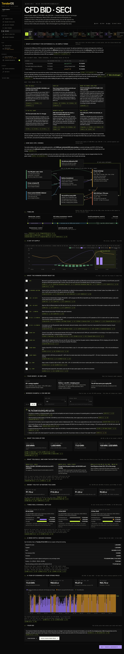
What is a CfD
Purpose. The whole tender in plain words before any number. Read it first.
1 · What a Contract for Difference is, in simple terms. A page a non-finance reader follows: a CfD is a promise about price, not a promise to buy; the three-evening table at ₹5.70 (a cheap evening, the market at the strike price, a dear evening) showing what the exchange pays, what the Pool pays or takes, and that you keep ₹5.70 every time; why SECI does it; what you build; what you do every day; where the energy may come from and the 25% / 75% / 50% limits; the weekly 10% tolerance and the 1.5× penalty; the Letter of Credit; what you bid and how the auction works; the 15-year term. Every sentence carries a chip (Amd-03 p. 5, CfDA p. 40): click it to open the page.
2 · The tender as a picture. The flow of energy and money (your RE, group RE and the green market charge the battery; the battery and wind supply the exchange; the Pool settles against the strike price), the timeline from the Effective Date to the end of the term, a day of supply on IEX evening prices, your obligations in order.
3 · Worked example. Pick 50 / 100 / 150 MW and a strike price: what you sign up for, what you build and how the battery is charged in each phase, the money put up before revenue, three real IEX evenings settled, a Contract Week with a missed evening, a year of evenings.
Nothing to enter here. Click Next.

Step 02 · Tender & amendments (Tender / Legal)
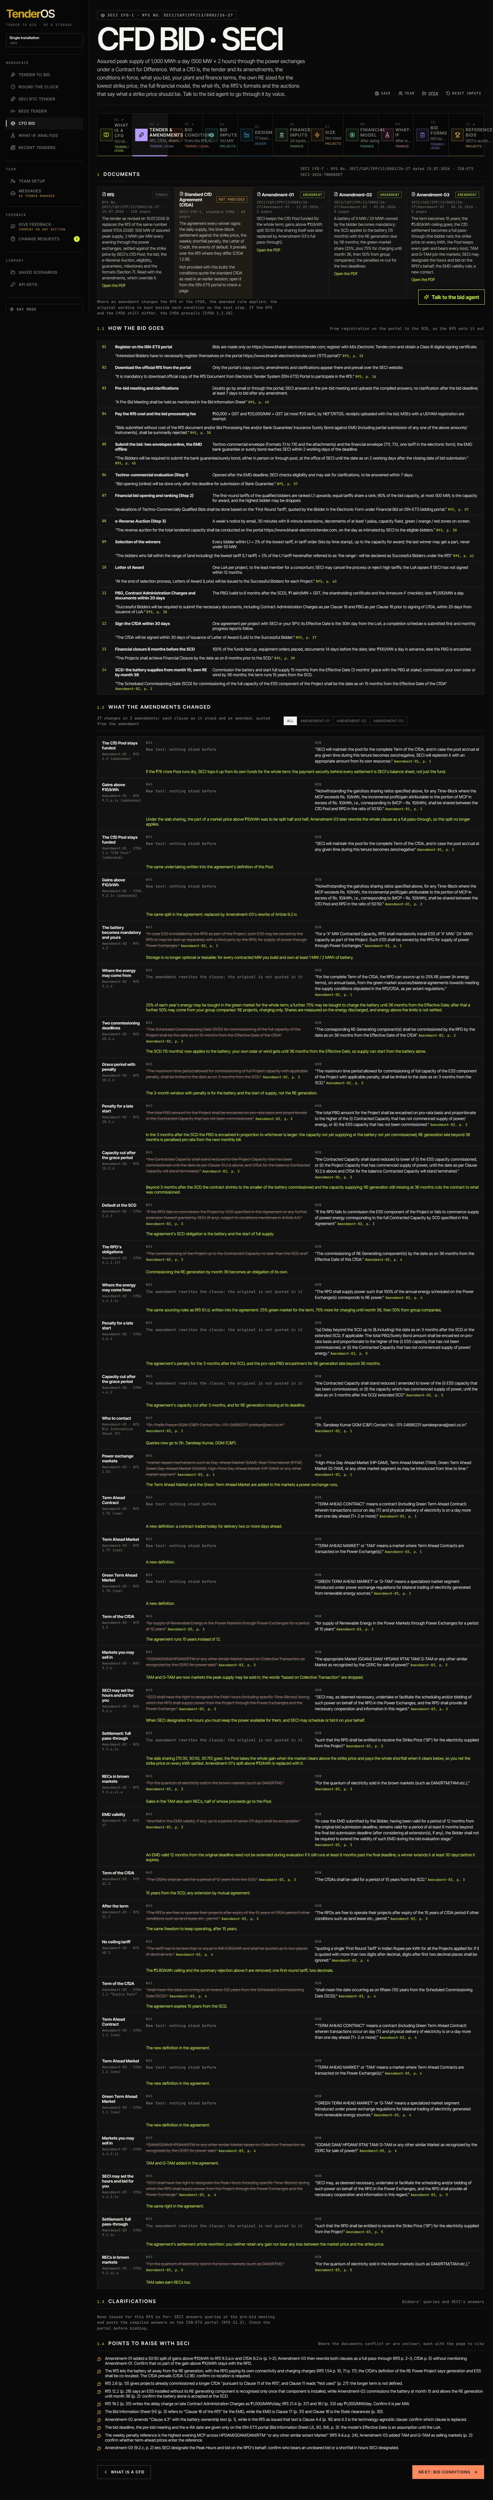
Tender and amendments
1 · Documents. The RfS of 15.07.2026 (it replaces the one of 17.04.2026), the standard CfD Agreement (not provided to the demo: its quotes are kept from the standard text), Amendment-01 (17.07.2026), Amendment-02 (03.08.2026) and Amendment-03 (08.10.2026). Open the PDF on each card.
1.1 · How the bid goes. From registration on ISN-ETS to the RfS cost and bid fee, the pre-bid meeting, the bid with the EMD, evaluation, the financial bid, the e-Reverse Auction, the LoA, the PBG and Contract Administration Charges within 20 days, the CfDA within 30 days, financial closure, the SCD; each with its page.
1.2 · What the amendments changed. All 37 changes (4 in Amendment-01, 11 in Amendment-02, 22 in Amendment-03) as the clause stood and as amended, quoted, with the page link and one sentence on what it means for you. Filter All / Amendment-01 / Amendment-02 / Amendment-03. The big ones: the battery is now mandatory and yours (Amd-02), the RE may come 36 months in with 75% of charging power from the market meanwhile (Amd-02), the settlement is full pass-through so you always net the strike price (Amd-03), the term is 15 years (Amd-03), the ₹5.80 ceiling is gone (Amd-03), TAM and G-TAM are allowed markets (Amd-03).
1.3 · Clarifications. None issued so far.
1.4 · Points to raise with SECI. Ten places where the documents conflict or are unclear, each with the page to cite (Amendment-01’s 50:50 sharing above ₹10 superseded by Amendment-03’s full pass-through; RfS 7.1 on a remote battery against the CfDA’s co-location; the “longer CfDA” for existing projects that points to a clause reading “Not used”; and others).

Step 03 · Bid conditions (Tender / Legal)
Bid conditions
2 · Bid conditions. All 251 conditions in eleven groups (Scheme and bid, Bid documents, Auction, Daily supply, CfD settlement, Plant, Energy sourcing, Dates, Bid security and charges, Penalties and security, Eligibility): the rule in one line, the quote word for word, the document, clause and page link. Badges: As issued, Amended · Amd-0x, Replaced · Amd-0x (the original is kept with As issued under it), Documents differ (three: the RfS and the CfDA disagree; the model follows the CfDA, which prevails). Filter All / Amended / Differ / RfS / CfDA. Assign hands a condition to Legal; their reading comes back through the Team panel and shows under the condition.

Step 04 · Bid inputs (Projects)
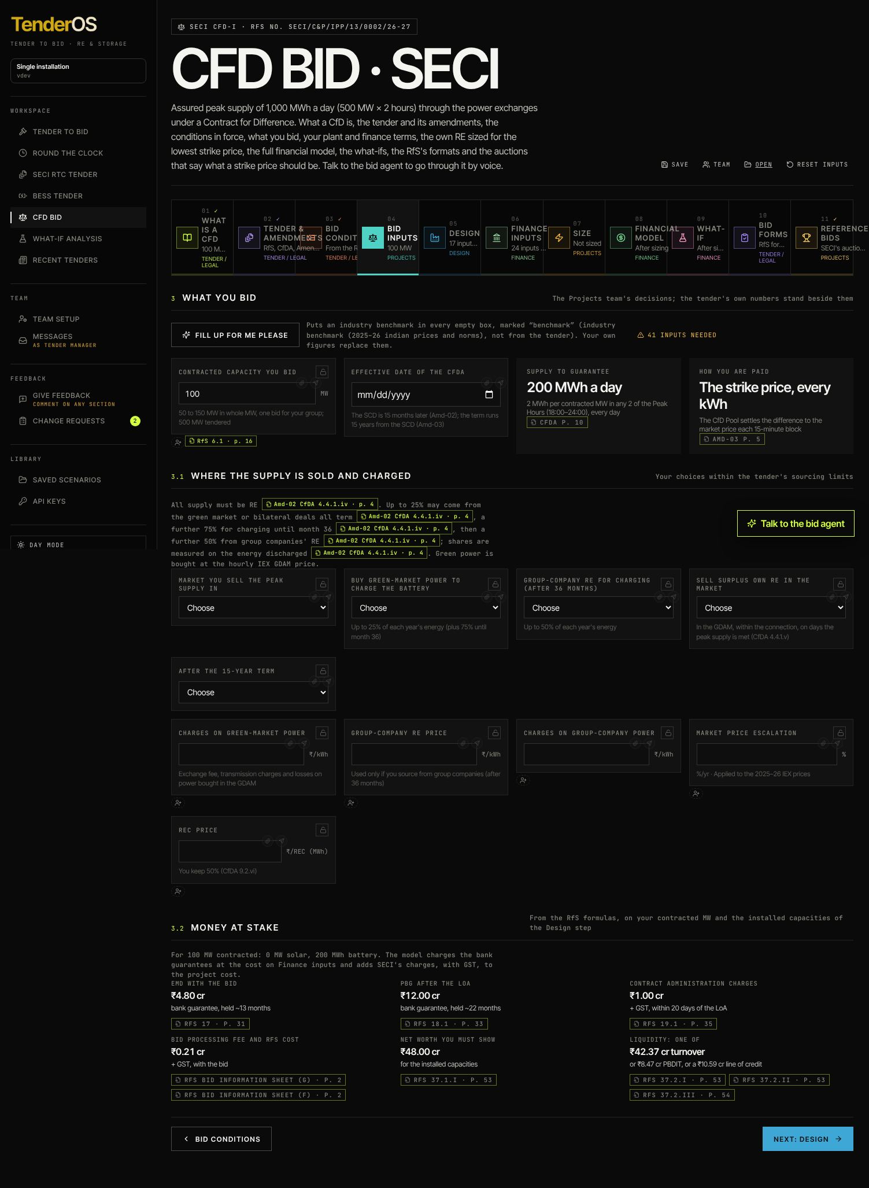
Bid inputs
3 · What you bid. Contracted capacity you bid (50 to 150 MW in whole MW, one bid for your group). Effective Date of the CfDA: every date follows it on the strip beneath (LoA 30 days before, documents and PBG due 20 days after the LoA, financial closure 6 months before the SCD, the SCD at 15 months, the last day with penalty 3 months later, the PBG valid to SCD + 6 months, the RE deadline at 36 months, the end of the term 15 years after the SCD).
3.1 · Markets and sourcing. Market you sell the peak supply in (DAM and RTM are brown markets and earn RECs, GDAM is green and does not); Buy green-market power to charge the battery (up to 25% of the year’s energy, plus 75% until month 36); Group-company RE for charging after month 36 (up to 50%) with its price and charges; Sell surplus own RE in the market; After the 15-year term (nothing, or keep selling at market prices for a number of years); the charges on bought power, the market price escalation, the REC price.
3.2 · Money at stake. What the RfS asks of this bid on the installed sizes: EMD, PBG, Contract Administration Charges, the RfS cost and bid fee, net worth, and the liquidity test (turnover, PBDIT or a line of credit).

Step 05 · Design (Design)
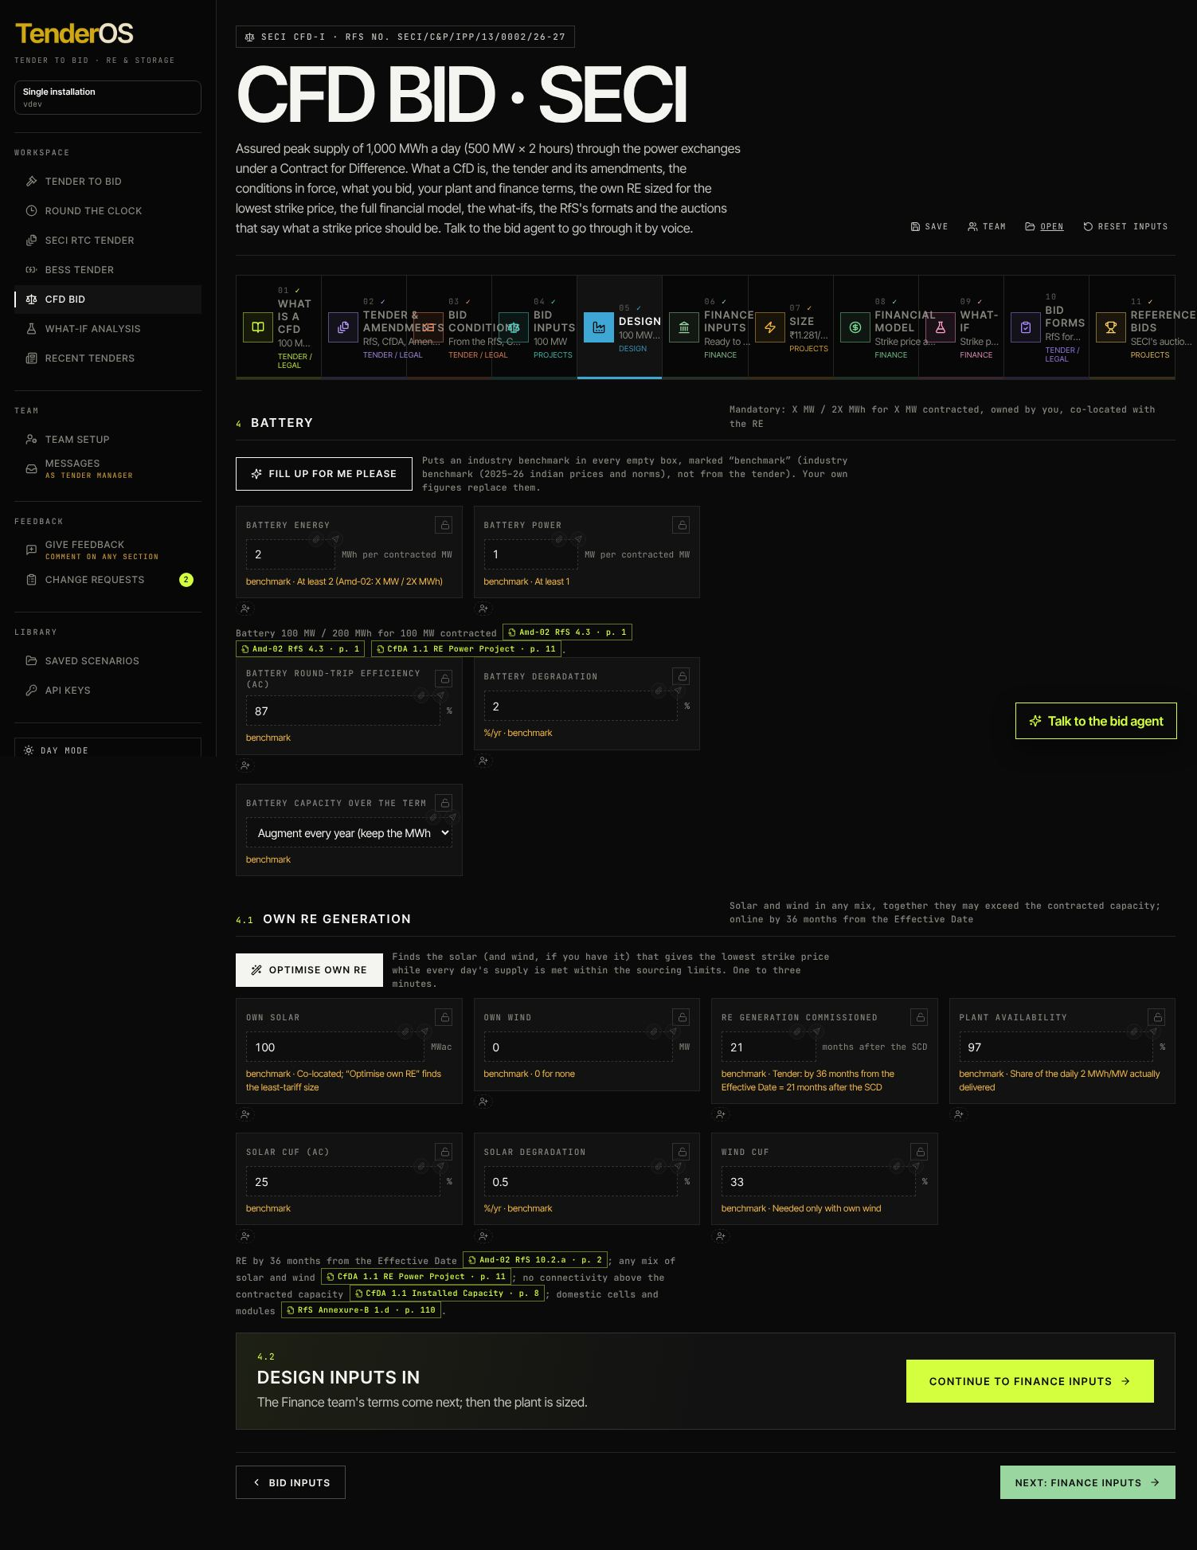
Design
Fill up for me please puts industry benchmarks in every empty box, marked until you replace them.
4 · Battery. Battery energy (MWh per contracted MW, at least 2) and Battery power (MW per contracted MW, at least 1), Round-trip efficiency, Battery degradation, Battery capacity over the term (augment every year, or let it fade).
4.1 · Own RE. Own solar (MWac) and Own wind (MW), RE generation commissioned (months after the SCD, at most 21), Plant availability, the CUFs and solar degradation. Optimise own RE finds the solar (and wind, if you have it) that gives the lowest strike price with every day’s supply met within the sourcing limits; it is offered here and on Size.
Continue to Finance inputs.

Step 06 · Finance inputs (Finance)
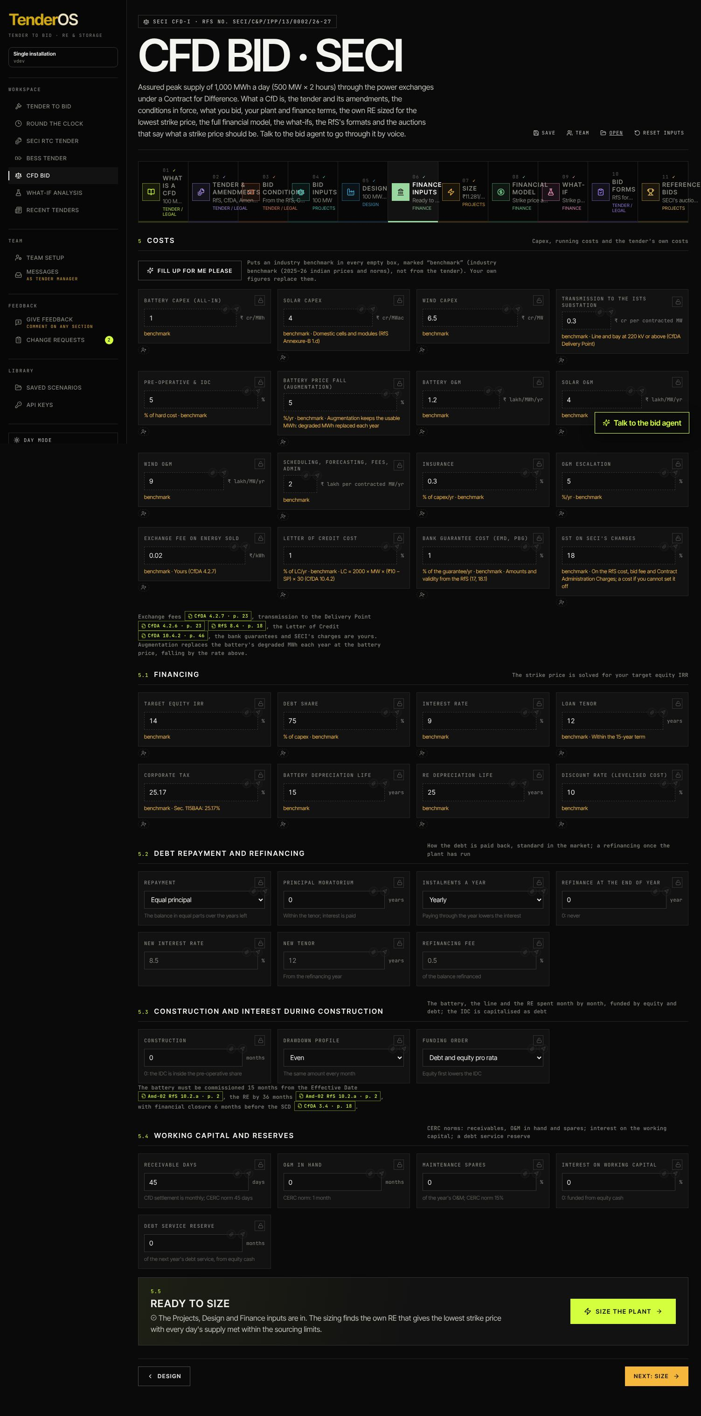
Finance inputs
5 · Costs. Battery capex (₹ cr/MWh, all-in), solar and wind capex, the line to the ISTS substation, pre-operative and IDC, the battery price fall for augmentation, O&M by source, the fixed scheduling and admin cost, insurance, O&M escalation, the exchange fee, the Letter of Credit cost, the bank guarantee cost, GST on SECI’s charges.
5.1 · Financing. Target equity IRR, debt share, interest rate, loan tenor, corporate tax, depreciation lives, the discount rate.
5.2 · Debt repayment and refinancing, 5.3 · Construction and interest during construction, 5.4 · Working capital and reserves: the same boxes as the RTC tender’s Finance inputs (six repayment methods with their extra box, moratorium, instalments a year, refinancing year, rate, tenor and fee; construction months, drawdown profile, funding order; receivable days, O&M in hand, spares, interest on working capital, debt service reserve).
5.5 · Size the plant. The bar lists what is still missing; Size the plant runs the optimiser and opens Size.

Step 07 · Size (Projects)
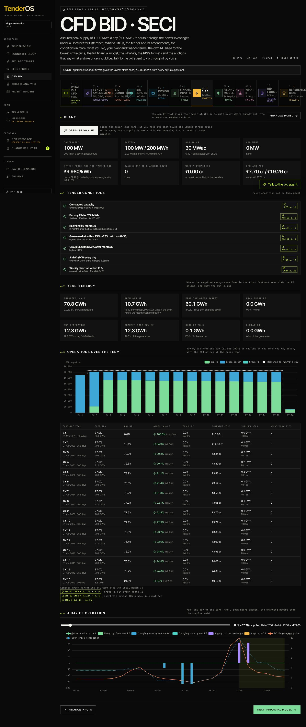
Size
6 · Plant. While it runs the chip says Optimising n/N and Stop halts it (seconds to a minute: the model simulates every day of the 15 years for each candidate size). The banner then says what it found. Tiles: Contracted, Battery, Own solar, Own wind, Strike price for the target IRR (the screening model’s exact price and the quote rounded up to the paisa), Days short of charging power, Weekly penalties, EMD and PBG. Optimise own RE reruns it; Financial model jumps on.
6.1 · Tender conditions. Seven checks, met or not, each with its page: capacity 50–150 MW, battery X MW / 2X MWh, RE online by month 36, green-market share within 25% (+75% until month 36), group RE within 50% after month 36, 2 MWh/MW every day, weekly shortfall within 10%.
6.2 · Year-1 energy. Where the supply came from in the first Contract Year with the RE online: own RE, the green market, group RE; own generation, charged from own RE, surplus sold, curtailed.
6.3 · Every Contract Year. The table of Contract Years (April to March from the SCD): required and delivered energy, the shares by source against the limits, charging costs, surplus sales, weeks with a penalty.
6.4 · A day’s operation. Pick any day: the hourly chart of solar and wind, charging from own RE, the market and group RE, the battery’s discharge in the two peak hours, the sale, and the prices of the day.

Step 08 · Financial model (Finance)
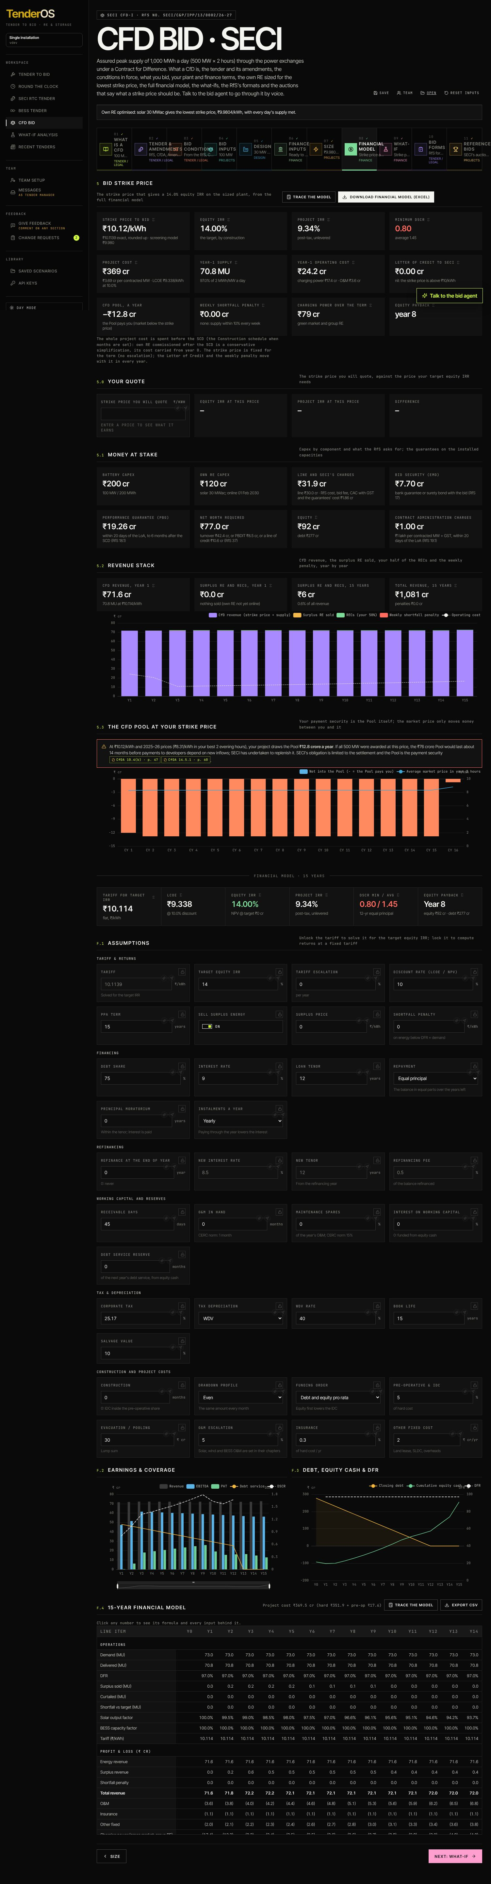
Financial model
5 · Bid strike price. The tiles come from the same financial engine as the RTC tender, fed with the CfD operations: Strike price to bid (the price that gives the target equity IRR; the screening model’s price beside it), Equity IRR, Project IRR, Minimum DSCR (red below 1.1: year 1 may run on bought charging power until the RE is online), Project cost (per contracted MW, with the LCOE), Year-1 supply, Year-1 operating cost (charging power and O&M), Letter of Credit to SECI (nil when the strike price is above ₹10), CfD Pool, a year (who pays whom at this price), Weekly shortfall penalty, Charging power over the term, Equity payback. Σ on a tile opens the traceable model at that number. Trace the model opens the explorer; Download financial model (Excel) builds the workbook with Cover, Live model, Construction, Profit and loss, Cash flow, Balance sheet, Debt schedule, Depreciation and tax, Working capital and Sensitivity, every number a formula on the blue inputs.
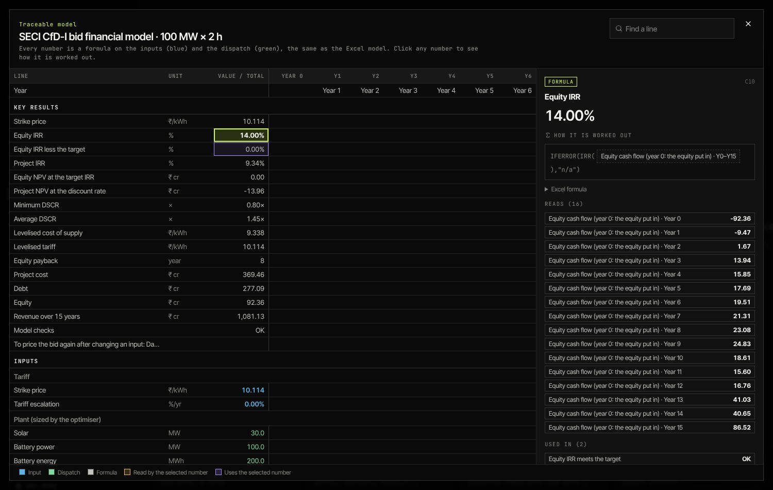
The traceable model
5.0 · Your quote. Type the strike price you will quote: the equity and project IRR it earns and the difference to the target; a warning below the target.
5.1 · Money at stake. Battery capex, own RE capex, the line and SECI’s charges, EMD, PBG, net worth required, equity and debt, Contract Administration Charges.
5.2 · Revenue stack. CfD revenue (strike price × energy), surplus RE and RECs, the penalties, year by year.
5.3 · The CfD Pool. This project’s net pay-in or pay-out each Contract Year at the strike price, against the IEX evenings.
F.1 to F.4. The assumptions (with the tariff lock: lock the strike price to see the returns at a fixed price), earnings and coverage, debt and equity cash, the construction month by month when months are set, and the full 15-year table; click any number for its formula; Export CSV.
A note on the two prices. The Size step’s price comes from the fast screening model the optimiser uses; the Financial model’s price adds the full tax, working-capital and reserve treatment and spends the whole capex at the start. The workbook’s cover states these simplifications.

Step 09 · What-if (Finance)
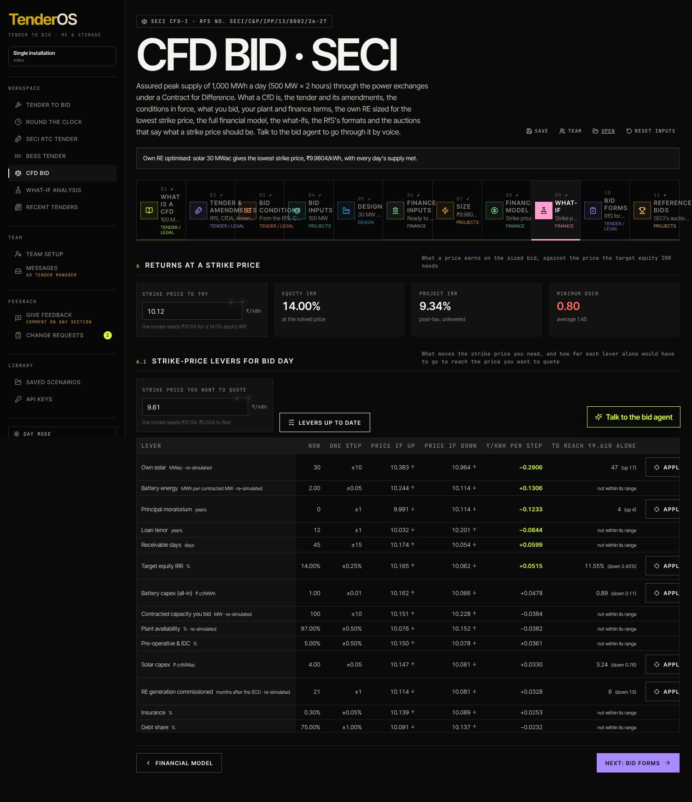
What-if
1 · Returns at a strike price. Type a price: equity and project IRR, DSCR.
2 · Levers. Enter the strike price you want to quote and click Compute the levers (about a minute: operations levers re-simulate the term, finance levers re-price it). One row per input: its value now, one step, the price if up, the price if down, ₹/kWh per step, and how far that lever alone must move to reach your price (or “not within its range”). Apply moves the input there; recompute after changing the case.

Step 10 · Bid forms (Tender / Legal)
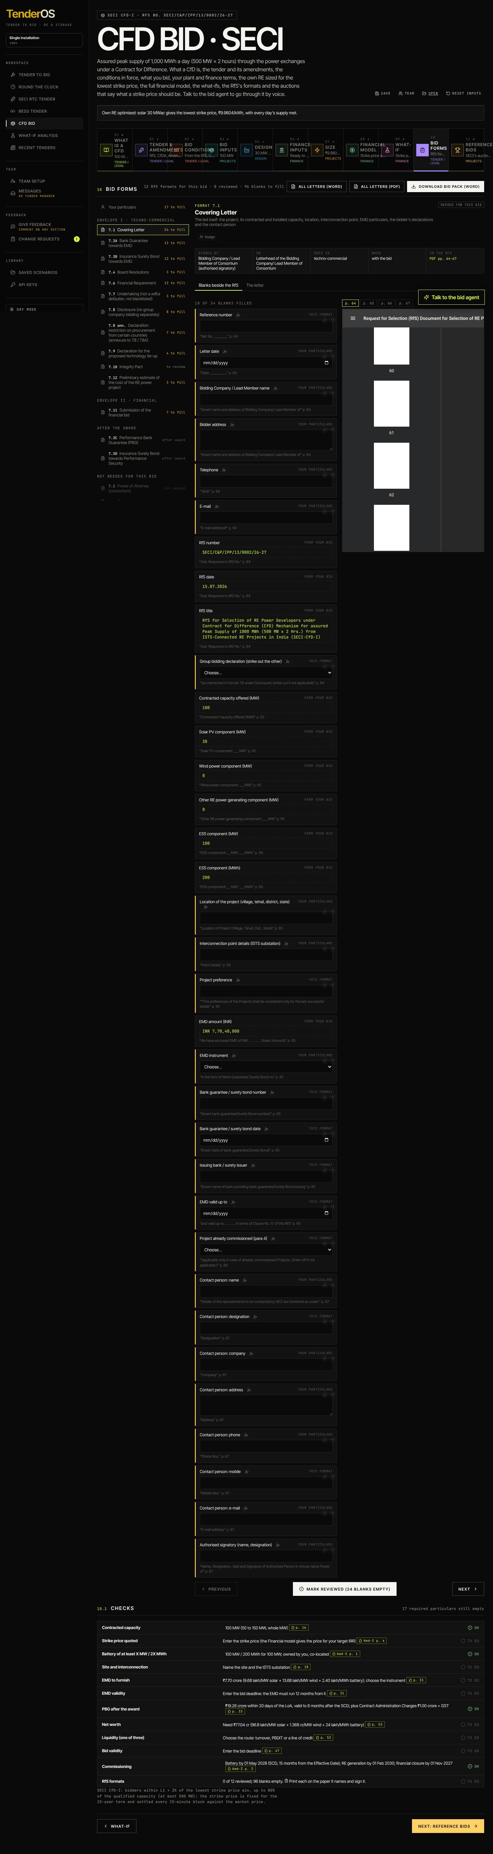
Bid forms
10 · Bid forms. The left column: Your particulars (asked once: company, bidding as, address, signatory, dates, the strike price you quote, EMD instrument, substation and connectivity, site, net worth and the liquidity route) and the RfS’s 17 formats grouped by envelope (Envelope I techno-commercial, Envelope II financial, after the award, not needed for this bid): 7.1 Covering Letter, 7.2 Power of Attorney, 7.3A/B the EMD as a bank guarantee or surety bond, 7.3C/D the PBG, 7.4 Board Resolutions, 7.5 Consortium Agreement, 7.6 Financial Requirement, 7.7 Undertaking, 7.8/7.8A Disclosure and its annexure, 7.9 technology tie-up, 7.10 Integrity Pact, 7.11 the financial bid letter, 7.12 the cost estimate. Each shows how many blanks are left. Click a format: its blanks beside the RfS page (Blanks beside the RfS) or The letter in the RfS wording filled from the bid; Reviewed ticks it once read; Assign hands it to Finance or Legal; a signed copy they upload appears on the format. Use ₹x/kWh puts the model’s strike price in the particulars. All letters (Word) / (PDF) and Download bid pack (Word) export them.
10.1 · Checks. Eleven checks against the conditions: capacity, the strike price (two decimals, no ceiling), battery, site and interconnection, EMD amount and validity, PBG and CAC, net worth, liquidity, bid validity, the commissioning dates.

Step 11 · Reference bids (Projects)
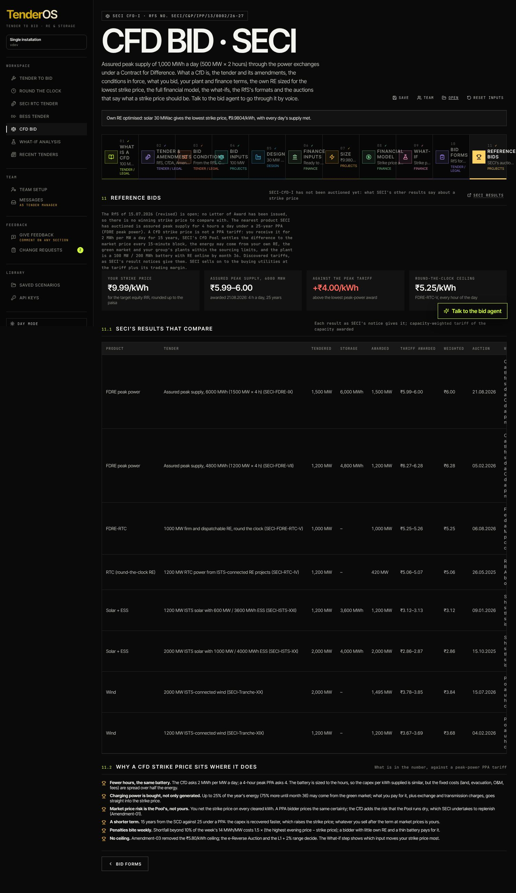
Reference bids
11 · Reference bids. SECI-CfD-I has not been auctioned yet. The tiles set your strike price against the lowest award of the nearest product SECI has auctioned (assured peak supply, 4 hours a day, 25-year PPA) and the round-the-clock ceiling. 11.1 lists SECI’s eight results that compare with why each does; 11.2 explains why a CfD strike price sits where it does (fewer hours on the same battery, charging power bought, no market risk, a 15-year term, weekly penalties, no ceiling).

The bid agent
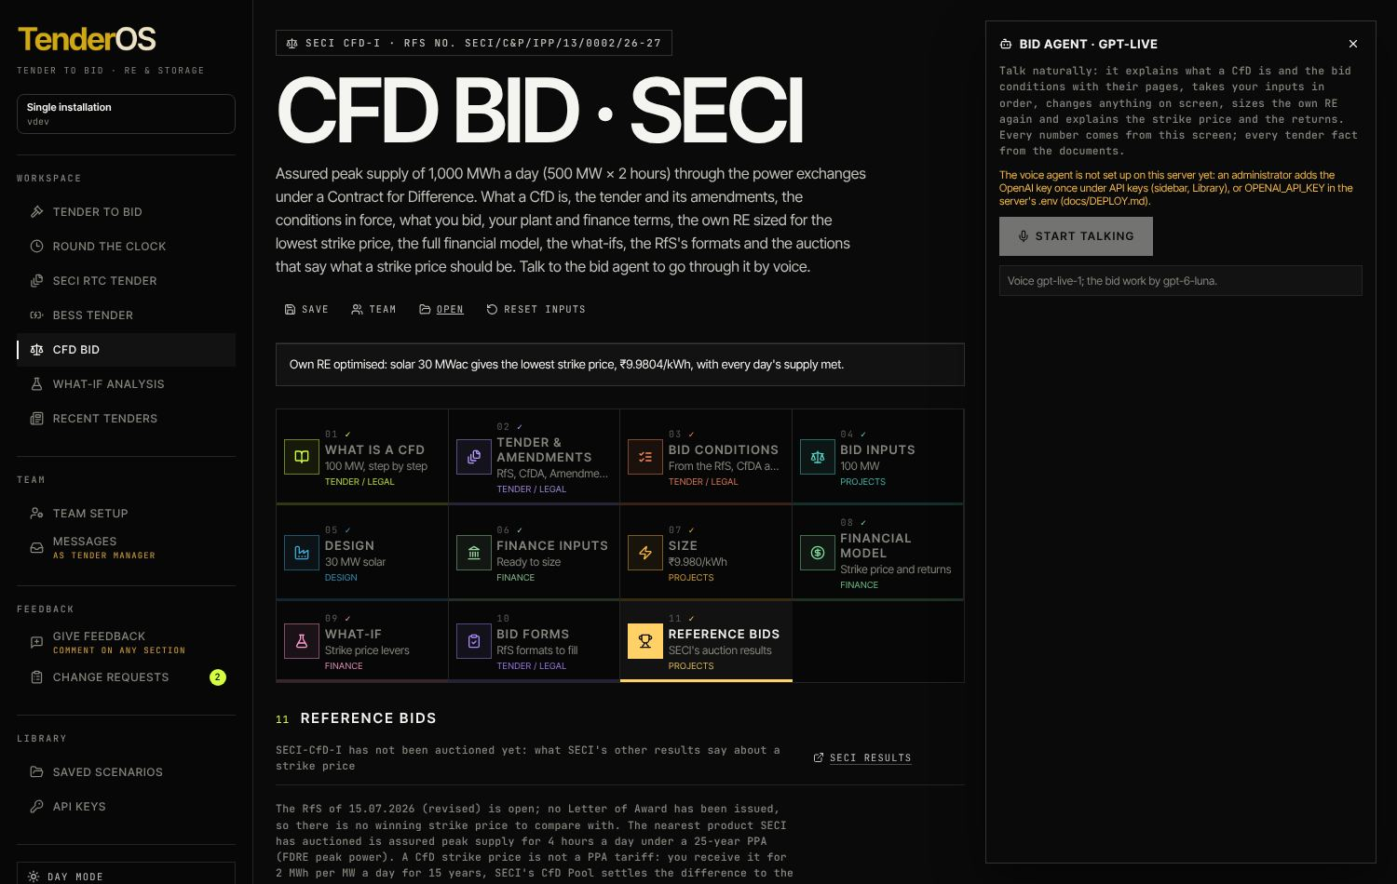
The bid agent
Talk to the bid agent (bottom right; needs the OpenAI key under API keys) opens the voice agent with sixteen tools for this tender: it explains what a CfD is and the conditions with their pages, reads the amendments’ changes, asks for the inputs in order, sets any input, fills the benchmarks, runs and stops the optimiser, reads the results and the financial model, and checks a strike price you name. Every number it says comes from this screen.

Quick reference: a CfD bid in ten clicks
- CfD Bid in the sidebar; read 01 What is a CfD.
- 04 Bid inputs → contracted MW, Effective Date, the market, the sourcing choices.
- 05 Design → Fill up for me please, then your battery and RE numbers.
- 06 Finance inputs → costs, financing, repayment, construction, working capital → Size the plant.
- Read 6.1 Tender conditions and 6.3 Every Contract Year on Size.
- 08 Financial model → the strike price; Download financial model (Excel).
- 5.0 Your quote → the price you will quote.
- 09 What-if → Compute the levers.
- 10 Bid forms → particulars, review each format, Download bid pack (Word).
- Save the bid; Assign what others must supply; 11 Reference bids for the comparison.

