LVQ-Clustering-Algorithm-For-WaterMelon-4.0
This file is a very simple code for clustering with the algorithm named LVQ(Learning Vector Quantization). We use the dataset in Machine Learning written by Zhihua.Zhou. Thanks for the detail pseudocode in the book. In this time, I use python to implement LVQ. I hope this code could give you some inspiration.
You can download the file free. I recommand you to run this program in Mac OS or Linux. Just a preference. You can use Windows definitely, however, remember, python is necessary.
I'll tell you how to use this program as follows(Especially for mac OS and Linux):
1. Open Your Terminal (No need to log in your ssh, cause this pro is so easy that the CPU in your Computer is enough)
2. Find the Folder where you download this file
3. Input python LVQ_Clustering.py and enter
4. The pro will show you 5 graphs, which tells you the iteration of the algorithm
5. Note, cause of the Random part in this pro, you'll find every time you run this pro, the result is different, it's normal.
Last but not Least : If you have any problems, you can write a comment, and I'll response to you if I see the question. Thanks for Download This file. Wish you have a fantastic time in LVQ Algorithm.

Next Part, I’m going to show you the result in one normal time:
Note: I used the Mac OS and Terminal. Python Of Course.
I was so sorry that I forgot to make the note of the graph. The red circle represents the Learning Vector, The red ‘*’ means the good melon, meanwhile the black dots are on behalf of the melons which are not that good.
There are five graphs as the result:
The first one tells you the initialization of the Learning Vector :
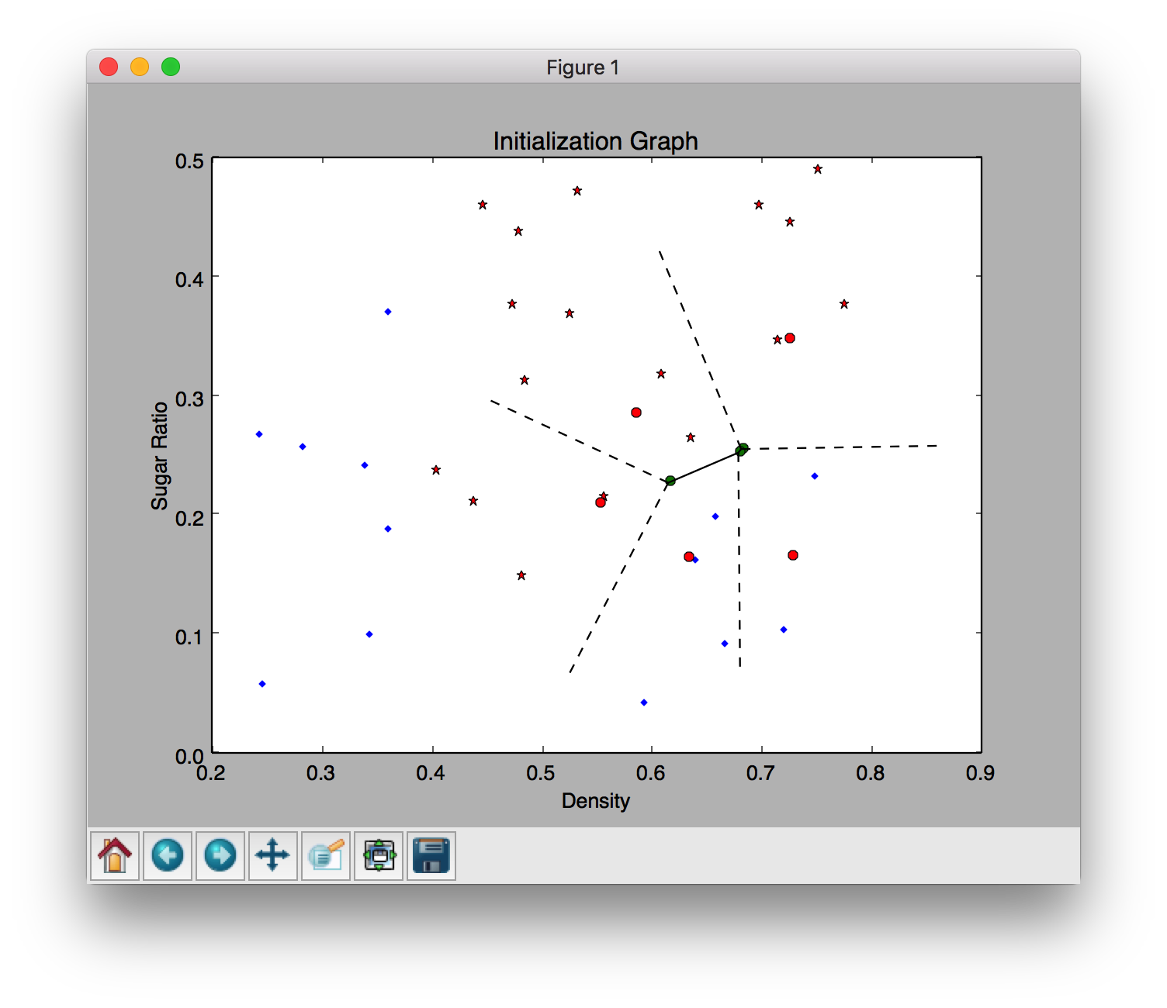

The second Graph shows you the Learning Vector After 50 Iterations
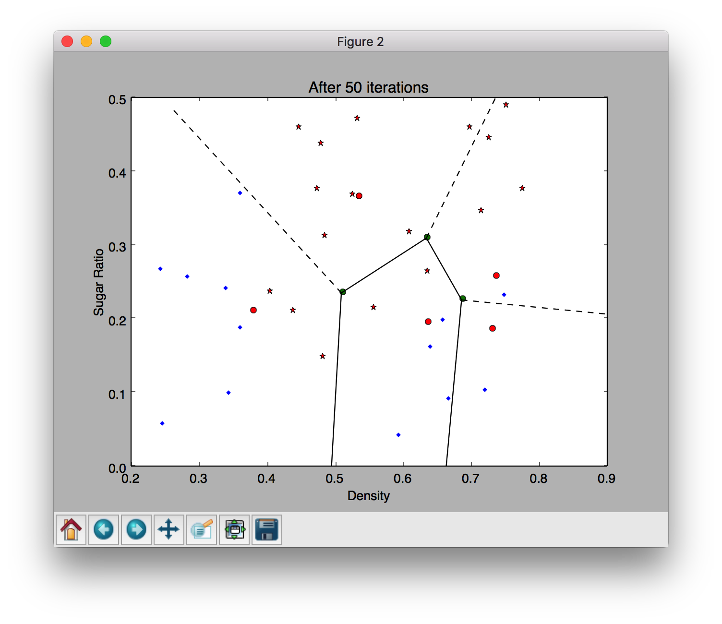

The third Graph shows you the Learning Vector after 100 Iterations
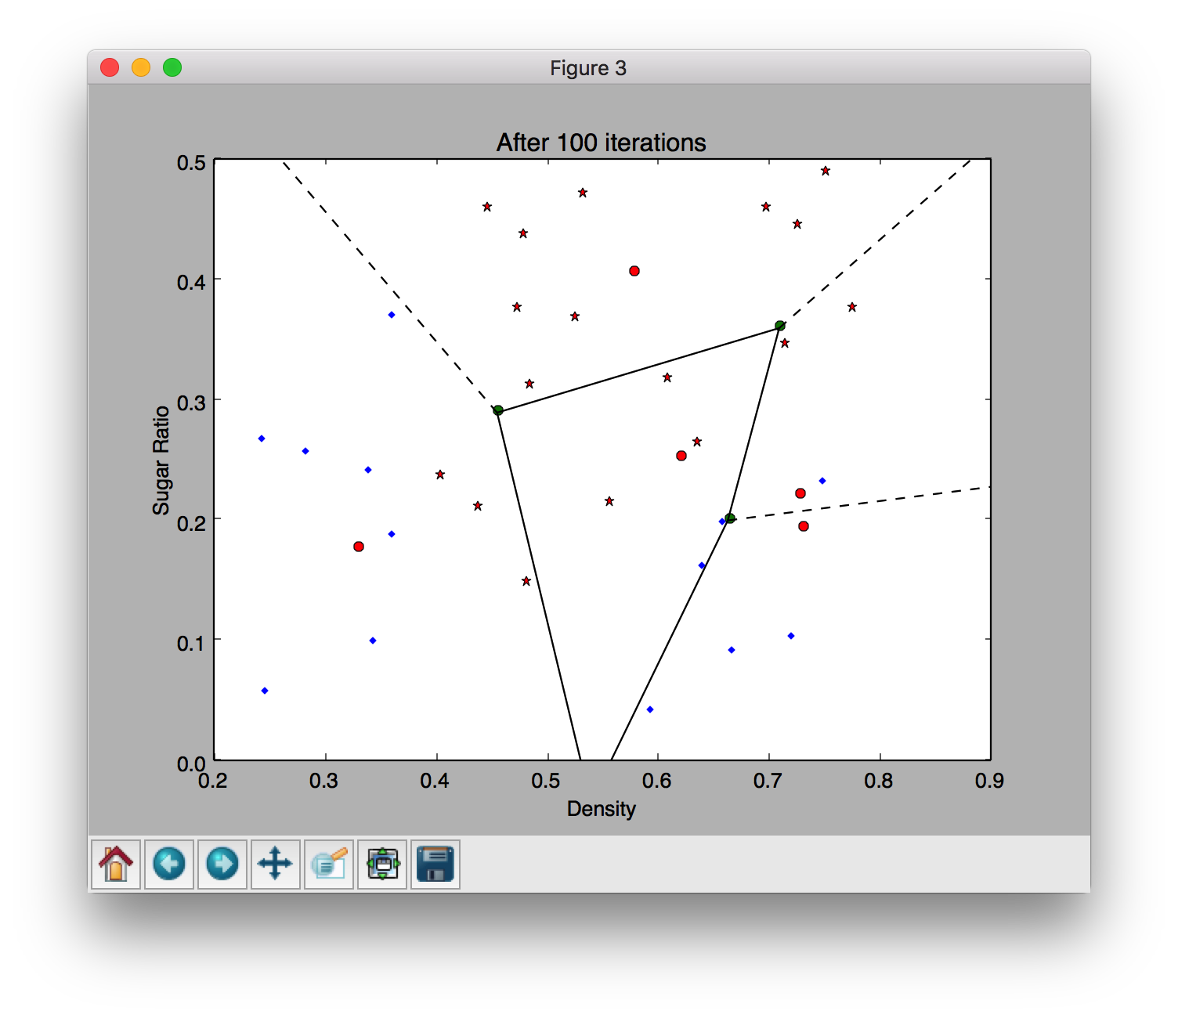

The forth Graph shows you the Learning Vector after 200 Iterations

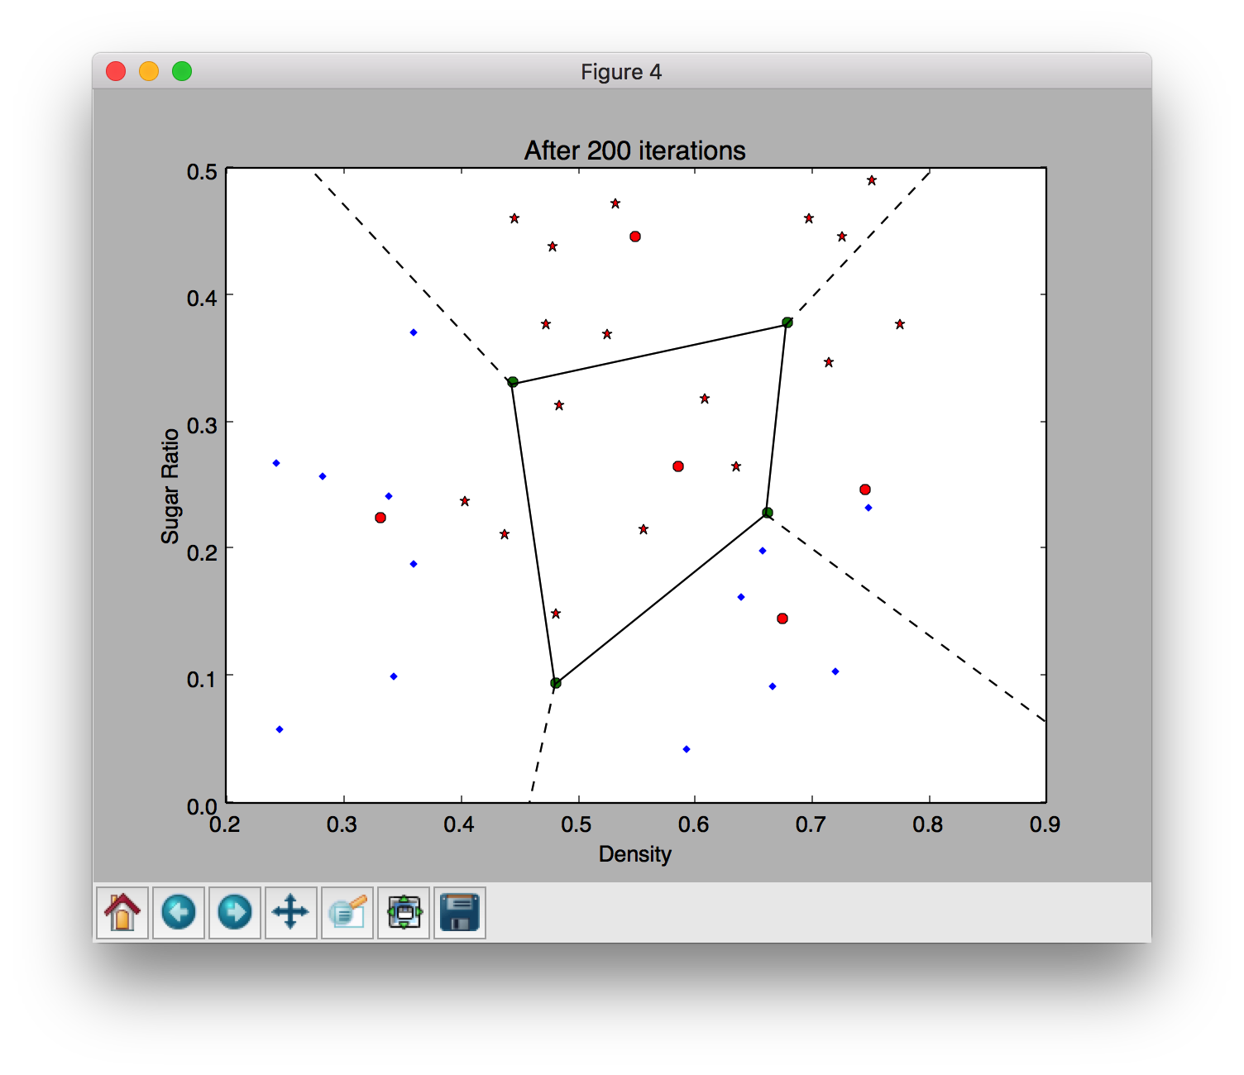

The fifth Graph shows you the Learning Vector after 100 Iterations

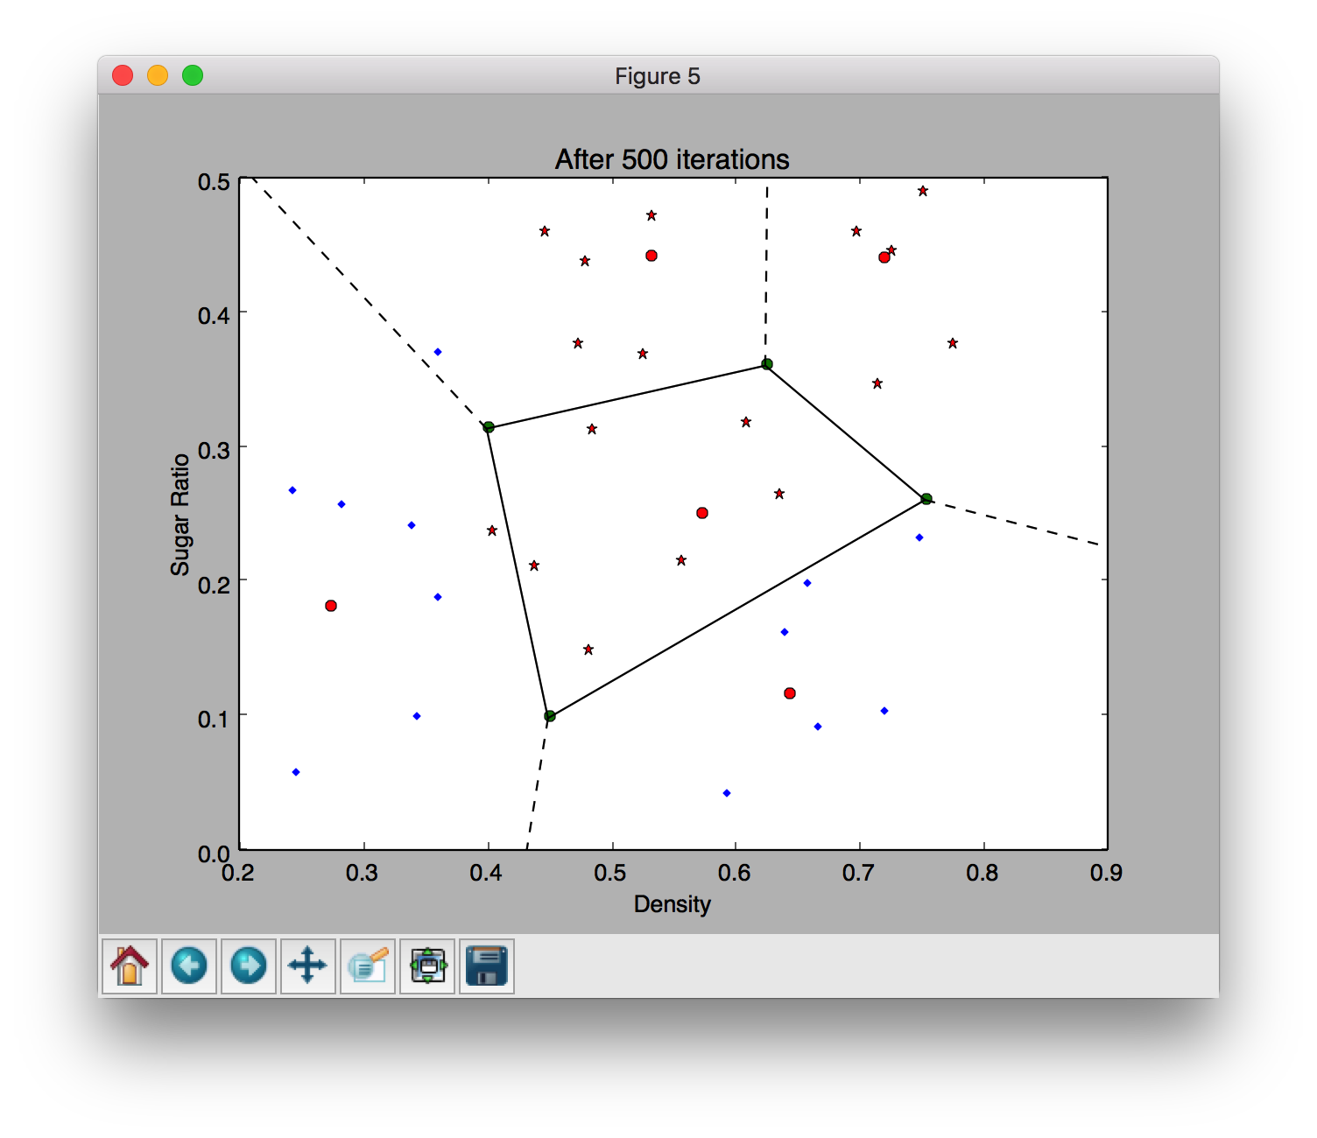

Through these graphs, you can easily find the change of the Learning Vector and you can also make any changes in the code as you like to explore more interesting things.

Eventually, I need to show you the Reference Book written by Zhihua.Zhou:

Machine Learning
