Report

Authors: Erik Krasilnikov, Alexey Astahov

Inverce kinematic of robot

$$\cos\left(q2\right)=\frac{x^{2}+y^{2}-{l_{1}}^{2}-{l_{2}}^{2}}{2*l_{1}*l_{2}}$$

$$\sin\left(q2\right)=\sqrt{\left(1-\cos\left(q2\right)**2\right)}$$

$$q2=atan2(\sin\left(q2\right),\cos\left(q2\right))$$

$$q1=atan2\left(x,y\right)-atan2(l_{1}*\sin\left(q2\right), l_{1}+l_{2}*\cos\left(q2\right))$$

$$q3= -(q1+q2)$$

Stiffness model

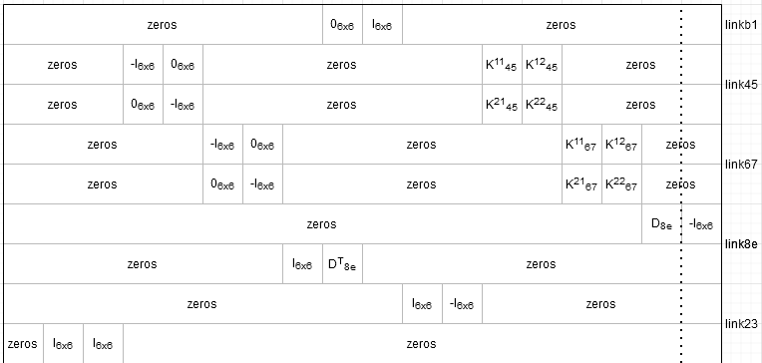

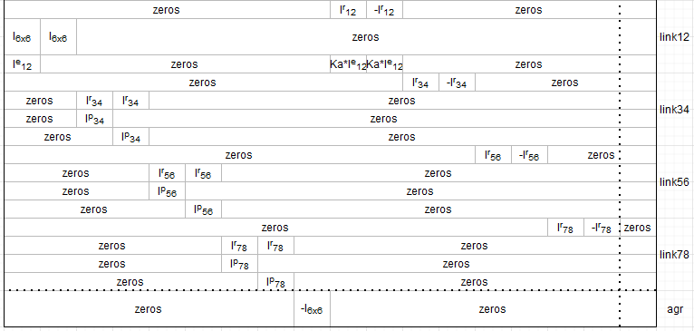

Kc=D-CA-1B

Wagr = Kc\*F

Result of analysis

Variance of results was too big to visualize so I use log of data

