Report

Virtual joint modeling

Inverce kinematic of robot

$$\cos\left(q2\right)=\frac{x^{2}+y^{2}-{l_{1}}^{2}-{l_{2}}^{2}}{2*l_{1}*l_{2}}$$

$$\sin\left(q2\right)=\sqrt{\left(1-\cos\left(q2\right)**2\right)}$$

$$q2=atan2(\sin\left(q2\right),\cos\left(q2\right))$$

$$q1=atan2\left(x,y\right)-atan2(l_{1}*\sin\left(q2\right), l_{1}+l_{2}*\cos\left(q2\right))$$

$$q3= -(q1+q2)$$

Forward kinematic of robot



Where θi,j is jth virtual joint of ith leg



For each leg  where  is Jacobian with respect to virtual joint variables and is aggregated stiffness matrix

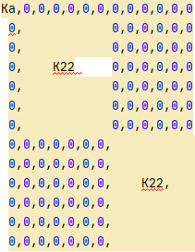 where 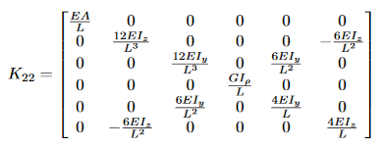

Cartesian stiffness matrix of leg 

where 

is Jacobian with respect to the passive joint variables

Cartesian stiffness matrix of whole robot equal sum of Kc,i. and W = Kc Δt

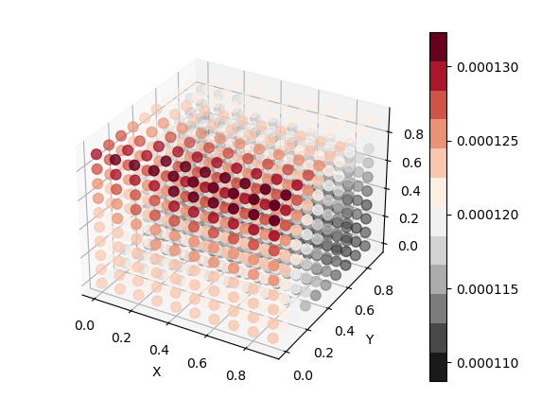

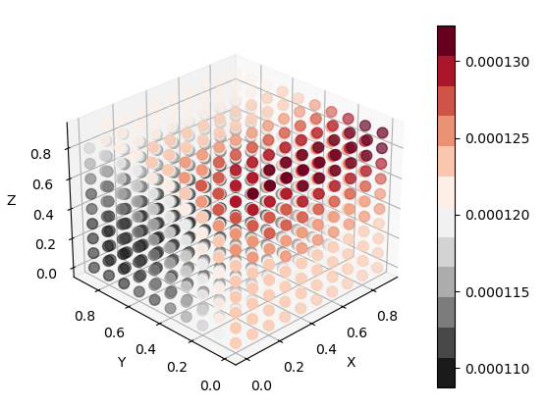

Result

Link to github https://github.com/EriKarasik/ARHW2