**Report**

1. Forward kinematics

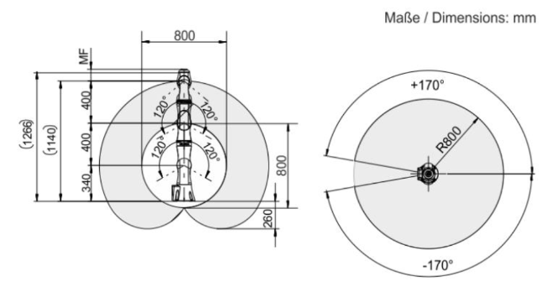

*Figure 1 – Manipulator structure*

Forward kinematics = Rz(q0)*Tz(l1)*Rx(q1)*Tz(l2)*Rz(q2)*Tz(l3)*Rx(q3)*Tz(l4)*Rz(q4)*Tz(l5)*Rx(q5)*Tx(l6)*Rz(q6)*Tx(l7)

1. Weighted pseudoinverse



Where W = diag(weights)

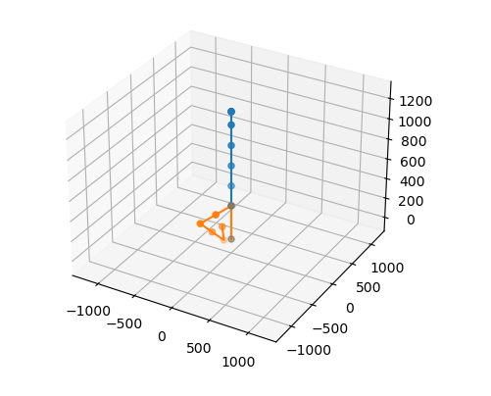

*Figure 2 – weighted pseudoinverse result*

1. Damped least squares



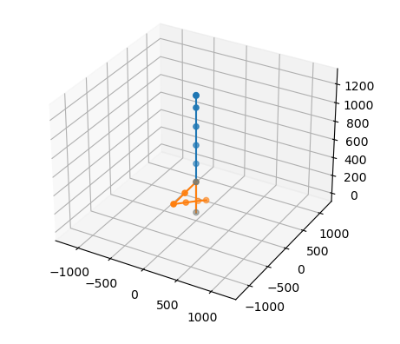

*Figure 3 – damped least squares result*

1. Null Space method

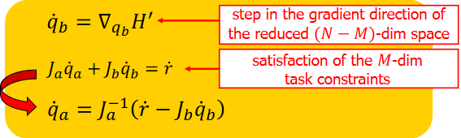



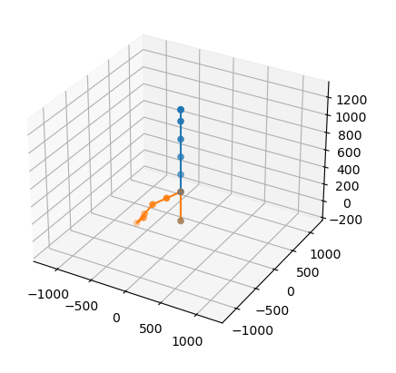

*Figure 4 –Null Space method result*

Git Hub: