Report

Kinematics of delta robot

Scheme of robot (figure 1)

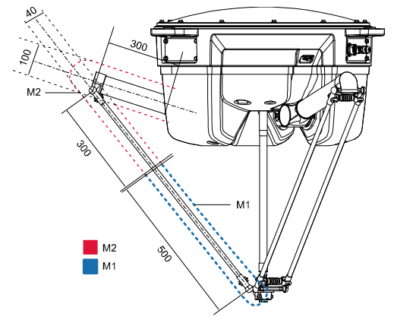

*Figure 1 – Scheme of robot*

Inverse kinematic:

All active joints can rotate in only one plane so in order to find angles of active joints firstable we should find projection of endeffector on rotation plane of each joint EE’

edge of platform E calculated as $\frac{Platform Size}{2\sqrt{3}}$

edge of Head of robot F calculated same way

distance between projection E’ and J calculated as: E’J = $\sqrt{{Passive Joint Length}^{2}-x^{2}}$

to find angle we should find coordinates of active joint end J that can be founded as intersection of two spheres with described as system of equations:

$$\left\{\begin{aligned}({J_{y}-F_{y})}^{2}+{\left(J_{z}-F_{z}\right)}^{2}={AJ}^{2} \\ ({J_{y}-{E^{'}}_{y})}^{2}+{\left(J_{z}-{E^{'}}_{z}\right)}^{2}={PJ}^{2}-{{pos}_{x}}^{2}\end{aligned}\right.$$

$$=>\left\{\begin{aligned}{J_{y}}^{2}-{2J_{y}F}_{y}+{F_{y}}^{2}+ {J_{z}}^{2}={AJ}^{2} \\ {J_{y}}^{2}-{2J_{y}E^{'}}_{y}+{{E^{'}}_{y}}^{2}+{J_{z}}^{2}-{2J_{z} pos}_{z}+{{pos}_{z}}^{2}={PJ}^{2}-{{pos}_{x}}^{2}\end{aligned}\right.$$

Solving system of equations get coordinates of J

Θ = atan2(JZ, Fy—Jy)

All other theta we can find same way but rotate cords

$$x^{'}= xcos\left(120\right)±ysin\left(120\right) y^{'}= ycos\left(120\right)∓xsin(120)$$

Forward Kinematic:

Endeffector coordinates can be founded as intersection of three spheres with radius = length of passive joint and center is the end of active joint

$$J_{1}=(0;-\frac{Head-Platform}{2\sqrt{3}}-AJcos\left(θ\right);-AJsin\left(θ\right)) \\ J_{2}=((\left(\frac{Head-Platform}{2\sqrt{3}}+AJcos\left(θ\right)\right)\cos\left(30\right);\left(\frac{Head-Platform}{2\sqrt{3}}+AJcos\left(θ\right)\right)\sin\left(30\right);-AJsin\left(θ\right))$$

$$J_{3}=((\left(\frac{Head-Platform}{2\sqrt{3}}+AJcos\left(θ\right)\right)\cos\left(30\right);\left(\frac{Head-Platform}{2\sqrt{3}}+AJcos\left(θ\right)\right)\sin\left(30\right);-AJsin\left(θ\right))$$

System of equations that described three spheres is:

$$\left\{\begin{aligned}x^{2}+{(y-y_{1})}^{2}+{(z-z_{1})}^{2}={PJ}^{2} \\ {(x-x_{2})}^{2}+{(y-y_{2})}^{2}+{(z-z_{2})}^{2}={PJ}^{2} \\ {(x-x_{3})}^{2}+{(y-y_{3})}^{2}+{(z-z_{3})}^{2}={PJ}^{2}\end{aligned}\right.$$

$$\left\{\begin{aligned}x^{2}+y^{2}+z^{2}-2y_{1}y-2z_{1}z={PJ}^{2}-{y_{1}}^{2}-{z_{1}}^{2} \\ x^{2}+y^{2}+z^{2}-2y_{2}y-2z_{2}z-2x_{2}x={PJ}^{2}-{y_{2}}^{2}-{z_{2}}^{2}-{x_{2}}^{2} \\ x^{2}+y^{2}+z^{2}-2y_{3}y-2z_{3}z-2x_{3}x={PJ}^{2}-{y_{3}}^{2}-{z_{3}}^{2}-{x_{3}}^{2}\end{aligned}\right.$$

By subtracting second equation from first and third from first and third from second get following system of equation:

$$\left\{\begin{aligned}x_{2}x+\left(y_{1}-y_{2}\right)y+\left(z_{1}-z_{2}\right)z=(w_{1}-w_{2})/2 \\ x_{3}x+\left(y_{1}-y_{3}\right)y+\left(z_{1}-z_{3}\right)z=(w_{1}-w_{3})/2 \\ \left(x_{2}-x_{3}\right)x+\left(y_{2}-y_{3}\right)y+\left(z_{2}-z_{3}\right)z=(w_{2}-w_{3})/2\end{aligned}where w_{i}={x_{i}}^{2}+{y_{i}}^{2}+{z_{i}}^{2}\right.$$

$a_{1}=\frac{\left(\left(z_{2}-z_{1}\right)\left(y_{3}-y_{1}\right)-\left(z_{3}-z_{1}\right)\left(y_{2}-y_{1}\right)\right)}{d}; b_{1}=\frac{\left(\left(w_{2}-w_{1}\right)\left(y_{3}-y_{1}\right)-\left(w_{3}-w_{1}\right)\left(y_{2}-y_{1}\right)\right)}{2d}$

$a_{2}=\frac{\left(\left(z_{2}-z_{1}\right)x_{3}-\left(z_{3}-z_{1}\right)x_{2}\right)}{d};b_{2}=\frac{\left(\left(w_{2}-w_{1}\right)x_{3}-\left(w_{3}-w_{1}\right)x_{2}\right)}{2d}$

$$d= \left(y_{2}-y_{1}\right)x_{3}-\left(y_{3}-y_{1}\right)x_{2}$$

$${{(a}_{1}}^{2}+{a_{2}}^{2}+1)z^{2}+2\left(a_{1}+a_{2}\left(b_{2}-y_{1}\right)-z_{1}\right)z+\left({b_{1}}^{2}+{\left(b_{2}-y_{1}\right)}^{2}+{z_{1}}^{2}-{PJ}^{2}\right)=0$$

By slowing this equation we get z

x= a1z+b1; y = a2z+b2

Jacobian for singularity map:

J = Inv(

$AJ(\left(y+head-2platform\right)\sin\left(θ_{1}\right)-zcos\left(θ_{0}\right)$, 0,0

0, $-AJ(\left(\sqrt{3}\left(x+platform\sqrt{3}-\frac{\sqrt{3}head}{2}\right)+y+platform-\frac{head}{2}\right)\sin\left(θ_{1}\right)+2zcos(θ_{1})$,0

0,0, $-AJ(\left(\sqrt{3}\left(x-platform\sqrt{3}+\frac{\sqrt{3}head}{2}\right)-y-platform+\frac{head}{2}\right)\sin\left(θ_{2}\right)-2zcos(θ_{2})$)\*

($\begin{matrix}x & y+head-2platform+AJcos(θ_{0}) & z+AJsin(θ_{0}) \\ 2\left(x+platform\sqrt{3}-\frac{\sqrt{3}head}{2}\right)-\sqrt{3}AJcos(θ_{1}) & 2\left(y+platform-\frac{head}{2}\right)-AJcos(θ_{1}) & 2(z+AJsin(θ_{1})) \\ 2\left(x-platform\sqrt{3}+\frac{\sqrt{3}head}{2}\right)+\sqrt{3}AJcos(θ_{2}) & 2\left(y+platform-\frac{head}{2}\right)-AJcos(θ_{2}) & 2(z+AJsin(θ_{2}))\end{matrix}$)

Deflection equal: Δ(JJT)

Singularity map:

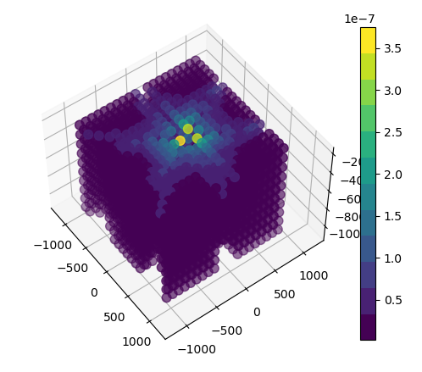

*Figure 2 – singularity map*

GitHub link: