Report

Task1: Forward Kinematic

Product of exponentials FK formula: 

Where M is home position of robot. M = $\begin{matrix}\begin{matrix}1 & 0 \\ 0 & 1\end{matrix} & \begin{matrix}0 & 0 \\ 0 & l\end{matrix} \\ \begin{matrix}0 & 0 \\ 0 & 0\end{matrix} & \begin{matrix}1 & h \\ 0 & 1\end{matrix}\end{matrix}$,

$$e^{\left[S_{i}\right]θ_{i}}=\begin{matrix}I & Svθ \\ 0 & 1\end{matrix} in case of translational joint \left(\left|\left|Sw\right|\right|= 0\right)$$

$$or \begin{matrix}I+\sin\left(θ\right)\left[Sw\right]+(1-cos⁡(θ){[Sw]}^{2} & (Iθ+(1-\cos\left(θ\right))\left[Sw\right]+(θ-\sin\left(θ\right)){\left[Sw\right]}^{2})Sv \\ 0 & 1\end{matrix} in other cases,$$

S is the matrix of screw vectors that consists of 3 rotational components Sw and 3 translational components Sv

S = $\begin{matrix}\begin{matrix}0 \\ 0 \\ 1\end{matrix} & \begin{matrix}1 \\ 0 \\ 0\end{matrix} & \begin{matrix}0 \\ 0 \\ 0\end{matrix} \\ \begin{matrix}0 \\ 0 \\ 0\end{matrix} & \begin{matrix}0 \\ 1 \\ 0\end{matrix} & \begin{matrix}0 \\ 1 \\ 0\end{matrix}\end{matrix}$

Task2: Jacobian

Product of exponentials Jacobian calculated by following algorithm:

$$J_{Si}=[{Ad}_{e^{\left[S_{1}\right]θ_{1}}…e^{\left[S_{n-1}\right]θ_{n-1}}}]S_{i}$$

Task3: visualization

Visualization goes same way as in previous home tasks by following algorithm:

1. Calculate Forward kinematic for next joint
2. Store joint coordinates
3. Repeat till endeffector

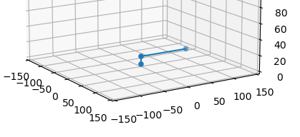

*Figure 1 – robot visualization in home position*

GitHub: https://github.com/EriKarasik/ARHW6