Report

Description of robot

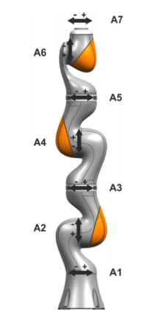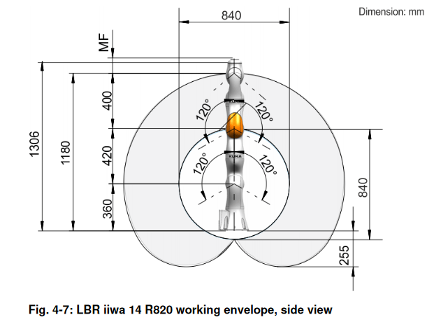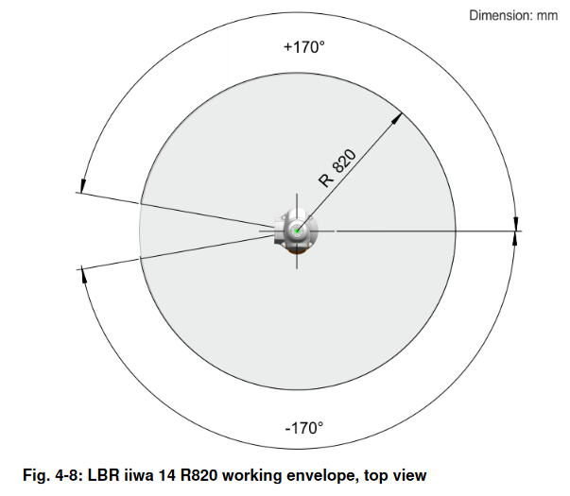

Kinematic scheme

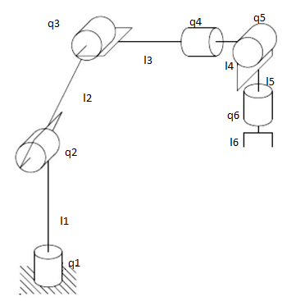

Description

|  |  |  |
| --- | --- | --- |
| Q | Min angle | Max angle |
| Q1 | -170 | 170 |
| Q2 | -120 | 120 |
| Q3 | -120 | 120 |
| Q4 | -170 | 170 |
| Q5 | -120 | 120 |
| Q6 | -170 | 170 |

|  |  |
| --- | --- |
| L | length |
| L1 | 360 |
| L2 | 400 |
| L3 | 200 |
| L4 | 200 |
| L5 | 126 |
| L6 | 20 |

Formulas of forward kinematic solution

Rx = $\left[\begin{aligned}\begin{matrix}1 & 0 \\ 0 & cq\end{matrix} \begin{matrix}0 & 0 \\ -sq & 0\end{matrix} \\ \begin{matrix}0 & sq \\ 0 & 0\end{matrix} \begin{matrix}cq & 0 \\ 0 & 1\end{matrix}\end{aligned}\right]$ Ry = $\left[\begin{aligned}\begin{matrix}cq & 0 \\ 0 & 1\end{matrix} \begin{matrix}sq & 0 \\ 0 & 0\end{matrix} \\ \begin{matrix}-sq & 0 \\ 0 & 0\end{matrix} \begin{matrix}cq & 0 \\ 0 & 1\end{matrix}\end{aligned}\right]$ Rz = $\left[\begin{aligned}\begin{matrix}cq & -sq \\ sq & cq\end{matrix} \begin{matrix}0 & 0 \\ 0 & 0\end{matrix} \\ \begin{matrix}0 & 0 \\ 0 & 0\end{matrix} \begin{matrix}1 & 0 \\ 0 & 1\end{matrix}\end{aligned}\right]$ T = $\left[\begin{aligned}\begin{matrix}1 & 0 \\ 0 & 1\end{matrix} \begin{matrix}0 & 0 \\ 0 & 0\end{matrix} \\ \begin{matrix}0 & 0 \\ 0 & 0\end{matrix} \begin{matrix}1 & a \\ 0 & 1\end{matrix}\end{aligned}\right]$

Step by step explaining of inverse kinematics

xg, yg and zg is the coordinates of goal

Q1 = atan2(xg/yg)

Rc = $\sqrt{{xg}^{2}+ {yg}^{2}}$

Cos(Q3) = $\frac{{Rc}^{2}+{zc}^{2}-{l1}^{2}-{l2}^{2}}{2*l1*l2}$

Q3 = atan2(cos(q3),sin(q3))

Q2 = atan2(zc, rc)-atan2(l2*sin(q3),l1+l2*cos(q3))

P = transposed rotation part of (Rz(q0) * T(l1) * Ry(q1) * T(l2) * Ry(q2) * T(l3))

Q4 = atan2(p[1,2], p[0,2])

Q5 = atan2(sqrt((p[0, 2])**2+(p[1, 2])**2),p[2,2])

Q6 = atan2(p[2,1],p[2,0])

Link to github

https://github.com/EriKarasik/HW22