Report

Task 1:

FK: Rz(q0)\*Tz(a1)\*Rx(q1)\*Ty(a2)\*Ty(q2)

Task 2:

IK: q0 = atan2(goal.x, goal.y)

Q1 = atan2(goal.z-a1, $\sqrt{{goal.x}^{2}+{goal.y}^{2}}$)

Q2 = distance between goal and 2nd joint

Robot have 0 or 2 solutions

Task 3: jacobian computing for geametrical and numerical aproaches given in code

Clasical aproach:

*x: (a2 + q2)sq0\*cq1*

*y: (a2 + q2)cq0\*cq1*

*z: a1 + (a2 + q2)sq1*

*J = $\begin{matrix}\frac{dx}{dq0} & \frac{dx}{dq1} & \frac{dx}{dq2} \\ \frac{dy}{dq0} & \frac{dy}{dq1} & \frac{dy}{dq2} \\ \frac{dz}{dq0} & \frac{dz}{dq1} & \frac{dz}{dq2}\end{matrix}$ =*

$\begin{matrix}R_{0}^{0} & R_{1}^{0} & R_{2}^{0}\end{matrix}$

*=* [-(a2 + q2)\*cos(q0)\*cos(q1),(a2 + q2)\*sin(q0)\*sin(q1), -sin(q0)\*cos(q1)],  
[-(a2 + q2)\*sin(q0)\*cos(q1), -(a2 + q2)\*sin(q1)\*cos(q0), cos(q0)\*cos(q1)],  
[ 0, (a2 + q2)\*cos(q1), sin(q1)],  
[ 0, cos(q0), 0],  
[ 0, sin(q0), 0],  
[ 1, 0, 0]

Task 4:

analysingJacobian for singularities is finding dependent rows

I use for it python function rref. If some of rows are dependent on other function return that row as zeros row

Task 5:

Graphics:

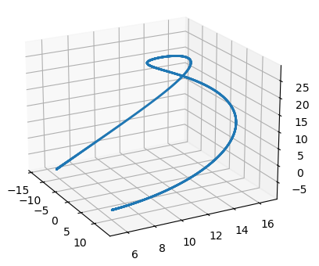

That graphic represent position of endefector during spinning all joints by the given functions

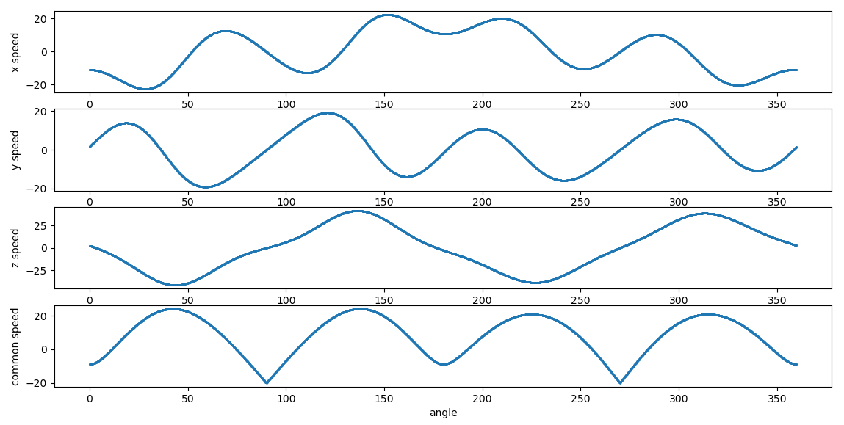

That graphic represent linear velocity for each variable and common speed that calculating on formula $\sqrt{x^{2}+y^{2}+z^{2}}$