Task 1

For calculating Jacobian I choose skew theory method because in this method is hard to make mistake

Result:

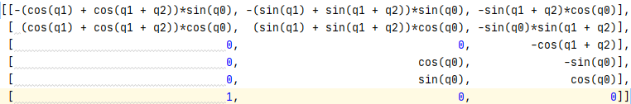

Task 2

Matrix A = $\begin{matrix}\begin{matrix}1 & 0 & 0 \\ 0 & 1 & 0 \\ 0 & 0 & 2\end{matrix} & \begin{matrix}0 & 0 & 0 \\ 0 & 0 & 0 \\ 0 & 0 & 0\end{matrix} \\ \begin{matrix}1 & 2 & 4 \\ 0 & 1 & 4 \\ 0 & 0 & 2\end{matrix} & \begin{matrix}8 & 16 & 32 \\ 12 & 32 & 80 \\ 12 & 48 & 160\end{matrix}\end{matrix}$

Matrix A-1 =

Coefficients = A-1\*Matrix($\begin{matrix}\begin{matrix}q0 & v0 & a0\end{matrix} & \begin{matrix}qt & vt & at\end{matrix}\end{matrix}$)

Endeffector position graphic

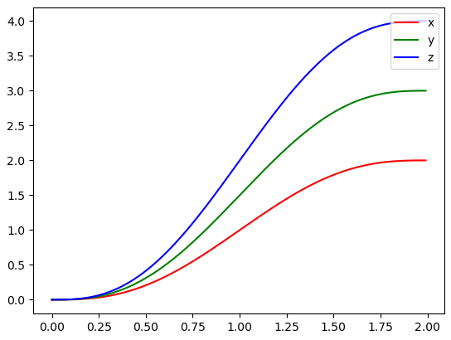

Endeffector velocity graphic

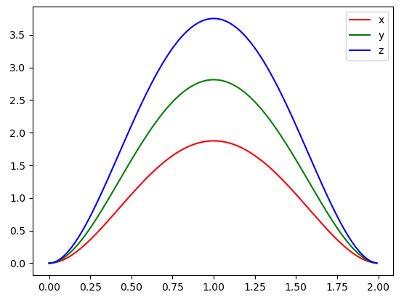

Endeffector acceleration graphics

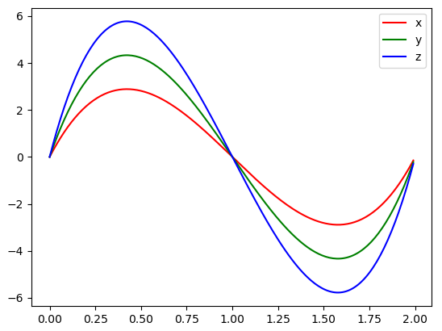

Task 3

q(t) = $\left\{\begin{aligned}a_{10}+a_{11}*t+a_{12}*t^{2} 0≤t<t_{a} \\ a_{20}+ a_{21}*t t_{a}≤t<t_{f}-t_{a} \\ a_{30}+ a_{31}*t+a_{32}*t^{2} t_{f}-t_{a}≤t<t_{f}\end{aligned}\right.$

Endeffector position graphic

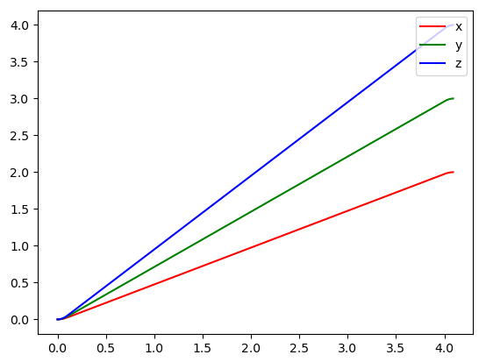

Endeffector velocity graphic

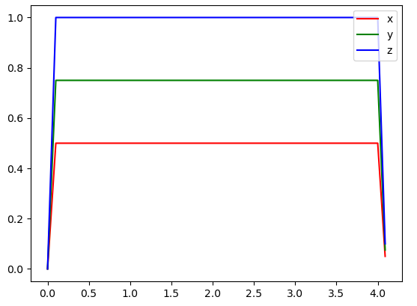

Endeffector acceleration graphics

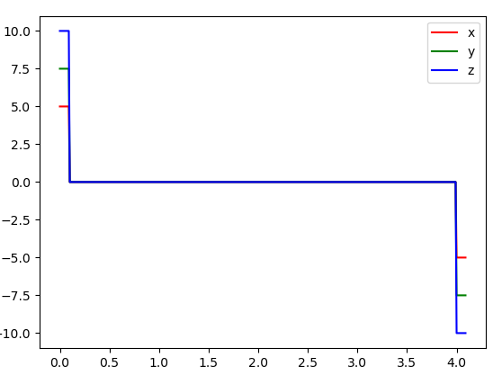

Task 4

Endeffector position graphic

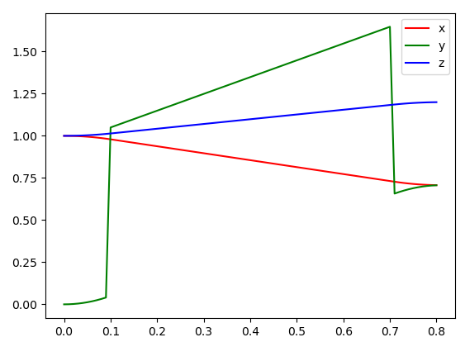

Endeffector velocity graphic

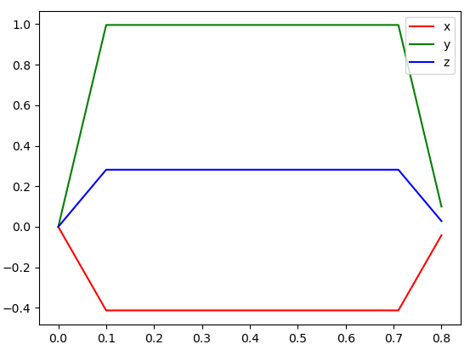

Endeffector acceleration graphic

