**TestLogin**

**31/01/2023**

**21:44:13.045**

**1. Open home  
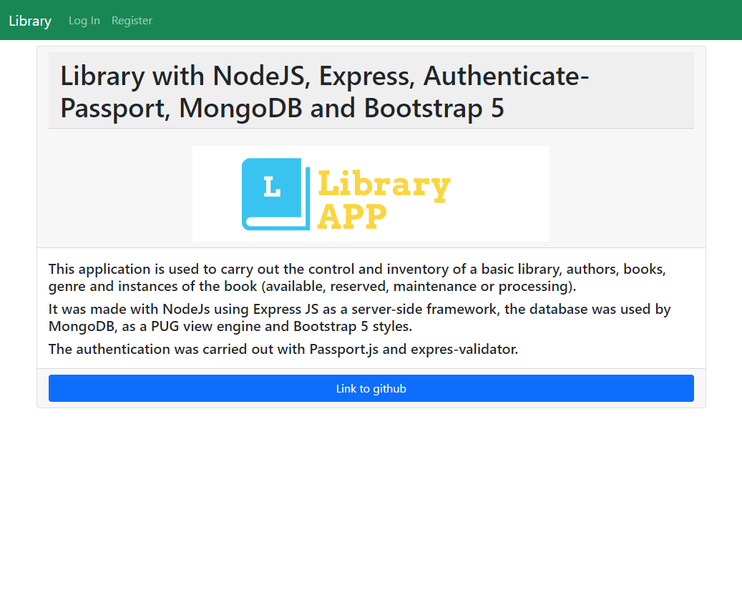**

**2. Open login  
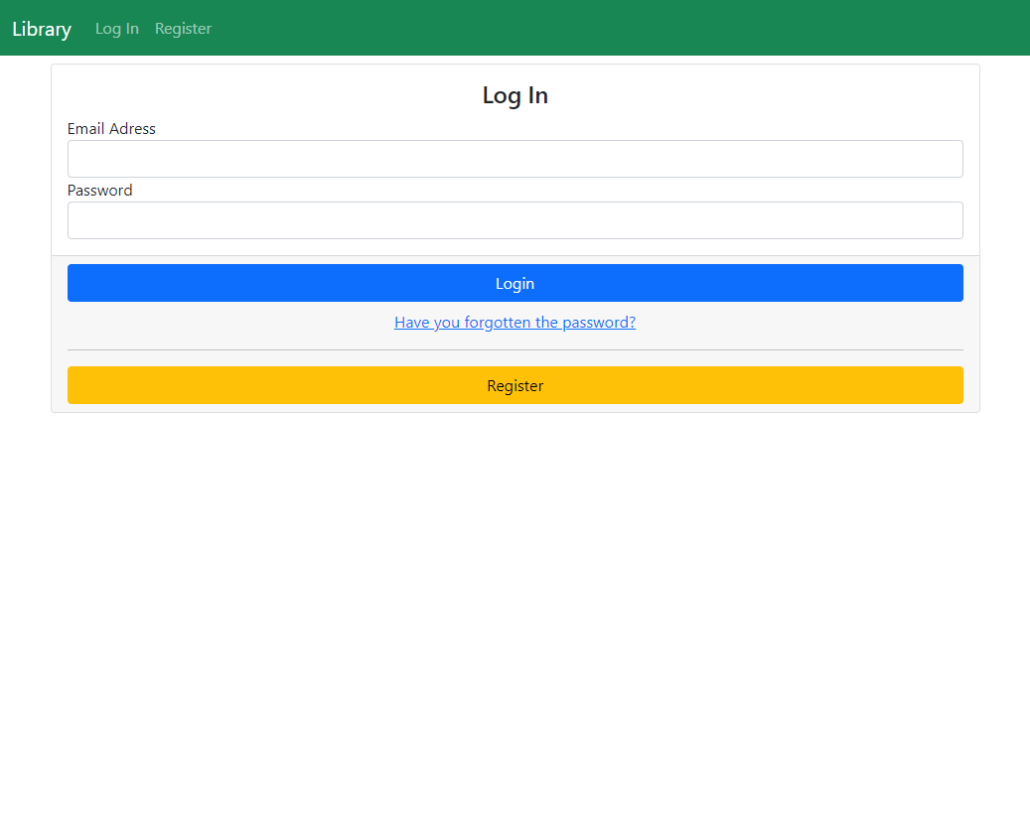**

**3. Sign in  
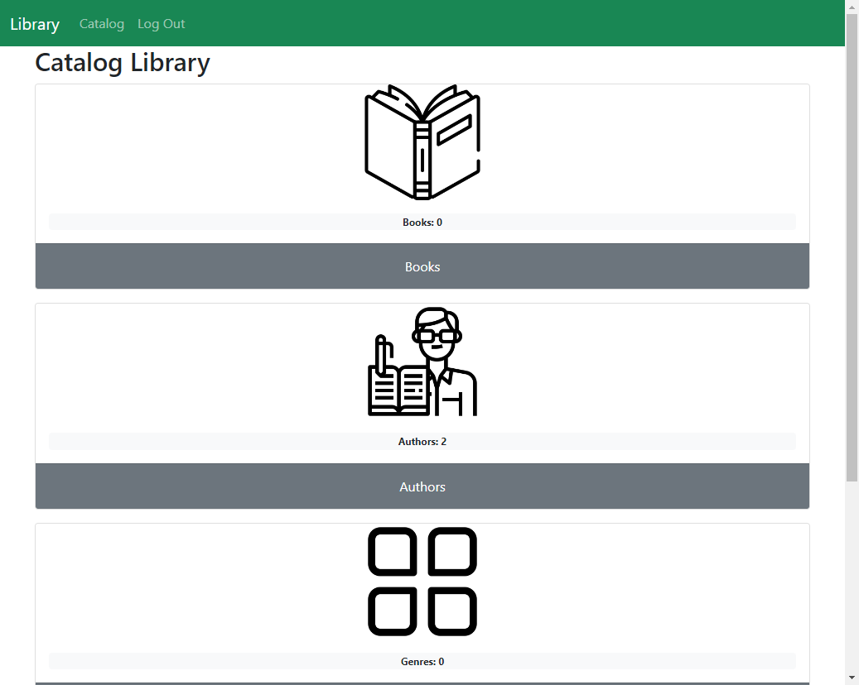**

**4. Exit  
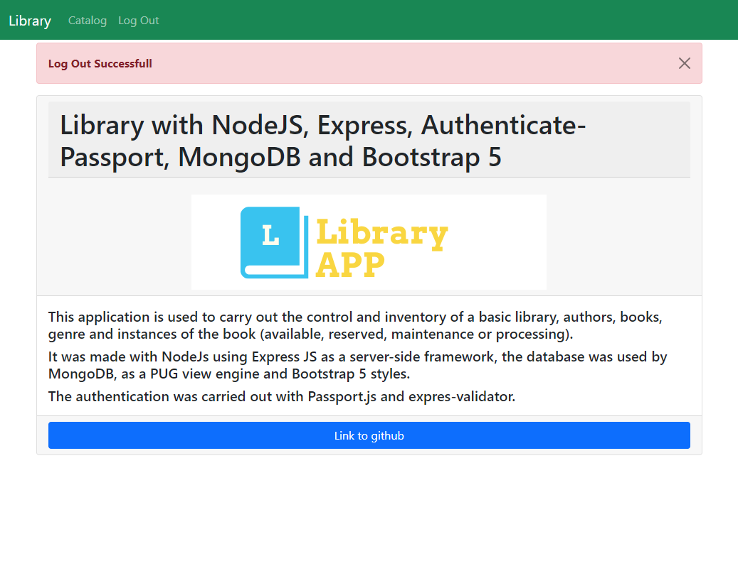**

**Errores**

**Assertion Error - expected: <Librar> but was: <Library>**