Part D
- Screenshot of W3C Validation of HTML & CSS
Css:
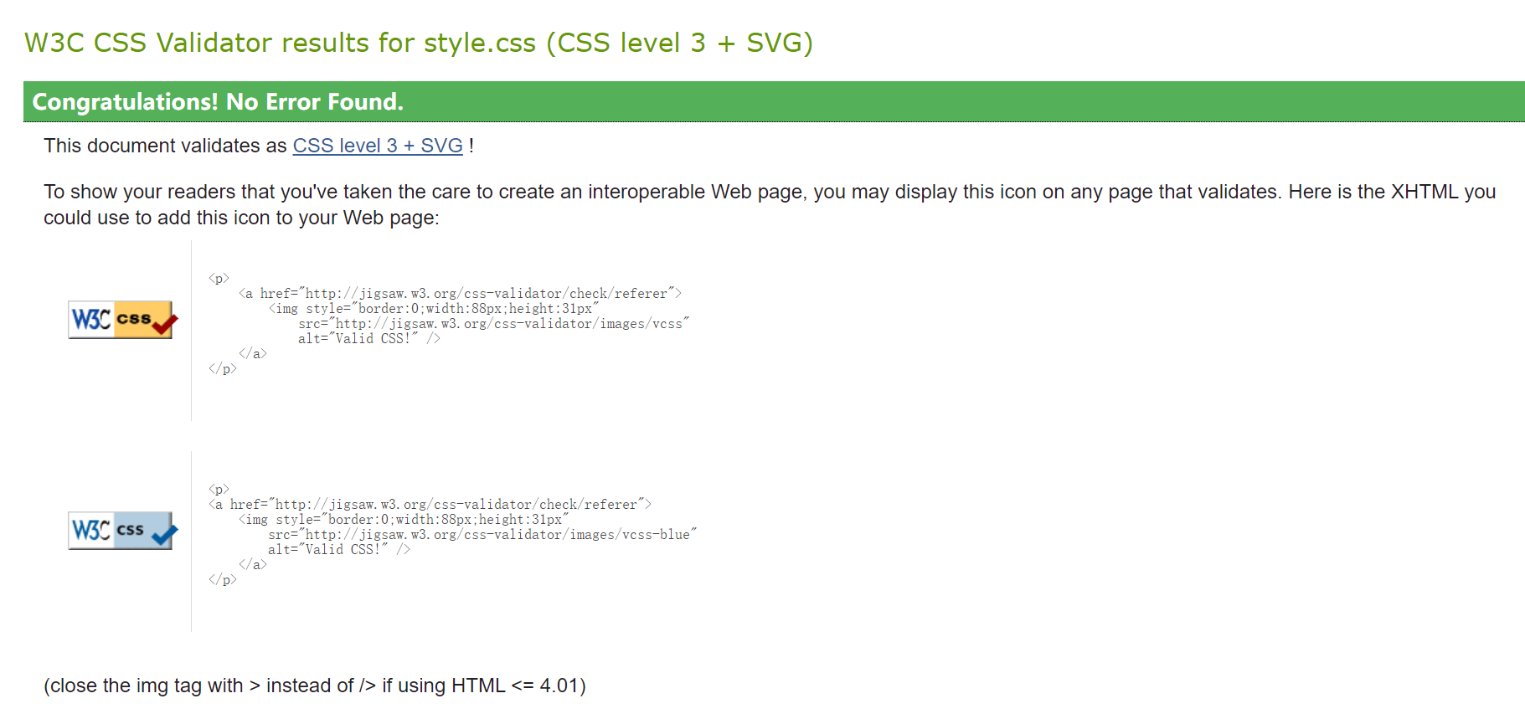
Html :
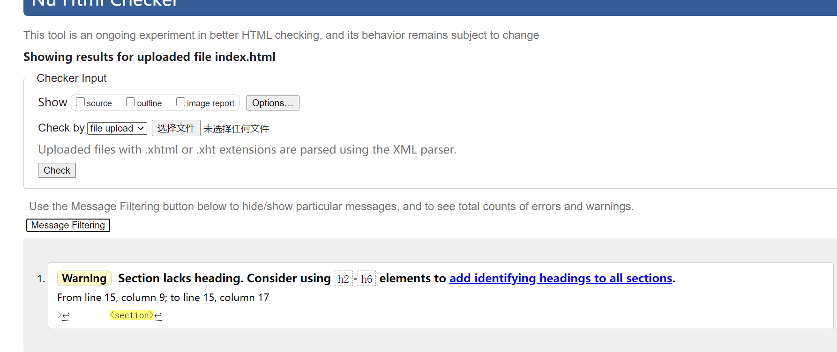
- Cross-Browser test three examples including mobile phone
Google :

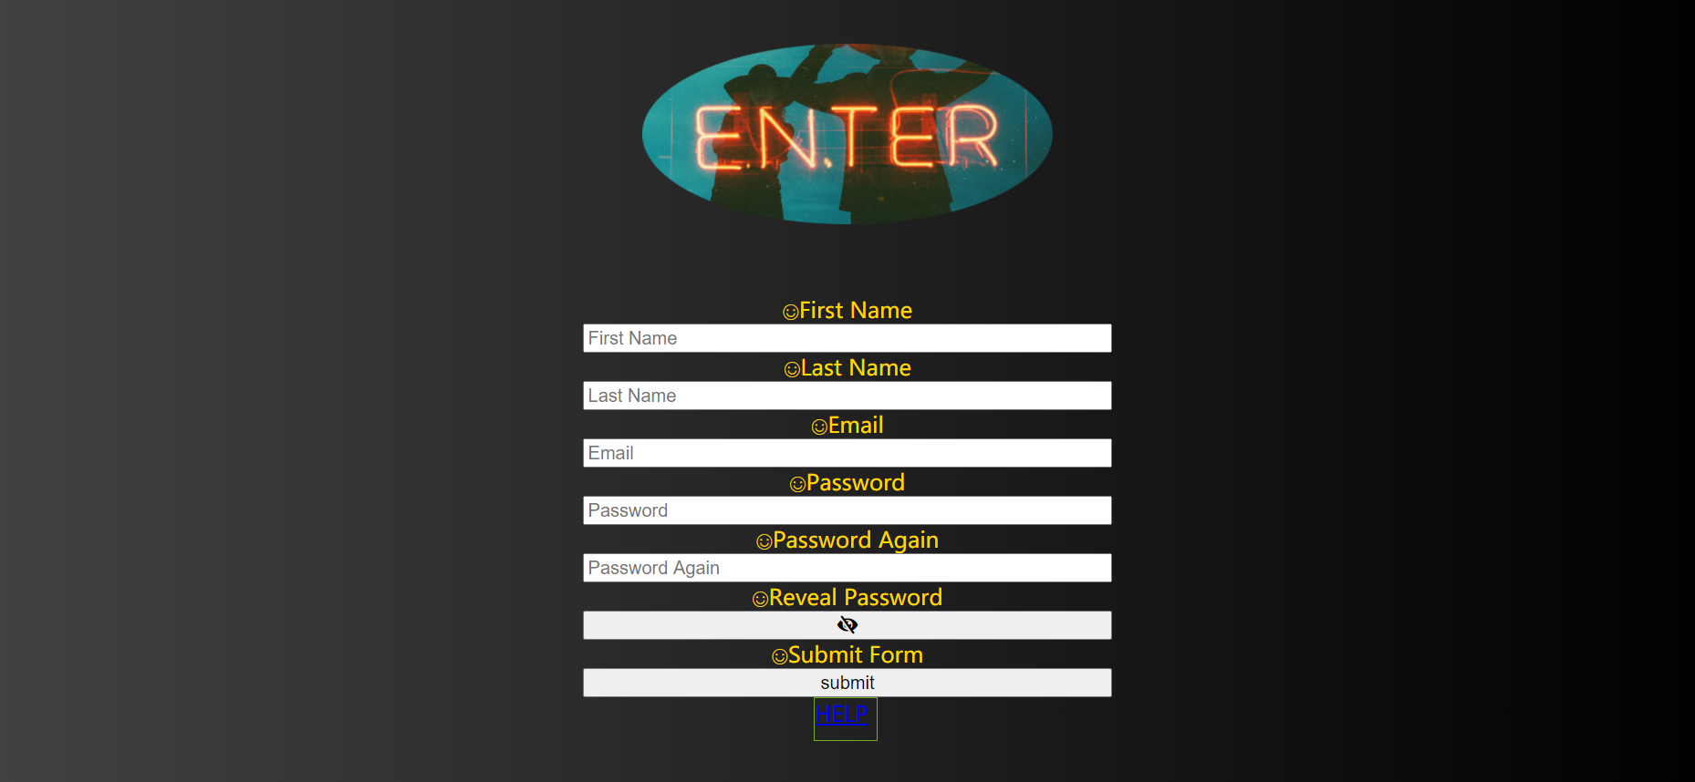

IE :
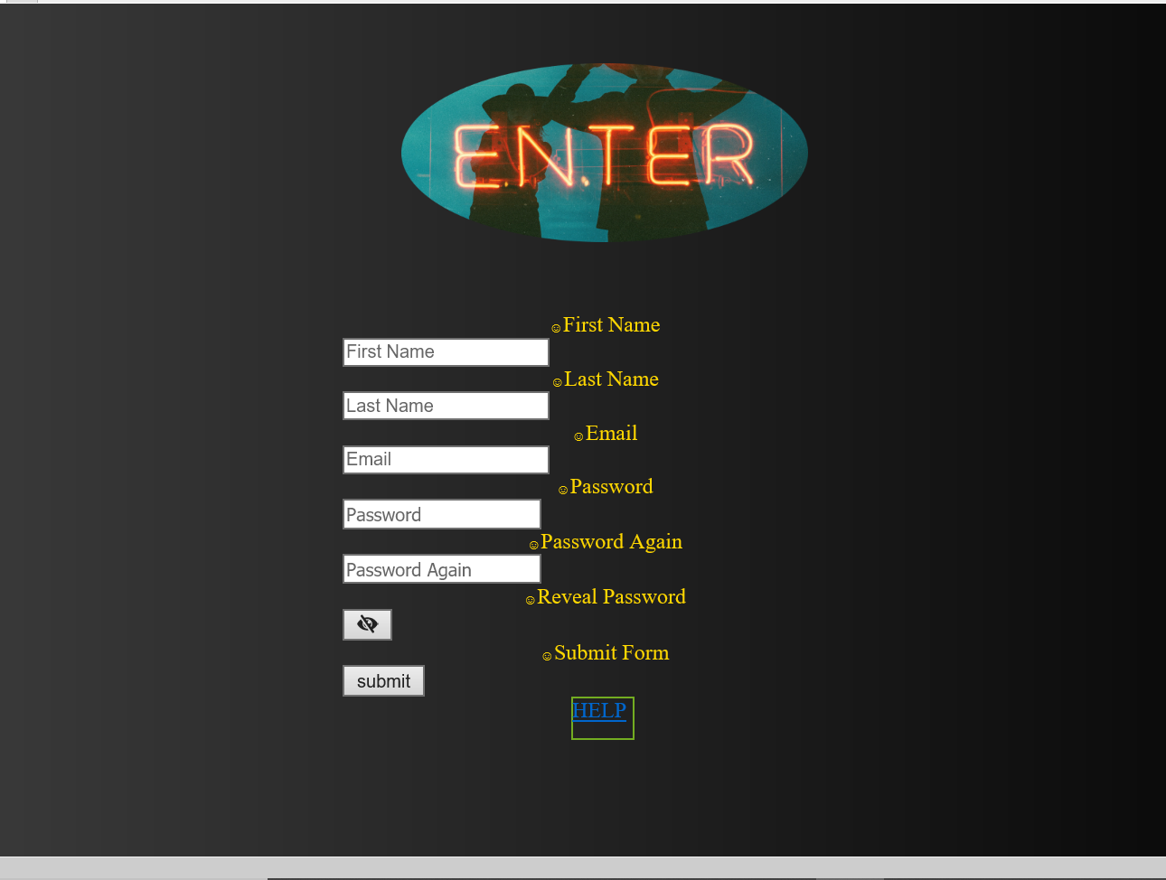

Firefox :
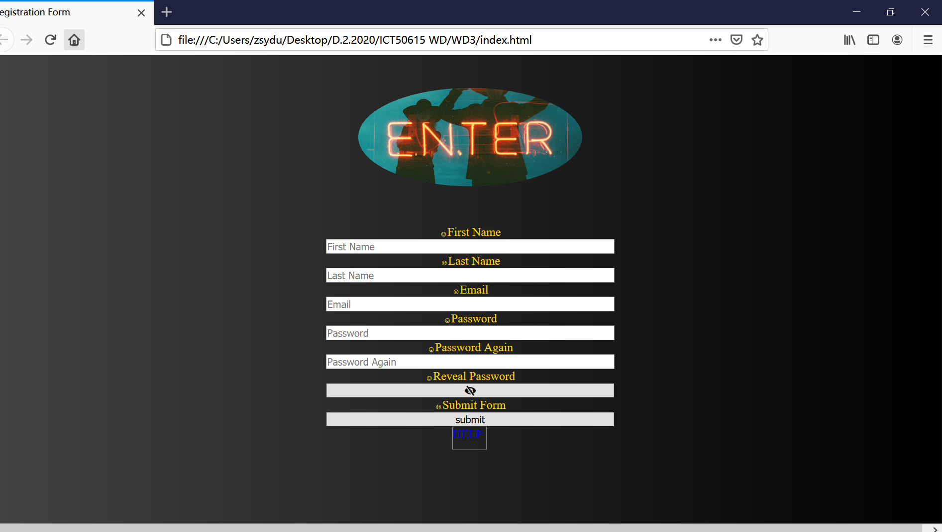

Part E
What is it that you are trying to convey in the logo design created.
The logo include word “enter”, this is meaning welcome clints registration on this form and join us.
What WHS principles were followed while working on this project?

This project put a help link on the page, and project people’s private information carefully.

