UNDERGRADUATE PROJECT PROPOSAL

Project Title | Energy-Aware Coverage Path Planning for a Single UAV
Project Title | over Irregular Farmland using Ant Colony Optimisation
Student ID | 202318010214
Supervisor Name | Maged Refat
Student Name | Eric
Student Major | Computer Science

 |  | Date Submitted | 5 November 2026

Table of Contents

Table of Contents I
Chapter 1. Introduction 1
1.1 Background of Study 1
1.2 Project Aim 1
1.3 Project Objectives 1
1.4 Project Overview 1
1.4.1 Scope 1
1.4.2 Audience 1
1.5 Proposed Structure of the Report 1
Chapter 2. Literature Review 3
2.1 Fundamental Theories 3
2.2 Literature Review 3
2.3 Gaps in the Existing Literature 4
2.4 Summary 4
Chapter 3. Methodology 5
3.1 Problem Statement 5
3.2 Approach 5
3.3 Technology 6
3.4 Project Version Management Plan 6
3.5 Summary 6
Chapter 4. Project Management 7
4.1 Activities 7
4.2 Schedule 7
4.3 Data Management Plan 7
4.4 Project Deliverables 7
References 8
General Guidance 8
Formatting Requirements 8
Written Presentation 8
AI Declaration Section 10

Chapter 1. Introduction

1.1 Background of Study
Precision agriculture now uses small multirotor UAVs for crop scouting and spraying. A battery lasts only twenty to thirty minutes, so what matters is how much field one mission can cover per unit of energy, not how fast the aircraft flies. Coverage path planning (CPP) is the part that decides this: it produces a route whose sensor footprint passes over every point of the field [4], [5].
Most planners assume a rectangular field and minimise path length, yet real farmland is irregular and often concave. Such fields must be decomposed into convex sub-regions before a boustrophedon sweep can be applied, and the visit order then dominates distance and turn count. Field data show that this order matters far more for energy than for distance: routes differing by under 2.5 % in length differed by 30-35 % in energy per metre, because turning draws more power than cruising [3].

1.2 Project Aim
The aim is to design, implement and evaluate an energy-aware coverage planner for a single multirotor over irregular farmland, in which ant colony optimisation orders convex sub-regions under an analytical energy model and reports battery feasibility.

1.3 Project Objectives
1. To decompose irregular field polygons into convex sub-regions and to generate, within each sub-region, a boustrophedon sweep whose orientation minimises in-cell turning energy.
2. To formulate an analytical energy model that separates cruise, turning and climb phases and that is calibrated against published flight measurements.
3. To formulate sub-region sequencing as an energy-weighted generalised travelling salesman problem, including the choice of entry and exit points, and to solve it with an adapted ant colony optimisation algorithm.
4. To test each planned route against a battery constraint and to divide an infeasible mission into the smallest number of feasible sorties.
5. To compare the planner with greedy and genetic-algorithm baselines on synthetic and real field boundaries, using flight distance, turn count, estimated energy and battery feasibility as metrics.

1.4 Project Overview
The program takes a field polygon, a set of UAV parameters and a battery capacity. It returns waypoints that cover the field, an energy estimate for each flight phase, and a yes-or-no answer on whether one battery is enough. The work is split into three parts. The first cuts the field into pieces and sweeps each one, the second works out what each move costs in energy, and the third decides the order of the pieces. Everything runs in a two-dimensional geometric simulation, because the optimiser has to be run many times and real flights are far too slow for that.

1.4.1 Scope
The study is confined to a single multirotor at constant altitude over a flat, static field, without wind or obstacle avoidance; three-dimensional terrain is documented elsewhere [10], while wind is excluded by assumption, and both are stated limitations here. The contribution is a planning method and its evaluation, not a flight controller. Its significance is that it replaces the distance proxy of current practice with an interpretable energy objective and treats the battery limit as a planning output.

1.4.2 Audience
Agronomists and UAV operators planning missions over irregular plots, developers of ground-station route engines, and researchers needing a reproducible energy-oriented benchmark.

1.5 Proposed Structure of the Report
The final report follows the six chapters of Figure 1-1; this proposal covers Chapters 1 to 4, with Chapters 5 and 6 reporting experiments and conclusions. Chapter 2 establishes the theoretical background and ends with the research gap, Chapter 3 presents the method, and Chapter 4 the work plan.
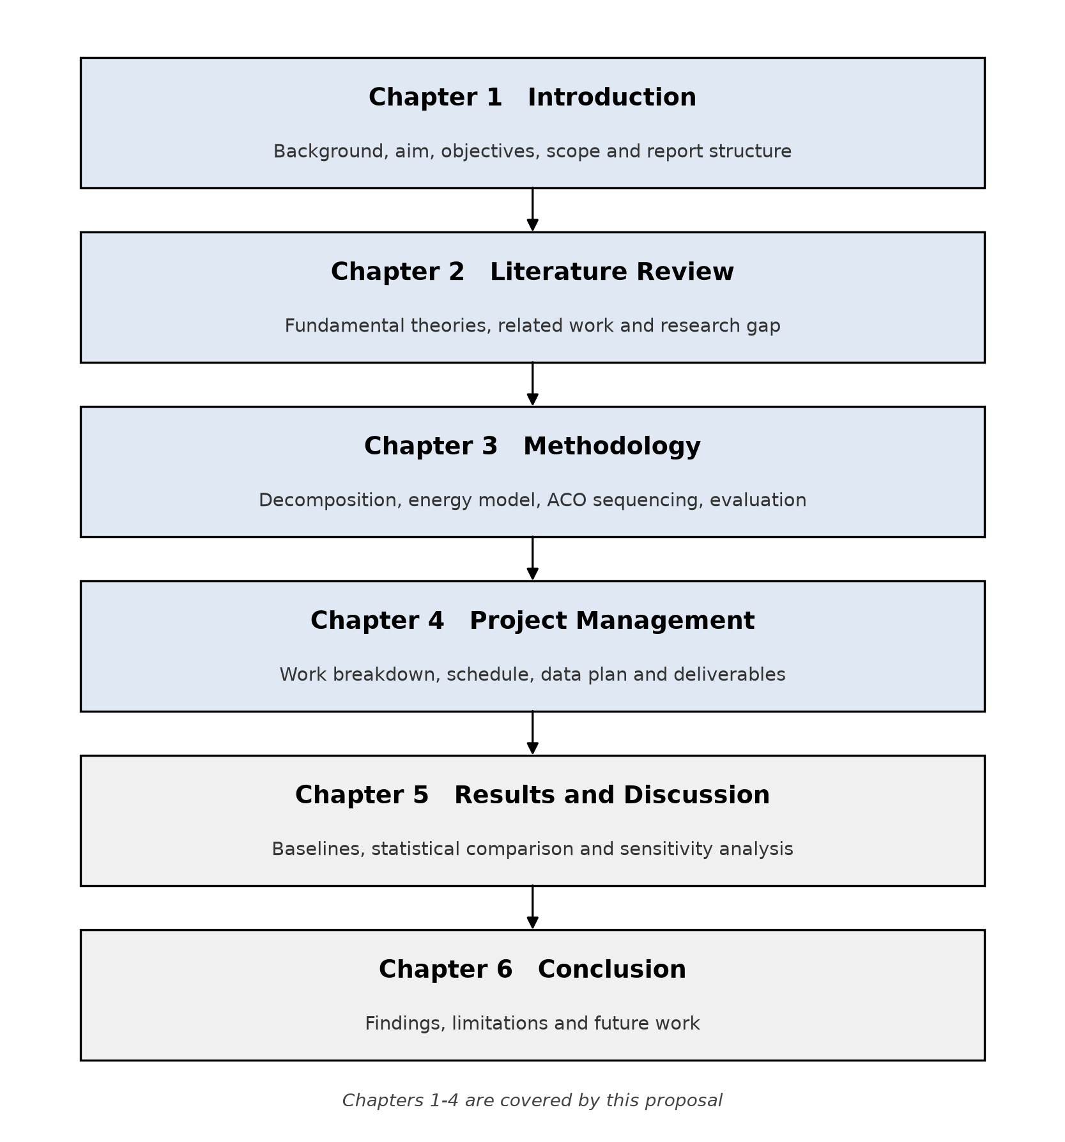
Figure 1-1. Structure of the project report.

Chapter 2. Literature Review

2.1 Fundamental Theories
Coverage path planning requires a route whose sensor footprint covers the target region completely with minimal duplication [4]. For a concave region, exact cellular decomposition partitions the area into cells in which a back-and-forth pattern is complete, the boustrophedon decomposition being the canonical case. Inside a convex cell, parallel tracks separated by the swath width are joined alternately, so turns scale with cell width over track spacing.
Multirotor energy is not proportional to distance. Induced, profile and climb power vary differently with speed and mass [13], and a headland turn requires deceleration, yaw and re-acceleration that a distance model cannot represent; field measurements on orchard spraying confirm that turns dominate the achievable energy saving [3]. Charging each phase at constant power gives a cost additive over route edges and hence compatible with graph search. Sequencing then becomes a generalised travelling salesman problem (GTSP), and is solved by ant colony optimisation (ACO), which balances pheromone intensity against an immediate-cost heuristic, weighted by alpha and beta, with rho controlling evaporation [11].

2.2 Literature Review
Three strands inform this project: geometric planners, metaheuristic ordering and energy-aware formulations. Table 2-1 compares them.

2.2.1 Decomposition and Sweep for Irregular Fields
Kato et al. [1] give the most complete pipeline for irregular fields: concave polygons are decomposed greedily into convex sub-areas, each swept along its longest dimension, four path alternatives that differ only in entry and exit points are built per sub-area, and the visit order is optimised as a GTSP by ACO against a widely used flight-planning package. The pipeline is complete, but the cost it optimises is still turn count plus distance, and the decomposition is decided on geometry alone, before any question about energy is asked. Battery capacity, payload and communications are explicitly neglected. The authors also note that the ant colony stage does not change the number of turns at all, because turns are already fixed by the decomposition and the sweep orientation. For spraying missions, margin reduction and concave-corner handling are already recognised as decisive [5].

2.2.2 Metaheuristic Ordering and ACO
Jia et al. [2] combine a greedy constructor with ACO for sweep coverage of scattered targets. A cost that blends flight time and target weight drives the assignment, a secondary-advantage rule repairs infeasible choices when endurance runs short, and ACO reorders the selected points, keeping a new tour only if it is shorter. Building a solution first and improving it afterwards transfers directly, and so does treating turning time as angle divided by angular rate. Their problem, however, is point coverage rather than area coverage. Work on mobile-robot coverage also shows that the direction in which a route enters and leaves a region changes its cost [8], which is exactly what the order of sub-regions controls. For plant-protection UAVs working across several fields, metaheuristics have been used to order the fields themselves with energy in the objective, and the reported saving is up to 6.46 % [7].
Tian et al. [3] plan orchard spraying routes from tree-centre coordinates. They add a corner term to the heuristic, switch to a rank-based pheromone update, and delete waypoints whose heading change is small. In simulation, path length moved by only 2.86 to 4.60 per cent while the total turning angle dropped by 21.94 to 55.94 per cent. The flight trials show the same pattern: path length changed by at most 2.37 per cent, turning angle fell by 50.76 to 71.10 per cent, and energy per metre fell by 30 to 35 per cent. Their routes are still a tour over points, with no decomposition, no battery constraint and no model that predicts energy before flight.

2.2.3 Energy-Aware Formulations
Energy-aware coverage planning has been studied for some time. A 2022 survey groups the energy-saving methods by mechanism: using the wind, cutting turns and path length, flying higher, holding an efficient speed, and smoothing turns with Bezier curves [4]. The closest study to this project chooses the decomposition granularity and the sweep pattern inside each cell by an energy criterion [6], which shows that energy can shape the geometry, though the order of the cells is still fixed by a greedy rule. Energy-aware planning has also been combined with optimal flight speed for teams of UAVs [9], and for fleets the multiregional coverage problem has been formulated with explicit energy constraints [12].
Table 2-1. Comparison of the closest related work with this project.
Study | Field representation and ordering | Objective | Energy model | Battery / sorties
Kato et al. [1] | Concave polygons to convex cells; four entry/exit points; ACO solves a GTSP | Turns plus distance | None (distance proxy) | None
Jia et al. [2] | Dispersed points; greedy assignment then ACO reordering | Flight time, weighted coverage | None (endurance limit) | Return time only
Tian et al. [3] | Tree-centre waypoints; one tour, no decomposition | Length, corner angle, nodes | Measured after flight | None
Aerospace 2026 [6] | Energy-driven choice of decomposition granularity and cell pattern | Energy per unit area | Yes, per-cell | None
RA-L 2024 [9] | Multi-UAV coverage with variable flight speed | Energy and mission time | Yes, speed-dependent | Multi-UAV, no split
This project | Convex cells with entry/exit chosen jointly with the order | Estimated energy plus turns and distance | Yes (cruise, turn, climb) | Yes (feasibility and sortie split)

2.3 Gaps in the Existing Literature
There are three gaps. The first is that energy is either missing from the objective or used only to choose cells [1], [6], so the order of sub-regions is still decided by distance or turn count. The second is that the planners which do model energy work on grids, on point sets or on teams of aircraft [2], [9], [11], [12]. The methods compared in that survey change sweep direction, altitude or speed; none of them decides the order in which sub-regions of an irregular field are visited [4]. For a single aircraft, the closest studies either fix the order with a greedy rule [6] or optimise it for a team [9]; none of them plans around a finite battery. The third gap is battery feasibility: it is treated as a fixed endurance limit rather than a planning output, so no study decides where a mission should be divided.

2.4 Summary
Turning is what costs energy, and energy-aware decomposition has started to appear, but ordering sub-regions by energy while keeping the battery in check is still open.

Chapter 3. Methodology
This chapter defines the problem, develops the energy model, describes the architecture and specifies the evaluation protocol.

3.1 Problem Statement
Given a polygon representing a field boundary, UAV parameters (cruise speed, turn rate and phase powers) and usable battery energy, find a route covering the polygon with a minimum swath overlap that minimises energy subject to single-battery feasibility, partitioning it into the fewest feasible sorties if necessary. Existing planners solve a distance or turn-count version; the added difficulty is that the cost between two cells depends on the chosen entry and exit points, coupling geometry with sequencing.

3.2 Approach
The approach has three layers: geometry, which decomposes and sweeps; energy, which prices every edge; and search, which sequences cells. Separating them allows independent validation and an ablation of the energy objective.

3.2.1 Mathematical Basis
Total energy is the sum of the cruise, turn and climb terms along the route:
E_{total} = Σ_{i=1}^{n} P_{c}(d_{i}/v) + Σ_{k=1}^{m} E_{turn,k} + P_{cl}(h/v_{cl}) (3-1)
where d is the length of a straight segment, v the cruise speed, h the altitude gained, and Pc and Pcl the power drawn in cruise and in climb.
E_{turn} = P_{t}(πR/v) (3-2)
A headland turn of radius R at speed v costs this much, with Pt the turn power and R taken as half the track spacing so that the turn joins two neighbouring sweep lines. A route fits within one sortie only if
E_{total} ≤ η E_{batt} (3-3)
where eta is 0.8, leaving a fifth of the capacity for wind and for the flight home. Ants move from cell i to cell j with probability
p_{ij} = (τ_{ij}^{α}η_{ij}^{β}) / Σ_{s∈N(i)} (τ_{is}^{α}η_{is}^{β}), η_{ij} = 1/E_{ij} (3-4)
where E is the transit energy from the exit of cell i to the entry of cell j plus the sweep energy of cell j, tau the pheromone on that edge and eta its inverse, alpha and beta the weights given to each, and N(i) the cells still allowed. Pheromone evaporates at rate rho and is reinforced in inverse proportion to tour energy, with a 2-opt local search on the best tour. Calibration uses the per-metre energy reported for this platform class: about 0.12 kJ per metre flown after optimisation and about 0.18 before it [3]. The model is counted as plausible if it lands in that range.

3.2.2 Overview of Model Architecture
The system follows the eight steps of Figure 3-1, grouped into the three layers. Steps 1 to 4 are geometric: a polygon is accepted, decomposed into convex cells by extending a vertical line from each reflex vertex, swept with the orientation minimising in-cell turning energy, and verified by rasterising the field and confirming that every raster cell meets a track. Steps 5 and 6 evaluate phase-wise energy per cell and transit energy between every ordered pair, producing the cost matrix. Steps 7 and 8 run ACO over cell order and entry and exit points, apply Eq. (3-3) and, where it fails, split the mission at the largest cumulative-energy gap.
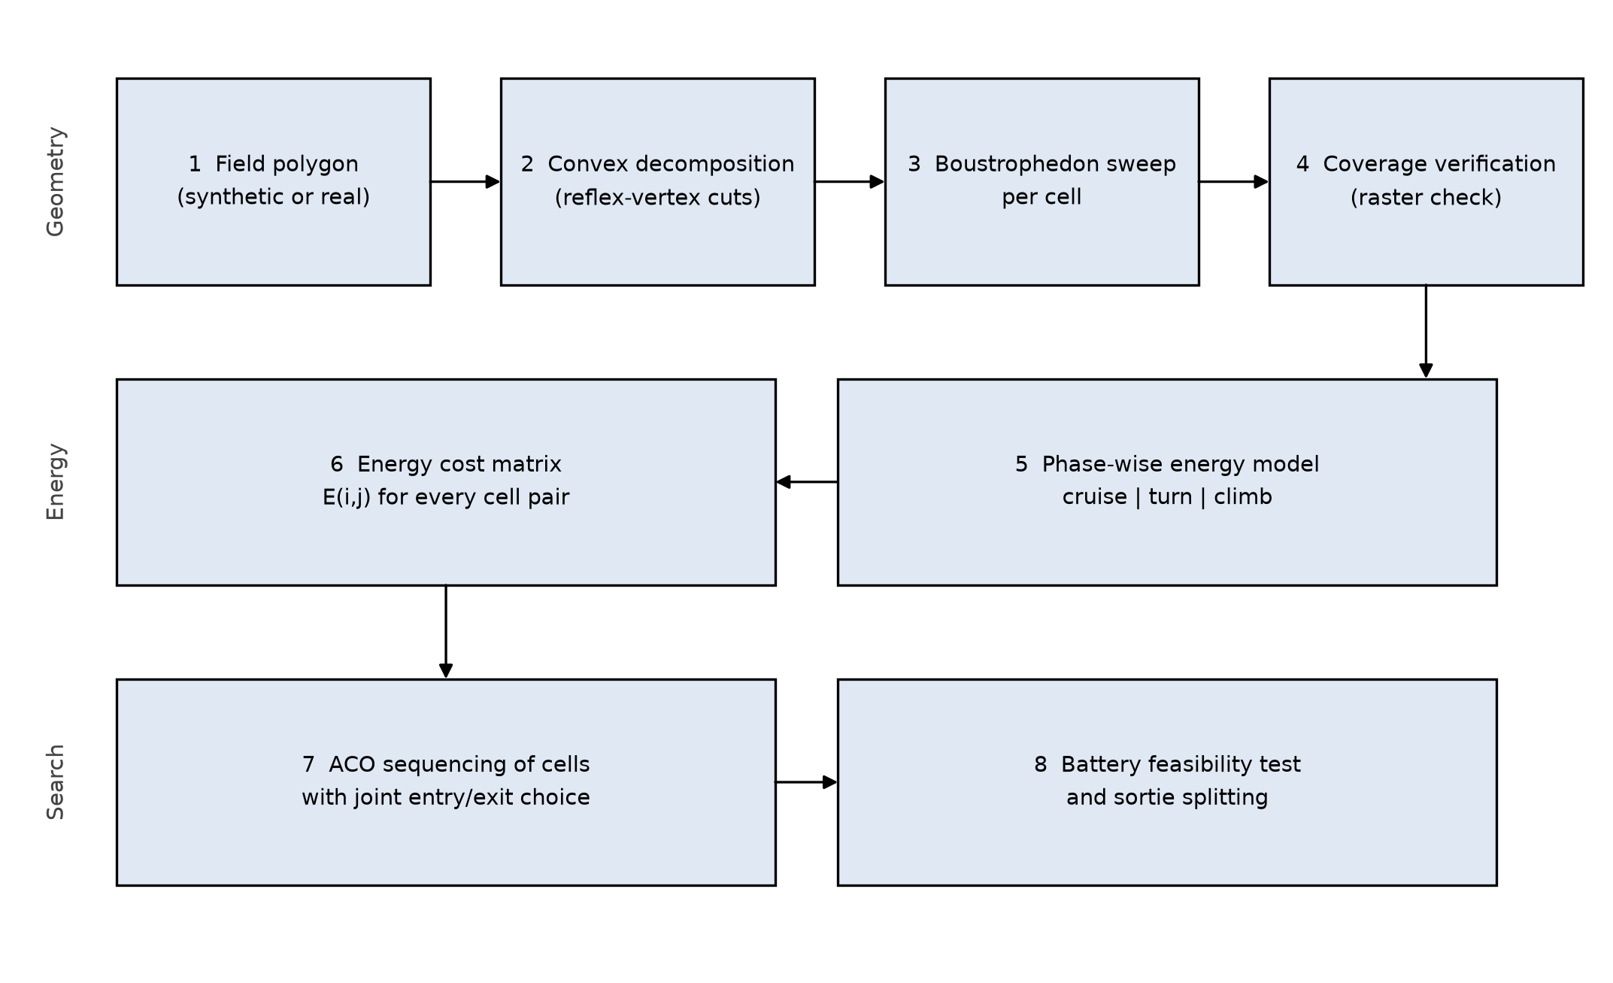
Figure 3-1. Architecture of the proposed energy-aware coverage planner.

3.2.3 Dataset and Data Processing
Two sources are used (Table 3-1). Synthetic fields come from a generator that controls concavity, elongation and hole count, giving graded difficulty and exact coverage ground truth. Real boundaries come from the EuroCrops dataset, which harmonises geo-referenced agricultural parcel polygons and crop labels from sixteen EU countries [14]; a sample of parcels is projected to a local metric system, simplified below one metre, and clipped to one to twenty hectares.
Table 3-1. Field datasets used in the evaluation.
Dataset | Type | Scale | Purpose
Synthetic fields | Generated polygons; controlled concavity, elongation, holes | 40 instances | Graded difficulty; exact coverage ground truth
EuroCrops [14] | Geo-referenced parcel polygons (16 EU countries) | 30 sampled parcels | Realistic irregular geometry

3.3 Technology
Python 3.11 with shapely for geometry, numpy for vectorised costs, matplotlib for route and energy plots and pandas for experiment logs. The ACO and genetic algorithm are implemented directly so that the cost function, pheromone model and constraint handling stay controllable and reproducible. Gazebo is optional and would only animate two routes.

3.4 Project Version Management Plan
Code is kept in a public repository at https://github.com/Eric-Aria/uav-coverage-planning. Work goes on one branch per feature: decomposition, sweep, energy, aco and experiments. A branch is merged only after its script runs without errors. Each experiment is tagged with a date and a short name, so a number in the report can be traced back to the code and parameter file that produced it.

3.5 Summary
This chapter set out the problem, gave an energy model whose parameters can be checked against published measurements, described the eight steps and the three layers they fall into, and listed the data and tools.

Chapter 4. Project Management

4.1 Activities
Table 4-1 maps each objective to its activities and weeks. The plan assumes nine working weeks, with the final report due on 4 January 2027.
Table 4-1. Work breakdown structure and activity schedule.
Objective | Activities | Week
1. Decomposition and sweep | Field generator; convex decomposition; boustrophedon sweep; raster coverage check | 2-3
2. Energy model | Phase-wise power model; parameter sourcing; calibration against published per-metre energy | 4-5
3. ACO sequencing | GTSP formulation; joint entry/exit selection; ACO with 2-opt; convergence study | 5-6
4. Battery feasibility | Feasibility test; sortie partitioning; sensitivity to battery capacity | 6-7
5. Evaluation | Greedy and GA baselines; 30 runs per instance; statistics; ablation of the energy objective | 7-8
Reporting | Progress report; dissertation; figures; submission and defence preparation | 8-9

4.2 Schedule
The nine-week schedule appears in Figure 4-1. Development is front-loaded so an end-to-end pipeline exists by week five, leaving weeks six to eight for battery logic, baselines and statistics.
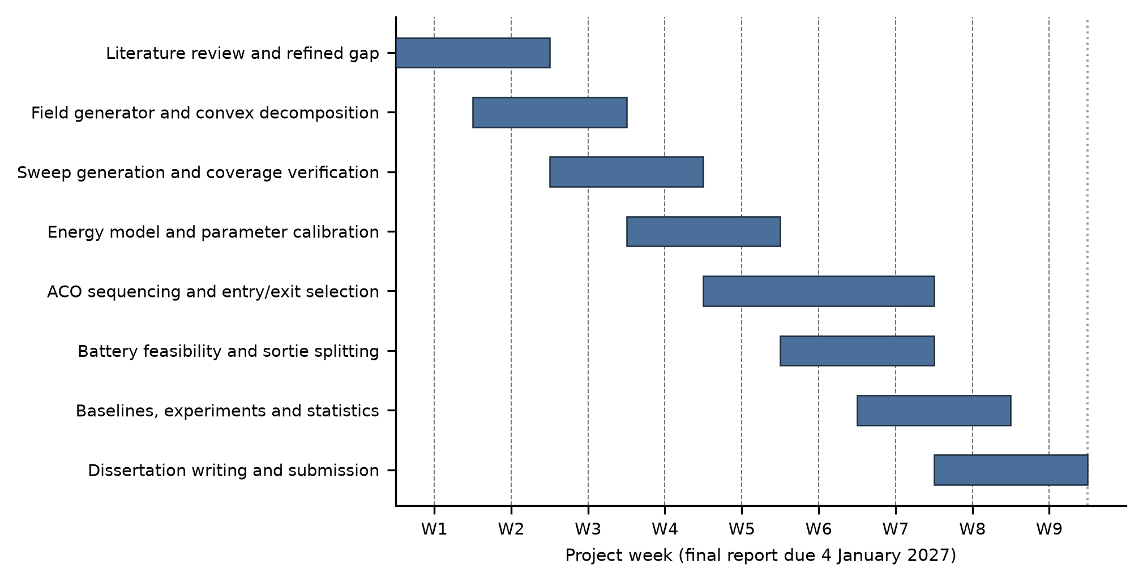
Figure 4-1. Project schedule.

4.3 Data Management Plan
Field data, with provenance and licence notes, is versioned with Git LFS. Experiment outputs are written to timestamped CSV files by a single runner script, so no number is transcribed by hand. Documents sit in a shared folder and the literature in a reference manager exported as BibTeX, with a weekly backup held off-device.

4.4 Project Deliverables
This proposal; a progress report; the dissertation; documented code with a one-command experiment runner; the datasets with provenance; the results and figures; and a demonstration rendering a route with its energy profile.

References
[1] E. R. R. Kato, R. S. Inoue, and L. dos S. Franco, "A method for planning multirotor unmanned aerial vehicle flight paths to cover areas using the ant colony optimization metaheuristic," Comput. Electron. Agric., vol. 231, Art. no. 109983, 2025, doi: 10.1016/j.compag.2025.109983.
[2] Y. Jia, S. Zhou, Q. Zeng, C. Li, D. Chen, K. Zhang, L. Liu, and Z. Chen, "The UAV path coverage algorithm based on the greedy strategy and ant colony optimization," Electronics, vol. 11, no. 17, Art. no. 2667, 2022, doi: 10.3390/electronics11172667.
[3] H. Tian, Z. Mo, C. Ma, J. Xiao, R. Jia, Y. Lan, and Y. Zhang, "Design and validation of a multi-objective waypoint planning algorithm for UAV spraying in orchards based on improved ant colony algorithm," Front. Plant Sci., vol. 14, Art. no. 1101828, 2023, doi: 10.3389/fpls.2023.1101828.
[4] G. Fevgas, T. Lagkas, V. Argyriou, and P. Sarigiannidis, "Coverage path planning methods focusing on energy efficient and cooperative strategies for unmanned aerial vehicles," Sensors, vol. 22, no. 3, Art. no. 1235, 2022, doi: 10.3390/s22031235.
[5] J. Li, H. Sheng, J. Zhang, and H. Zhang, "Coverage path planning method for agricultural spraying UAV in arbitrary polygon area," Aerospace, vol. 10, no. 9, Art. no. 755, 2023, doi: 10.3390/aerospace10090755.
[6] A. Tyshchenko, I. Iljin, V. Masalskyi, O. Masalskyi, and V. Bucinskas, "Hybrid strategy selection and polygon decomposition for energy-aware 2D UAV coverage path planning," Aerospace, vol. 13, no. 11, Art. no. 976, 2026, doi: 10.3390/aerospace13110976.
[7] Z. Tan, K. Huang, Y. Tang, M. Fang, and H. Huang, "Multi-area coverage path planning for plant protection UAVs based on a hybrid strategy beluga whale optimization," Smart Agric. Technol., vol. 12, Art. no. 101379, 2025, doi: 10.1016/j.atech.2025.101379.
[8] S. Karakaya and M. Z. Konyar, "Hybrid boustrophedon and direction-biased region transitions for mobile robot coverage path planning: A region-based multi-cost framework," Appl. Sci., vol. 15, no. 23, Art. no. 12666, 2025, doi: 10.3390/app152312666.
[9] D. Datsko, F. Nekovar, R. Penicka, and M. Saska, "Energy-aware multi-UAV coverage mission planning with optimal speed of flight," IEEE Robot. Autom. Lett., vol. 9, no. 3, pp. 2893-2900, 2024, doi: 10.1109/LRA.2024.3358581.
[10] H. Jiang and P. Yang, "A three-dimensional coverage path planning method for robots for farmland with complex hilly terrain," Appl. Sci., vol. 14, no. 23, Art. no. 11231, 2024, doi: 10.3390/app142311231.
[11] Y. Gong, K. Chen, T. Niu, and Y. Liu, "Grid-based coverage path planning with NFZ avoidance for UAV using parallel self-adaptive ant colony optimization algorithm in cloud IoT," J. Cloud Comput., vol. 11, no. 1, Art. no. 29, 2022, doi: 10.1186/s13677-022-00298-2.
[12] J. Xie and J. Chen, "Multiregional coverage path planning for multiple energy constrained UAVs," IEEE Trans. Intell. Transp. Syst., vol. 23, pp. 17366-17381, 2022, doi: 10.1109/TITS.2022.3160402.
[13] D. Hong, S. Lee, Y. H. Cho, D. Baek, J. Kim, and N. Chang, "Least-energy path planning with building accurate power consumption model of rotary unmanned aerial vehicle," IEEE Trans. Veh. Technol., vol. 69, no. 12, pp. 14803-14817, 2020, doi: 10.1109/TVT.2020.3040537.
[14] M. Schneider, T. Schelte, F. Schmitz, and M. Koerner, "EuroCrops: The largest harmonized open crop dataset across the European Union," Sci. Data, vol. 10, Art. no. 612, 2023, doi: 10.1038/s41597-023-02517-0.

AI Declaration Section
I have utilised / have not utilised the use of AI tool(s) in this assessment.
I have used the following AI tool(s): please provide the name of the AI tool(s) you have used and provide the exact prompt(s) you provided in
For example:
AI Tool: CHAT GPT – Prompt: Find information on what are the impacts of utilising AI Tools for academic Purposes and career prospects?
Baidu translator: I have written the task 3, task 6, task 7 and task 8 in Chinese language and used Baidu Translate to covert these tasks to English.

Important Notes:
- If the declaration has not been made, and your tutors suspect use of AI, you will be called into do an oral presentation and it will be considered academic misconduct if you fail the oral presentation. You must also declare the use of translation software.
- Full disclosure will not result in an academic penalty or a lower score, so please be honest and fill in the declaration when submitting your assignment(s).

