Features:

* Switch languages (en, cn, fr)
* Dark mode
* Pokemons
* List of pokemons
* Filter by gen, types, showMega, showDynamax
* Search by name
* Type Table
  + Display table
  + Search type
* Nature Table
* Abilities
  + List of abilities
  + Search ability
* Moves
  + List of moves
  + Filter by type, damage type
  + Search move

Data structures:

* Pokemon Brief Info
  + Names
  + National pokedex id
  + Generation
  + Types
  + Image
  + Species url
  + Variety url
* Type
* Name
* Names (in different lang)
* url
* icon

@media only screen and (min-width: 768px) {}

* Pokemon-species Object: useful keys:
  + Capture_rate
  + egg_groups
  + evolution_chain
  + ~~flavor_text_entries ?~~
  + gender_rate ( x / 8 are females)
  + genera
  + generation
  + growth_rate
  + hatch_counter
  + id
  + name
  + names
  + **varieties**
* Pokemon variety object: useful keys:
  + abilities
  + base_experience
  + cries ?
  + forms
  + is_default
  + moves
  + sprites
  + stats
  + types
  + weight (in hectograms)
  + height (in decimeters)
  + Get introduced gen: forms => version_group => generation => name

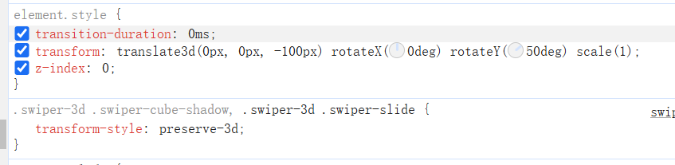

const images = [

    "/src/assets/type_icons/fairy.png",

    "/src/assets/type_icons/bug.png",

    "/src/assets/type_icons/fire.png",

  ];

Form name: option 1: varieties => form => names

Get variety gen:

getList( data, list )

cur = data.species;

data.evolves_to.foreach{

next = e.species

list.push (obj = {

id1,id2,

cur, next,

})

getList(e.evoles.to, list);

}

Move:

Name

Names

Gen

Learn_method

Learned level

Type

Damage-class

Power

accuracy