Review 3:
1.
/**
* Returns the product of the digits of {@code n}.
*
* @param n
* {@code NaturalNumber} whose digits to multiply
* @return the product of the digits of {@code n}
* @clears n
* @ensures productOfDigits1 = [product of the digits of n]
*/
private static NaturalNumber productOfDigits1(NaturalNumber n) {
NaturalNumber product = new naturalNumber2(1);
While(!n.isZero()){
NaturalNumber digit = new NaturalNumber2(n.divideBy10());
Product.multiply(digit);
}
Return product;
}

/**
* Returns the product of the digits of {@code n}.
*
* @param n
* {@code NaturalNumber} whose digits to multiply
* @return the product of the digits of {@code n}
* @ensures productOfDigits2 = [product of the digits of n]
*/
private static NaturalNumber productOfDigits2(NaturalNumber n) {
NaturalNumber copt = new naturalNumber2(n);
NaturalNumber product = new naturalNumber2(1);
While(!copy.isZero()){
NaturalNumber digit = new NaturalNumber2(n.divideBy10());
Product.multiply(digit);
}
Return product;
}

2.
/**
* Reports the value of {@code n} as an {@code int}, when {@code n} is
* small enough.
*
* @param n
* the given {@code NaturalNumber}
* @return the value
* @requires n <= Integer.MAX_VALUE
* @ensures toInt = n
*/
private static int toInt(NaturalNumber n) {
assert n.compareTo(new NaturalNumber2(Integer.MAX_VALUE))
:”Violation of: n<= Integer.MAX_VALUE”:
Return n.toInt;
}

3.
/**
* Reports whether the given tag appears in the given {@code XMLTree}.
*
* @param xml
* the {@code XMLTree}
* @param tag
* the tag name
* @return true if the given tag appears in the given {@code XMLTree},
* false otherwise
* @ensures <pre>
* findTag =
* [true if the given tag appears in the given {@code XMLTree}, false otherwise]
* </pre>
*/
private static boolean findTag(XMLTree xml, String tag) {
boolean found = xml.label().equals(tag));
for(int I = 0; I <xml.numberOfChildren() && !found; i++){
found = finaTag(xml.child(i),tag);
}
Return found;
}
4.
- design-by-contract: A programming methodology where software components interact based on explicitly defined contracts that specify preconditions, postconditions, and invariants.
- Precondition: A condition that must be true before a function or method executes to ensure correct behavior.
- Postcondition: A condition that must be true after a function or method has executed, assuming the precondition was met.
- Testing: The process of executing a program with different inputs to verify that it behaves correctly.
- Debugging: The process of identifying, analyzing, and fixing errors or bugs in a program.
- parameter mode: Specifies how a parameter is passed to a method.
- Clears: A parameter mode that ensures the parameter is reset to a default state after the function executes.
- Replaces: A parameter mode where the output value completely replaces the input value.
- Restores: A parameter mode ensuring that a parameter’s value is unchanged after method execution.
- Updates: A parameter mode where the value is modified based on the previous value and method logic. (has a value that might be changed from its incoming value)
- immutable type: A data type whose instances cannot be modified after creation.
- primitive type: The built-in types.
- reference type: All other types.
- Object: An instance of a class that contains state and behavior.
- Aliasing: When multiple variables reference the same object in memory.
- declared type/static type: The type of a variable as defined
- object type/dynamic type: The actual type of an object at runtime, which may be a subclass of the declared type.
- Implements: A keyword on Java used when a class provides the implementation for an interface.
- Extends: The name of the inheritance relationship.
- method overriding: Provide two or more methods with the same name but different formal parameters
- subinterface/derived interface/child interface: An interface that extends another interface, inheriting its method signatures.
- superclass/base class/parent class: A class from which other classes inherit properties and behaviors.
- Polymorphism: The ability of different classes to be treated as instances of a common superclass.
- Recursion: A technique where a function calls itself to solve a smaller instance of the problem.

5. 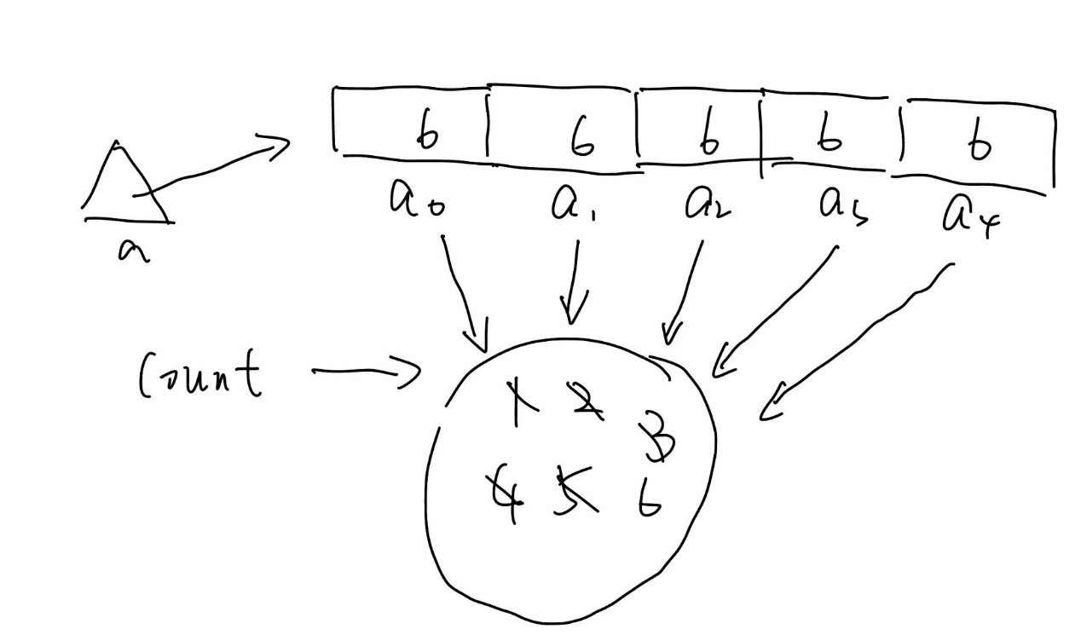
They will array to the same count, so that we need to create a new count to fix it.
6. NaturalNumber extends NaturalNumber-Kernel and the NaturalNumber-Kernel also extends standard so that NaturalNumber has all the functions or methods in the standard.
7. C3 has implemented I2 so that it can use I2 and I2 also extend I1 so that C3 also can use or implement I1.
C4 has extended C3 so that C4 has all the methods in C3 and C3 has implemented I2 so that C4 can also implement I2.

