Homework 4: Static Methods
1.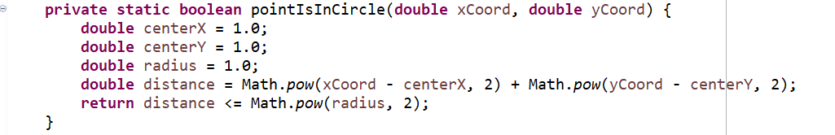

2.
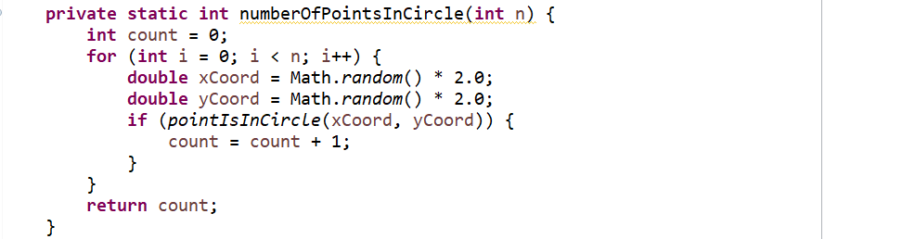

3.
