- yellow
- magenta, cyan, green, orange, white, gray, brown
- black, white, gray, brown
- red
- yellow – blue – black – orange
- 11
- 4

- <WebServiceResponse> </WebServiceResponse>
- <status> </status>
- <result> </result>
- <type> </type>
- <name> </name>
- <location> </location>
- <lat> </lat>
- <lng> </lng>
- <message> </message>

- OK
- Building
- Dreese Labs
- 40.002382
- -83.015958
- CSE Department
- ? No attribute?

-----WebServiceResponce
----- status: OK
----- result
----- type: Building
----- name: Dreese Labs
----- location
----- lat: 40.002382
----- lng: -83.015958
----- result
----- message: CSE Department
- <album> <released> <track>
- <album> --- labels --- “Sony”
<released> --- date --- “Oct 25, 1990”
<track> --- number --- “1”
--- duration --- “16:29”
<track> --- number --- “1”
--- duration --- “18:30”
14.
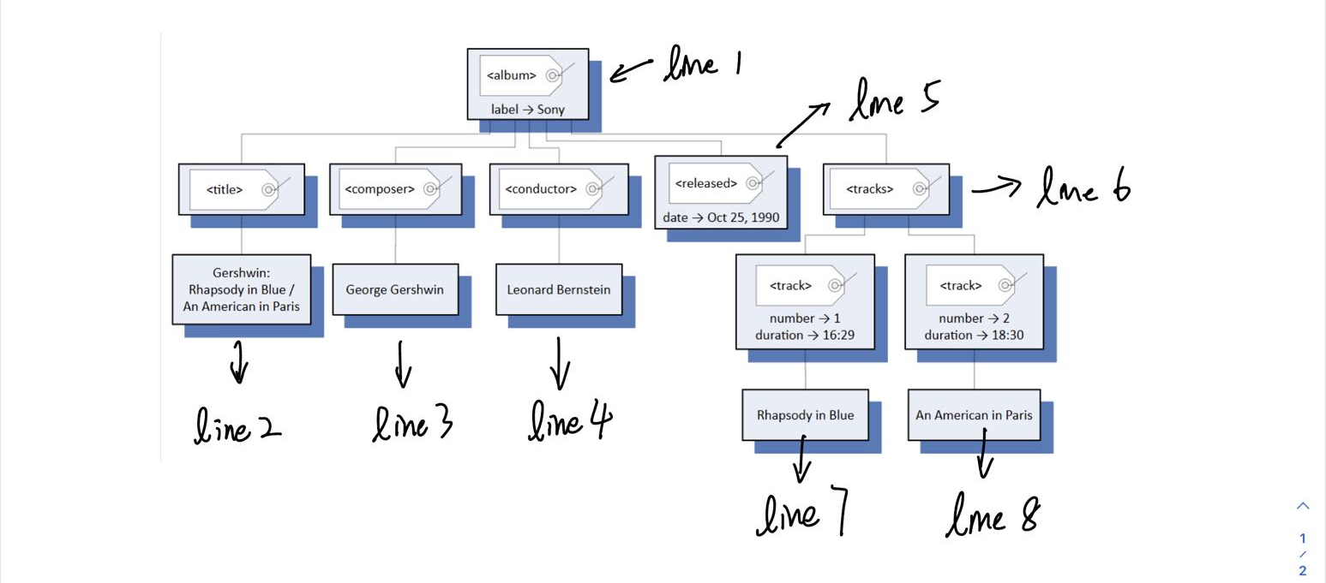
15.
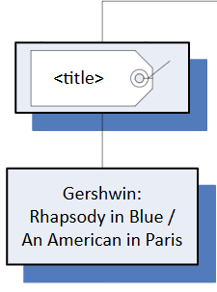
16.
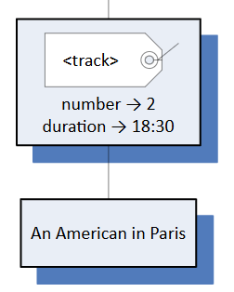
17. Line 4
18. Line 6-9
19. <released>
20. <released>
21. <track>
22. No child 1
23. <album> -- <tracks> -- <track>
24. 4, 1
25.
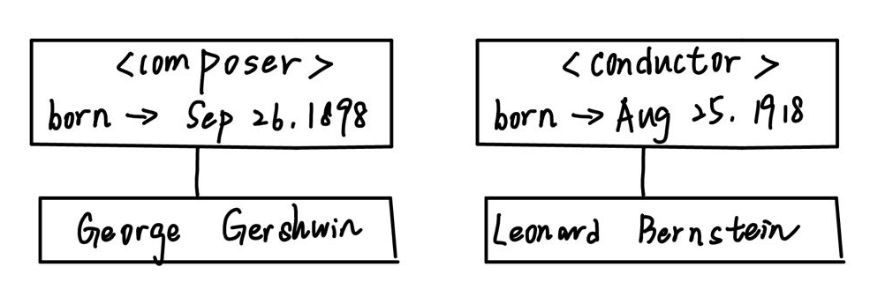
26. <released> Oct 25, 1990 </released>
27.
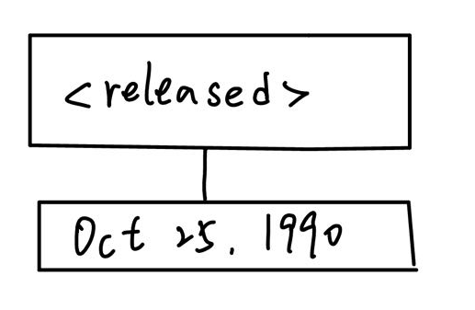
28.
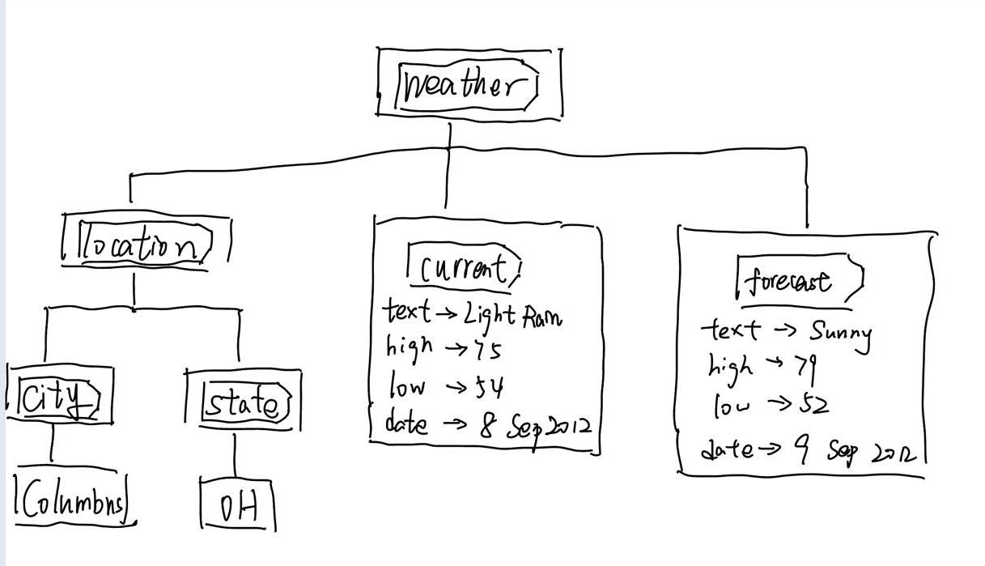
29.
<weather>
<location>
<state>
OH
<city>Columbus</city>
</state>
</location>
<current text="Light Rain" high="75" low="54" date="8 Sep 2012"></current>
<forecast text="Sunny" high="79" low="52" date="9 Sep 2012"></forecast>
</weather>
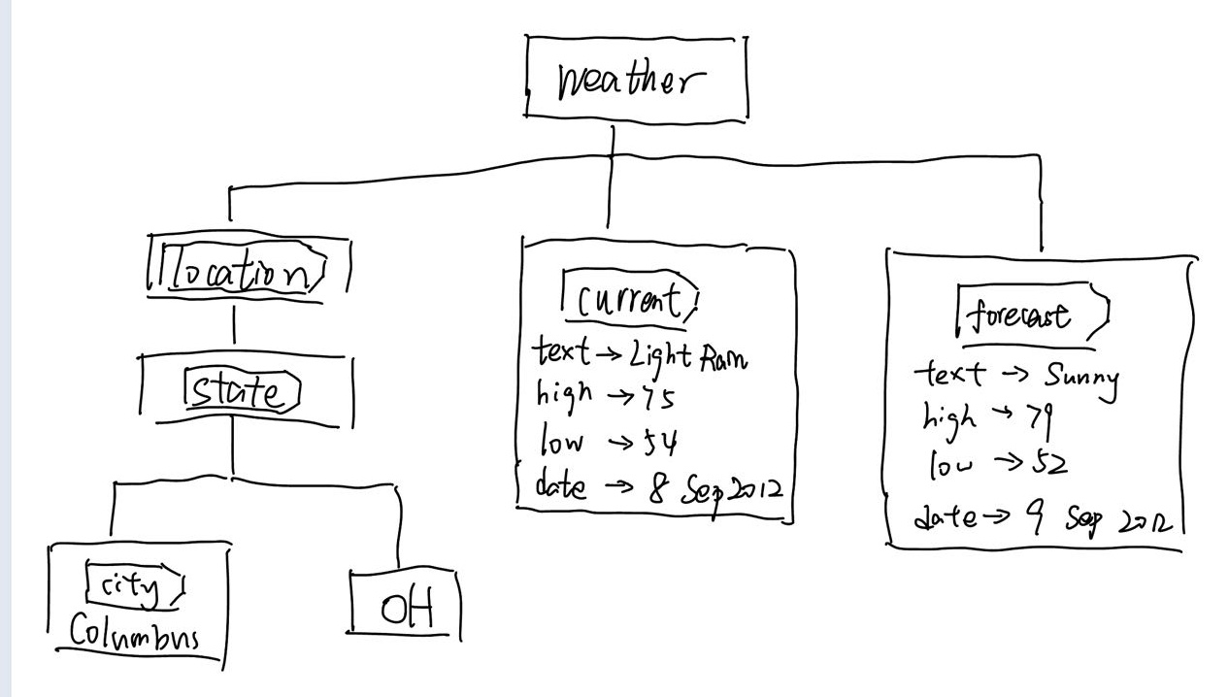
30. <query>
31. 4
32. en-US
33. 1
34. 1
35. 13
36. 0-12
37. 8
38. country --- United States
city --- Columbus
xmlns:yweather --- http://xml.weather.yahoo.com/ns/rss/1.0
region --- OH
39. 39.985329 -82.985329
40. [0, 0, 12, 1]
[0, 0, 12, 2]
41. <yweather:forecast>
42. 7
43. date --- 31 Jan 2017
high --- 41
code --- 28
low --- 31
xmlns:yweather --- http://xml.weather.yahoo.com/ns/rss/1.0
text --- Mostly Cloudy
day --- Tue
44. 6
45. <query> - <result> - <channel> - <item> - <geo:lat> - 39.985329
46. 0 0 12 1 0
47.

