Homework 7: Review 2
1.a.
String input = in.nextLine();
String upperLetters = “”;
for (int i = 0; i < input.length(); i++){
char c = input.charAt(i);
if (Character.isUpperCase(c)){
upperLetters += c;
}
}
out.println(upperLetters);
b.
String input = in.nextLine();
String letter = “”;
for (int i = 1; i < input.length(); i += 2){
letter += input.charAt(i);
}
out.println(letter);
c.
String input = in.nextLine();
String replace = “”;
for (int i = 0; i < input.length(); i++){
char c = input.charAt(i);
if (c == ‘A’ || c == ‘E’ || c == ‘I’ || c == ‘O’ || c == ‘U’ || c == ‘a’ || c == ‘e’ || c == ‘i’ || c == ‘o’ || c == ‘u’){
replace += ‘-‘;
}else{
Replace += c;
}
}
out.println(replace);
d.
String input = in.nextLine();
int count = 0;
for (int i = 0; i < input.length(); i++){
char c = input.charAt(i);
if (c == ‘A’ || c == ‘E’ || c == ‘I’ || c == ‘O’ || c == ‘U’ || c == ‘a’ || c == ‘e’ || c == ‘i’ || c == ‘o’ || c == ‘u’){
count ++;
}
}
Out.println(count);
e.
String input = in.nextLine();
String position = “”;
for (int i = 0; i < input.length(); i++){
char c = input.charAt(i);
if (c == ‘A’ || c == ‘E’ || c == ‘I’ || c == ‘O’ || c == ‘U’ || c == ‘a’ || c == ‘e’ || c == ‘i’ || c == ‘o’ || c == ‘u’){
position += i;
}
}
out.println(position);
2.
a. {1, 1, 1, 1, 1, 1, 1, 1, 1, 1}
b. {1, 1, 2, 3, 4, 5, 4, 3, 2, 1}
c. {2, 3, 4, 5, 4, 3, 2, 1, 0, 0}
d. {0, 0, 0, 0, 0, 0, 0, 0, 0, 0}
e. {1, 3, 6, 10, 15, 19, 22, 24, 25, 25}
f. {1, 0, 3, 0, 5, 0, 3, 0, 1, 0}
g. {1, 2, 3, 4, 5, 1, 2, 3, 4, 5}
h. {1, 1, 2, 3, 4, 4, 3, 2, 1, 0}
3.
int max = a [0];
int min = a [0];
for (int i = 1; i < a.length(); i++){
if (a [i] > max){
max = a [i];
}
if (a [i] < min){
min = a [i];
}
}
4.
boolean isOrdered = true;
for (int i = 0; i < a.length(); i++){
if ( a[i] > a[i+1] ){
isOrdered = false;
}
}
5.
a.
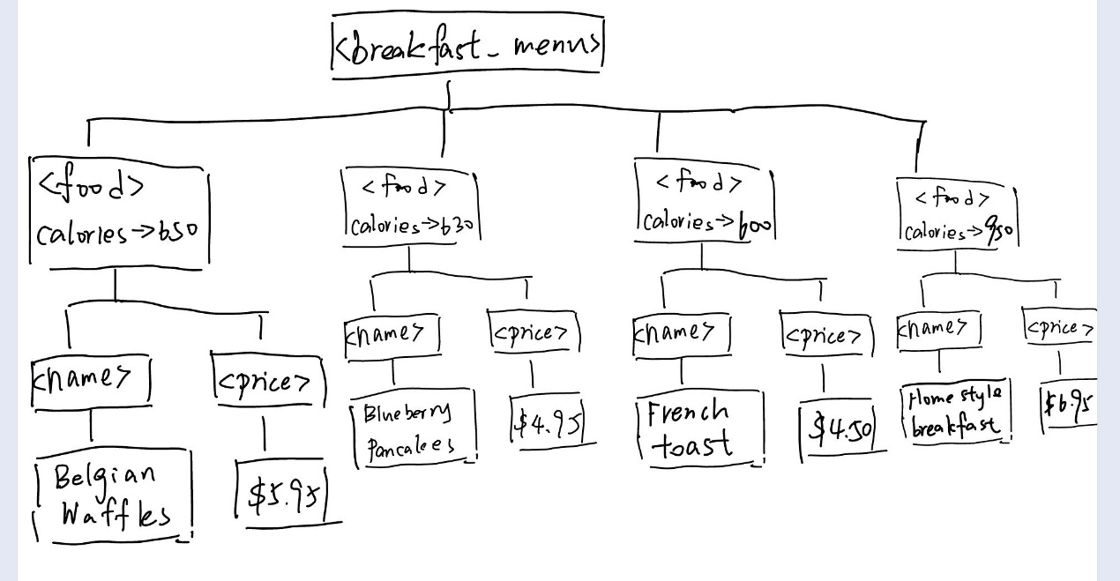
b.
1. true
2. breakfast.menu
3. 4
4. false
5. <food calories= “630”>
6. true
7. food
8. 2
9. true
10. 630
11. true;
12. false
13. Blueberry Pancakes
c.
<breakfast_menu>
<food calories="650">
<name price="$5.95">Belgian Waffles</name>
</food>
<food calories="630">
<name price="$4.95">Blueberry Pancakes</name>
</food>
<food calories="600">
<name price="$4.50">French Toast</name>
</food>
<food calories="950">
<name price="$6.95">Homestyle Breakfast</name>
</food>
</breakfast_menu>
d.