HW9：Tracing with references
1.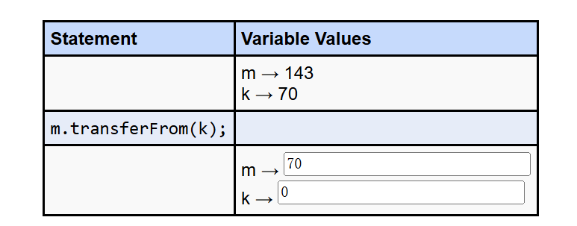
2. Because the transferFrom method need to change the value of m and k. If there is an immutable type, the value cannot be changed.
3.
1.
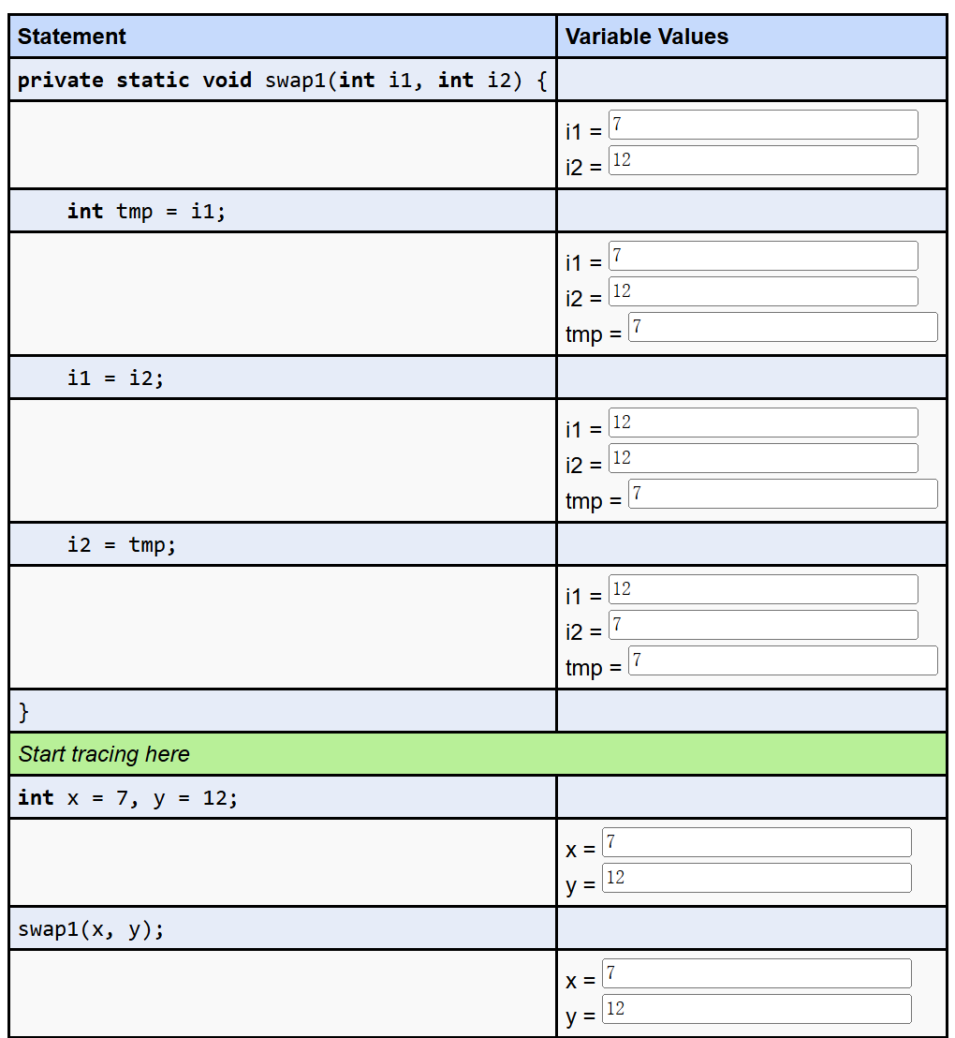
2.
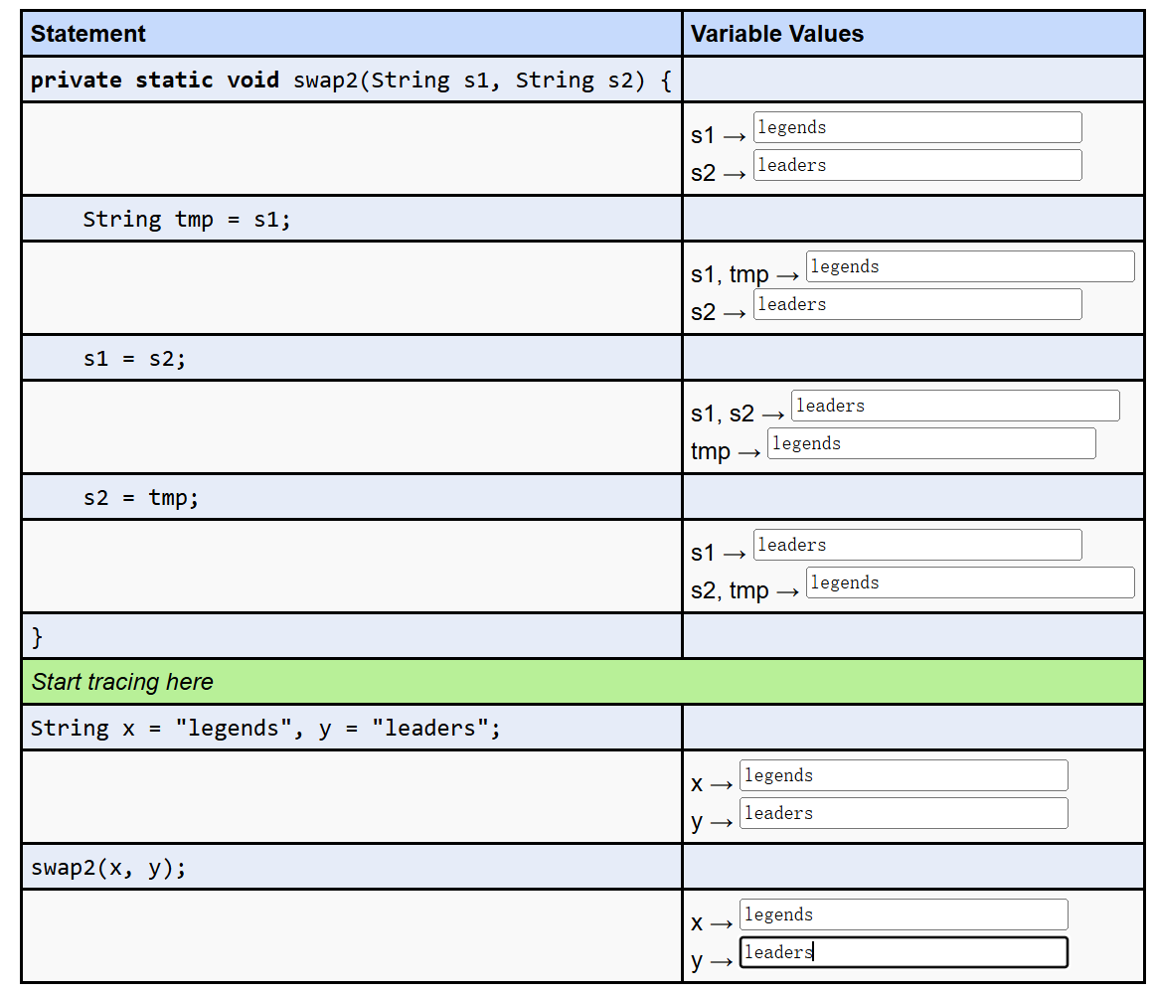
3.
