Start of Block: Intro

Intro_Block In this survey, you will be asked some questions about you and your political views. Then, you will be shown a brief news article about a fictional local police department undergoing a recruitment drive. After viewing the article, you will answer several questions about your impressions. Please answer them honestly. There are no right or wrong answers.

End of Block: Intro

Start of Block: Screeners

Women in police Having more women in a police department will improve the services provided to the community.
- Strongly disagree (1)
- Disagree (2)
- Somewhat disagree (3)
- Neither agree nor disagree (4)
- Somewhat agree (5)
- Agree (6)
- Strongly agree (7)

Page Break

Minority_police Adding more people of color as police officers will make policing outcomes more fair.
- Strongly disagree (1)
- Disagree (2)
- Somewhat disagree (3)
- Neither agree nor disagree (4)
- Somewhat agree (5)
- Agree (6)
- Strongly agree (7)

Page Break

Gender Please indicate your gender identity.
- Male (1)
- Female (2)
- Non-binary / third gender (3)
- Prefer not to say (4)

Page Break

Age How old are you?
________________________________________________________________

Page Break

Party_ID Generally speaking, do you think of yourself as a Democrat, Republican, Independent, or something else?
- Democrat (1)
- Republican (2)
- Independent (3)
- Other (4)
- Not sure (5)

Page Break

Party_ID_Republican Generally speaking, do you think of yourself as a...?
- Strong Republican (1)
- Not very strong Republican (2)

Page Break

Party_ID_Democrat Generally speaking, do you think of yourself as a...?
- Strong Democrat (1)
- Not very strong Democrat (2)

Page Break

Party_ID_Independent Generally speaking, do you think of yourself as closer to the Democratic Party, the Republican Party, or neither?
- The Republican Party (1)
- The Democratic Party (2)
- Neither (3)

Page Break

Ideology Rating In general, how would you rate your own ideology?
- Very liberal (1)
- Liberal (2)
- Somewhat liberal (3)
- Moderate (4)
- Somewhat conservative (5)
- Conservative (6)
- Very conservative (7)

Page Break

Race Now thinking about your race or ethnicity, do you consider yourself White, Black, Hispanic, Asian, Native American, or Multiracial?
- White (1)
- Black (2)
- Hispanic (3)
- Asian (4)
- Native American (5)
- Multiracial (6)
- Middle Eastern or North African (7)
- Other (8)

Page Break

Education What is your highest level of education completed?
- Less than high school (1)
- High school graduate (2)
- Some college (3)
- 2 year degree (4)
- 4 year degree (5)
- Professional degree (6)
- Doctorate (7)

End of Block: Screeners

Start of Block: Control

Control: Hiring

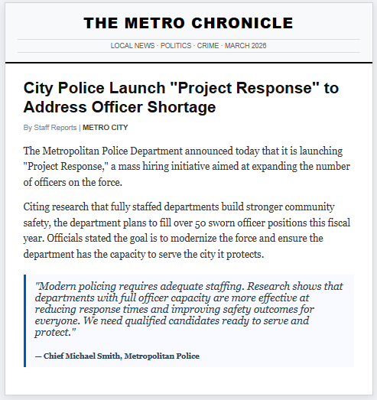

Timing_Control Timing
First Click (1)
Last Click (2)
Page Submit (3)
Click Count (4)

End of Block: Control

Start of Block: Treatment_Race

T2: Race
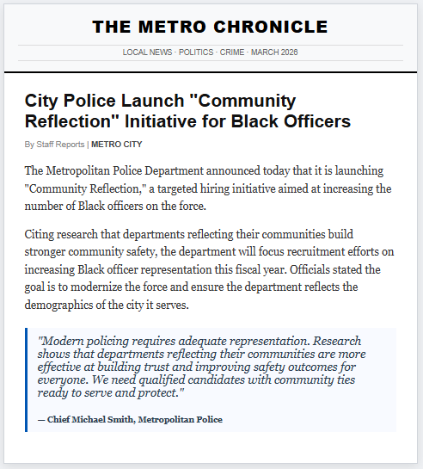

Timing_Race Timing
First Click (1)
Last Click (2)
Page Submit (3)
Click Count (4)

End of Block: Treatment_Race

Start of Block: Treatment_Gender

T3: Gender

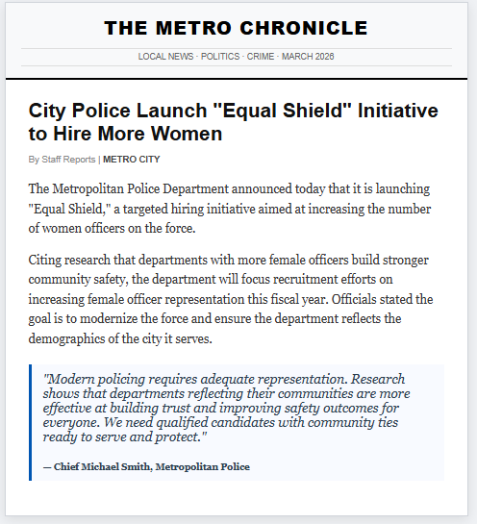

Timing_Gender Timing
First Click (1)
Last Click (2)
Page Submit (3)
Click Count (4)

End of Block: Treatment_Gender

Start of Block: Outcomes

Evaluate Statements Indicate whether you agree or disagree with each of the following statements.

Page Break

Trust_General Generally, I would trust this police department to make the community safer.
- Strongly disagree (1)
- Disagree (2)
- Somewhat disagree (3)
- Neither agree nor disagree (4)
- Somewhat agree (5)
- Agree (6)
- Strongly agree (7)

Page Break

Trust_Self I would trust this police department to assist me in an emergency
- Strongly disagree (1)
- Disagree (2)
- Somewhat disagree (3)
- Neither agree nor disagree (4)
- Somewhat agree (5)
- Agree (6)
- Strongly agree (7)

Page Break

Trust_Hiring I would be willing to suggest to a friend or family member that they should apply to work for this police department.
- Strongly disagree (1)
- Disagree (2)
- Somewhat disagree (3)
- Neither agree nor disagree (4)
- Somewhat agree (5)
- Agree (6)
- Strongly agree (7)

Page Break

Procedural_Justice I expect that, following this recruitment drive, I would be treated fairly by this police department.
- Strongly disagree (1)
- Disagree (2)
- Somewhat disagree (3)
- Neither agree nor disagree (4)
- Somewhat agree (5)
- Agree (6)
- Strongly agree (7)

Page Break

Police_resources This police department should be provided with more resources (i.e. a higher budget) to complete this recruiting drive.
- Strongly disagree (1)
- Disagree (2)
- Somewhat disagree (3)
- Neither agree nor disagree (4)
- Somewhat agree (5)
- Agree (6)
- Strongly agree (7)

Page Break

Explain Please explain your responses to the previous questions.
________________________________________________________________
________________________________________________________________
________________________________________________________________
________________________________________________________________
________________________________________________________________

End of Block: Outcomes

Start of Block: Personal

Police_experience I, or a loved one, have previously been subject to use-of-force by a police officer.
- Yes (1)
- No (2)
- Prefer not to say (3)

End of Block: Personal

