Trust_Policing

Survey Flow
EmbeddedData
PROLIFIC_PIDValue will be set from Panel or URL.
STUDY_IDValue will be set from Panel or URL.
SESSION_IDValue will be set from Panel or URL.
Standard: Consent (1 Question)
Block: Intro (1 Question)
Standard: Screeners (11 Questions)
Standard: Control (2 Questions)
Standard: Treatment_Race (2 Questions)
Branch: New Branch
If
If Please indicate your gender identity. Male Is Selected
Branch: New Branch
If
If Now thinking about your race or ethnicity, do you consider yourself White, Black, Hispanic, Asian... White Is Selected
Branch: New Branch
If
If Generally speaking, do you think of yourself as a Democrat, Republican, Independent, or something... Democrat Is Selected
Or Generally speaking, do you think of yourself as closer to the Democratic Party, the Republican Pa... The Democratic Party Is Selected
BlockRandomizer: 3 - Evenly Present Elements
Block: Control (2 Questions)
Block: Treatment_Race (2 Questions)
Block: Treatment_Gender (2 Questions)
Branch: New Branch
If
If Generally speaking, do you think of yourself as a Democrat, Republican, Independent, or something... Republican Is Selected
Or Generally speaking, do you think of yourself as closer to the Democratic Party, the Republican Pa... The Republican Party Is Selected
BlockRandomizer: 3 - Evenly Present Elements
Block: Control (2 Questions)
Block: Treatment_Race (2 Questions)
Block: Treatment_Gender (2 Questions)
Branch: New Branch
If
If Generally speaking, do you think of yourself as closer to the Democratic Party, the Republican Pa... Neither Is Selected
BlockRandomizer: 3 - Evenly Present Elements
Block: Control (2 Questions)
Block: Treatment_Race (2 Questions)
Block: Treatment_Gender (2 Questions)
Branch: New Branch
If
If Now thinking about your race or ethnicity, do you consider yourself White, Black, Hispanic, Asian... Black Is Selected
Branch: New Branch
If
If Generally speaking, do you think of yourself as a Democrat, Republican, Independent, or something... Democrat Is Selected
Or Generally speaking, do you think of yourself as closer to the Democratic Party, the Republican Pa... The Democratic Party Is Selected
BlockRandomizer: 3 - Evenly Present Elements
Block: Control (2 Questions)
Block: Treatment_Race (2 Questions)
Block: Treatment_Gender (2 Questions)
Branch: New Branch
If
If Generally speaking, do you think of yourself as a Democrat, Republican, Independent, or something... Republican Is Selected
Or Generally speaking, do you think of yourself as closer to the Democratic Party, the Republican Pa... The Republican Party Is Selected
BlockRandomizer: 3 - Evenly Present Elements
Block: Control (2 Questions)
Block: Treatment_Race (2 Questions)
Block: Treatment_Gender (2 Questions)
Branch: New Branch
If
If Generally speaking, do you think of yourself as closer to the Democratic Party, the Republican Pa... Neither Is Selected
BlockRandomizer: 3 - Evenly Present Elements
Block: Control (2 Questions)
Block: Treatment_Race (2 Questions)
Block: Treatment_Gender (2 Questions)
Branch: New Branch
If
If Now thinking about your race or ethnicity, do you consider yourself White, Black, Hispanic, Asian... Hispanic Is Selected
Branch: New Branch
If
If Generally speaking, do you think of yourself as a Democrat, Republican, Independent, or something... Democrat Is Selected
Or Generally speaking, do you think of yourself as closer to the Democratic Party, the Republican Pa... The Democratic Party Is Selected
BlockRandomizer: 3 - Evenly Present Elements
Block: Control (2 Questions)
Block: Treatment_Race (2 Questions)
Block: Treatment_Gender (2 Questions)
Branch: New Branch
If
If Generally speaking, do you think of yourself as a Democrat, Republican, Independent, or something... Republican Is Selected
Or Generally speaking, do you think of yourself as closer to the Democratic Party, the Republican Pa... The Republican Party Is Selected
BlockRandomizer: 3 - Evenly Present Elements
Block: Control (2 Questions)
Block: Treatment_Race (2 Questions)
Block: Treatment_Gender (2 Questions)
Branch: New Branch
If
If Generally speaking, do you think of yourself as closer to the Democratic Party, the Republican Pa... Neither Is Selected
BlockRandomizer: 3 - Evenly Present Elements
Block: Control (2 Questions)
Block: Treatment_Race (2 Questions)
Block: Treatment_Gender (2 Questions)
Branch: New Branch
If
If Now thinking about your race or ethnicity, do you consider yourself White, Black, Hispanic, Asian... Hispanic Is Not Selected
And Now thinking about your race or ethnicity, do you consider yourself White, Black, Hispanic, Asian... Black Is Not Selected
And Now thinking about your race or ethnicity, do you consider yourself White, Black, Hispanic, Asian... White Is Not Selected
Branch: New Branch
If
If Generally speaking, do you think of yourself as a Democrat, Republican, Independent, or something... Democrat Is Selected
Or Generally speaking, do you think of yourself as closer to the Democratic Party, the Republican Pa... The Democratic Party Is Selected
BlockRandomizer: 3 - Evenly Present Elements
Block: Control (2 Questions)
Block: Treatment_Race (2 Questions)
Block: Treatment_Gender (2 Questions)
Branch: New Branch
If
If Generally speaking, do you think of yourself as a Democrat, Republican, Independent, or something... Republican Is Selected
Or Generally speaking, do you think of yourself as closer to the Democratic Party, the Republican Pa... The Republican Party Is Selected
BlockRandomizer: 3 - Evenly Present Elements
Block: Control (2 Questions)
Block: Treatment_Race (2 Questions)
Block: Treatment_Gender (2 Questions)
Branch: New Branch
If
If Generally speaking, do you think of yourself as closer to the Democratic Party, the Republican Pa... Neither Is Selected
BlockRandomizer: 3 - Evenly Present Elements
Block: Control (2 Questions)
Block: Treatment_Race (2 Questions)
Block: Treatment_Gender (2 Questions)
Branch: New Branch
If
If Please indicate your gender identity. Female Is Selected
Branch: New Branch
If
If Now thinking about your race or ethnicity, do you consider yourself White, Black, Hispanic, Asian... White Is Selected
Branch: New Branch
If
If Generally speaking, do you think of yourself as a Democrat, Republican, Independent, or something... Democrat Is Selected
Or Generally speaking, do you think of yourself as closer to the Democratic Party, the Republican Pa... The Democratic Party Is Selected
BlockRandomizer: 3 - Evenly Present Elements
Block: Control (2 Questions)
Block: Treatment_Race (2 Questions)
Block: Treatment_Gender (2 Questions)
Branch: New Branch
If
If Generally speaking, do you think of yourself as a Democrat, Republican, Independent, or something... Republican Is Selected
Or Generally speaking, do you think of yourself as closer to the Democratic Party, the Republican Pa... The Republican Party Is Selected
BlockRandomizer: 3 - Evenly Present Elements
Block: Control (2 Questions)
Block: Treatment_Race (2 Questions)
Block: Treatment_Gender (2 Questions)
Branch: New Branch
If
If Generally speaking, do you think of yourself as closer to the Democratic Party, the Republican Pa... Neither Is Selected
BlockRandomizer: 3 - Evenly Present Elements
Block: Control (2 Questions)
Block: Treatment_Race (2 Questions)
Block: Treatment_Gender (2 Questions)
Branch: New Branch
If
If Now thinking about your race or ethnicity, do you consider yourself White, Black, Hispanic, Asian... Black Is Selected
Branch: New Branch
If
If Generally speaking, do you think of yourself as a Democrat, Republican, Independent, or something... Democrat Is Selected
Or Generally speaking, do you think of yourself as closer to the Democratic Party, the Republican Pa... The Democratic Party Is Selected
BlockRandomizer: 3 - Evenly Present Elements
Block: Control (2 Questions)
Block: Treatment_Race (2 Questions)
Block: Treatment_Gender (2 Questions)
Branch: New Branch
If
If Generally speaking, do you think of yourself as a Democrat, Republican, Independent, or something... Republican Is Selected
Or Generally speaking, do you think of yourself as closer to the Democratic Party, the Republican Pa... The Republican Party Is Selected
BlockRandomizer: 3 - Evenly Present Elements
Block: Control (2 Questions)
Block: Treatment_Race (2 Questions)
Block: Treatment_Gender (2 Questions)
Branch: New Branch
If
If Generally speaking, do you think of yourself as closer to the Democratic Party, the Republican Pa... Neither Is Selected
BlockRandomizer: 3 - Evenly Present Elements
Block: Control (2 Questions)
Block: Treatment_Race (2 Questions)
Block: Treatment_Gender (2 Questions)
Branch: New Branch
If
If Now thinking about your race or ethnicity, do you consider yourself White, Black, Hispanic, Asian... Hispanic Is Selected
Branch: New Branch
If
If Generally speaking, do you think of yourself as a Democrat, Republican, Independent, or something... Democrat Is Selected
Or Generally speaking, do you think of yourself as closer to the Democratic Party, the Republican Pa... The Democratic Party Is Selected
BlockRandomizer: 3 - Evenly Present Elements
Block: Control (2 Questions)
Block: Treatment_Race (2 Questions)
Block: Treatment_Gender (2 Questions)
Branch: New Branch
If
If Generally speaking, do you think of yourself as a Democrat, Republican, Independent, or something... Republican Is Selected
Or Generally speaking, do you think of yourself as closer to the Democratic Party, the Republican Pa... The Republican Party Is Selected
BlockRandomizer: 3 - Evenly Present Elements
Block: Control (2 Questions)
Block: Treatment_Race (2 Questions)
Block: Treatment_Gender (2 Questions)
Branch: New Branch
If
If Generally speaking, do you think of yourself as closer to the Democratic Party, the Republican Pa... Neither Is Selected
BlockRandomizer: 3 - Evenly Present Elements
Block: Control (2 Questions)
Block: Treatment_Race (2 Questions)
Block: Treatment_Gender (2 Questions)
Branch: New Branch
If
If Now thinking about your race or ethnicity, do you consider yourself White, Black, Hispanic, Asian... Hispanic Is Not Selected
And Now thinking about your race or ethnicity, do you consider yourself White, Black, Hispanic, Asian... Black Is Not Selected
And Now thinking about your race or ethnicity, do you consider yourself White, Black, Hispanic, Asian... White Is Not Selected
Branch: New Branch
If
If Generally speaking, do you think of yourself as a Democrat, Republican, Independent, or something... Democrat Is Selected
Or Generally speaking, do you think of yourself as closer to the Democratic Party, the Republican Pa... The Democratic Party Is Selected
BlockRandomizer: 3 - Evenly Present Elements
Block: Control (2 Questions)
Block: Treatment_Race (2 Questions)
Block: Treatment_Gender (2 Questions)
Branch: New Branch
If
If Generally speaking, do you think of yourself as a Democrat, Republican, Independent, or something... Republican Is Selected
Or Generally speaking, do you think of yourself as closer to the Democratic Party, the Republican Pa... The Republican Party Is Selected
BlockRandomizer: 3 - Evenly Present Elements
Block: Control (2 Questions)
Block: Treatment_Race (2 Questions)
Block: Treatment_Gender (2 Questions)
Branch: New Branch
If
If Generally speaking, do you think of yourself as closer to the Democratic Party, the Republican Pa... Neither Is Selected
BlockRandomizer: 3 - Evenly Present Elements
Block: Control (2 Questions)
Block: Treatment_Race (2 Questions)
Block: Treatment_Gender (2 Questions)
Branch: New Branch
If
If Please indicate your gender identity. Non-binary / third gender Is Selected
Or Please indicate your gender identity. Prefer not to say Is Selected
Branch: New Branch
If
If Now thinking about your race or ethnicity, do you consider yourself White, Black, Hispanic, Asian... White Is Selected
Branch: New Branch
If
If Generally speaking, do you think of yourself as a Democrat, Republican, Independent, or something... Democrat Is Selected
Or Generally speaking, do you think of yourself as closer to the Democratic Party, the Republican Pa... The Democratic Party Is Selected
BlockRandomizer: 3 - Evenly Present Elements
Block: Control (2 Questions)
Block: Treatment_Race (2 Questions)
Block: Treatment_Gender (2 Questions)
Branch: New Branch
If
If Generally speaking, do you think of yourself as a Democrat, Republican, Independent, or something... Republican Is Selected
Or Generally speaking, do you think of yourself as closer to the Democratic Party, the Republican Pa... The Republican Party Is Selected
BlockRandomizer: 3 - Evenly Present Elements
Block: Control (2 Questions)
Block: Treatment_Race (2 Questions)
Block: Treatment_Gender (2 Questions)
Branch: New Branch
If
If Generally speaking, do you think of yourself as closer to the Democratic Party, the Republican Pa... Neither Is Selected
BlockRandomizer: 3 - Evenly Present Elements
Block: Control (2 Questions)
Block: Treatment_Race (2 Questions)
Block: Treatment_Gender (2 Questions)
Branch: New Branch
If
If Now thinking about your race or ethnicity, do you consider yourself White, Black, Hispanic, Asian... Black Is Selected
Branch: New Branch
If
If Generally speaking, do you think of yourself as a Democrat, Republican, Independent, or something... Democrat Is Selected
Or Generally speaking, do you think of yourself as closer to the Democratic Party, the Republican Pa... The Democratic Party Is Selected
BlockRandomizer: 3 - Evenly Present Elements
Block: Control (2 Questions)
Block: Treatment_Race (2 Questions)
Block: Treatment_Gender (2 Questions)
Branch: New Branch
If
If Generally speaking, do you think of yourself as a Democrat, Republican, Independent, or something... Republican Is Selected
Or Generally speaking, do you think of yourself as closer to the Democratic Party, the Republican Pa... The Republican Party Is Selected
BlockRandomizer: 3 - Evenly Present Elements
Block: Control (2 Questions)
Block: Treatment_Race (2 Questions)
Block: Treatment_Gender (2 Questions)
Branch: New Branch
If
If Generally speaking, do you think of yourself as closer to the Democratic Party, the Republican Pa... Neither Is Selected
BlockRandomizer: 3 - Evenly Present Elements
Block: Control (2 Questions)
Block: Treatment_Race (2 Questions)
Block: Treatment_Gender (2 Questions)
Branch: New Branch
If
If Now thinking about your race or ethnicity, do you consider yourself White, Black, Hispanic, Asian... Hispanic Is Selected
Branch: New Branch
If
If Generally speaking, do you think of yourself as a Democrat, Republican, Independent, or something... Democrat Is Selected
Or Generally speaking, do you think of yourself as closer to the Democratic Party, the Republican Pa... The Democratic Party Is Selected
BlockRandomizer: 3 - Evenly Present Elements
Block: Control (2 Questions)
Block: Treatment_Race (2 Questions)
Block: Treatment_Gender (2 Questions)
Branch: New Branch
If
If Generally speaking, do you think of yourself as a Democrat, Republican, Independent, or something... Republican Is Selected
Or Generally speaking, do you think of yourself as closer to the Democratic Party, the Republican Pa... The Republican Party Is Selected
BlockRandomizer: 3 - Evenly Present Elements
Block: Control (2 Questions)
Block: Treatment_Race (2 Questions)
Block: Treatment_Gender (2 Questions)
Branch: New Branch
If
If Generally speaking, do you think of yourself as closer to the Democratic Party, the Republican Pa... Neither Is Selected
BlockRandomizer: 3 - Evenly Present Elements
Block: Control (2 Questions)
Block: Treatment_Race (2 Questions)
Block: Treatment_Gender (2 Questions)
Branch: New Branch
If
If Now thinking about your race or ethnicity, do you consider yourself White, Black, Hispanic, Asian... Hispanic Is Not Selected
And Now thinking about your race or ethnicity, do you consider yourself White, Black, Hispanic, Asian... Black Is Not Selected
And Now thinking about your race or ethnicity, do you consider yourself White, Black, Hispanic, Asian... White Is Not Selected
Branch: New Branch
If
If Generally speaking, do you think of yourself as a Democrat, Republican, Independent, or something... Democrat Is Selected
Or Generally speaking, do you think of yourself as closer to the Democratic Party, the Republican Pa... The Democratic Party Is Selected
BlockRandomizer: 3 - Evenly Present Elements
Block: Control (2 Questions)
Block: Treatment_Race (2 Questions)
Block: Treatment_Gender (2 Questions)
Branch: New Branch
If
If Generally speaking, do you think of yourself as a Democrat, Republican, Independent, or something... Republican Is Selected
Or Generally speaking, do you think of yourself as closer to the Democratic Party, the Republican Pa... The Republican Party Is Selected
BlockRandomizer: 3 - Evenly Present Elements
Block: Control (2 Questions)
Block: Treatment_Race (2 Questions)
Block: Treatment_Gender (2 Questions)
Branch: New Branch
If
If Generally speaking, do you think of yourself as closer to the Democratic Party, the Republican Pa... Neither Is Selected
BlockRandomizer: 3 - Evenly Present Elements
Block: Control (2 Questions)
Block: Treatment_Race (2 Questions)
Block: Treatment_Gender (2 Questions)
Standard: Outcomes (7 Questions)
Standard: Personal (1 Question)
Page Break

Start of Block: Consent

Consent Thank you for your interest in this research study! You are being asked to be in a research study, which is designed to answer a scientific question. If you agree to participate in this study, you will be one of 1,500 people who are taking this survey conducted by researchers at Emory University. It should take approximately 7-9 minutes for you to complete this survey. You must be 18 years of age or older to participate. Why is this study being done? This study aims to better understand the thoughts and opinions that people in the United States hold about police department hiring practices. Do you have to be in the study? It is your choice to join this research study. You do not have to be in it. Before you choose, take time to learn about the study. Costs and Benefits There will be no financial costs to you for participating in this study. A loss of privacy is a potential risk of this study. You will not directly benefit from participation in this study. Compensation for participation in this study will be provided through the platform which recruited you to participate. What do you have to do if you choose to join this study? If you agree to participate, you will be asked some general questions about your background, as well as questions about your experiences and opinions regarding politics and topics on social media. You will also be asked to view a fictional news article. Please answer the questions to the best of your ability. There are no right or wrong answers. All answers will remain confidential and no directly identifying information will be collected. Contact If you have questions about the study or other concerns about the research or your part in it, contact Eric Dobbie at eric.dobbie@emory.edu. This study has been reviewed by an ethics committee to ensure the protection of research participants. If you have questions about your rights as a research participant, or if you have complaints about the research or an issue you would rather discuss with someone outside the research team, contact the Emory Institutional Review Board at 404-712-0720 or 877-503-9797 or irb@emory.edu. If you agree to participate, select "I agree" below and click the next button below to proceed to the survey. If you do not, please exit the survey now by closing the browser window.
- I agree (1)

End of Block: Consent

Start of Block: Intro

Intro_Block In this survey, you will be asked some questions about you and your political views. Then, you will be shown a brief news article about a fictional local police department undergoing a recruitment drive. After viewing the article, you will answer several questions about your impressions. Please answer them honestly. There are no right or wrong answers.

End of Block: Intro

Start of Block: Screeners

Gender Please indicate your gender identity.
- Male (1)
- Female (2)
- Non-binary / third gender (3)
- Prefer not to say (4)

Page Break

Age How old are you?
________________________________________________________________

Page Break

Party_ID Generally speaking, do you think of yourself as a Democrat, Republican, Independent, or something else?
- Democrat (1)
- Republican (2)
- Independent (3)
- Other (4)
- Not sure (5)

Page Break

Display this question:
If Generally speaking, do you think of yourself as a Democrat, Republican, Independent, or something... = Republican

Party_ID_Republican Generally speaking, do you think of yourself as a...?
- Strong Republican (1)
- Not very strong Republican (2)

Page Break

Display this question:
If Generally speaking, do you think of yourself as a Democrat, Republican, Independent, or something... = Democrat

Party_ID_Democrat Generally speaking, do you think of yourself as a...?
- Strong Democrat (1)
- Not very strong Democrat (2)

Page Break

Display this question:
If Generally speaking, do you think of yourself as a Democrat, Republican, Independent, or something... = Independent
Or Generally speaking, do you think of yourself as a Democrat, Republican, Independent, or something... = Other
Or Generally speaking, do you think of yourself as a Democrat, Republican, Independent, or something... = Not sure

Party_ID_Independent Generally speaking, do you think of yourself as closer to the Democratic Party, the Republican Party, or neither?
- The Republican Party (1)
- The Democratic Party (2)
- Neither (3)

Page Break

Ideology Rating In general, how would you rate your own ideology?
- Very liberal (1)
- Liberal (2)
- Somewhat liberal (3)
- Moderate (4)
- Somewhat conservative (5)
- Conservative (6)
- Very conservative (7)

Page Break

Race Now thinking about your race or ethnicity, do you consider yourself White, Black, Hispanic, Asian, Native American, or Multiracial?
- White (1)
- Black (2)
- Hispanic (3)
- Asian (4)
- Native American (5)
- Multiracial (6)
- Middle Eastern or North African (7)
- Other (8)

Page Break

Education What is your highest level of education completed?
- Less than high school (1)
- High school graduate (2)
- Some college (3)
- 2 year degree (4)
- 4 year degree (5)
- Professional degree (6)
- Doctorate (7)

Page Break

Women in police Having more women in a police department will improve the services provided to the community.
- Strongly disagree (1)
- Disagree (2)
- Somewhat disagree (3)
- Neither agree nor disagree (4)
- Somewhat agree (5)
- Agree (6)
- Strongly agree (7)

Page Break

Minority_police Adding more people of color as police officers will make policing outcomes more fair.
- Strongly disagree (1)
- Disagree (2)
- Somewhat disagree (3)
- Neither agree nor disagree (4)
- Somewhat agree (5)
- Agree (6)
- Strongly agree (7)

End of Block: Screeners

Start of Block: Control

Control: Hiring

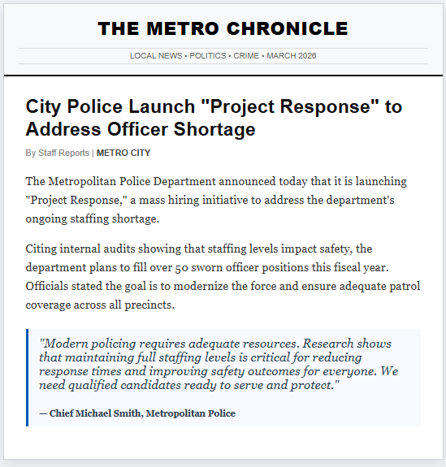

Timing_Control Timing
First Click (1)
Last Click (2)
Page Submit (3)
Click Count (4)

End of Block: Control

Start of Block: Treatment_Race

T2: Race

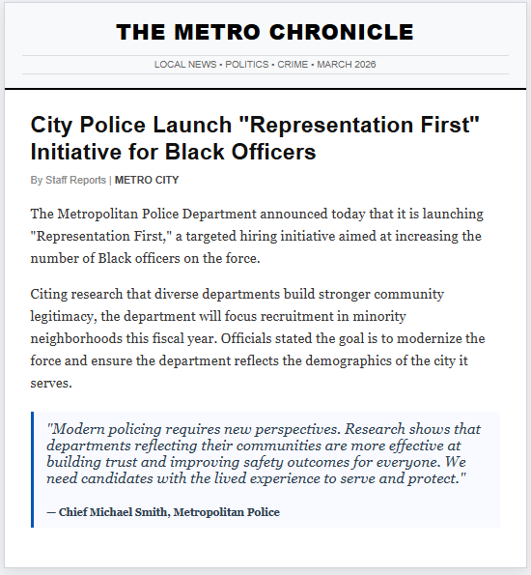

Timing_Race Timing
First Click (1)
Last Click (2)
Page Submit (3)
Click Count (4)

End of Block: Treatment_Race

Start of Block: Treatment_Gender

T3: Gender
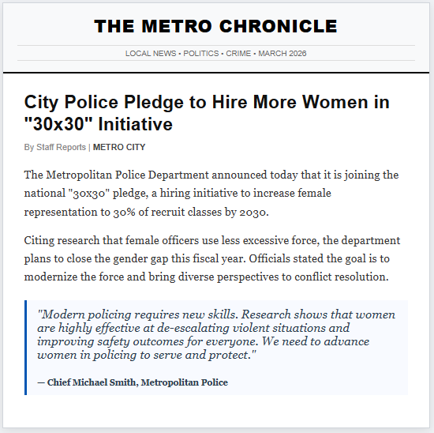

Timing_Gender Timing
First Click (1)
Last Click (2)
Page Submit (3)
Click Count (4)

End of Block: Treatment_Gender

Start of Block: Outcomes

Evaluate Statements Indicate whether you agree or disagree with each of the following statements.

Page Break

Trust_General Generally, I would trust this police department to make the community safer.
- Strongly disagree (1)
- Disagree (2)
- Somewhat disagree (3)
- Neither agree nor disagree (4)
- Somewhat agree (5)
- Agree (6)
- Strongly agree (7)

Page Break

Trust_Self I would trust this police department to assist me in an emergency
- Strongly disagree (1)
- Disagree (2)
- Somewhat disagree (3)
- Neither agree nor disagree (4)
- Somewhat agree (5)
- Agree (6)
- Strongly agree (7)

Page Break

Trust_Hiring I would be willing to suggest to a friend or family member that they should apply to work for this police department.
- Strongly disagree (1)
- Disagree (2)
- Somewhat disagree (3)
- Neither agree nor disagree (4)
- Somewhat agree (5)
- Agree (6)
- Strongly agree (7)

Page Break

Procedural_Justice I expect that I would be treated more fairly based on the changes being made in this department.
- Strongly disagree (1)
- Disagree (2)
- Somewhat disagree (3)
- Neither agree nor disagree (4)
- Somewhat agree (5)
- Agree (6)
- Strongly Agree (7)

Page Break

Police_resources This police department should be provided with more resources (i.e. a higher budget) to complete this recruiting drive.
- Strongly disagree (1)
- Disagree (2)
- Somewhat disagree (3)
- Neither agree nor disagree (4)
- Somewhat agree (5)
- Agree (6)
- Strongly agree (7)

Page Break

Explain Please explain your responses to the previous questions.
________________________________________________________________
________________________________________________________________
________________________________________________________________
________________________________________________________________
________________________________________________________________

End of Block: Outcomes

Start of Block: Personal

Police_experience I, or a loved one, have previously been subject to use-of-force by a police officer.
- Yes (1)
- No (2)
- Prefer not to say (3)

End of Block: Personal

