Team Evaluation

Eric DuBose

October 9, 2018

##   
## Attaching package: 'dplyr'

## The following objects are masked from 'package:stats':  
##   
## filter, lag

## The following objects are masked from 'package:base':  
##   
## intersect, setdiff, setequal, union

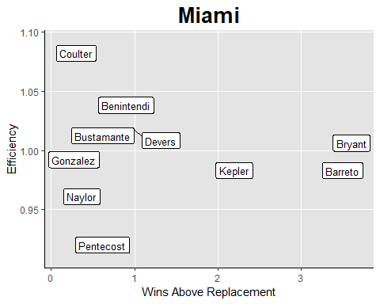

This graph compares wins above replacement to defensive efficiency. Players on the far right represent a solid WAR, but where you really want the player is the top right. THat means great WAR AND great defense. Conversely, the bad, lies below 1 WAR, and below .95 Eff.

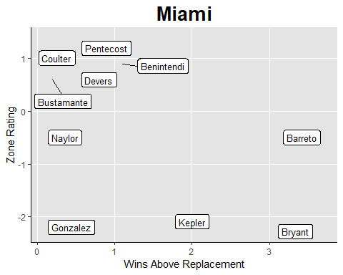

Similar to the Efficiency graph, this compares WAR to Zone Rating. Same scale applies. Anything below 0 in ZR is considered subpar defensively.

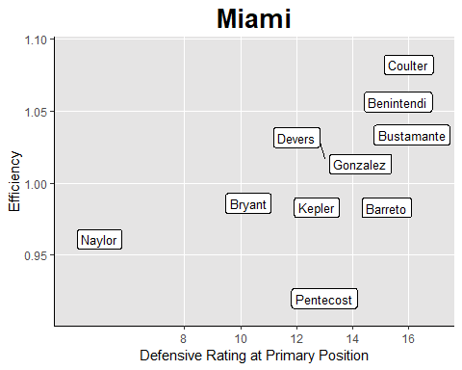

This is an interesting comparative graph, comparing the Defensive rating of a player at thier primary position, to their defensive efficiency. Ideally, as a player’s rating is higher, so should be their efficiency. This is a good graph to gauge defensive performance vs expectation.

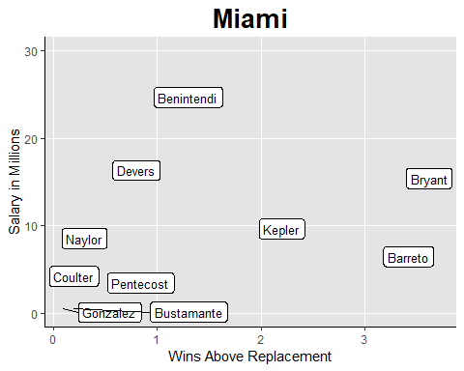

This graph, basically tells you if you’re getting your money’s worth, or where you are finding very valuable players. Bottom right, is ideal here. You want high war, low salary. This is your value player. What you dont want, is top left. That means low war, high salary.

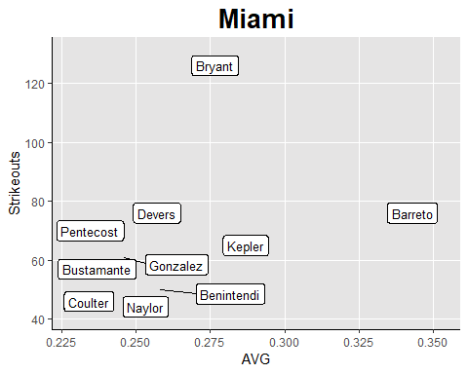

This graph compares your batters averages to the number of strikeouts they have. It’s a good gauge of how well a player is making contact with the baseball, or at a minimum putting the ball in play. Better is bottom right, worst is top left.

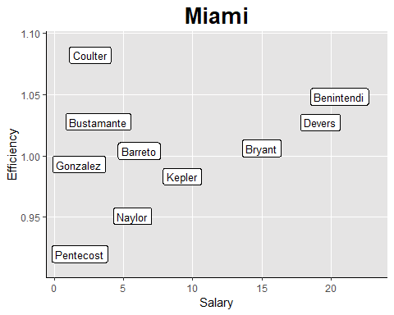

This will tell you where you’re spending money defensively. Players above 1 Efficiency, and lower salary are your best value. Ideal category here is top left. Worst, is bottom right.

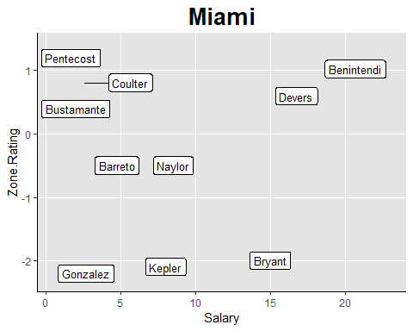

This will tell you where you’re spending money defensively. Players above 5 Zone Rating, and lower salary are your best value. Ideal category here is top left. Worst, is bottom right.