Comparing Machine Learning Algorithms on
Time Series Data

Course Number: CS 4982

Name: Eric Foote
3502094

Department of Computer Science

University of New Brunswick

Dr. Mahanti
December 8, 2021

Abstract
When comparing machine learning algorithms, such as autoregressive integrated moving average (ARIMA); long-short term memories (LSTM) and convolutional neural networks; we see a difference between the artificial intelligence models and the machine learning models. Particularly, in the areas of accuracy of forecast and execution time. This project uses Black Berry stock data collected from Yahoo Finance from the period of February 3, 1999 to September 27, 2021 to forecast the September 28, 2021 period. Furthermore, it applies Python 3 libraries such as tensor flow and keras to create and test these models. We see that ARIMA models with not detrended data had the smallest percent error.
Table of Contents
Abstract 2
1.0 Introduction 6
2.0 Background Information 6
2.1 Time Series 6
2.2 ARIMA 7
2.3 Long Short Term Memories 8
2.4 Convolutional Neural Network 9
3.0 Methodology 10
4.0 Results 14
5.0 Discussion 15
6.0 Conclusion 16
7.0 Recommendations 16
References 18
Appendix A: Flow Chart of Code 22
Appendix B: System Design 23
Appendix C: Code 24
Appendix D: Data 34

Table of Figures
Figure 1: Daily Closing Price of BlackBerry 11
Figure 2: DeTrened BlackBerry Dataset 12
Figure 3: Raw Data 34

Index of Tables
Table 1: Descriptive Statistics 11
Table 2: Results 14

1.0 Introduction
“The techniques I developed for studying turbulence, like weather, also apply to the stock market''.[31] The common techniques shared between meteorological and financial data is the field known as time series data. Which is defined as “a sequence of observations measured as successive times.”[1] The field of stock prediction is a popular one, with many papers and articles on the subject. Since being able to forecast(i.e., predict) the price of a stock can lead to financial insight and possible financial gain. However, forecasting stock prices is not the singular goal of the paper. The aim of the paper is to answer the question: when comparing autoregressive integrated moving average (ARIMA); long-short term memory (LSTM) and convolutional neural networks (CNN) models on the metrics of accuracy and forecasting time, which one performs the best? To answer this question, first a background discussion covering time series, time series analysis and the three model types. Secondly, a look at the methodology of creating these models and forecasting the Black Berry stock price on September 28, 2021 using data starting from February 3, 1999 up to September 27, 2021.

2.0 Background Information
This section is several subsections to discuss the various parts of the theory behind the project. We start with a look at what exactly time series is and outline some ways to analyze the data.

2.1 Time Series
Time series data is “a sequence of observations measured as successive times.'[1] Basically it is collecting data points over the same period for the same object of study. This time period is either “monthly, trimesteral, annual, weekly, daily, hourly, biennial, decennial.”[1] Some examples of time series data is: “weather records, economic indicators, patient health evolution, disk ops write and usage data, network log data, traces (a list of subroutine calls that an application performs during execution)”[33] are all examples of different time series data. Since this type of data covers so many fields of study, it is useful to want to analyze the data. The models we can use to analyze the data are autoregressive integrated moving average (ARIMA); long-short term memory (LSTM) and convolutional neural networks (CNN). Time series analysis is “a statistical technique dealing in trend analysis, or time series data.”[2] In other words, it's using the earlier information to have insight on the future data. Time series data is broken down into three categories: time series data, cross-sectional data “data values of one or more variables, gathered at the same time point.”[2] and finally, pooled data which is “a combination of time series and cross-sectional data”[2]. An example of time series analysis is examining stock prices.
We also can consider univariate and multivariate time series forecasting. Univariate time series forecasting is “if you use only the previous values of the time series to predict its future values.”[5] In other words it's basically just the time series no other variables is in model creation. Multivariate time series forecasting is “if you use predictors other than the series to forecast.”[5] Basically, it's considering other factors in the model creation. We deal with forecasting new data using time-series analysis which “comprises the use of some significant model to forecast future conclusions by known past outcomes.” [5] Which means that we are applying machine learning algorithms to predict some new data point given the model knows the history of the data. We are next going to look in detail on our first model ARIMA.

2.2 ARIMA
ARIMA is known as autoregressive integrated moving average. It's defined as “a class of models that ‘explains’ a given time series based on its own past values.”[5] One key trait that cannot be present in the dataset is the time series has to be “non-seasonal”. To break it down a little further “an ARIMA model is characterized by 3 terms: p,d,q where, p is the order of the AR term, q is the order of the MA term and d is the number of differencing required to make the time series stationary”[5]. In other words, p is the order of the autoregressive part and q is the order of the moving average part and d is the number of differences to make the series stationary. Now we need to discuss what exactly the term autoregressive means, it can be described as “a linear regression model that uses its own lags as predictors”[5]. Now that we have this understanding of what exactly autoregressive means we can put the two statements together to get that p “refers to the number of lags of Y to be used as predictors”[5]. Furthermore, q is “the number of lagged forecast errors that should go into the ARIMA model”[5]. We can state the mathematical definition of ARIMA model in words as: “Predicted Y_{t} = Constant + Linear combination Lags of Y (up to p lags) + Linear Combination of Lagged forecast errors (up to q lags)”[5]. This is a sufficient understanding of the model in order to be able to apply it, any other discussion is beyond the scope of this project.

2.3 Long Short Term Memories
Long-short term memory or LSTM in short is “an advanced version of recurrent neural network architecture that was designed to model chronological sequences and their long-range dependencies more precisely than conventional RNNs”[16]. With “the major highlights include the interior design of a basic LSTM cell.”[15] LSTM consists “of four layers that interact with one another in a way to produce the output of that cell along with the cell state. These two things are then passed onto the next hidden layer.”[15] “LSTMs consists of three logistic sigmoid gates and one hyperbolic tangent layer. Gates have been introduced to limit the information that is passed through the cell. They determine which part of the information will be needed by the next cell and which part to be discarded”[15]. In other words a LSTM network is a series of four neural network layers that is designed similarly to recurrent neural networks, each cell interacts with the four layers and are then passed on to the next layer. One of the layers applies the hyperbolic tangent function from mathematics and each cell uses the sigmoid function three times to limit the information passed. We are now going to go to our last model type a CNN.

2.4 Convolutional Neural Network
Convolutional neural network or CNN for short is a “deep learning algorithm which can take an input image, assign importance (learnable weights and biases) to various aspects/objects in the image and be able to differentiate one from the other”[34]. Basically, it is an algorithm that takes input learns traits about it and be able to distinguish between them. There are three layers to the CNN : the convolution layer, pooling layer, and fully connected layer. The convolutional layer “is the core building block of a CNN, and it is where a majority of computation occurs. It requires a few components, which are input data, a filter, and a feature map”[35]. In other words, it is the central piece of it which has input data, some way to filter the data and a function between the layers. The pooling layer is “also known as down sampling, conducts dimensionality reduction, reducing the number of parameters in the input” [35] Basically, this layer removes samples and not necessary variables from the network. Finally, the fully-connected layer “performs the task of classification based on the features extracted through the previous layers and their different layers.”[35] It computes the classification based on the work done in convolutional layer. Now that we have some background knowledge of the theory behind the models. I am going to now go through my methods.

3.0 Methodology
When considering the methodology, the sequence of steps is: first, use the download historical data feature of Yahoo Finance [13] to get our dataset. This is an easy-to-use tool that allows the ability to get historical data going back to the beginning of the stocks' history. The added benefit of which is the format of the file being csv which is good since its easy to load into any programming language. Furthermore, this tool gives nicely formatted data which leads to an easier time since cleaning the data set is not necessary.
Secondly, the choice of programming language for this project was Python 3. This choice was for a few reasons: one, it's a popular tool for data science and two, there are packages and libraries readily available to make the model creation simpler. Furthermore, there are plenty of online resources and tutorials available to make the code easier to understand and to guide what specific packages and libraries would be necessary in order for everything to work. The environment for coding is a Jupyter Notebook because it cleanly divides the code into sections such as library/package imports, rough data import, exploratory data analysis, data transformation, model creation, model forecasting and finally data analysis. This came in handy for reducing overall execution time, since individual blocks could be executed. Refer to Appendix C for the entire code. For ease of readability common shorthand for libraries such as “pyplot as plt” and “tensorflow as tf” are avoided.
Thirdly, importing all needed libraries and packages. For example, pandas to give us an easy way to import the data with a convenient data structure; keras and tensorflow to give us neural networks and finally, statsmodels to give us the statistical tests and ARIMA model. The next step was to import the raw data from the csv file. Good practice is to print the dataset to look at the structure of the data, and the types of variables (See Appendix D). Following this, a decision on which variable to forecast; for this project the variable of choice is closing price. Good statistical practice is to plot the relevant data, below is a plot of date vs closing price:
This plot shows the daily closing value of the Black Berry stock over the period of February 3, 1999 to September 27, 2021. Following that calculation of some basic statistics (i.e., mean and standard deviation) from the dataset tabulated below:
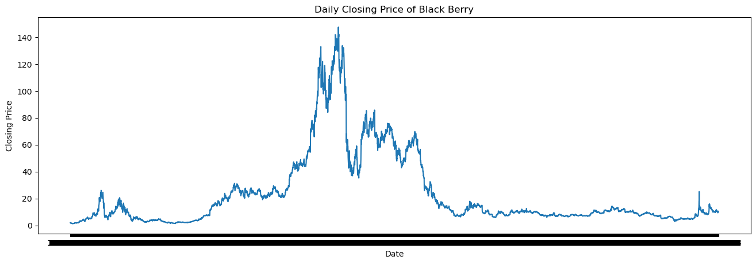Figure 1: Daily Closing Price of BlackBerry
Table 1: Descriptive Statistics
 | Open | High | Low | Close | Adj Close | Volume
Count | 5699.000000 | 5699.000000 | 5699.000000 | 5699.000000 | 5699.000000 | 5699.000000
Mean | 23.095688 | 23.567537 | 22.573332 | 23.058380 | 23.058380 | 1.649957e+07
Std | 27.719227 | 28.232380 | 27.102127 | 27.667360 | 27.667360 | 2.091388e+07
Min | 1.291667 | 1.291667 | 1.140625 | 1.270833 | 1.270833 | 2.442000e+05
25% | 7.115000 | 7.240000 | 6.990000 | 7.100000 | 7.100000 | 5.497250e+06
50% | 10.360000 | 10.590000 | 10.180000 | 10.370000 | 10.370000 | 1.196540e+07
75% | 25.523333 | 25.921666 | 25.073334 | 25.480000 | 25.480000 | 2.041865e+07
Max | 146.479996 | 148.130005 | 143.889999 | 147.550003 | 147.550003 | 5.367394e+08

This table shows the number of data points recorded for each variable. The mean of the individual variables. The standard deviation of each variable. The minimum value of each variable. The 25th percentile of each variable. The 50th percentile (or commonly referred to as the median) of each variable. The 75th percentile of each variable and the maximum value of each variable. These values allow us to get a better understanding of the different trends of the dataset for when we start to make forecasts, we can better relate them to the dataset. After that a test for stationarity using ADF Test and KPSS Test. Since the p-value for the ADF test was less than 0.05 we reject the null hypothesis that the time series posses a unit root and is non-stationary. Since the p-value for the KPSS test was less than 0.05 we reject the null hypothesis that the time series is stationary around a deterministic trend. Therefore, in this case we require de-trending the dataset. The method used is subtracting the line of best fit from the time series, which gave the below plot:
This plot shows the daily closing value of the Black Berry stock de-trended over the period of February 3, 1999 to September 27, 2021.
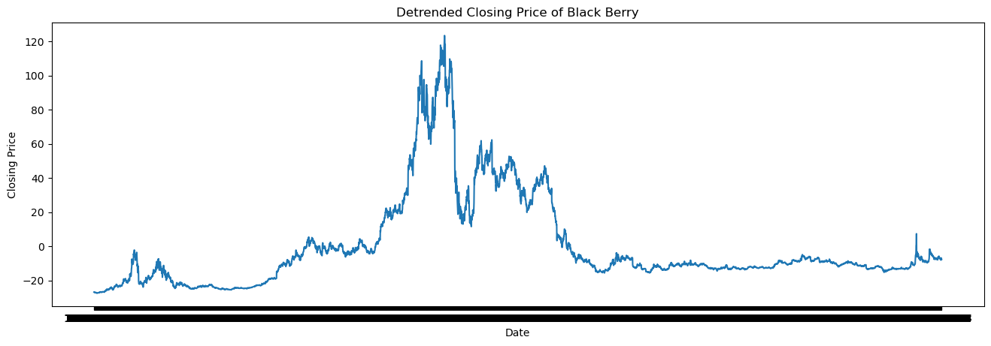Figure 2: DeTrened BlackBerry Dataset
The next step is to create the models: firstly, the ARIMA model using the auto_arima function of the pmdarima package. This function uses a step wise search to minimize AIC to give the best possible model. After that the creation of the LSTM network by doing the following steps: taking the detrended closing data and making it our training set. Take the training set and scale it to values between zero and one using the minimax scaler. Furthermore, two arrays: x and y are created that have scaled data points, where x at each step has all the data points from the beginning to the time step which is set as 100 but could be changed. Y is just a singular data point at the j+time step position. Following that the reshaping of the training set to be of the form of a 3D vector to be put into the network. Then the creation of the four layers of the LSTM network. Next, the compilation of the network using a mean squared error loss, adam optimizer with 10 epochs. After that the creation of a second version of the LSTM network, but this time used the non detrended dataset instead.
The last model created was the CNN. For data preparation, the sequence of steps is similar to the LSTM is applied. The CNN is similar to the LSTM except Cov1D is used instead of LSTM. Following that, the creation of a new set of the same models which used the non detrended dataset.
After that the forecasting and data analysis for each model. The first step of which is to import the new dataset which contained the September 28th data point; since the models use detrended data, this dataset is also detrended, to compare the results of the detrended models. After that the extraction of the September 28 data point from both the regular and the detreneded datasets and put as separate variables. The first model that is forecasted is the ARMIA model, and it used the built-in predict function with the number of periods set to 1. Then the calculation of the forecasted percent error.
To predict using LSTM model, the sequence of steps is to transform the new dataset using minimax scaler. Following that, applying a similar sequence of steps to put the test points in a vector, reshaping that vector, and then sending that to the LSTM predict function. To get the actual predicted values however, the application of the inverse minimax scaler gives the original predicted values. Then the calculation of percent error for the LSTM model.
To predict using CNN model, the application of a similar sequence of steps to the LSTM model (i.e., put the test points in a vector, reshaping that vector and then sending that to the CNN predict function.) Following that, the prediction for September 28 for the CNN model and the percent error. Finally, the repetition of all the above forecasting steps to collect the predicted values and the percent errors for the non detrended dataset. Next is a discussion of the results of the forecasting, the percent error of the forecasting and the amount of time needed to compile the models.

4.0 Results
Before a discussion of the results, the closing value of the Black Berry stock on September 28, 2021 is 10.14. The results of the models are below in tabular form:
Table 2: Results
Model | Predicted Value | % Error | Compile Time
ARIMA (detrended data) | 7.25594278 | 4.50041861% | 10.472 seconds
LSTM (detrended data) | 21.898241 | 188.21518% | 2864 seconds
CNN (detrended data) | 6.1309347 | 19.307285% | 1000 seconds
LSTM (not detrended) | 37.14097 | 279.3766% | 2975 seconds
CNN (not detrended) | 11.373558 | 16.17526% | 1000 seconds
ARIMA (not detrended) | 10.13926028 | 3.56752077% | 11.323 seconds

Each row of the table represents a specific model, predicted closing value, percent error and compile time. The formula for percent error is:

As we see from the table: ARIMA with detrended data has a predicted value of 7.25594278, took 10.472 seconds and had a 4.55041861% error; LSTM with detrended data has a predicted value of 21.898241, took 2864 seconds and had a 188.21518% error; CNN with detrended data had a predicted value of 6.1409347, took 1000 seconds to compile and had a 19.307285% error. Now if we consider the data set which has not been detrended we see: LSTM has a predicted value of 37.14097, took 2975 seconds to compile and had a 279.3766% error; CNN had a predicted value of 11.373558, took 1000 seconds to compile and had a 16.17526% error; ARIMA had a predicted value of 10.13926028, took 11.323 seconds to compile and had a 3.56752077% error.
Therefore, we see that the smallest % error is the ARIMA (not detrended) model. The fastest compile time was the ARIMA (detrended data) model. The slowest compile time was the LSTM (not detrended) model; which was also the one that was the farthest off. So we see that the ARIMA models had the smallest percent error, with the not detrended dataset having the closest value. The LSTM models had the largest percent error with the detrended dataset being the closest of the two. Finally, the CNN models were in the middle between the two other models used with the not detrended dataset having the smallest percent error. A discussion of these results is in the next section.

5.0 Discussion
In the previous section it described that the model that was closest to the actual value was the ARIMA model with non detrended input data. This is interesting since the two statistical tests early indicated that the dataset should have been detrended. Between the two artificial intelligence models the CNN with detrended data had the smallest percent error. Furthermore, both LSTM models had extremely large percent error. An interesting point about the LSTM models are that they are in the range of the 75th percentile; which shows that a spike in the stock prices (see figure 1) that happened in the semi recent history affected these models. The CNN was similar to the ARIMA model where the non detrended data did better than the detrended data. This could be due to how the CNN learned the dataset.
The compilation of the neural networks is interesting, for the LSTM models when comparing the detrended against the non detrended there is a 3.73% difference in the compilation time between the two which lead to a 41.040217% difference in the predicted value. An interesting discussion point is the choice of the detrending method. This projects choice of detrending the dataset which is to simply just subtract the line of best fit; there are a few different methods for detrending the dataset such as subtracting the mean of the dataset, or apply “a filter like Baxter-King filter or the Hodrick-Prescott Filter to remove the moving average trend lines or the cyclical components”[32].

6.0 Conclusion
In conclusion, through creating six models: ARIMA with detrended data; ARIMA without detrended data; LSTM with detrended data; LSTM without detrended data; CNN with detrended data and CNN without detrended data and testing them on Black Berry Stock data from February 3, 1999 to September 27, 2021 to forecast the closing price of September 28, 2021. We see that the smallest % error is the ARIMA (not detrended) model. The fastest compile time was the ARIMA (detrended data) model. The slowest compile time was the LSTM (not detrended) model; which was also the one that was the farthest off. One possible result for this was the method chosen for the detrending process. Through testing the best overall model was the ARIMA model with not detrended data. This is possibly due to a spike in the closing stock price in recent history. Furthermore, a lot of volatility in the stock occurred which could have lead to the neural networks learning the wrong features. Finally, some recommendations for future work is discussed.

7.0 Recommendations
Some recommendations that for future work is to compare all of these models with bidirectional encoder representations from transformers (BERT) and generative adversarial network (GAN) models, to see if these neural networks learn the dataset better. Furthermore, to generalize the work beyond the Black Berry data set such that these models can be applied to other stock market entities. Another thing is to train the artificial intelligence models on smaller chunks of the data. This is to see if that makes a difference on the predicted value as we saw with the LSTM network they were heavily affected by the spike in the closing stock price. Another thing is to look into the field of econometrics to see if that particular field has some domain specific insights; that would lead to different model choices, different choices for scaling data and possibly some different split percentages for training and testing sets. Also, consider comparing different detrending methods to see if one particular method is better then another. Finally, forecasting beyond just the single day to see if there is some propagating error for later days.

References
1. Time Series. In: The Concise Encyclopedia of Statistics. New York, NY: Springer New York; 2008. p. 536–539.

2. Tyagi N. Introduction to Time Series Analysis in Machine learning. Analyticssteps.com. [accessed 2021 Nov 19]. https://www.analyticssteps.com/blogs/introduction-time-series-analysis-time-series-forecasting-machine-learning-methods-models

3. Ruiz P. ML approaches for time series - towards data science. Towards Data Science. 2019 May 19 [accessed 2021 Nov 19]. https://towardsdatascience.com/ml-approaches-for-time-series-4d44722e48fe

4. Cyrus. Time series forecasting with stacked machine learning models. Medium. 2019 Jul 27 [accessed 2021 Nov 19]. https://medium.com/@qs2178/time-series-forecasting-with-stacked-machine-learning-models-7250abdece0f

5. Prabhakaran S. ARIMA model - complete guide to time series forecasting in python. Machinelearningplus.com. 2021 Aug 22 [accessed 2021 Nov 19]. https://www.machinelearningplus.com/time-series/arima-model-time-series-forecasting-python/

6. Brownlee J. How to model volatility with ARCH and GARCH for time series forecasting in python. Machinelearningmastery.com. 2018 Aug 23 [accessed 2021 Nov 19]. https://machinelearningmastery.com/develop-arch-and-garch-models-for-time-series-forecasting-in-python/

7. Brownlee J. Multistep time series forecasting with LSTMs in python. Machinelearningmastery.com. 2017 May 9 [accessed 2021 Nov 19]. https://machinelearningmastery.com/multi-step-time-series-forecasting-long-short-term-memory-networks-python/

8. Brownlee J. How to develop convolutional Neural Network models for time series forecasting. Machinelearningmastery.com. 2018 Nov 11 [accessed 2021 Nov 19]. https://machinelearningmastery.com/how-to-develop-convolutional-neural-network-models-for-time-series-forecasting/

9. Brownlee J. Multivariate time series forecasting with LSTMs in keras. Machinelearningmastery.com. 2017 Aug 13 [accessed 2021 Nov 19]. https://machinelearningmastery.com/multivariate-time-series-forecasting-lstms-keras/

10. Biswal A. An easy guide to stock price prediction using machine learning. Simplilearn.com. 2021 May 11 [accessed 2021 Nov 19]. https://www.simplilearn.com/tutorials/machine-learning-tutorial/stock-price-prediction-using-machine-learning

11. Dai Y, Zhang Y. Machine learning in stock price trend forecasting. Stanford.edu. [accessed 2021 Nov 19]. https://cs229.stanford.edu/proj2013/DaiZhang-MachineLearningInStockPriceTrendForecasting.pdf

12. Li K (yi). Predicting stock prices using machine learning. Neptune.ai. 2021 Jul 29 [accessed 2021 Nov 19]. https://neptune.ai/blog/predicting-stock-prices-using-machine-learning

13. BlackBerry Limited (BB). Yahoo.com. [accessed 2021 Nov 19]. https://finance.yahoo.com/quote/BB/history?period1=918086400&period2=1632787200&interval=1d&filter=history&frequency=1d&includeAdjustedClose=true

14. Understanding LSTM Networks. Github.io. [accessed 2021 Nov 19]. https://colah.github.io/posts/2015-08-Understanding-LSTMs/

15. Srivastava P. Long short term memory. Analyticsvidhya.com. 2017 Dec 10 [accessed 2021 Nov 19]. https://www.analyticsvidhya.com/blog/2017/12/fundamentals-of-deep-learning-introduction-to-lstm/

16. Understanding of LSTM networks. Geeksforgeeks.org. 2020 May 10 [accessed 2021 Nov 19]. https://www.geeksforgeeks.org/understanding-of-lstm-networks/

17. Brownlee J. Time series prediction with LSTM recurrent neural networks in python with keras. Machinelearningmastery.com. 2016 Jul 20 [accessed 2021 Nov 19]. https://machinelearningmastery.com/time-series-prediction-lstm-recurrent-neural-networks-python-keras/

18. Clemente F. Synthetic time-series data: A GAN approach - towards data science. Towards Data Science. 2021 Jan 27 [accessed 2021 Nov 19]. https://towardsdatascience.com/synthetic-time-series-data-a-gan-approach-869a984f2239

19. Sonkiya P, Bajpai V, Bansal A. Stock price prediction using BERT and GAN. arXiv [q-fin.ST]. 2021. http://arxiv.org/abs/2107.09055. doi:10.1145/nnnnnnn.nnnnnnn

20. Sen J, Mehtab S. Design and analysis of robust deep learning models for stock price prediction. In: Artificial Intelligence. IntechOpen; 2021.

21. Bhardwaj K. Convolutional neural network in stock price movement prediction. Arxiv.org. [accessed 2021 Nov 19]. http://arxiv.org/abs/2106.01920v1

22. Zhong S, Hitchcock DB. S&P 500 stock price prediction using technical, fundamental and text data. arXiv [stat.ML]. 2021 [accessed 2021 Nov 19]. http://arxiv.org/abs/2108.10826

23. Time series forecasting. Tensorflow.org. [accessed 2021 Nov 19]. https://www.tensorflow.org/tutorials/structured_data/time_series

24. Forecasting: Principles and practice (2nd ed). Otexts.com. [accessed 2021 Nov 19]. https://otexts.com/fpp2/

25. Brownlee J. How to develop LSTM models for time series forecasting. Machinelearningmastery.com. 2018 Nov 13 [accessed 2021 Nov 19]. https://machinelearningmastery.com/how-to-develop-lstm-models-for-time-series-forecasting/

26. Time Series - LSTM Model. Tutorialspoint.com. [accessed 2021 Nov 19]. https://www.tutorialspoint.com/time_series/time_series_lstm_model.htm

27. Cohen I. Time series-introduction - towards data science. Towards Data Science. 2019 Jun 5 [accessed 2021 Nov 19]. https://towardsdatascience.com/time-series-introduction-7484bc25739a

28. Doron. How to import a CSV file into Python using Pandas. Datatofish.com. 2018 Feb 20 [accessed 2021 Nov 19]. https://datatofish.com/import-csv-file-python-using-pandas/

29. Pyplot tutorial — Matplotlib 3.5.0 documentation. Matplotlib.org. [accessed 2021 Nov 19]. https://matplotlib.org/stable/tutorials/introductory/pyplot.html

30. Pandas DataFrame iloc Property. W3schools.com. [accessed 2021 Nov 19]. https://www.w3schools.com/python/pandas/ref_df_iloc.asp

31. Benoit Mandelbrot - The techniques I developed for. Brainyquote.com. [accessed 2021 Nov 19]. https://www.brainyquote.com/quotes/benoit_mandelbrot_301434?src=t_stock_market
32. Prabhakaran S. Time series analysis in python - A comprehensive guide with examples - ML+. Machinelearningplus.com. 2019 Feb 13 [accessed 2021 Nov 19]. https://www.machinelearningplus.com/time-series/time-series-analysis-python/

33. What is Time Series Data? Influxdata.com. 2019 Dec 7 [accessed 2021 Nov 20]. https://www.influxdata.com/what-is-time-series-data/

34. Saha S. A comprehensive guide to convolutional neural networks — the ELI5 way. Towards Data Science. 2018 Dec 15 [accessed 2021 Nov 25]. https://towardsdatascience.com/a-comprehensive-guide-to-convolutional-neural-networks-the-eli5-way-3bd2b1164a53

35. IBM Cloud Education. What are Convolutional Neural Networks? Ibm.com. [accessed 2021 Nov 25]. https://www.ibm.com/cloud/learn/convolutional-neural-networks

Appendix A: Flow Chart of Code
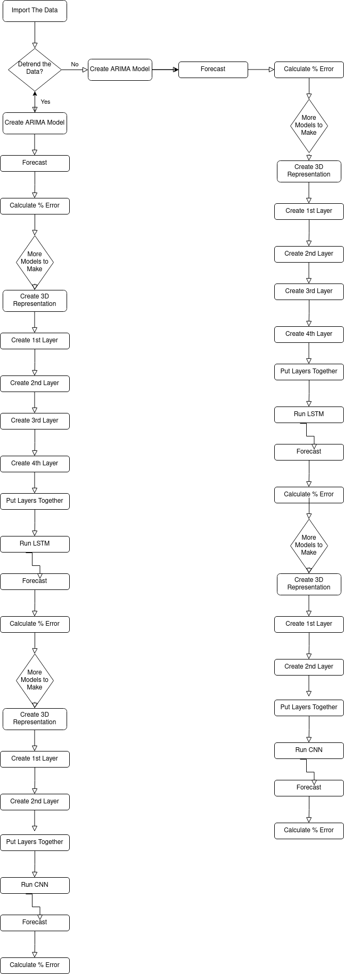

Appendix B: System Design
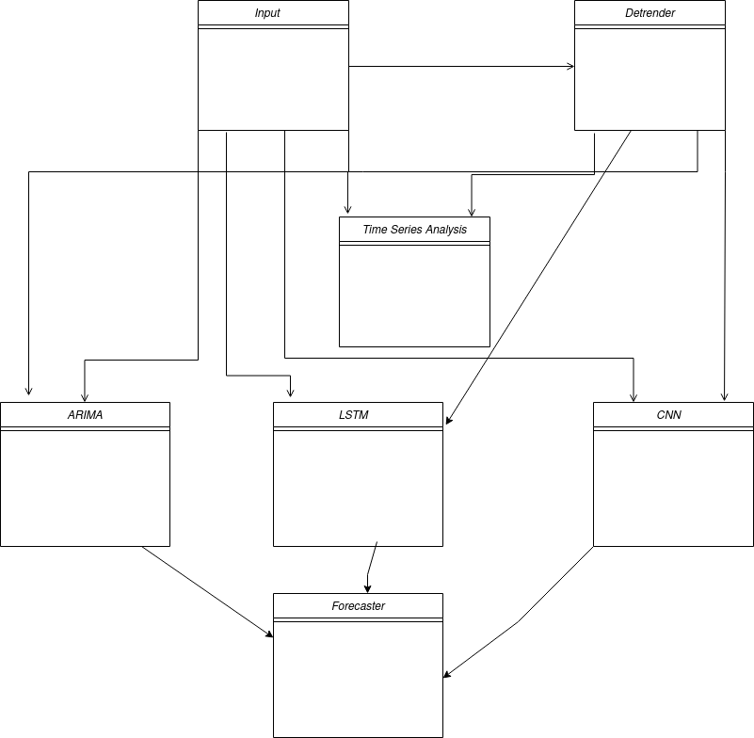

Appendix C: Code
# A list of possible needed imports
import os
import IPython
import IPython.display
import matplotlib as matplotlib
import matplotlib.pyplot as pyplot
import numpy as numpy
import pandas as pandas
import seaborn as seaborn
import tensorflow as tensorflow
from statsmodels.tsa.stattools import adfuller
from statsmodels.tsa.arima.model import ARIMA
from arch import arch_model
import pmdarima as pmdarima
from arch.__future__ import reindexing
from numpy import array
from keras.models import Sequential
from keras.layers import Dense
from keras.layers import Flatten
from keras.layers.convolutional import Conv1D
from keras.layers.convolutional import MaxPooling1D
from keras.layers import LSTM
from keras.layers import Dropout
from sklearn.preprocessing import MinMaxScaler
from statsmodels.tsa.stattools import kpss
from scipy import signal
# Import the Raw Data
raw_data = pandas.read_csv(r'/home/knighttwisted/2021fallcoursework/CS4980/BB.csv')
print(raw_data)
# Plot the Date vs. Closing Price

pyplot.figure(figsize=(16,5), dpi = 100)
pyplot.gca().set(title = "Daily Closing Price of Black Berry", xlabel = "Date", ylabel = "Closing Price")
pyplot.plot(raw_data["Date"], raw_data["Close"])
pyplot.show()
# Get some basic statistics from the dataset
raw_data.describe()
# Test for stationarity
# ADF Test
ADF_Test_Result = adfuller(raw_data["Close"], autolag = 'AIC')
# KPSS Test
KPSS_Test_Result = kpss(raw_data["Close"], regression = 'ct')
ADF_Test_Statistic = ADF_Test_Result[0]
ADF_Test_p_value = ADF_Test_Result[1]
KPSS_Test_Statistic = KPSS_Test_Result[0]
KPSS_Test_p_value = KPSS_Test_Result[1]
print("ADF Test Statistic " + str(ADF_Test_Statistic))
print("KPSS Test Statistic " + str(KPSS_Test_Statistic))
print("ADF p-value " + str(ADF_Test_p_value))
print("KPSS p-value " + str(KPSS_Test_p_value))
# Since the p-value for the ADF test was less than 0.05 we reject the null hypothesis that the time series posses a unit root and is non-stationary
# Since the p-value for the KPSS test was less than 0.05 we reject the null hypothesis that the time series is stationary around a deterministic trend
# We need to de-trend the dataset
# I am just going to subtract the line of best fit from the time series
raw_closing_data = raw_data["Close"]
detrended_closing_data = signal.detrend(raw_closing_data)
pyplot.plot(detrended_closing_data)
pyplot.title("Detrended Closing Data")
pyplot.show()
ARIMA_Model = pmdarima.auto_arima(detrended_closing_data, start_p =1, start_q=1,
test='adf',
max_p =5, max_q =5,
m=1,
d=None,
seasonal=False,
start_P=0,
D=0,
trace=True,
error_action='ignore',
suppress_warnings=True,
stepwise=True)
print(ARIMA_Model.summary())
ARIMA_Model_Not_Detrended = pmdarima.auto_arima(raw_closing_data, start_p =1, start_q=1,
test='adf',
max_p =5, max_q =5,
m=1,
d=None,
seasonal=False,
start_P=0,
D=0,
trace=True,
error_action='ignore',
suppress_warnings=True,
stepwise=True)
print(ARIMA_Model.summary())
#detrended_training_data = detrended_closing_data[0:3989]
#detrended_testing_data = detrended_closing_data[3990:5699]
detrended_training_data = detrended_closing_data
# We now need to feature scale
Scaler = MinMaxScaler(feature_range = (0,1))
detrended_training_data_scaled = Scaler.fit_transform(detrended_training_data.reshape(-1,1))
timeStep = 100
x_train = []
y_train = []

for i in range(len(detrended_training_data)-timeStep-1):
point = detrended_training_data_scaled[i:(i+timeStep),0]
x_train.append(point)
y_train.append(detrended_training_data_scaled[i+80,0])
x_train = numpy.array(x_train)
y_train = numpy.array(y_train)
#Reshaping
x_train = x_train.reshape(x_train.shape[0], x_train.shape[1],1)
#Create and Fit the Network
LSTM_Model = Sequential()
LSTM_Model.add(LSTM(50,return_sequences=True, input_shape = (x_train.shape[1],1)))
LSTM_Model.add(Dropout(0.2))
LSTM_Model.add(LSTM(50))
LSTM_Model.add(Dropout(0.2))
LSTM_Model.add(Dense(units=1))
LSTM_Model.compile(loss = 'mean_squared_error', optimizer='adam')
LSTM_Model_fit = LSTM_Model.fit(x_train,y_train,batch_size=1,epochs=10)
training_data = numpy.array(raw_closing_data)
# We now need to feature scale
Scaler = MinMaxScaler(feature_range = (0,1))
training_data_scaled = Scaler.fit_transform(training_data.reshape(-1,1))
timeStep = 100
x_train = []
y_train = []
for i in range(len(training_data)-timeStep-1):
point = training_data_scaled[i:(i+timeStep),0]
x_train.append(point)
y_train.append(training_data_scaled[i+80,0])
x_train = numpy.array(x_train)
y_train = numpy.array(y_train)

#Reshaping
x_train = x_train.reshape(x_train.shape[0], x_train.shape[1],1)
#Create and Fit the Network
LSTM_Model_2 = Sequential()
LSTM_Model_2.add(LSTM(50,return_sequences=True, input_shape = (x_train.shape[1],1)))
LSTM_Model_2.add(Dropout(0.2))
LSTM_Model_2.add(LSTM(50))
LSTM_Model_2.add(Dropout(0.2))
LSTM_Model_2.add(Dense(units=1))
LSTM_Model_2.compile(loss = 'mean_squared_error', optimizer='adam')
LSTM_Model_2_fit = LSTM_Model_2.fit(x_train,y_train,batch_size=1,epochs=10)
training_data = detrended_closing_data
# We now need to feature scale
Scaler = MinMaxScaler(feature_range = (0,1))
training_data_scaled = Scaler.fit_transform(training_data.reshape(-1,1))
timeStep = 100
x_train = []
y_train = []
for i in range(len(training_data)-timeStep-1):
point = training_data_scaled[i:(i+timeStep),0]
x_train.append(point)
y_train.append(training_data_scaled[i+80,0])
x_train = numpy.array(x_train)
y_train = numpy.array(y_train)
#Reshaping
x_train = x_train.reshape(x_train.shape[0], x_train.shape[1],1)
#Create and Fit the Network
CNN_Model = Sequential()
CNN_Model.add(Conv1D(filters=64, kernel_size=2, activation ='relu', input_shape=(x_train.shape[1],1)))
CNN_Model.add(MaxPooling1D(pool_size=2))
CNN_Model.add(Flatten())
CNN_Model.add(Dense(50, activation='relu'))
CNN_Model.add(Dense(1))
CNN_Model.compile(optimizer='adam', loss='mse')
CNN_Model.fit(x_train,y_train, epochs=1000)
training_data = numpy.array(raw_closing_data)
# We now need to feature scale
Scaler = MinMaxScaler(feature_range = (0,1))
detrended_training_data_scaled = Scaler.fit_transform(training_data.reshape(-1,1))
timeStep = 100
x_train = []
y_train = []
for i in range(len(training_data)-timeStep-1):
point = training_data_scaled[i:(i+timeStep),0]
x_train.append(point)
y_train.append(training_data_scaled[i+80,0])
x_train = numpy.array(x_train)
y_train = numpy.array(y_train)
#Reshaping
x_train = x_train.reshape(x_train.shape[0], x_train.shape[1],1)
#Create and Fit the Network
CNN_Model_2 = Sequential()
CNN_Model_2.add(Conv1D(filters=64, kernel_size=2, activation ='relu', input_shape=(x_train.shape[1],1)))
CNN_Model_2.add(MaxPooling1D(pool_size=2))
CNN_Model_2.add(Flatten())
CNN_Model_2.add(Dense(50, activation='relu'))
CNN_Model_2.add(Dense(1))
CNN_Model_2.compile(optimizer='adam', loss='mse')
CNN_Model_2.fit(x_train,y_train, epochs=1000)
# First step is to import the data with the September 28 2021 data point included
data_including_Sept_28 = pandas.read_csv(r'/home/knighttwisted/2021fallcoursework/CS4980/BB_Including_Sept_28.csv')
print(data_including_Sept_28)
# We need to de-trend the dataset
# I am just going to subtract the line of best fit from the time series
data_including_Sept_28_detrended = data_including_Sept_28["Close"]
data_including_Sept_28_detrended = signal.detrend(data_including_Sept_28["Close"])
pyplot.figure(figsize=(16,5), dpi = 100)
pyplot.gca().set(title = "Detrended Closing Price of Black Berry", xlabel = "Date", ylabel = "Closing Price")
pyplot.plot(data_including_Sept_28["Date"], data_including_Sept_28_detrended)
pyplot.show()
# Next up we need to extract Sept 28 from this to check the validatity of our forcasting
Sept_28 = data_including_Sept_28_detrended[5699]
Sept_28 = abs(Sept_28)
print(Sept_28)
September_28 = data_including_Sept_28["Close"][5699]
print(September_28)
# ARIMA MODEL FORECASTING AND % Error
ARMIA_Model_Sept28 = ARIMA_Model.predict(n_periods=1)
# % ERROR = (ACTUAL - THEORITICAL) / THEORITICAL * 100%
ARMIA_Model_Sept28 = abs(ARMIA_Model_Sept28)
print(ARMIA_Model_Sept28)
Percent_Difference_ARMIA_Model = (Sept_28 - ARMIA_Model_Sept28) / Sept_28 * 100
print(Percent_Difference_ARMIA_Model)
# LSTM MODEL FORECASTING AND % ERROR
#LSTM FORCASTING
detrended_testing_data_scaled = Scaler.fit_transform(data_including_Sept_28_detrended.reshape(-1,1))
x_test = []
for i in range(len(detrended_testing_data_scaled)-10-1):
point = detrended_training_data_scaled[i:(i+10),0]
x_test.append(point)
x_test = numpy.array(x_test)
x_test = x_test.reshape(x_test.shape[0],x_test.shape[1],1)
LSTM_Model_Prediction = LSTM_Model.predict(x_test)
LSTM_Model_Prediction = Scaler.inverse_transform(LSTM_Model_Prediction)
#print(len(LSTM_Model_Prediction))
LSTM_Sept28 = LSTM_Model_Prediction[5688]
LSTM_Sept28 = abs(LSTM_Sept28)
print(LSTM_Sept28)
Percent_Difference_LSTM_Model = abs(((Sept_28 - LSTM_Sept28 )/Sept_28) * 100)
print(Percent_Difference_LSTM_Model)
#21.898241
# CNN MODEL FORECASTING AND % ERROR
# CNN FORCASTING
detrended_testing_data_scaled = Scaler.fit_transform(data_including_Sept_28_detrended.reshape(-1,1))
x_test = []
for i in range(len(detrended_testing_data_scaled)-100-1):
point = detrended_training_data_scaled[i:(i+100),0]
x_test.append(point)
x_test = numpy.array(x_test)
x_test = x_test.reshape(x_test.shape[0],x_test.shape[1],1)
CNN_Model_Prediction = CNN_Model.predict(x_test)
CNN_Model_Prediction = Scaler.inverse_transform(CNN_Model_Prediction)
#print(len(CNN_Model_Prediction))
CNN_Sept28 = CNN_Model_Prediction[5598]
CNN_Sept28 = abs(CNN_Sept28)
print(CNN_Sept28)
Percent_Difference_CNN_Model = ((Sept_28 - CNN_Sept28 )/Sept_28) * 100
print(Percent_Difference_CNN_Model)
# LSTM_2 NOT DETRENDED MODEL FORECASTING AND % ERROR
#LSTM_2 FORCASTING
data_including_Sept_28 = numpy.array(data_including_Sept_28)
testing_data_scaled = Scaler.fit_transform(data_including_Sept_28.reshape(-1,1))
x_test = []
for i in range(len(testing_data_scaled)-10-1):
point = training_data_scaled[i:(i+10),0]
x_test.append(point)
x_test = numpy.array(x_test)
x_test = x_test.reshape(x_test.shape[0],x_test.shape[1],1)
LSTM_2_Model_Prediction = LSTM_Model_2.predict(x_test)
LSTM_2_Model_Prediction = Scaler.inverse_transform(LSTM_2_Model_Prediction)
#print(len(LSTM_Model_Prediction))
LSTM_2_Sept28 = LSTM_2_Model_Prediction[5688]
LSTM_2_Sept28 = abs(LSTM_2_Sept28)
print(LSTM_2_Sept28)
Percent_Difference_LSTM_2_Model = abs(((September_28 - LSTM_2_Sept28 )/September_28) * 100)
print(Percent_Difference_LSTM_2_Model)
#21.898241
# CNN_2 MODEL FORECASTING AND % ERROR
# CNN_2 FORCASTING
testing_data_scaled = Scaler.fit_transform(data_including_Sept_28.reshape(-1,1))
x_test = []
for i in range(len(testing_data_scaled)-100-1):
point = training_data_scaled[i:(i+100),0]
x_test.append(point)
x_test = numpy.array(x_test)
x_test = x_test.reshape(x_test.shape[0],x_test.shape[1],1)
CNN_Model_2_Prediction = CNN_Model_2.predict(x_test)
CNN_Model_2_Prediction = Scaler.inverse_transform(CNN_Model_2_Prediction)
#print(len(CNN_Model_Prediction))
CNN_2_Sept28 = CNN_Model_2_Prediction[5598]
CNN_2_Sept28 = abs(CNN_2_Sept28)
print(CNN_2_Sept28)
Percent_Difference_CNN_Model_2 = ((September_28 - CNN_2_Sept28 )/September_28) * 100
print(abs(Percent_Difference_CNN_Model_2))
# ARIMA MODEL FORECASTING AND % Error
ARMIA_Model_Not_Detrended_Sept28 = ARIMA_Model_Not_Detrended.predict(n_periods=1)
# % ERROR = (ACTUAL - THEORITICAL) / THEORITICAL * 100%

ARMIA_Model_Not_Detrended_Sept28 = abs(ARMIA_Model_Not_Detrended_Sept28)
print(ARMIA_Model_Not_Detrended_Sept28)
Percent_Difference_ARMIA_Model_Not_Detrended = (September_28 - ARMIA_Model_Not_Detrended_Sept28) / September_28 * 100
print(abs(Percent_Difference_ARMIA_Model_Not_Detrended))

Appendix D: Data
Below is a snapshot of the dataset
The dataset has seven different variables each having 5699 different values. The seven variables are: date, opening price, the highest daily value, the lowest daily value, closing price, adjusted closing price and the volume of stocks.
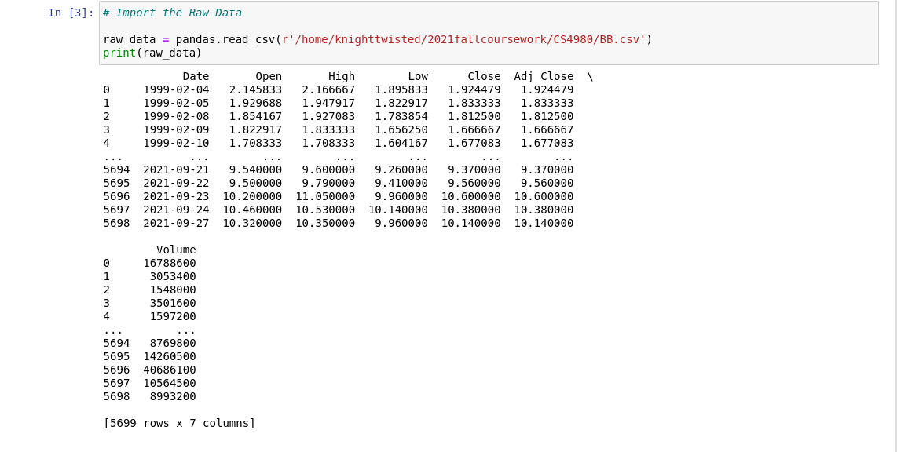Figure 3: Raw Data

