**Machine Problem 4:**

Results:

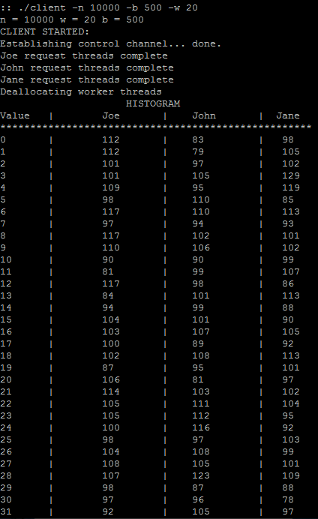

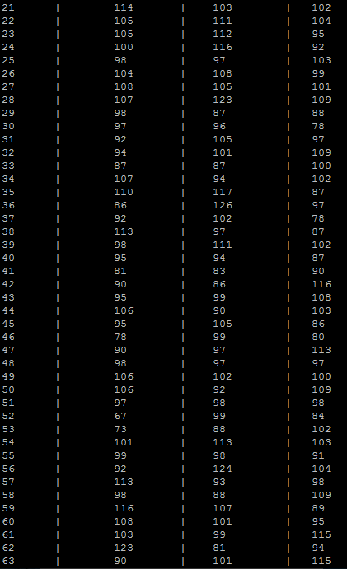

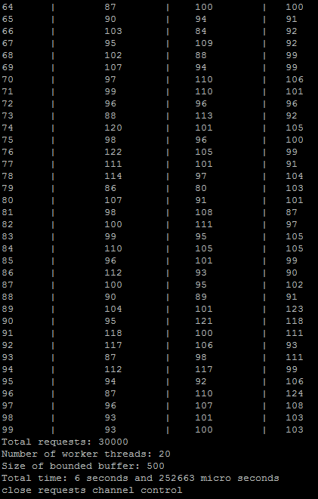

**Sample Runs:**

-n is 10000 for all values in the chart:

|  |  |  |
| --- | --- | --- |
| -b | -w | Runtime |
| 500 | 20 | 9.512460 |
| 500 | 21 | 7.233590 |
| 500 | 22 | 9.305809 |
| 500 | 25 | 9.135809 |
| 500 | 28 | 5.695180 |
| 500 | 30 | 4.806573 |

|  |  |  |
| --- | --- | --- |
| -b | -w | Runtime |
| 100 | 30 | 5.191650 |
| 200 | 30 | 3.757037 |
| 300 | 30 | 7.724483 |
| 400 | 30 | 5.510610 |
| 450 | 30 | 4.198210 |
| 500 | 30 | 6.698093 |